SOUTH DUBLIN COUNTY COUNCIL

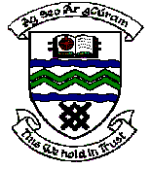

MEETING OF TERENURE/RATHFARNHAM AREA COMMITTEE (2)

Tuesday 14th November, 2006.

Question No. 14

Question: Councillor Máire Árdagh

“To ask the Manager to remove or severely prune the tree at (details provided) which is between 10 - 12 m in height and is blocking the resident's access to his driveway?"

Reply:

This location will be considered for tree pruning under the Arboricultural Programme.

