COMHAIRLE CHONTAE ATHA CLIATH THEAS

SOUTH DUBLIN COUNTY COUNCIL

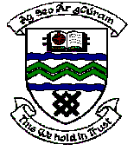

MEETING OF TERENURE/RATHFARNHAM AREA COMMITTEE (2)

Tuesday 14th November, 2006

Question No. 13

Question: Councillor Máire Árdagh

“To ask the Manager to remove the graffiti from the room of the pavillon in Beechfield Park?"

REPLY:

Arrangements are being made for the removal of the graffiti in conjunction with the graffiti removal crew from the Council’s Environmental Services Department.

