COMHAIRLE CHONTAE ATHA CLIATH THEAS

SOUTH DUBLIN COUNTY COUNCIL

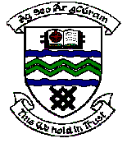

MEETING OF TERENURE/RATHFARNHAM AREA COMMITTEE (2)

Tuesday 10th October, 2006.

Headed Item No: H- I (2)

A Contribution is being made to the following groups:

Group | Type of Application | Amount
Helen Mc Daid,  15 Hermitage Downs,  Rathfarnham,  Dublin 16. | Contribution towards world masters swimming championship | €300
Order of Malta Ambulance Corps Templeogue Unit | Contribution towards a new ambulance | €2,000

