COMHAIRLE CHONTAE ÁTHA CLIATH THEAS

SOUTH DUBLIN COUNTY COUNCIL

TERENURE RATHFARNHAM AREA
COMMITTEE MEETING (1)

Minutes of Terenure Rathfarnham Area Committee Meeting (1), (dealing with Planning, Development, Corporate Services and Roads business) held on 5th September 2006.

PRESENT

Councillors
M. Ardagh
C. Keane
J. Lahart
S. Laing
T. McDermott
E. Walsh
A. White

An Cathaoirleach, Councillor T. McDermott presided.

OFFICIALS PRESENT
Senior Executive Officers | F. Nevin, M. Judge
Senior Engineers | T. O’Grady, D. Ryan, J.McLoughlin
Senior Planner | M. Kenny
Administrative Officers | T. Curtin, M. Hunt
Senior Executive Engineers | S. Daly
Senior Executive Planners | L. McGauran, M. O’Connor
Staff Officer | N. Fitzgibbon

A minute silence was observed to mark the death of Councillor Fintan McCarthy and Sonya Rabbitte.

TR/535/06 CONFIRMATION AND RE-AFFIRMATION OF MINUTES

Minutes of meeting of Terenure Rathfarnham Area Committee (1) dealing with Roads, Planning, Development and Corporate Services business, held on 6th June 2006, which had been circulated were submitted, APPROVED as a true record and signed.

It was proposed by Councillor T. McDermott, seconded by Councillor S. Laing and RESOLVED:

“That the recommendations contained in the Minutes of the Terenure Rathfarnham Area Committee Meeting (1) held on 6th June 2006 be ADOPTED and APPROVED.”
Minutes of Special Meeting of Terenure Rathfarnham Area Committee (1) dealing with Planning Department, held on 22nd June 2006, which had been circulated were submitted, APPROVED as a true record and signed.

It was proposed by Councillor T. McDermott, seconded by Councillor J. Lahart and RESOLVED:

“That the recommendations contained in the Minutes of the Terenure Rathfarnham Area Committee Meeting (1) held on 22ND June 2006 be ADOPTED and APPROVED.”

PLANNING BUSINESS

TR/536/06 QUESTIONS

It was proposed by Councillor T. McDermott, seconded by Councillor J. Lahart and RESOLVED:

“That pursuant to Standing Order No. 13 questions numbered 1 to 4 inclusive be ADOPTED and APPROVED.”

TR/537/06 UNAUTHORISED VAN SALES
QUESTION: Councillor M. Ardagh
“To ask the Manager to report on the situation in relation to the operation of the unauthorized Roundabout Van Sales business on Walkinstown Roundabout and will he give a report on the matter?”
REPLY:
A plot of land lying between St Peter’s Road and Cromwellsfort Road, Walkinstown is in the ownership of the proprietor of the nearby public house and has been used as an overflow car park for the patrons of the public house. It appears that the plot has not been used for car parking for some time and was recently leased to the proprietor of Roundabout Van Sales.

During a recent inspection, both the landowner and proprietor of the van sales company were advised verbally that the change of use is not considered exempt from the requirement to obtain planning permission.

A Warning Letter dated 24th August 2006 pursuant to Section 152 of the Planning & Development Act was served on both the owner and occupier of the lands.

TR/538/06 PLANNING ENFORCEMENT
QUESTION: Councillor J. Lahart
"To ask the Manager for the up to date position on Planning Enforcement at Rosemount Shopping Centre (Londis) and at Cedar Grove, Firhouse Road?"
REPLY:
Cedar Grove, Firhouse Road

Planning permission, subject to conditions, was granted by An Bord Pleanála for the “demolition of existing two-storey house and the construction of a three-storey apartment block over basement car parking consisting of 24 number apartments comprising of four number one bedroom apartments, 19 number two bedroom apartments and one number three bedroom apartment, 24 number basement car parking spaces, bicycle parking, three number surface car parking spaces, landscaping, planting, new entrance to include pedestrian access and associated site development works at Cedar Grove, Firhouse Road, Templeogue, Dublin (reg. ref. SD03A/0789 refers).”

Following the commencement of development, concerns were expressed by local residents that the development may not have been carried out in accordance with the permission. Of particular concern were the removal of trees from the site and the use of the footpath and grass verge immediately outside the site for parking of their cars by employees.

Parking on public roadways and footpaths is a matter for the Gardaí and this particular issue has been brought to the attention of the Gardai, Rathfarnham Garda Station.

The permission granted by An Bord Pleanála required the developer to submit, prior to the commencement of development, detailed proposals for agreement in relation to the materials, colours and textures of external finishes, a management scheme providing adequate measures relating to the future maintenance of private open spaces, roads and communal areas and proposals to landscape the site.

As the required proposals had not been submitted, an Enforcement Notice pursuant to Section 154 of the Planning & Development Act 2000 was served on the developer on 26 April 2006 requiring him to cease work on the site until his proposals to comply with the above conditions were received. The developer has submitted his proposals in relation to landscaping the site. These proposals are being examined at present.

Rosemount Shopping Centre, Marian Road
Planning permission was granted on 29 June 2005 for “Alterations to previously approved planning permission register reference No. SD04A/0449 to incorporate a single storey rear extension to include 2 no. offices, goods store, elevational changes and all associated site works” at Unit 7, Rosemount Shopping Centre, Marian Road, Rathfarnham.

The approved plans indicated a height of 3.960 metres at the north-west corner of the extension. Following receipt of complaints concerning the height of the extension, measurements taken by the area Planning Inspector showed that the structure at the north-west corner was 5.767 metres high. A Warning Letter pursuant to Section 152 of the Planning & Development Act, 200 was served on the owner on 2 February 2006.

A planning application for “Retention of works to previously approved planning permission no's. SD04A/0449 & SD05A/0223, namely raising of roof structure, increase of parapet height, minor amendments to elevations and all associated site works” was submitted on 13 March 2006. a decision to refuse permission was made on 27 April 2006. This decision was not appealed to An Bord Pleanála.

An Enforcement Notice was served on the shop’s owners on 3 May 2006 requiring that they reduce the height of the building to the height indicated on the approved plans. They were allowed 10 weeks (i.e. until 14 July 2006) to complete this work.

A further planning application was lodged on 24 May 2006 for “Retention of alterations to previously approved planning permission (Reg. Ref. SD04A/0449 & SD05A/0223), namely retention of finished modified height to northern, eastern and western elevations and revised elevational treatment to northern elevation; minor internal alterations, provision of plant to flat roof area, landscaping treatment and all associated site works”. This application proposed a reduction in the height of the wall by a minimum of 0.7 metres and a maximum of 1.25 metres. These revisions provided for an increase in height of 0.994 metres over the original proposal. A decision to grant permission was made by the Council on 18 July 2006. This decision is currently under appeal to An Bord Pleanala.

TR/539/06 ENFORCEMENT MATTER S/4520
QUESTION: Councillor A. White
"To ask the Manager for a report regarding Enforcement Matter S/4520?"
REPLY:
Planning permission, subject to conditions, was granted by An Bord Pleanála for the “demolition of existing two-storey house and the construction of a three-storey apartment block over basement car parking consisting of 24 number apartments comprising of four number one bedroom apartments, 19 number two bedroom apartments and one number three bedroom apartment, 24 number basement car parking spaces, bicycle parking, three number surface car parking spaces, landscaping, planting, new entrance to include pedestrian access and associated site development works at Cedar Grove, Firhouse Road, Templeogue, Dublin (reg. ref. SD03A/0789 refers).”

Following the commencement of development, concerns were expressed by local residents that the development may have not been carried out in accordance with the permission. Of particular concern were the removal of trees from the site and the use of the footpath and grass verge immediately outside the site for parking of their cars by employees.

Parking on public roadways and footpaths is the responsibility of the Gardaí and this particular concern has been brought to the attention of the Gardai at Rathfarnham Garda Station.

The permission granted by An Bord Pleanála required the developer to submit detailed proposals in relation to the following conditions:

5. Prior to commencement of construction of development, details of the materials, colours and textures of all the external finishes to the proposed development shall be submitted to the planning authority for agreement.

Reason: In the interest of orderly development and the visual amenities of the area.

6. Prior to commencement of development, a management scheme providing adequate measures relating to the future maintenance of private open spaces, roads and communal areas in a satisfactory manner shall be submitted to the planning authority for agreement.

Reason: To ensure the adequate future maintenance of this private development in the interest of residential amenity.

7. The site shall be landscaped in accordance with a (tree survey and) landscaping scheme which shall be submitted to the planning authority for agreement before development commences. This scheme shall include:

(a) A plan to scale of not less than 1/500 showing-

(i) the trees to be removed and those to be retained, indicating species, heights, crown spread and condition

(ii) the species and setting of all new planting

(iii) proposals for levelling, mounding and surface treatment of communal areas including hard surfaced areas of public open space;

(b) l landscape management plan to include details of the measures to protect existing trees and shrubs during the construction phase; and

(c) A timescale for the implementation of this scheme indicating details of phasing.

Reason: In the interest of visual amenity.

As the required proposals had not been submitted, an Enforcement Notice pursuant to Section 154 of the Planning & Development Act 2000 was served on the developer on 26 April 2006 requiring him to cease work on the site until his proposals to comply with the above conditions were received. The developer has submitted his proposals in relation to landscaping the site. These proposals are being examined at present by the area Planner.

Further enforcement action in relation to this matter is being held in abeyance pending consideration of the compliance documents submitted.

TR/540/06 ENFORCEMENT MATTER S/4726
QUESTION: Councillor A. White
"To ask the Manager for a report regarding Enforcement Matter S/4726?"

Reply:

Article 86 (1) (a)(i) of the Planning & Development Regulations, 2001 provides that the provisions of the Planning & Development Act 2000 relating to development consisting of the provision of “Garda stations or other buildings, or other premises or installations, or other structures or facilities, used for the purposes of or in connection with the operations of An Garda Síochána” shall be exempt from requiring planning permission.

Article 86 (1) (d) further provides that the Act shall not apply to “development consisting of the carrying out of any works within, or bounding, the curtilage of a building, premises or other installation referred to in paragraph (a), insofar as such works are incidental to the use of such building, premises or installation.” While works carried out under subsection (1) (a) of Article 86 require the publication of prior notice and the erection of a notice on site, no such requirement pertains to subsection (d).

Planning permission was granted on 9 June 2000 for the “Retention of an existing cabin, to form part of the digital mobile telecommunications network” at Rathfarnham Garda Station. The replacement of a telecommunications antennae support structure could be considered as exempt from a requirement to obtain planning permission, subject to certain conditions and limitations, (Class 31, Schedule 2, Part 1, Planning & Development Regulations, 2001). Conflicting information has been received as to who has erected this replacement mast. The height of the replacement mast compared to the previous mast is also pertinent to this case

The Office of Public Works is the agency responsible for the maintenance of Garda Stations. The OPW has been asked to supply details of the replacement mast so that a determination can be made as to whether it complies fully with the requirements of the Regulations.

TR/541/06 PLANNING FILES
- Large Applications Under Consideration
SD06A/0725 | Reg. Date:  22-Aug-2006  Applicant’s Name:  JRG Construction Ltd.,  Submission Type:  New Application | Location:  Site at junction of Ballymount Avenue/Ballymount Road Upper, Walkinstown, Dublin 12  Proposed Development:  Construction of 2 no. warehousing blocks as follows: (1) Block A, 9 no. units (8.9m high) totaling 1,368sqm including 522sqm of mezzanine storage at first floor; (2) Block B, 18 no. units (8.9m high) totaling 2,700sqm including 1,350sqm of ancillary office/staff facilities at first floor together with services, utilities, boundary fences, landscaping, planting paving, parking and associated site development works.  Decision Due on or before:  15-Oct-2006

- Files Requested by Members

Cllr. Eamonn Walsh

S95A/0520
Applicant: | Electricity Supply Board,
Date Received: | 23-Oct-1995
Location: | Palmer Park/Pearse Brothers Park, Ballyboden, Dublin 16.
Development: | Erect at its existing 38kV substation a free standing steel lattice telecommunications mast, carrying mobile phone cellular antennae and microwave dishes - overall height 20 metres over ground - and associated ground mounted equipment cabinet, security fence with a pedestrian gate, to form part of the second planned G.S.M. (mobile phone) network.

TR/542/06 NEW WORKS

It was NOTED that there was no business under this heading.

TR/543/06 CORRESPONDENCE

It was NOTED that there was no business under this heading.

TR/544/06 CATHAOIRLEACH’S BUSINESS
It was proposed by Councillor T. McDermott and seconded by Councillor M. Ardagh
"That this meeting discuss, with the aid of a report from the Manager, the remaining obstacles to the taking in charge of Longwood/Stonepark Abbey."
The following Report by the Manager, which had been circulated, was READ:
“The Roads and Services in Longwood Park were taken in charge by the Council at its meeting on the 13th November, 1995.
Stonepark Abbey, Rathfarnham, Dublin 14, was developed by M. & N. O’Grady developments. The Council has prepared and issued a list of outstanding remedial works necessary to bring the roads and services in this development to taking-in-charge standard, to the developer. The outstanding works include: works to manholes, cable link manhole and reinstatement of ESB trench. “As constructed” drawings have been requested from the developer and are awaited.
It is the policy of the Council to ensure that all necessary taking in charge works are carried out by developers prior to taking in charge. To ensure the implementation of this policy the security, which is lodged by the developer, at the commencement of the development is held by the Council and is released only on certification that all necessary works have been carried out.
The Council holds a total of £89,000 (€113,000.00) cash security in respect of housing development at Stonepark Abbey.

A letter has issued to M & N O’Grady on the 17th August, 2006 detailing outstanding works and documentation required to enable the Council to take Stonepark Abbey in charge. The developer has informed the Council by letter dated 23rd August, 2006 that the matter of the taking in charge of the estate has been referred to his Solicitor for his attention.
The Council will take all the necessary steps to ensure that the developer completes this estate to the necessary taking in charge standard.”
The following Motion in the name of Councillor M. Ardagh was taken in conjunction with the above.
It was proposed by Councillor M. Ardagh and seconded by Councillor T. McDermott.

"That the Manager give a report on the taking in charge of Stonepark Abbey and to say when this process will be completed."
REPORT
“Stonepark Abbey, Rathfarnham, Dublin 14, was developed by M. & N. O’Grady developments. The Council has prepared and issued a list of outstanding remedial works necessary to bring the roads and services in this development to taking-in-charge standard, to the developer. The outstanding works include: works to manholes, cable link manhole and reinstatement of ESB trench. “As constructed” drawings have been requested from the developer and are awaited.
It is the policy of the Council to ensure that all necessary taking in charge works are carried out by developers prior to taking in charge. To ensure the implementation of this policy the security, which is lodged by the developer, at the commencement of the development is held by the Council and is released only on certification that all necessary works have been carried out.
The Council holds a total of £89,000 (€113,000.00) cash security in respect of housing development at Stonepark Abbey.

A letter has issued to M & N O’Grady on the 17th August, 2006 detailing outstanding works and documentation required to enable the Council to take Stonepark Abbey in charge. The developer has informed the Council by letter dated 23rd August, 2006 that the matter of the taking in charge of the estate has been referred to his Solicitor for his attention.
The Council will take all the necessary steps to ensure that the developer completes this estate to the necessary taking in charge standard.”
Following contributions from Councillors, T. McDermott, M. Ardagh, J. Lahart, C. Keane and S. Laing, Mr. T. O’Grady, Senior Engineer, responded to queries raised and the reports were NOTED.

TR/545/06 ENFORCEMENT ACTION CEDAR GROVE
It was proposed by Councillor J. Lahart and seconded by Councillor C. Keane.

"That the Council take all necessary action to enforce action at the development site at Cedar Grove, Firhouse Road, and ensure that the builder complies with all conditions imposed by An Bord Pleanala.”
The following Report by the Manager, which had been circulated, was READ and NOTED.
REPORT:
“Planning permission, subject to conditions, was granted by An Bord Pleanála for the “demolition of existing two-storey house and the construction of a three-storey apartment block over basement car parking consisting of 24 number apartments comprising of four number one bedroom apartments, 19 number two bedroom apartments and one number three bedroom apartment, 24 number basement car parking spaces, bicycle parking, three number surface car parking spaces, landscaping, planting, new entrance to include pedestrian access and associated site development works at Cedar Grove, Firhouse Road, Templeogue, Dublin (reg. ref. SD03A/0789 refers).”

Following the commencement of development, concerns were expressed by local residents that the development may have not been carried out in accordance with the permission. Of particular concern were the removal of trees from the site and the use of the footpath and grass verge immediately outside the site for parking of their cars by employees.

Parking on public roadways and footpaths is the responsibility of the Gardaí and this particular concern has been brought to the attention of the Gardai at Rathfarnham Garda Station.

The permission granted by An Bord Pleanála required the developer to submit detailed proposals in relation to the following conditions:

5. Prior to commencement of construction of development, details of the materials, colours and textures of all the external finishes to the proposed development shall be submitted to the planning authority for agreement.

Reason: In the interest of orderly development and the visual amenities of the area.

6. Prior to commencement of development, a management scheme providing adequate measures relating to the future maintenance of private open spaces, roads and communal areas in a satisfactory manner shall be submitted to the planning authority for agreement.

Reason: To ensure the adequate future maintenance of this private development in the interest of residential amenity.

7. The site shall be landscaped in accordance with a (tree survey and) landscaping scheme which shall be submitted to the planning authority for agreement before development commences. This scheme shall include:

(a) A plan to scale of not less than 1/500 showing-

(i) the trees to be removed and those to be retained, indicating species, heights, crown spread and condition,

(ii) the species and setting of all new planting,

(iii) proposals for levelling, mounding and surface treatment of communal areas including hard surfaced areas of public open space;

(b) landscape management plan to include details of the measures to protect existing trees and shrubs during the construction phase; and

(c) A timescale for the implementation of this scheme indicating details of phasing.

Reason: In the interest of visual amenity.

As the required proposals had not been submitted, an Enforcement Notice pursuant to Section 154 of the Planning & Development Act 2000 was served on the developer on 26 April 2006 requiring him to cease work on the site until his proposals to comply with the above conditions were received. The developer has submitted his proposals in relation to landscaping the site. These proposals are being examined at present by the area Planner.

Further enforcement action in relation to this matter is being held in abeyance pending consideration of the compliance documents submitted.”
TR/546/06 UNAUTHORISED MAST
It was proposed by Councillor E. Walsh and seconded by Councillor T. McDermott.
"That the Manager make arrangements to remove the telecommunications mast recently erected in Greenhills Industrial Estate and in close proximity to St. Columbas Road, Greenhills without Planning Permission and is causing serious concern and offence to the local residents."
The following report by the Manager was NOTED and it was AGREED that the Motion be RE-ENTERED for the October meeting of the Committee.
REPORT:
“An inspection of the mast erected at Greenhills Industrial Estate was carried out by the Planning Inspector. It appears that the mast may have been provided by O₂, a statutory service provider of a telecommunications service. Statutory undertakers of telecommunications services are exempt from the requirement to obtain planning permission for the erection of masts on commercial buildings, subject to conditions and limitations, (Class 31 (k), Schedule 2, Part 1, Planning & Development Regulations, 2001).

In this instance O₂ did not comply fully with the Regulations in that details of the mast were not forwarded to the Planning Authority as required.

Accordingly a Warning Letter dated 25th August 2006 pursuant to Section 152 of the Planning & Development Act 2000 has been served on the land owners and the occupiers of the premises.

As a person served with the Warning Letter, he/ she may make submissions to the Planning Authority in relation to the contents of the letter within 4 weeks of the date of the letter.

Should the Planning Authority, following further investigation of the lands, consider that unauthorised development has been carried out, an Enforcement Notice may be served.

The Councillor will be kept informed as the investigation progresses.”

TR/547/06 TAKING IN CHARGE EDENBROOK MANOR
It was proposed by Councillor M. Ardagh and seconded by Councillor C. Keane.
"That the Manager give a report on the present situation regarding the taking-in-charge of Edenbrook Manor and the proposed meeting with the developer and residents that was to have been arranged in July last to discuss the matter and resolve the problems."
The following report by the Manager was READ and NOTED:
REPORT:
“Edenbrook Manor was developed by Clayworth Investments Ltd. under planning permission granted in 1996 (Register Reference S96A/0159)

It was intended by the developer that this estate would not be offered for taking in charge to the council but would remain private and the planning permission required that a management company would be set up to take charge of the maintenance and up-keep of the estate.
It was agreed at the Terenure/Rathfarnham Area Committee Meeting of 14th February 2006 that the Council’s Building Control Section would facilitate a meeting between the developers, Clayworth Investments Limited, and the residents of Edenbrook Manor, with a view to finding a resolution of the situation. A letter dated 17th February 2006, informed the developer of this proposal.
The principal of Clayworth Investments Ltd. has stated that he is prepared to meet the residents of Edenbrook Manor with a view to resolving the issues involved.
Arrangements are being put in place and it is anticipated that this meeting will take place during week ending 15th September 2006.”

TR/548/06 TAKING IN CHARGE STONEPARK ABBEY
The following Motion in the name of Councillor A. White was NOT MOVED:
"That the Manager furnish an updated report to enable this Committee to consider the position regarding the delay in taking-in-charge of Stonepark Abbey."

TR/549/06 REPORT ON PLANNING APPLICATION SD06A/0360
It was proposed by Councillor J. Lahart and seconded by Councillor T. McDermott.
"That the Manager present a full report on Planning Application No.SD06A/0360 and Planning Application: SD/06A/0361 and note my objections to the applications."
The following report by the Manager was READ and NOTED:
REPORT:
“Planning Register Reference SD06A/0360 was received on 10th May 2006 from Vodafone Ireland Ltd. at Palmer Park/Pearse Brothers Park, Ballyboden, Dublin 16, for permanent retention of a 20 metre high telecommunications support structure with 6 no. 0.3 metre diameter link dishes, 3 no. 0.6 metre diameter link dishes, 3 no. 1.9 metre high panel antenna and 6 no. 1.3 metre high pane antenna, erected on the structure; a 2.4 metre high security fence with access gate; 3 no. associated equipment shelters measuring approx. 0.8m2 each, 1 no. associated equipment shelter measuring approx 1.2m2, 4 no. associated equipment shelters measuring approx. 1m2 and 2 no. associated equipment shelters measuring 0.6m2 each and all associated site development works. This development had temporary permission under Reg. Ref. S95A/0520, An Bord Pleanala Ref. PL 06S.098068 which lapsed on 15th May 2001.

A decision was made by the Council to Refuse Permission for Retention on 4th July 2006 for the following reasons:

- The proposed development, by virture of its scale and design, would have a negative impact on the visual amenity of the area, and would therefore seriously injure the amenities, or depreciate the value, of property in the vicinity.
- Having regard to the proximity of the proposed antennae within 100 metres of a residential area and a school it is considered that the proposed development would materially contravene section 12.10.1 iii of the South Dublin County Council Development Plan 2004-2010 regarding the location of antennae. Thus the proposed development would be contrary to the proper planning and sustainable development of the area.
A First Party appeal was lodged with An Bórd Pleanála on 31st July 2006. A decision is due from An Bórd Pleanála on or before 20th November 2006.

Planning Register Reference SD06A/0361 was received on 10th May 2006 from Hutchison 3G Ireland Limited for construction of a 30m high cellular tree with 3 no. 1.7 metre antenna and 3 no. 0.3 metre radio link dishes attached, associated equipment cabinets and fencing for a new 3G broadband network. This development will be carried out within the curtilage of a Protected Structure at Pearse Museum, Sarah Curran Avenue, Rathfarnham, Dublin 16.

A decision was made by the Council to Refuse Permission on 3rd July 2006 for the following reason:

It is considered that the proposed development in the form of a 30m high fake tree with cabinets and palisade fencing would represent an inappropriate intrusion into the 18th Century designed parkland setting of the Pearse Museum, a Protected Structure (Ref. 293). The proposed development would therefore be seriously injurious to the amenity of a national heritage site and to the setting of a Protected Structure and would materially contravene the zoning objective at this location, namely 'To preserve and provide for Open Space and Recreational Amenity'. The development would also contravene a Specific Development Plan Objective 'to protect and preserve Trees and Woodlands' at this location. The proposed development is therefore contrary to the proper planning and sustainable development of the area.

A First Party appeal was lodged with An Bórd Pleanála on 31st July 2006. A decision is due from An Bórd Pleanála on or before 20th November 2006.

The objections to both applications from the members at the Terenure Rathfarnham Area Committee Meeting of June 6th 2006, including Cllr. Lahart, have been noted.”

TR/550/06 POSITION WITH REGARD TO EDENBROOK MANOR ESTATE
The following Motion in the name of Councillor A. White was NOT MOVED:
"That the Committee again consider the position with regard to Edenbrook Manor Estate, with the aid of a report from the Manager regarding discussions which were to take place on this matter"
DEVELOPMENT BUSINESS

TR/551/06 QUESTIONS

It was proposed by Councillor T. McDermott, seconded by Councillor J. Lahart and RESOLVED:

“That pursuant to Standing Order No. 13 questions numbered 5 and 6 be ADOPTED and APPROVED.”

TR/552/06 McHugh’s Shopping Centre

QUESTION: Councillor C. Keane
"To ask the Manager for an update on the Compulsory Purchase Order initiated by this Council on the site at McHugh’s Shopping Centre St. James’s Road Greenhills?"
REPLY:
It is intended to initiate the procedure to acquire this site by Compulsory Purchase Order under the provision of the Derelict Sites Act, 1990. Site drawings are now being finalised and the Compulsory Purchase Order procedure will commence thereafter.

It should be noted that planning register reference SD06A/0248 is a current application received for this site on 5/4/2006, the Planning Dept. requested additional information on 30/5/2006. This information has not yet been received.

TR/553 /06 CPO ST. JAMES ROAD GREENHILLS

QUESTION: Councillor E Walsh
“TO ASK THE MANAGER FOR AN UP DATE ON THE PROPOSED COMPULSORY PURCHASE ORDER FOR THE OLD SHOPPING CENTRE SITE ON ST. JAMES ROAD GREENHILLS DUBLIN 12 AND ON THE SECOND PLANNING APPLICATION FOR THE SAME SITE?”
REPLY:
It is intended to initiate the procedure to acquire this site by Compulsory Purchase Order under the provision of the Derelict Sites Act, 1990. Site drawings are now being finalised and the Compulsory Purchase Order procedure will commence thereafter.

It should be noted that planning register reference SD06A/0248 is a current application received for this site on 5/4/2006, the Planning Dept. requested additional information on 30/5/2006. This information has not yet been received.

TR/554/06 NEW WORKS

It was NOTED that there was no business under this heading.

TR/555/06 CORRESPONDENCE

It was NOTED that there was no business under this heading.

TR/ 556/06 CATHAOIRLEACH’S BUSINESS
It was NOTED that there was no business under this heading.

TR/557 /06 HOARDINGS WILLBROOK LAWN
It was proposed by Councillor S. Laing and seconded by Councillor C. Keane
"That the Manager give an up to date report on the hoardings at Willbrook Lawn especially the legal position.”

The following Report by the Manager, which had been circulated, was CONSIDERED:
REPORT:

“As advised to the Committee previously, the Company, which dedicated the strip of open space adjacent to 29 & 30 Willbrook Lawns to the Council and is the last known owner of the land, was dissolved some years ago and any remaining assets would have vested in the Minister for Finance. The Council’s Law Department has made a further application to the Minister to transfer this strip of land by Deed of Waiver to the Council and the Chief State Solicitor’s office is acting for the Minister in this regard. Correspondence is ongoing between the Council and the Chief State Solicitor’s Office regarding the clarification of details in relation to the Company and title issues with a view to progressing the various procedures necessary to enable the Minister to waive his interest in the lands in favour of the Council.

The future use of the site will be reviewed once the title issues have been resolved.”

The following Motion in the name of Councillor C. Keane was taken in conjunction with the above.

It was proposed by Councillor C. Keane and seconded by Councillor S. Laing
The following report by the Manager was CONSIDERED:
"That this Committee discusses the Willbrook Lawn open space issue- with the aid of an up to date report.”

REPORT:

“As advised to the Committee previously, the Company, which dedicated the strip of open space adjacent to 29 & 30 Willbrook Lawns to the Council and is the last known owner of the land, was dissolved some years ago and any remaining assets would have vested in the Minister for Finance. The Council’s Law Department has made a further application to the Minister to transfer this strip of land by Deed of Waiver to the Council and the Chief State Solicitor’s office is acting for the Minister in this regard. Correspondence is ongoing between the Council and the Chief State Solicitor’s Office regarding the clarification of details in relation to the Company and title issues with a view to progressing the various procedures necessary to enable the Minister to waive his interest in the lands in favour of the Council.

The future use of the site will be reviewed once the title issues have been resolved.”

Following contributions from Councillors S.Laing and C. Keane the reports were NOTED.

CORPORATE SERVICES BUSINESS

TR/558/06 QUESTIONS

It was NOTED that there was no business under this heading.

TR/559 /06 NEW WORKS

It was NOTED that there was no business under this heading.

TR/560/06 CORRESPONDENCE

It was NOTED that there was no business under this heading.

TR/ 561/06 CATHAOIRLEACH’S BUSINESS
It was NOTED that there was no business under this heading.

ROADS BUSINESS

TR/562/06 QUESTIONS

It was proposed by Councillor T. McDermott, seconded by Councillor J.Lahart and RESOLVED:

“That pursuant to Standing Order No. 13 questions numbered 7 to 19 inclusive be ADOPTED and APPROVED.”

TR/563 /06 FOOTPATH ON HILLSBROOK AVENUE
QUESTION: Councillor M. Árdagh
"To ask the Manager to dish the footpath on Hillsbrook Avenue at the junction of Whitehall Road West to enable disabled residents get to the P.O. for their pensions?"
REPLY:
This will be included in the works programme.

TR/564/06 SURVEY OF FOOTPATHS HILLSBROOK/MUCKROSS
QUESTION: Councillor M. Árdagh
"To ask the Manager to carry out a survey of the footpaths in the Hillsbrook/Muckross area of Perrystown to see where repair work needs to be carried out in the interests of the safety of the many elderly residents in the area?"
REPLY:
The area will be investigated and any necessary works will be considered for inclusion.

TR/565/06 FLOODING
QUESTION: Councillor M. Árdagh
“To ask the Manager to examine the roadway at (details supplied) where serious flooding is taking place following rainfall. The resident is elderly and cannot leave her house when the roadway is flooded?”
REPLY:
The location will be inspected and remedial works will be carried out if necessary.
TR/ 566 /06 TEMPLEOGUE SIGNPOSTED ON EXIT 11
QUESTION: Councillor C. Keane
"To ask the Manager to ensure that Templeogue is signposted on exit no 11 i.e. the Tallaght exit as many motorists are leaving it too late to exit as the Templeogue sign is just at the exit itself and motorists are crossing the white line barrier to exit – which is illegal?”
REPLY:
The positioning and content of all signposting on National Routes, including the M50, is subject to approval by the NRA. The matter the subject of the above question will be discussed with the NRA and the outcome advised to the members.

TR/567/06 ILLEGAL PARKING ROCKFIELD AVE/WHITEHALL RD. WEST
QUESTION: Councillor C. Keane
"To ask the Manager for an update on the works agreed for Rockfield Ave./Whitehall Road West junction where illegal parking takes place destroying the grass margin?"
REPLY:
Works for the installation of bollards plus extension of double yellow lines and repainting of existing lines have been given out to a contractor and are expected to be completed by end of September 2006.
TR/568/06 PUBLIC LANEWAY PEARSE BROTHERS PARK
QUESTION: Councillor J. Lahart
"To ask the manager to examine the public laneway to the rear of 5 Pearse Brothers Park in Ballyboden with a view to ascertaining whether or not a "Keep Clear" sign is necessary in order to ensure that temporary parking only is permitted and to ensure that permanent blockages by vehicles do not happen and that therefore the laneway is clear for all residents who wish to use it to on a temporary basis?"
REPLY:
A report on this matter will be submitted to the September 2006 Traffic Management Meeting.
TR/569/06 RAILINGS AT ROSEMOUNT CAR PARK
QUESTION: Councillor J. Lahart
"To ask the Manager that an additional dividing railing be providied at Rosemount Car Park , Ballyroan, to prevent cars , particularly with tow-bars, over-hanging the footpath, thereby causing a health and safety hazard to pedestrians, particularly senior citizens?"
REPLY:
Additional railings will be provided at this location.

TR/570/06 RESURFACING OF LANEWAYS
QUESTION: Councillor S. Laing
"To ask the Manager to provide a plan for the resurfacing of the laneways throughout our Committee area on a schedule basis and that this be included in preparation for the Estimates?"
REPLY:
Having regard to the demands for the repair and renewal of footpaths, renewal of signs, cleaning of gullies and the other normal maintenance issues it is is difficult to set aside a major amount of funding for the resurfacing of laneways. However a sum will be included in the preparation of the estimates.

TR/571/06 PEDESTRIAN CROSSINGS AT TEMPLEVILLE-WAINSFORT
QUESTION: Councillor S. Laing
"To ask the Manager when is he going to provide the necessary pedestrian crossings as requested by me at Templeville-Wainsfort and Greentrees Roundabouts?"
REPLY:
Previous counts indicated that warrant was not reached at both locations. These locations are being continuously monitored and should an increase in pedestrian volumes occur then recounts will be carried out.

TR/572 /06 TRAFFIC CALMING PROPOSALS – FERNHILL ESTATE
QUESTION: Councillor E. Walsh
"To ask the Manager for a progress report on the traffic calming proposals for Fernhill Estate?"

REPLY:
In response to a large number of requests for traffic calming measures throughout the Council’s administrative area the Council’s Transportation Strategic Policy Committee at its meeting on the 11th May 2006 adopted a new Traffic Calming programme comprising of four schemes in each of the Council’s five electoral areas. The selection of each individual scheme will be made by the relevant Area Committee.

Fernhill Estate is on the traffic calming request list for the Terenure/Rathfarnham electoral area.

Consideration of further locations for traffic calming purposes will be included on the Terenure/Rathfarnham Agenda for the October meeting.

TR/573/06 REPAIR TO MANHOLE COVER
QUESTION: Councillor E. Walsh
"To ask the Manager to request Eircom to repair the manhole cover at (details supplied) as it may cause an accident to pedestrians?"
REPLY:
The location will be inspected and Eircom will be contacted regarding repairs to the manhole.
TR/574/06 PLANS TO WIDEN GRANGE ROAD
QUESTION: Councillor A. White
"To ask the Manager for a report regarding plans to widen and/or re-align the upper section of Grange Road adjacent to the Hermitage Estate?"
REPLY:
The upgrade of the Grange road adjacent to Hermitage Estate will be carried out in conjunction with the Green Route Realignment Scheme. The section of the Grange Road in question extends from the T-junction with Fortification Hill northwards to the southern side of the entrance to 217-231 Grange Road. Construction works are targeted to commence in late September, early October 2006 with a duration of approximately 15 months.

TR/575/06 RAISED FOOTPATH WILLINGTON GROVE
QUESTION: Councillor A. White
"To ask the Manger to deal with the raised footpath ouside 15 Willington Grove?"
REPLY:
The location will be investigated and any necessary works will be carried out.

TR/576/06 DECLARATION OF ROADS TO BE PUBLIC ROADS

It was NOTED that there was no business under this heading.

TR/577/06

PROPOSED INITIATION OF PROCEDURE TO EXTINGUISH PUBLIC RIGHT-OF-WAY.

Proposed extinguishment of public right of way at the rear of 1-14 Limekiln Green, Walkinstown, Dublin 12

An application has been received from Development Department and the residents of 11 Limekiln Green and 61 Limekiln Avenue to formally extinguish the public right-of-way at the rear of 1-14 Limekiln Green, Walkinstown, due to antisocial behaviour and to affect the closure by means of incorporation into their gardens.

If the Committee agree the procedure to extinguish the public right-of-way as listed above will be initiated.

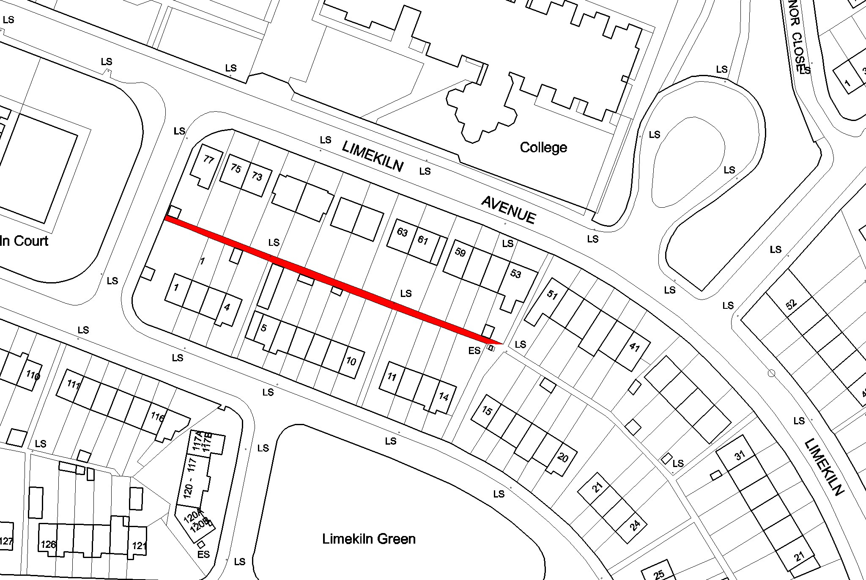

It was AGREED to initiate the procedure to extinguish the public right of way at the above location.

TR/578/06 EXTINGUISH PUBLIC RIGHT OF WAY ADJACENT TO ST. PETERS DRIVE

PROPOSED INITIATION OF PROCEDURE TO EXTINGUISH PUBLIC RIGHT-OF-WAY.
Proposed extinguishment of public right at the laneway adjacent to 34 St Peter’s Drive, Greenhills

An application has been received from the Development Department and the resident of 34 St Peter’s Drive, Greenhills to formally extinguish the public right-of-way at the laneway adjacent to 34 St Peter’s Drive, Greenhills, due to antisocial behaviour and to affect the closure by means of incorporation into their gardens.

If the Committee agree the procedure to extinguish the public right-of-way as listed above will be initiated.
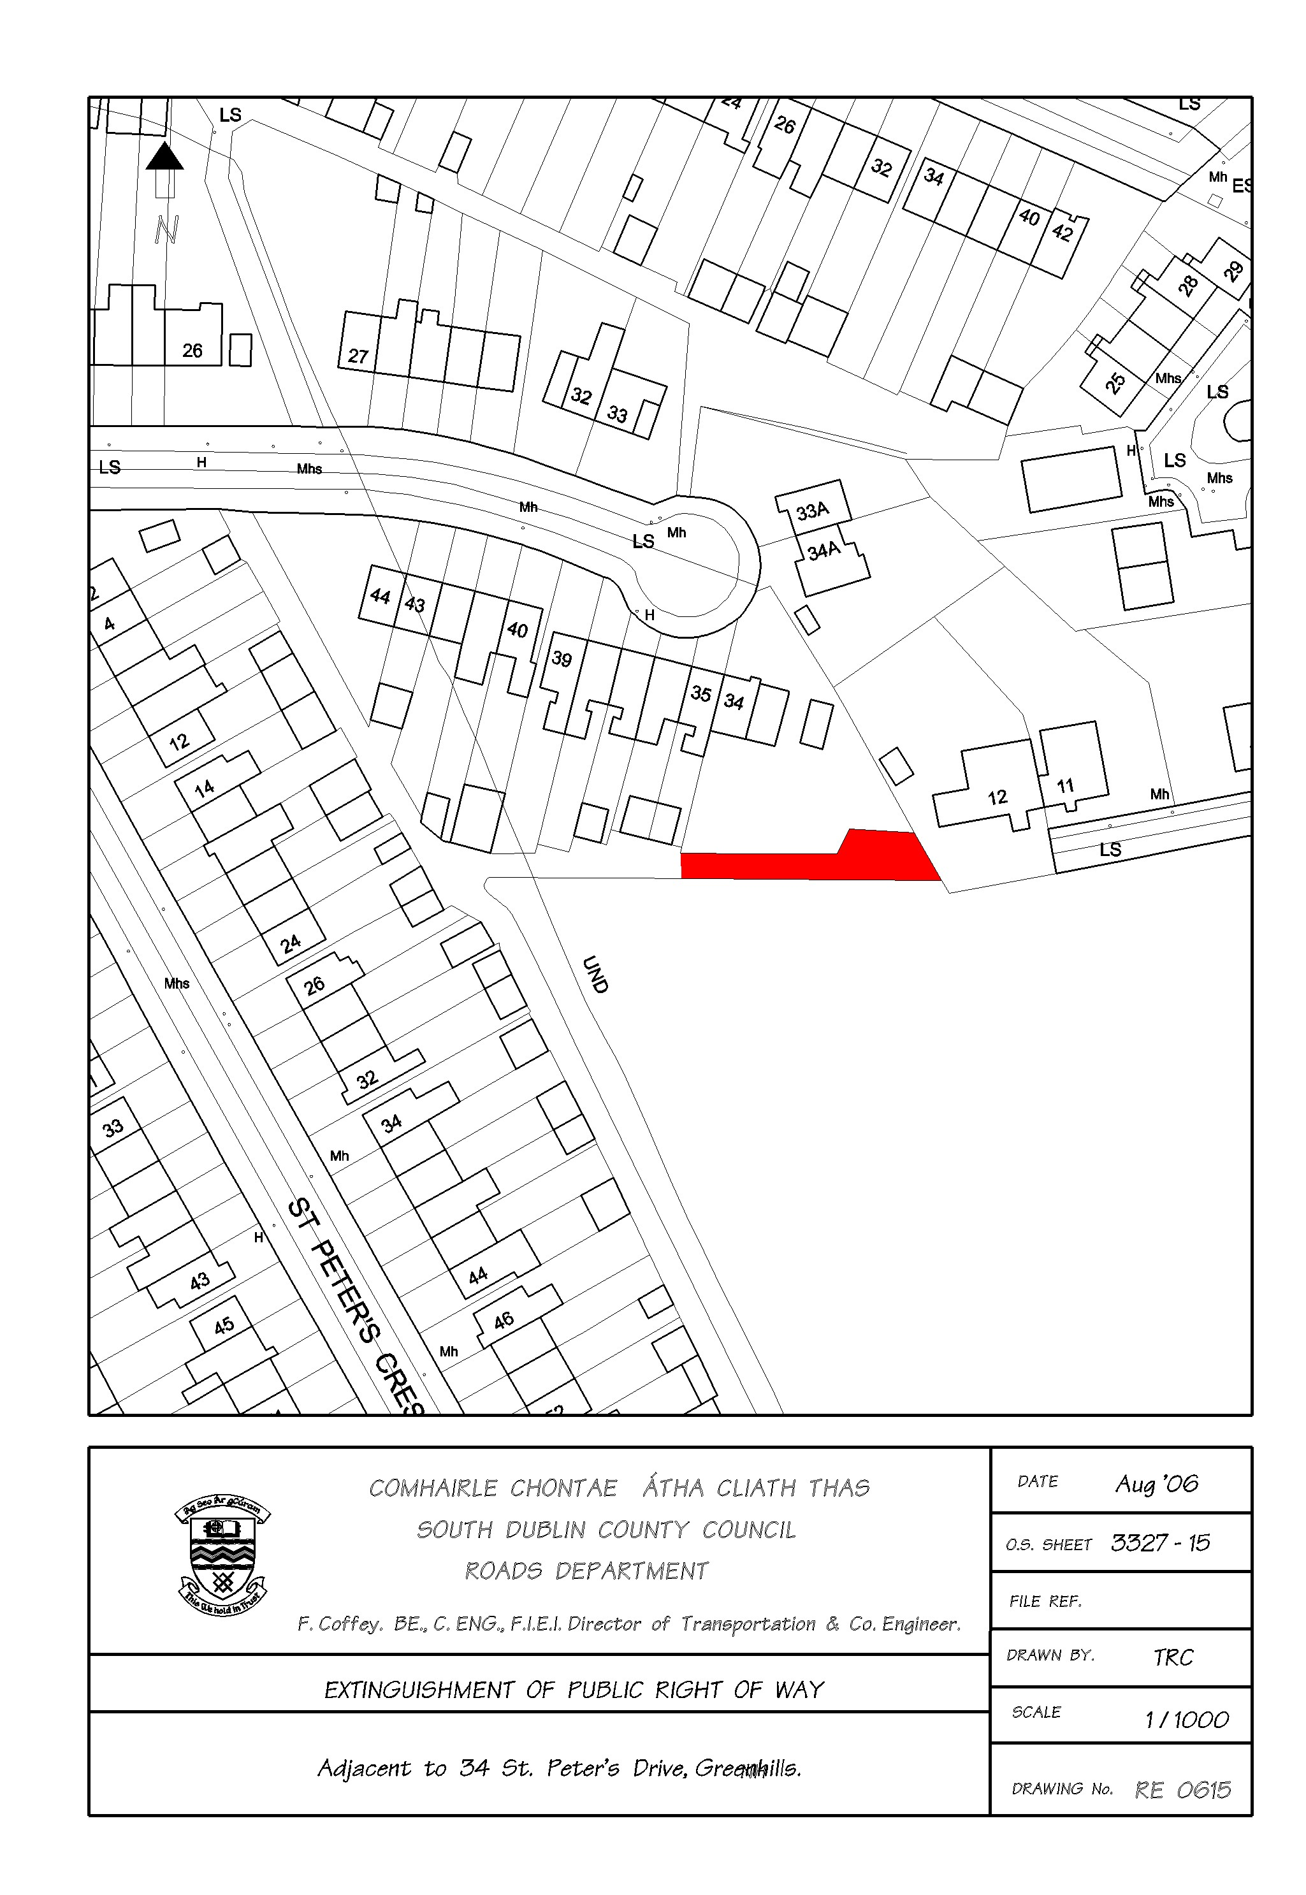
It was AGREED to DEFER consideration of this matter to the October Meeting of this Committee.

TR/579/06 EXTINGUISH RIGHT OF WAY BALLYBODEN

PROPOSED INITIATION OF PROCEDURE TO EXTINGUISH PUBLIC RIGHT-OF-WAY.
Proposed extinguishment of public right of way at site adjoining The Drive, The Green & The Green Route, Boden Park, Ballyboden, Dublin 16.

An application has been received from CPM Architecture on behalf of Park Developments to formally extinguish the public right-of-way at site adjoining The Drive, The Green & The Green Route, Boden Park, Ballyboden, Dublin 16, to enable Sky Property Management (who maintain the residential development) maintain this section of land.

If the Committee agree the procedure to extinguish the public right-of-way as listed above will be initiated.

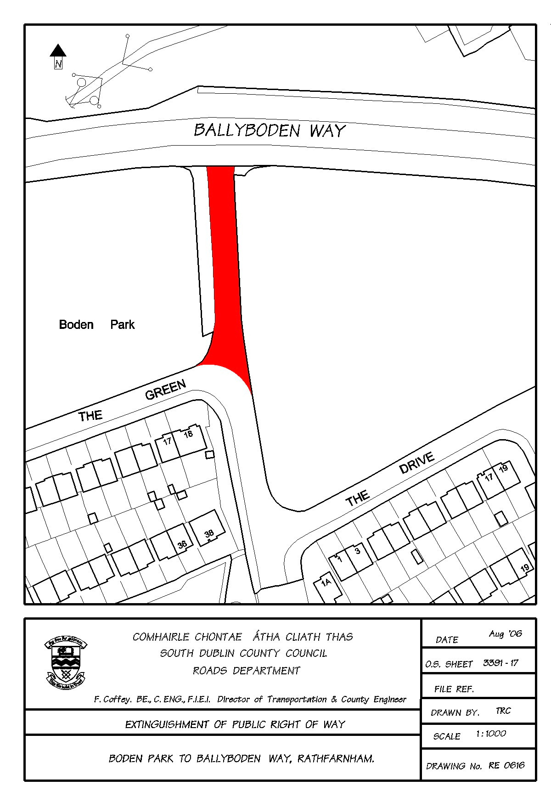

It was AGREED to initiate the procedure to extinguish the public right of way at the above location.

TR/580/06 NEW WORKS

It was NOTED that there was no business under this heading.

TR/581/06 CORRESPONDENCE

It was NOTED that there was no business under this heading.

TR/582/06 CATHAOIRLEACH’S BUSINESS
It was NOTED that there was no business under this heading.

TR/583/06 PEDESTRIAN LIGHTS FIRHOUSE ROAD
It was proposed by Councillor J. Lahart and seconded by Councillor C. Keane
"That the Roads Department re-visit the need to provide pedestrian lights at Ballyboden St Enda's on the Firshouse Road, which have been sought for the last ten years,given that additonal resources are now available to the Council."
The following report by the Manager was CONSIDERED:
REPORT:
“A previous count at this location indicated that warrant was not reached and also indicated that the pedestrian demand is not continuous throughout the year, it being related to the clubs activities. However the situation will be revisited and a report submitted to the next Traffic Management Meeting.”
Following contributions from Councillors J. Lahart, S. Laing, M. Ardagh, C. Keane and T. McDermott, S. Daly, Senior Exectuive Engineer responded to queries raised and the report was NOTED.
TR/584/06 PARKING PROPOSALS PEARSE/PALMER PARK
It was proposed by Councillor C. Keane and seconded by Councillor S. Laing
"That this committee discuss with the aid of an informed report - parking proposals for Pearse/Palmer Park - now that the submissions/recommendation have been recieved from the community as part of the consultation process in the Ballyboden Village Plan."
The following report by the Manager was CONSIDERED:

REPORT:
“The report on the Ballyboden Village as presented by the Planning Department has dealt with the issue of Parking requirements in Ballyboden Village (page 23). Generally new developments will be required to provide appropriate on site parking and on street parking will be improved where appropriate. The report also recommends “that an objective be included in the Draft Village Plan to seek improved parking facilities and traffic management”.
The proposals for the provision of parking in Palmer Park , Rathfarnham was presented to the members previously. The proposed arrangements were either not accepted by the members or not within the financial ability of the Council, and were rejected by the residents in any case. The residents seek the provision of parking in front of their respective dwellings. This would entail major excavations.The provision of parking areas substantially lower than the adjoining footpath is undesirable and would create major safety concerns.”

Following contributions from Councillors, C. Keane, S. Laing, M. Ardagh and J. Lahart, Mr. D. Ryan, Senior Engineer and Mr. S. Daly, Senior Executive Engineer responded to queries raised. It was AGREED to arrange a meeting with the residents association and present a further report to the November 2006 meeting of this Committee.

TR/585/06 INCREASED TRAFFIC ON STOCKING LANE
It was proposed by Councillor S. Laing and seconded by Councillor C. Keane
"That the Manager give a detailed report on what measures will he put in place on Stocking Lane to cope with the increased treffic from new developments and the opening of the link road from Ballycullen."
The following report by the Manager was CONSIDERED:
REPORT:
“A Consultant is to be appointed to carry an assessment of the various traffic issues associated with the new developments above and to make recommendations on safety measures etc. A further report will be brought to a Traffic Management Meeting when the Consultants report is received.”
Following contributions from Councillors S. Laing, J. Lahart, C. Keane and T. Mc Dermott, Mr. S. Daly, Senior Executive Engineer responded to queries raised and the report was NOTED.

TR/586/06 WIDENING OF WHITECHURCH ROAD
It was proposed by Councillor M. Ardagh and seconded by Councillor C. Keane
“That the Manager give a report on the issues raised by Willbrook Lawn Residents Association in relation to the widening of Whitechurch Road, provision of a pedestrian crossing and traffic calming measures and to say what progress has been made to date.”
The following report by the Manager was CONSIDERED:
REPORT:
“Slow markings and double yellow lines have been installed at some locations. The feasibility of any additional measures is currently under examination having regard to the wishes of the members to retain ' the rural rustic nature' of the road.”
Following contributions from Councillors M. Ardagh, C. Keane and T. McDermott, Mr. S. Daly, Senior Executive Engineer responded to queries raised and the report was NOTED.
TR/587/06 PARKING TONDUFF CLOSE
It was proposed by Councillor E. Walsh and seconded by Councillor S. Laing
"THAT THE MANAGER MAKE ARRANGEMENTS TO HAVE THE 3 FURNATURE REMOVAL TRUCKS PARKED IN TONDUFF CLOSE GREENPARK DUBLIN 12 REMOVED AND BANED FROM PARKING IN THE ESTATE WHICH HAS BEEN THE CASE FOR ALMOST 15 YEARS AND THIS TYPE OF PARKING IS OFFENSIVE TO THE RESIDENTS ON THE ROAD AND THE AREA AND THAT THE MANAGER USE THE MOST EFFECTIVE LEGLISLATION AVAILABLE TO DEAL WITH THIS SERIOUS PROBLEM."
The following report by the Manager was CONSIDERED:
REPORT:
“These vehicles are generally parked within the curtilage of the dwelling and as such there is no action which can be pursued under the Roads legislation.”
Following contributions from Councillors E. Walsh, T. McDermott, C. Keane and S. Laing, Mr. S. Daly Senior Executive Engineer responded to queries raised and it was AGREED to present a further report to the October Meeting of this Committee.
TR/588/06 COMPLETION OF WORKS AT WHITECHURCH STREAM
It was proposed by Councillor A. White and seconded by Councillor C. Keane
"That the Manager arrange for the immediate completion of all outstanding works at Whitechurch Stream, especially in view of the clear commitment given in this regard before the Summer break."
The following report by the Manager was CONSIDERED:
REPORT:
“A contractor has been appointed to resurface the carpark area of Whitechurch Stream Estate. It is anticipated that this work will be carried out in September 2006.”
Following contributions from Councillors, A. White, C. Keane, T. McDermott and J. Lahart, Mr. D. Ryan, Senior Engineer responded to queries raised and it was AGREED to present a further report to the October meeting of this Committee.
TR/589/06 NOISE LEVELS AT M50 CORRIDOR
It was proposed by Councillor J. Lahart and seconded by Councillor A. White
"That the Manager take immediate steps to measure the noise levels at the M50 corridor affecting Woodfield, Orlagh Grove, Park, Beverly and Knockfield manor (and Woodstown Village) particularly since the opening of the motorway to Carrickmines and to report what steps the Council intends to take to ameliorate the impact of the increased noise levels."
The following report by the Manager was CONSIDERED:
REPORT:
“It is intended as part of the upgrade of the M50 scheme to provide noise amelioration measures in accordance with Figure 2.2j, Vol 6 and as described in section 2.3 and 2.4 of Vol 4 of the EIS for the scheme. These works will be undertaken as part of the 2nd contract (PPP) in the upgrade scheme. The tendering process is already underway with a view to commencing construction in the first half of 2007.”
Following contributions from Councillors, J. Lahart, A. White, C. Keane, T. McDermott and S. Laing, Mr. J. McLoughlin, Senior Engineer responded to queries raised and the report was NOTED.
TR/590/06 UPGRADE OF FOOTPATHS IN TEMPLEOGUE VILLAGE
It was proposed by Councillor C. Keane and seconded by Councillor M. Ardagh
“That this committee discuss once again the upgrade of the footpaths in Templeogue Village – a meeting was to be arranged with the Traders last year. Taking into consideration that Rathfarnham Village and every village in the county has been upgraded not once but twice since I was elected back in 1991 – Templeogue Village pathways are in a terrible and dangerous state of repair and nobody is taking responsibility – this cannot be allowed to continue.”
The following report by the Manager was CONSIDERED:
REPORT:
“The footpaths under the responsibility of the Council in Templeogue Village are not in urgent need of repair at present. A Village and Urban Renewal scheme was carried out in Templeogue Village in 2001. Since then, significant road and footpath upgrading has been carried out by the Council. When the Village and Urban Renewal scheme was undertaken, the traders were unwilling to transfer ownership of the open areas in front of their premises. These areas still remain in private ownership.
The Council have no responsibility for those open areas which remain within the control of the owner / occupiers of the commercial properties. We will again contact the owners to remind them of their potential liabilities in this regard.”
Following contributions from Councillors C. Keane, S. Laing and M. Ardagh, Mr. D. Ryan, Senior Engineer responded to queries raised and it was AGREED to discuss the repair works with the traders and present a further report to a future meeting of this Committee.
TR/591/06 REPORT ON PROPOSED REALIGNMENT OF KNOCKLYON ROAD
It was proposed by Councillor S. Laing and seconded by Councillor by C. Keane
"That the Manager give an up to date report on the proposed realignment of the Knocklyon Road and the time schedule for the completion of this project."
The following report by the Manager was CONSIDERED:
REPORT:
“The site investigation contract is now underway and it is intended to publish the necessary CPO in October of this year. The design is progressing and contract documents are being prepared and it is intended to commence work on site in the second half of 2007.”
Following contributions from Councillors, S.Laing, C. Keane and T. McDermott, Mr. J. McLoughlin, Senior Engineer, responded to queries raised and the report was NOTED.

The meeting concluded at 4.20 p.m.

Siniú ________________ Dáta ________________
An Cathaoirleach

