Appointments to the In Context 3 Per Cent for Art Programme

Appointments have recently been made to In Context 3, South Dublin County Council’s Per Cent for Art programme which is funded through the Government’s Per Cent for Art Scheme. The appointments were made between April and July 2006 following a several stage international open competition, in accordance with best practice in commissioning, as outlined by the Public Art: Per Cent for Art Scheme General National Guidelines 2004.

These appointments, which are in line with the In Context 3 strategy adopted by Council in 2005, include five artistic residency commissions across a number of artistic disciplines, a sculptural commission for the Kingswood Interchange, a mediation commission and an evaluation project. Several of these positions were awarded to international artists.

The following information provides a broad outline of what the resident artists, the sculptural commission artist, the mediator and evaluator propose to achieve through the In Context 3 programme.

Artistic Residencies:

Dermot Bolger, Writer, Ireland
A highly regarded writer, poet and playwright, Dermot has numerous awards and previous experience of residency work with this Council. Through this residency he intends to create one or more major pieces of writing, either poetry or playwriting, that interpret life in South Dublin County. He has already produced a poem about Lucan for inscription in stone at Lucan Weir. He also intends to interact with the growing community of writers in the County.

Liebeth Bik and Jos Van der Pol, Multidisciplinary artists, The Netherlands
These two artists have an extensive international exhibition and project history and also have previous experience of residency work. For this residency, they aim to investigate the connection between human optimism/future visions and ideas of construction and destruction within the County. They intend to identify some small remarkable local ‘specific’ which they will then develop in a multimedia project that ultimately addresses larger situations and topics.

Anne Cleary and Denis Connolly, Installation/Video artists, Ireland
These two award winning installation and video artists are originally from Ireland but are now living and working in France. They have exhibited widely and participated in numerous video and film festivals. Their proposal for In Context 3 focuses on the idea of City Loops videos. These digital videos will follow paths of everyday journeys (short walks, bicycle, bus, car, tram etc) through the County, observing and commenting on the urban and social change that takes place along these paths. Ultimately, it is planned to present the videos in a large scale interactive installation.

Jackie Sumell, Multidisciplinary artist, USA
From a background in science, Jackie went on to study for a post graduate degree in ‘New Genres’ and then a MFA in ‘New Practices’. Currently on fellowship in Germany, she has exhibited widely and has received significant critical acclaim. As a multidisciplinary artist, her work attempts to make explicit the common denominator of human experience. In her work for In Context she intends to further explore unifying aspects of identity.

Jennifer Walshe, Composer/Sonic artist, Ireland
Jennifer is an award winning composer/sonic artist, also on fellowship in Germany, who has a phd in Music Composition and experience in lecturing and residency work. For In Context 3 she proposes to undertake a South Dublin County Songlines project which will involve her exploring the County on foot, creating paths, singing in the landscape, recording sounds and observing. The material collected may be presented in a large scale solo concert, a CD and a website documenting the process. She also intends to produce a number of sound installations and compose ensemble pieces for multiple brass/marching bands.

Sculptural Commission for the Kingswood Interchange
Andreas Kopp, Sculptor, Germany
Currently based in Germany, fine art graduate Andreas Kopp has exhibited widely across Europe and worldwide. His proposal for a sculptural work, entitled ‘Marker Tree’, to be located at Kingswood Interchange involves the construction of a 15 meter high tree trunk-shaped structure of corten-steel with simplified branches that will support large saucer-shaped forms of various sizes. These forms will be illuminated from inside by fluorescent light in various colours.

Mediation Commission - Sarah Searson, Arts Consultant, Ireland
With a background in Fine Art, Sarah has extensive arts administration experience in the area of local authority, and a major focus of her work has been arts education and audience development. As mediator, Sarah’s task will develop and manage strategies for opening up dialogue and exchange between the In Context 3 artists and the local community. There are several themes to Sarah’s proposal for the mediation. These include creating suitable structures or partnerships for the artists to present their work to the public, making explicit the creative processes used by the artists, encouraging discussion and critic around the artists’ work, and facilitating effective artistic interaction between the public and the artists.

Evaluation Commission - Peter Cox, TMPL Consultants, UK
Based in Wales and England, TMPL is a business consultancy/training company with numerous high profile international clients, including those in the arts/cultural industry, and local government. For the In Context 3 programme, TMPL Managing Director, Peter Cox, will head an evaluation team that will undertake both a formative and a summative evaluation. The formative evaluation will allow for experience and data to be regularly fed back into the programme, assisting in its ongoing success. The summative evaluation will provide an end review of the entire In Context 3 programme.

Current and future actions to progress In Context 3

Preparation for the team of appointees commencing work is now underway. Orientation tours of the county will be organised and the artists provided with information packs. Arts administrator, Nonie Gaynor, has been contracted on a temporary basis to assist during this stage of the programme.

An introductory ‘kick-off’ meeting is being arranged for the appointees to facilitate discussion around how they might function as both artistic individuals and a creative team within this programme and to identify the supports that might be required to support this.

The first meeting of the evaluation advisory panel is scheduled for the 2nd of November. An Evaluation Advisory Panel has been established and comprises: Billy Coman (SEO Community Services, SDCC), Orla Scanell (Arts Officer, SDCC) Caroline Orr (Public Art Coordinator, SDCC) Sarah Finlay (Artistic Director, In Context 3), Sarah Searson (Mediator, In Context 3), Paula Meehan (Writer), Mark Maguire (Visual artist).

A provisional date for the formal launch of the In Context 3 programme is scheduled for 6th December 2006 when all the In Context 3 appointees will be in place. The logistics of this event are being planned.

Launch of Rowlagh Church Bell Tower and Per Cent for Art Commission

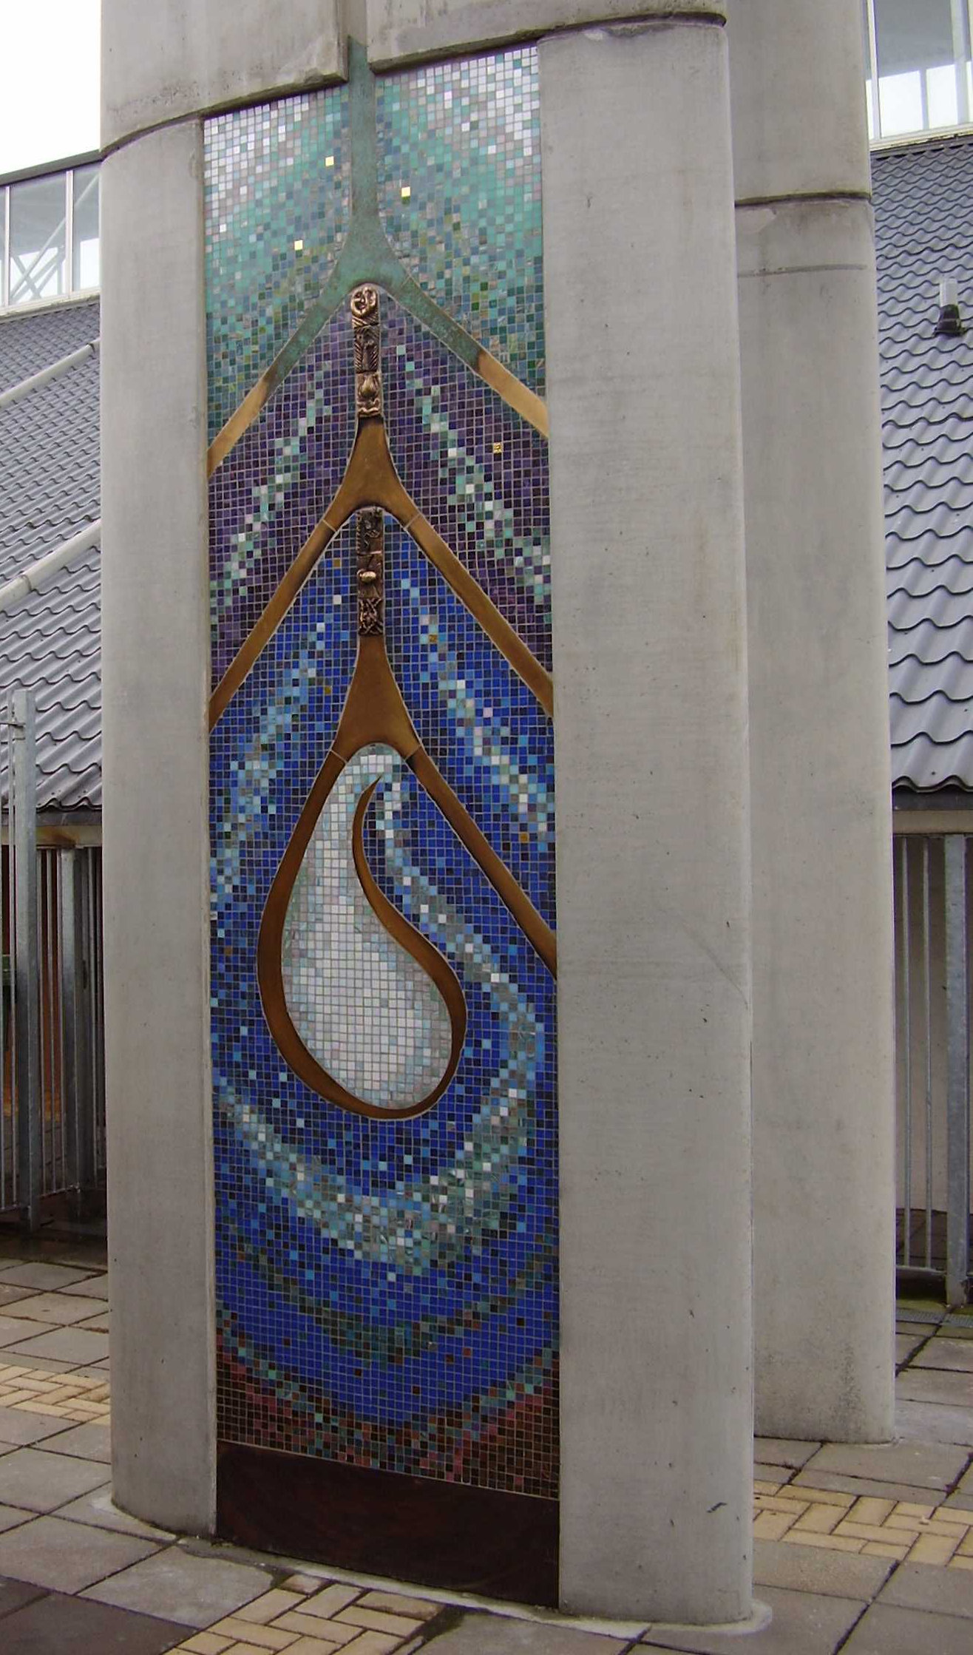
The new bell tower for Rowlagh Church, which also incorporated a Per Cent for Art commission by artist Cecilia Moore, was launched by Deputy Mayor Alex White on Sunday, 24th September at 12 noon in the Church of the Immaculate Heart of Mary, Rowlagh Church, Clondalkin. Archbishop Diarmuid Martin, performed a blessing at the event.

In conjunction with a South Dublin County Council housing development scheme in the area surrounding Rowlagh Church, the Council, in co-operation with Rowlagh parish, initiated a project to restore the church grounds and build a new freestanding bell tower. Murray O’Laoire architects worked in consultation with the Council and the Diocesan Sacred Art and Architecture Commission to realise this project.

In addition, with funding from the Department of Environment, Heritage and Local Government’s Per Cent for Art Scheme, South Dublin County Council commissioned a visual art work for the bell tower. Following a competition in which several invited artists submitted proposals, artist Cecilia Moore was selected to undertake the commission. The resulting art work forms two colourful panels of glass mosaic tiles, inset with bronze, on either side of the tower. Specially designed bronze tiles, which curve through each panel, were produced by students of local schools, Collinstown Park Community College and St. Kevin’s Community College, through artist-led workshops.

