COMHAIRLE CHONTAE ÁTHA CLIATH THEAS
SOUTH DUBLIN COUNTY COUNCIL

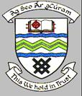

MEETING OF TALLAGHT AREA COMMITTEE (1)

18th September 2006

MOTION 5

MOTION: Councillor Mark Daly
"That this Commitee calls on the Council to encourage NTL to remove/amend the service box located at the green space at Old Bawn way which is the subject of anti social behaviour"

Report:
Arrangements will be made to meet representatives from NTL on site with a view to relocating the overground service box at Old Bawn Way.

