COMHAIRLE CHONTAE ATHA CLIATH THEAS

SOUTH DUBLIN COUNTY COUNCIL
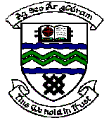

MEETING OF TALLAGHT AREA COMMITTEE MEETING (1)

Monday 18th September, 2006.

Motion No. 1

Motion: Councillor Catriona Jones

“That this Committee wants the Community centre planned for Ballycragh Park be planned as an “Eco House?"

Report:

The “Eco House” as referred to in the Councillor’s motion would not be suitable as a Community Facility and also given the budget constraints for the proposed new Community Centre at Ballycragh.

However, the Centre will be designed as environmentally friendly, efficient and sustainable as is possible.

