COMHAIRLE CHONTAE ATHA CLIATH THEAS

SOUTH DUBLIN COUNTY COUNCIL
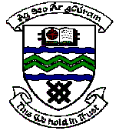

MEETING OF TALLAGHT AREA COMMITTEE MEETING (1)

Monday 18th September, 2006.

Question No. 4

Question: Councillor Cathal King

"To ask the Manager, what is proposed will happen to the €17,000 unspent monies from the community linkage fund and is it envisaged that community groups will have an opportunity to apply for this outstanding money?"

Reply:

Some monies were withheld in relation to Round 1 Funding until clarification was received from the groups involved regarding their work programmes.

This clarification was received and release of the monies was agreed by the Monitoring Committee.

Accordingly there are no monies available from Round 1 Funding.

