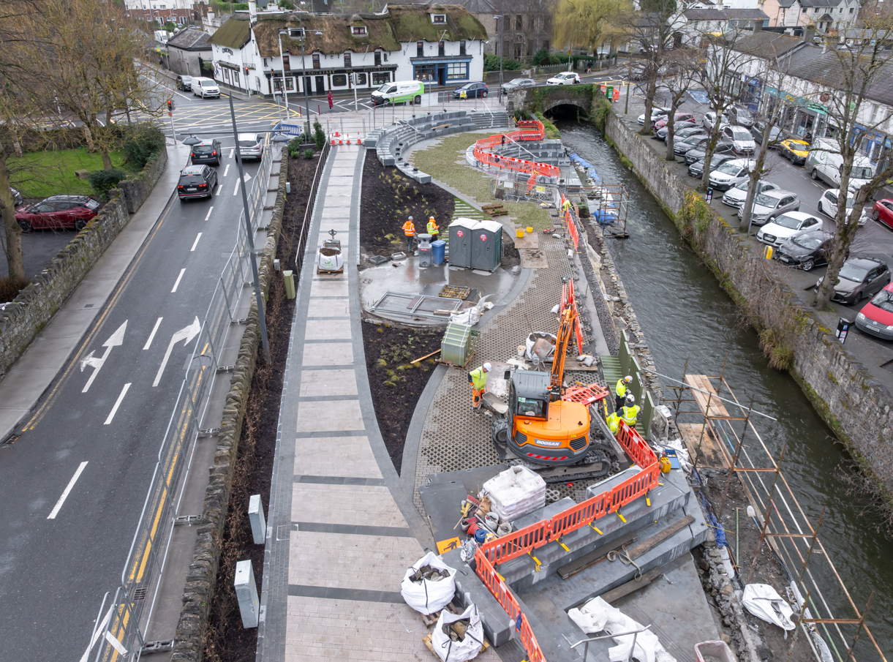
Lucan Village Green progress 11th March 2026

