COMHAIRLE CONTAE ÁTHA CLIATH THEAS
SOUTH DUBLIN COUNTY COUNCIL
Minutes of South Dublin County Council July 2024 County Council Meeting held on Monday 8 July 2024

PRESENT
Adelaide, D. | Keane, K
Ahern. C. | Kearns, P.
Barnes, S. | Lawlor, B.
Brady, C. | Mannion, R.
Carey, W. | McCrave, L.
Casserly, V. | McMahon, R.
Collins, Y. | McManus, B.
Costello, T. | Moore, G.
de Courcy, L | Moynihan, S.
Duff, M. | Murphy, E.
Dunne, L. | O’Hara, S.
Edge, A. | O’Toole, L.
Gilligan, T. | Perepaddan, Baby
Gogarty, P. | Pereppadan, Britto
Hayes, A. | Richardson, D.
Holohan, P. | Spear, J.
Johansson, M. | Timmons, F.
Tuffy, J.
Whelan, N.

OFFICIALS PRESENT
 | Chief Executive | C. Ward.
 | Directors | J. Frehill, M. Mulhern, T. Walsh, E. Leech, L. Maxwell,
 | Head of IT | T. Kavanagh
 | County Architect | C. Harte
Financial Management Accountant |  | F. Carroll
Senior Executive Officer |  | L. Leonard, M. Murtagh
 | Administrative Officer | M. Reilly
 | Communications Manager | D. Healy
 | A/ Staff Officer | D. Murphy
 | Assistant Staff Officer | L. Farrell
 | EVAD | P. Martinson

The Mayor, Councillor Baby Pereppadan, presided.
Apologies were received from Councillors J. Sinnott, N. Fennell, E. Ó Broin,

WEBCASTING NOTICE

This meeting may be filmed for live or subsequent broadcast via the Councils website. At the start of the meeting the Chair will confirm if all or part of the meeting is being filmed.

You should be aware that the Council is subject to the Freedom of Information Act 2014, the Data Protection Act 1988, General Data Protection Regulations (EU) 2016/679 and the Defamation Act 2009. Data collected during this webcast will be retained in accordance with the legislation.

Therefore, by entering the Council Chamber and using the seats around the meeting tables, public gallery etc. you are consenting to being filmed and to the possible use of those images and sound recordings for webcasting.

The Mayor, Councillor Baby Pereppadan, welcomed everyone and informed the Members of the etiquette for Hybrid Meetings:

Members attending remotely must check that they can access the “Chat Function” before commencing the meeting.

Members can indicate they wish to speak on an item through the chat function – using “Speak please.”

Members must be able to be seen, specifically for roll call, when speaking and voting.
Mics to be on mute until invited to speak through the Chair.

Members attending in person can indicate they wish to speak by signalling to the Chair.

H1/0724 CONFIRMATION AND REAFFIRMATION OF MINUTES - FOR APPROVAL
H1 May Council Minutes 13th May 2024

Minutes of the April Council Meeting held on 13th May 2024 which had been circulated were submitted and APPROVED as a true record and signed in the proposition of Councillor Baby Pereppadan and seconded by Councillor F. Timmons.

At this point, the Mayor, Councillor Baby Perepaddan proposed, and the Members AGREED to vary the sequence of items on the agenda in order to take Headed Item no. 13 (H13) next and welcomed Ms. Tricia Nolan, Chair of the LCDC to the meeting.

H13/0724 LCDC 2023 ANNUAL REPORT – FOR NOTING
The following reports by the Chief Executive, which had been circulated, were presented by Ms. Tricia Nolan, Chair of the LCDC, and were CONSIDERED.

H13 (a) Draft 2023 Annual Report
H13 (b) LCDC Presentation
A discussion followed with contributions from Councillors A. Edge, P. Holohan, K. Keane, and E. Murphy.

Ms. Tricia Nolan, Chair of the LCDC responded to the members queries.

The Report was NOTED.

H2/0724 REPORTS OF AREA COMMITTEES - FOR NOTING

a) Rathfarnham/Templeogue/Firhouse/Bohernabreena Area Committee
Dealing with Public Realm, Water & Drainage, Housing, Community, Planning, Economic Development, Libraries & Arts, Corporate Support, Performance & Change Management

It was NOTED that there was NO Business under this Heading.

b) Clondalkin, Newcastle, Rathcoole, Saggart and Brittas Area Committee Meeting
Dealing with Public Realm, Water & Drainage, Housing, Community, Planning, Economic Development, Libraries & Arts, Corporate Support, Performance & Change Management

It was NOTED that there was NO Business under this Heading.

c) Tallaght Area Committee
Dealing with Public Realm, Water & Drainage, Housing, Community, Planning, Economic Development, Libraries & Arts, Corporate Support, Performance & Change Management

It was NOTED that there was NO Business under this Heading.

d) Lucan/Palmerstown/North Clondalkin Area Committee
Dealing with Public Realm, Water & Drainage, Housing, Community, Planning, Economic Development, Libraries & Arts, Corporate Support, Performance & Change Management

It was NOTED that there was NO Business under this Heading.

H3/0724 STANDING COMMITTEES ORGANISATION, PROCEDURE & FINANCE - FOR APPROVAL

It was NOTED that there was NO Business under this Heading.

H4/0524 STRATEGIC POLICY COMMITTEES - FOR NOTING
The following reports by the Chief Executive, which had been circulated were CONSIDERED

a) Land Use, Planning & Transportation SPC
H4(A)(i)Mins Feb 2024 LUPT SPC
H4(A)(ii)Report May 2024 LUPT SPC

b) Housing SPC
H4(B)(i) Minutes of Housing SPC Meeting February 2024
H4(B)(ii) Report of Housing SPC Meeting May 2024

c) Social, Community & Equality SPC
H4(C)(i) Minutes of Social, Community Equality SPC Meeting February 2024
H4(C)(ii) Report of Social, Community Equality SPC Meeting February 2024

d) Economic, Enterprise & Tourism SPC
H4(D) (i) Minutes of EETD SPC held in February
H4(D) (ii) Report of EETD SPC held on 8th May

e) Environment, Water, Climate Change & Biodiversity SPC
H4(E) (i) Minutes Feb 2024 Environment, Public Realm and Climate Change SPC
H4(E) (ii) Report of meeting May 2024 Environment, Public Realm and Climate Change SPC

f) Arts, Culture, Gaeilge, Heritage & Libraries SPC
H4(F)(i) Minutes of ACHGL SPC Feb-24
H4(F)(ii) Report of ACHGL SPC May-24
The Reports were NOTED.

H5/0524 REPORTS REQUESTED BY AREA COMMITTEES - FOR NOTING

It was NOTED that there was NO Business under this Heading.

Questions:

It was proposed by Councillor Baby Pereppadan, seconded by Councillor R. McMahon and RESOLVED:

“That pursuant to Standing Order No. 22, Questions numbered Q1 – Q44 be ADOPTED and APPROVED.”

Q1/0724 QUESTION: Councillor D. Adelaide
To ask the Chief Executive for a report on vacant homes, report to include how many vacant homes have been identified and how many have being brought back into use?

REPLY:
Under Housing for All, local authorities are now required to adopt a proactive, planned and systematic approach to address vacancy and dereliction within their administrative area by:
- Identification of vacant and derelict properties
- Identification of and engagement with owners
- Communication regarding the various grants and schemes in place to support bringing vacant and derelict properties back into us

The Department has proposed the following targets to address vacancy and dereliction within the County for 2024:
- 30 properties to enter the CPO Activation Programme, and
- 3 compulsory purchases / compulsory acquisitions to commence.

There are a number of grants available to bring vacant and derelict properties back into use through the CPO Activation Programme including the Vacant Property Refurbishment Grant and the Repair and Lease Scheme. We currently have 1 application for the Repair and Lease Scheme and we have received 101 applications for the Vacant Property Refurbishment Grant to date of which:

Grants Approved/Approved in Principle | 66
Grants paid ( up to 28.06.24) | 11
Further Information requested/awaiting inspection | 13
Withdrawn | 4
Declined | 7

The Council has been allocated €6 million in funding under the Urban Regeneration and Development Fund Round 3 funding to address long term vacant and derelict properties. In April 2024, the Council acquired 4 properties under the provisions of the Derelict Sites Act and Housing, Social and Community Development has taken possession of the houses. Funding for the acquisition of the properties was secured under the URDF call 3 and works will be carried out in order to bring these properties to the market for purchase by first time buyers.
Negotiations are also underway with the registered owner for the purchase of 2 vacant properties in Rathcoole which have been approved for funding under URDF call 3.
The Vacant Homes section continues to work closely with the Derelict Sites section in Environment, Water and Climate Change to proactively address vacant and dereliction in the County.

Q2/0724 QUESTION: Councillor D. Adelaide
To ask the chief executive how much was spent in 2022, 2023, and 2024 purchasing homes for use as social housing and how many units were purchased.

REPLY:
The table below illustrates the number of homes purchased and expenditure to date on acquiring units for social housing during the period 2022, 2023 and 2024 to end June.

Year | No of Units | Expenditure
2022 | 3 | €921,671
2023 | 47 | €15,171,873
2024 | 53 | €16,778,460
Total | 103 | €32,872,004

Q3/0724 QUESTION: Councillor D. Adelaide
To ask the chief executive how many homes SDCC is leasing from private owners for use as social homes, and the related cost to leasing these homes.

REPLY:
The Council’s revenue budget currently provides for expenditure of €19.35m in 2024 in relation to costs associated with the provision of approximately 850 homes through long-term leasing. Funding is received by the Council from the Department of Housing, Local Government and Heritage in respect of the payments made to the landlords of these properties.

Q4/0724 QUESTION: Councillor D. Adelaide
To ask the chief executive what proportion of workers employed by the council in 2022, 2023 and 2024 were contract workers as opposed to permanent members of staff.

REPLY:
Please find set out below the information requested:-
Date | No. of Temporary Staff | No. of Permanent Staff | % of Temporary -v- Permanent
31/12/2022 | 27 | 1251 | 2.16
31/12/2023 | 29 | 1262 | 2.30
01/06/2024 | 22 | 1256 | 1.75

Q5/0724 QUESTION: Councillor D. Adelaide
To ask the Chief Executive for a report on the vacant home grant, report to include number of applications and how many have been successful?

REPLY:
The Vacant Property Refurbishment Grant is a payment you can get if you are turning a vacant house or building into your principal private residence. A grant of up to €50,000 is available. If the refurbishment costs exceed the standard grant of up to €50,000, a top-up grant amount of up to €20,000 is available. To get this top-up grant, you must confirm that the property is derelict. This means that the property is structurally unsound and dangerous. The total grant available for a derelict property is therefore €70,000. Applicants must submit an independent report prepared by a qualified professional, along with the application confirming that the property is derelict.

101 vacant property refurbishment grants have been received to date of which 77 have be approved/approved in principle. A full breakdown of all applications received is below:
Approved/Approved in Principle | 66
Grants paid ( up to 28.06.24) | 11
Further information requested/awaiting inspection | 13
Withdrawn | 4
Declined | 7

Q6/0724 QUESTION: Councillor C Ahern
To ask the chief executive what procedures are in place in its procurement processes and elsewhere to ensure that any contractors engaged by SDCC are (and remain) fully compliant with employment and labour law.

REPLY:
South Dublin County Council has effective procedures in place in its procurement processes and elsewhere to ensure that any contractors engaged by SDCC are (and remain) fully compliant with employment and labour law.
Procurement templates have built in declarations and standard contractual clauses in line with applicable legislation.

Tenderers who do not meet certain requirements may be excluded from participation in the tender process. The exclusion criteria may be assessed as a declaration of bona fides or by using the ESPD (European Single Procurement Document). Regulation 57(1) of S.I. No. 284 of 2016, the European Union (Award of Public Authority Contracts) Regulations 2016 details the reasons for exclusions; these include participation in a criminal organisation, terrorist offences and child labour and other forms of trafficking in human beings.

As per Regulation (4) (a) of S.I. No. 284 of 2016, the European Union (Award of Public Authority Contracts) Regulations 2016 in the performance of a public contract, an economic operator (including sub-contractors) shall comply with applicable obligations in the fields of environmental, social and labour law that apply at the place where the works are carried out or the services provided that have been established by European Union Law, national law, collective agreements or by international, environmental, social and labour laws listed in schedule 7 of the S.I.
Should any employment violations by the economic operator (including sub-contractors) arise after a contract has been put in place the measures as outlined in the contract would apply. Any reports of employment violations would need to be investigated and depending on the outcome of the investigation this may result in the termination of the contract. Likewise, if an economic operator provides inaccurate or misleading information in the declarations this may lead to them being excluded from participation in future tenders and/or the termination of a contract.

Q7/0724 QUESTION: Councillor C. Brady
To ask the Chief Executive about the efforts being taken by the Council, including through engagement with telecom providers, to remove telephone kiosks and other eyesores that have been negatively impacting the scores of Tidy Towns groups across the county in the National Tidy Towns Competition?

REPLY:
Eir is currently in the process, in collaboration with communities and local authorities, to remove the last of the payphone boxes across the country. It is believed that nationally, several payphones have already been removed while others have been transformed into local digital kiosks.

Such collaboration has taken place to date with SDCC in relation to the removal of 4 kiosks in Lucan, and the Council will continue to work with Eir in any other removal programme, if necessary.

Similarly, the Council departments will continue to liaise with local communities in their endeavours, and where it is believed that units within the Council owned public realm are negatively impacting efforts.

Q8/0724 QUESTION: Councillor C. Brady
To ask the Chief Executive for a report into the management and conduct of local elections including the management of polling stations, the count, etc. Report to include if there will be an opportunity for candidates, agents, tally volunteers and polling station and count staff to provide feedback on relevant matters?

REPLY:
The local elections 2024 for South Dublin County Council were managed by the appointed Local Elections Returning Officer, Lorna Maxwell, in accordance with the following statutory provisions:

- Local Elections Regulations 1995, as amended,
- the Electoral Act 1992, as amended,
- Electoral (Polling Schemes) Regulations 2021,
- the Local Election (Disclosure of Donations and Expenditure) Act 1999,
- Local Elections (Petitions and Disqualifications) Act 1974,
- Parts III and IV of the Local Government Act 2001
- The Local Government Reform Act 2014,
- and the Electoral (Amendment) Regulations 2024.

A Memorandum for the Guidance of Local Authority Returning Officers at the Local Elections June 2024 was issued by the Department of Housing, Local Government and Heritage to provide further guidance on the interpretation of the regulations and setting out the arrangements and separation of responsibilities between the European and the Local Authority Returning Officers. For instance, the European Local Returning Officer had responsibility for taking the poll at polling stations for both European and Local Elections and also for the issuing of Polling cards, conducting special voting, the separation of the local and the European ballot papers and the verification of the ballot paper accounts.

Substantial preparations are required to ensure the local elections are run in full compliance with these requirements, which commenced in 2023. Considerations included the selection and layout of the venue, catering, compliance with health and safety requirements, security considerations, public communications plans, audio-visual systems within the venue, the selection and training of staff, supervisors and Deputy Returning Officers, interaction with the European Local Returning Officer, the Department of Housing, Local Government and Heritage, with candidates and agents, An Garda Síochána who have a key role throughout, public relations with the media, publication of the required advertisements, data and information at various stages of the process, and the preparation of the Return.

The Returning Officer would like to take this opportunity to thank all of those who were involved in and contributed to the management of the elections, and the exceptional work that was done to ensure the accuracy of the count and the transparency and professionalism which she observed throughout by all staff and at all times.

There was much feedback received by the Returning Officer and the Deputy Returning Officers from candidates and agents on the days covering the count and throughout the entire process. Where possible, this was responded to and addressed immediately when it was appropriate and possible to do so. In more general terms the feedback received has been very complimentary, with acknowledgements from parties/candidates involved of a transparent process with assistance provided where needed and queries responded to swiftly. Based on all of the feedback received to date, it is felt that the management and conduct of the Local Elections process was successful with the primacy of count accuracy and transparency at the forefront of the criteria of such an assessment.

Any further feedback from candidates and/or agents regarding the local elections is welcome and should be sent to returningofficer@sdublincoco.ie as a priority, or can be given to the Returning Officer in person. Internal debriefings with the key teams involved in the organisation of what is a large scale event is underway and a full document being compiled for consideration in the preparations for the next local elections in 2029.

Q9/0724 QUESTION: Councillor C. Brady
To ask the Chief Executive to report on the number of outstanding footpath repair requests recorded by the Council, broken down by electoral area. Report to include the process for inspection and prioritising of request, the number of requested defects which he expects will be repaired in 2024?

REPLY:
In 2024 Road Maintenance will spend over €2,900,000 in a footpath repair programme that incorporates 79 locations throughout the county. In addition to this figure our own direct labour crews will be repairing additional locations around the county that are not contained within the programme.

The footpath repair programme is compiled from
- Requests from elected representatives
- Requests from members of the public
- Works requirements identified by SDCC staff
Lists of locations requiring repair are compiled by the Area Engineers and Road Inspectors who will inspect any footpath repair requests received and action as per the below

- List the area for a scheme if the area has a number of defects
- List the location for repair by our direct labour crews if it is a one-off defect
- Repair immediately if a significant hazard is identified
- Report that no work is currently required

Locations that are listed for a scheme will go forward for consideration for inclusion on subsequent footpath renewal programmes.

We currently have approximately 215 locations listed for works across the county.
To date this year road maintenance have repaired over 20,000m2 of footpath. It is expected that by years end over 60,000m2 of footpath will have been repaired.

Q10/0724 QUESTION: Councillor C. Brady
To ask the Chief Executive for a report on the progress, broken down by electoral area, of the cyclical programme planned street tree maintenance. The report to include whether all roads and estates scheduled for maintenance in 2023 and 2024 will be completed by end of this year and to outline the level of resources, both internal and external, being deployed by the Council in 2024 to implement the programme?

REPLY:
The table below lists all of those estates which were included in the 3 year tree management programme for the period 2023 to '25 and indicates where the estate has been completed. The table lists estates in alphabetical order, the information is not available by electoral area at the present time but will be presented in that format to the area committees once the area committee meetings recommence in September. The table shows that at the end of May 40% of the programme had been completed, by the end of June which is the halfway point in the programme period it is expected that this will rise to approximately 45%. While this is a little behind the 50% completion which could be expected at the halfway point it is fully expected that all estates that are planned for completion in 2024 will be completed and that we will reach approximately 70% completion by year end. Resources assigned to this work include two Council crews assigned to this work on a full time basis, additional crews are also assigned to tree management work on a seasonal basis and when grass cutting has stopped. The Council also has framework agreements in place from which contractors are engaged to carry out work on trees which are under ESB cables, trees which are considered to be high risk and also for general tree maintenance. A total of 6 contractors are available to the Council under these framework agreements.

Location | Status
Abbeywood
Adamstown Road/Avenue
Alpine Rise | Complete
Ashfield Estate, Templeogue | Complete
Ashfield Open Space, Templeogue | Complete
Ashfield, Kingswood
Ashgrove
Ashpark
Ashton Estate
Aylmer Road | Complete
Ballymount Road Upper (Additional)
Ballyowen Road - L1042 (Larkfield to Fonthill Road)
Ballyroan Estate
Ballytore Road/Crannagh Road & Park/Rathfarnham Park | Complete
Bancroft Estate
Barton Road Extension/ Barton Road West
Bawnogue Road | Complete
Beaufort Downs Estate
Beechwood Lawns | Complete
Belgard Green
Belgard Heights Estate & Kingswood View | Complete
Bewley
Birchview Heights / Close | Complete
Boden Park Estate
Boden Wood Estate | Complete
Brookdale/Pine Lawn | Complete
Brookmount | Complete
Brookvale
Brookvale Downs and Road | Complete
Bushfield Estate | Underway
Butterfield Avenue, Grove, Park & Orchard
Cappaghmnore OS | Complete
Castle Riada
Castle Road
Castlefield Estate | Complete
Castleside Drive | Complete
Cherry Grove Estate
Chestnut Grove (Additional)
Cloonmore
Coldcut Road
Corkagh Park Mature Trees
Culmore Road and Park | Complete
Dalepark Road
Dangan Park Estate
Dargle Wood Estate
Deansrath Estate | Complete
Dodder Lawn (Trees at the rear 2-24 Dodder Lawn )
Dromcarra
Dun an Oir
Earlsfort | Complete
Eden Estate
Ellensborough Estate
Elm estate street and mature trees
Elmcastle Walk/Close | Complete
Esker Glebe and Esker Lane OS Mature trees
Esker Glebe and Esker Lane OS street trees
Esker Lodge street and mature trees
Esker Meadow
Esker Road and Drive
Esker Woods
Ferncourt Estate
Ferndale | Complete
Fforster estate | Complete
Floraville
Fonthill Road and Coldcut Road cycle paths (Greenfort Boundary)
Forest Hills and Church Road (Rathcoole)
Foxdene | Complete
Foxford and Ballyowen Lane
Garrynisk & Belgard Close
Glencarrig Estate, Firhouse | Complete
Glendale Park Templeogue
Glendoher Estate and Park
Glendown Estate
Glenmaroon Road and Park | Complete
Glenmore Court
Glenshane | Complete
Glenview Drive
Glenview Park & Lawns
Grange Park
Grange View
Green Isle Road/Old Naas Road
Greenfort estate | Complete
Greenogue Drive - Rathcoole
Griffeen Road, Avenue & Way | Complete
Harelawn
Hazelgrove
Hazelwood
Hermitage Park - Mature Trees
Hermitage Way - Rear of Houses
Hillview | Complete
Kilcarberry
Kilcarrig Avenue
Kilmartin | Complete
Kilmashogue | Complete
Kingswood Estate
Kippure Estate | Complete
Knockcullen Estate
Knockmore | Complete
Lanndale
Laurel Park
Liffey Estate | Complete
Limeklin | Complete
Lucan Road (Ballydowd to Woodies)
Lugnaquilla Avenue | Complete
MacUilliam | Complete
Manor Road and Park | Complete
Marian Road/Estate
Meile an Ri
Millbrook Lawns
Millcourt
Monalea Grove
Monastery Estate (Road, Park, Walk, Crescent, Drive) | Complete
Monastery Gate
Monastery Rise
Mount Carmel Park
Mount Down Estate | Complete
Mountain Park
Moyle Crescent | Complete
Nangor Crescent
Neilstown Estate | Complete
New Road, Newlands Cross, Knockmeenagh Road
Newcastle Road/R120 and L1011 to Esker Cottages
Oakdale Estate
Old Bawn Road incl trees on Old Bawn Football Field | Complete
Parkhill | Complete
Parklands Road/Estate
Pinetree Crescent | Complete
Prospect Estate | Complete
Raheen | Complete
Rathcoole Village | Complete
Rathfarnham Wood (Additional) | Complete
Rathlyon Estate
Redwood
Riversdale Estate
Riverside Drive | Complete
Rochfort
Rosebank/Summerfield | Complete
Rossfield | Complete
Saint Finians
Saint Marks | Complete
Sarsfield Park Mature Trees
Shancastle | Complete
Silverwood Road/Drive
Springfield Road
St. Aongus | Underway
St. Conleths Road | Complete
St. Gerards Road | Complete
St. Lomans Road (L1042) and Ballyowen Road
St. Patricks Crescent Rathcoole
St. Patricks Estate
St. Patricks Road | Complete
St. Peters Road and Drive | Complete
Suncroft | Complete
Sundale
Swiftbrook | Complete
Sycamore Avenue/Walnut/Cedar/Sylvan Avenue, Drive & Close | Complete
Tamarisk
Temple Manor Estate, Greenhills | Complete
Templeroan Estate incl. woodland along Templeroan Road
Tor an Ri
Tree Park Road | Complete
Turret Road | Complete
Washington Park | Complete
Watermeadow | Complete
Wellington Park
Westbury
Whitecliff | Complete
Whitestown Road/Drive
Willowbank
Willsbrook Estate and Road
Woodavens
Woodfarm Drive and Avenue
Woodside (Additional)
Woodstock Park
Woodstown Estate
Woodview Heights

Q11/0724 QUESTION: Councillor C. Brady
To ask The Chief Executive for a report on the SDCC housing stock. Report to include what is the status of merging the Windows and Doors program into the Energy Efficient Retro Fit program?

REPLY:
Energy Efficient Retrofit Programme
The Council has been allocated funding from the DHLGH for 83 Houses in 2024. Additional properties will be determined by the funding available and stock conditional surveys. Under the EERP, the Council has completed 261 homes to date with 60 properties currently issued to contractors and tender documents prepared to issue for another 104 properties. The table below provides the breakdown by stage and local electoral area:

LEA | Pre-Tender Stage | Contractor Stage | Complete
Tallaght South | 0 | 0 | 82
Tallaght Central | 55 | 1 | 22
Firhouse/ Bohernabreena | 0 | 0 | 55
Rathfarnham /Templeogue | 0 | 4 | 8
Clondalkin | 8 | 39 | 20
Palmerstown/ Fonthill | 41 | 16 | 58
Lucan | 0 | 0 | 16
Total | 104 | 60 | 261

Windows and Doors Programme
The Council has made provision in its 3 year Capital Budget for the window and door replacement. Once the programme is completed a review will take place, this review will take into consideration the results of the stock conditional surveys which are scheduled to commence in 2025.

343 homes have been upgraded to date with another 229 properties currently with our contractors and expected to be completed in 2024. An additional 109 properties will be tendered in 2024 for commencement 2025.The number for subsequent years will be determined by stock conditional surveys. The table provides a summary by local electoral area and status:

LEA | Tender Stage | Contractor Stage | Complete | Total
Tallaght South | 44 | 152 | 163 | 359
Tallaght Central | 7 | 33 | 37 | 77
Firhouse/Bohernabreena | 0 | 7 | 12 | 19
Rathfarnham/Templeogue | 0 | 35 | 10 | 45
Clondalkin | 26 | 2 | 52 | 80
Palmerstown/Fonthill | 27 | 0 | 63 | 90
Lucan | 5 | 0 | 6 | 11
Total | 109 | 229 | 343 | 681

Q12/0724 QUESTION: Councillor C. Brady
To ask the Chief Executive for a report on measures in place to reduce congestion and parking on school routes. Report to include plans to improve congestion and safety on roads leading to and from schools, outside the school gate, and in surrounding estates.

REPLY:
The Safe Routes to School (SRTS) Programme was developed in partnership by the National Transport Authority (NTA) and An Taisce Green-Schools, as a response to the need to support schools to increase walking and cycling to school, rather than using private cars for the school run, thereby reducing congestion. Details of the SRTS Programme can be found online at this website; Safe Routes to School - Green-Schools (greenschoolsireland.org)

The current SRTS Programme was launched in March 2021 and was open to all schools in Ireland to apply for active travel funding and delivery. Funding is provided annually by the NTA as part of the overall annual allocation to SDCC. Nationally, the programme received expressions of interest from 932 schools, almost one in four schools in the state. 25 schools in SDCC applied to the programme.

Due to resource and funding limitations, all schemes at schools cannot progress at the same pace through design, planning processes, procurement and delivery. Projects have been prioritised for funding by the NTA in rounds 1 and 2, subsequent schools will be engaged with on a rolling basis. SDCC engage closely with the An Taisce SRTS Team to help progress as many of the SRTS projects as is possible.

SDCC is pleased that there has been significant progress on the delivery of SRTS projects at schools in the SDCC area, including; Bishop Galvin NS in Templeogue, St Maelruain's, Tallaght and St Dominic's, Tallaght. In order to help accelerate the delivery of SRTS works, SDCC has incorporated schools works into larger Active Travel projects. This will enable projects to be delivered faster under the funding for the main projects.

SDCC has also completed Active Travel School Zone projects at schools in St. Lorcan’s and St. Brigid’s (Palmerstown), Gaelscoil Chluain Dolcáin and Coláiste Cillian (Clondalkin) and at St. Mark’s S.N.S. and J.N.S. in Springfield (Tallaght). These schemes have been well received and effective in reducing traffic volumes, speeds and congestion outside those schools. These schemes will continue to be monitored and adjusted if necessary to make them as effective as possible.

The Active Travel team in SDCC worked closely with the D12 Bus Bike group of parents and children who use the route to cycle to school each day. This engagement helped to deliver the Limekiln Lane scheme which was opened by the Mayor on 27th June 2024, and provides 1.2km of segregated cycle track, along the route to Riverview ETNS, Holy Spirt National School and St. Paul’s Secondary School.

Additionally, the D24 Neighbourhood Network, Phase 1 of which is complete and Phase 2 is under construction, is a project which will deliver 11km of protected cycletracks in the D24 area. The project passes 12 schools within 200m of the network enabling school children and parents to choose to walk or cycle to school safely rather than use private vehicles. As part of the D24 project significant works have been completed in front Scoil Croi Ró Naofa SNS and JNS, Killinarden Community School and it also links with the SRTS scheme at Scoil Maelruain's JNS and SNS schools.

Further works in front of and close to schools are planned for the summer months at Scoil Maelruain's, St Dominic's and Pope Pius X Schools.

Q13/0724 QUESTION: Councillor W. Carey
To ask the Chief Executive if he can offer a detailed list of traffic and community projects that are being delayed due to failure of ESB to install connections to the network.

Q13b/0724 Pedestrian Crossing Installation:
Item | Pedestrian Crossing Locations | Funded By | Progress
1 | Fonthill Road Toucan Crossing Lucan | NTA | Waiting ESB Connection
2 | N82/ Magna Drive Raised Belisha Beacon - North | NTA | Waiting ESB Connection
3 | N82/ Magna Drive Raised Belisha Beacon -South | NTA | Waiting ESB Connection
4 | Cookstown Road St Marks Belisha Beacon Crossing | NTA | Connected
5 | Fonthill Road (near St Johns W) Signal controlled crossing Fonthill Road | NTA | Waiting ESB Connection
6 | Peamount Road - raised signal-controlled crossing | NTA | Connected
7 | Treepark Road Tallaght Belisha Beacon Crossing | NTA | Waiting ESB Connection
8 | Hillcrest Raised Belisha Beacon (hooded) | NTA | Connected
9 | Kiltipper Road Raised Belisha Beacon | NTA | Waiting ESB Connection
10 | Airton Road Raised Belisha Beacon | NTA | Connected
11 | Weston Way/Ave Signal Controlled Crossing near (Raised table) | NTA | Waiting ESB Connection
12 | Mayberry Road Tallaght | NTA | Waiting ESB Connection
13 | Corkagh Park Raised Belisha Beacon near | NTA | Waiting ESB Connection
14 | Hunters Road Raised Belisha Beacon Crossing | NTA | Waiting ESB Connection

REPLY:
The attached report provides detail on the current status of ESB connection applications that are currently outstanding for the completion of new pedestrian crossings across the County.

SDCC have been contacting ESB on a weekly basis to expedite the number of connections delivered.
SDCC have been assured that our power connection applications will be reprioritised within the ESB work delivery programmes. This is hoped to improve the speed of the ESB connections delivered for SDCC going forward.

Q14/0724 QUESTION: Councillor T. Costello
To ask the Manager for an update on the public lighting issues - outlining if there has been a decrease in lights out of order / wait times for repair and how many are out of order?

REPLY:
The number of outages has decreased from 1,000 reported earlier in the year to 660.
The longer daylight hours mean that the nightly burn time for the lamps is shorter and therefore less are currently failing.

Unfortunately, the wait time for repair is still outside the normal contractual time of two calendar weeks due to the ongoing shortage of lamps.

Q15/0724 QUESTION: Councillor T. Costello
To ask the manager for a report on the number of voids in the county broken down by LEA

REPLY:
The following is the current status of the vacant properties within the Council's social housing stock:
Electoral Area | To issue | In Progress | Ready | Total
Clondalkin | 3 | 2 | 5 | 10
Lucan | 0 | 1 | 2 | 3
Palmerstown/Fonthill | 4 | 5 | 12 | 21
Tallaght South | 15 | 16 | 12 | 43
Tallaght Central | 1 | 1 | 3 | 5
Firhouse/Bohernabreena | 1 | 0 | 2 | 3
Rathfarnham/Templeogue | 0 | 0 | 2 | 2
Total | 24 | 25 | 38 | 87

Q16/0724 QUESTION: Councillor T. Costello
To ask the manager for current timelines for processing social housing support applications based on an application being correctly submitted

REPLY:
Fully completed social housing applications from applicants with all the required documents are assessed within the required 12-week time frame. The average turnaround time is currently at 9 weeks.

Q17/0724 QUESTION: Councillor T. Costello
To ask the manager for an update on the status of outstanding projects that have been allocated Sports capital grant funding by LEA.

REPLY:
The Sports Capital Programme update below outlines the total number of projects in progress, completed and not commenced in the County. The Public Realm team manage some of the projects under the Capital Programme, while the Community Team support the community facilities that have a direct landownership link to the Council.

Sports Capital Programme | Clondalkin, Newcastle, Rathcoole, Saggart and Brittas | Lucan/Palmerstown /North Clondalkin | Rathfarnham / Templeogue / Firhouse / Bohernabreena | Tallaght
Total Number of Projects | 5 | 13 | 3 | 19
Completed | 0 | 2 | 2 | 6
In Progress | 4 | 11 | 1 | 13
Not Commenced | 1 | 0 | 0 | 0

The Council is currently awaiting a decision from the Department of Tourism, Culture, Arts, Gaeltacht, Sport and Media, in relation to the 34 projects and over €2.7m applied for under the Sports Capital and Equipment Programme (SCEP) 2023.

Q18/0724 QUESTION: Councillor M. Duff
To ask the Chief Executive for a report on Traveller Accommodation upgrades. Report to include if there are plans to upgrade from "Day Houses" to proper three/four bedroomed family homes on the present sites?

REPLY:
The Draft Traveller Accommodation Programme 2024-2029 which was published on the 1st July'24, outlines the Council's plans to address the current and future accommodation needs of the Travellers in the County. The plan proposes a construction and refurbishment programme on several existing Traveller accommodation sites in consultation with the residents. The aim is to resolve quality, design and provision challenges at existing sites. Our assessment has identified several households currently residing in halting sites, with or without day houses, who have expressed a preference for group housing schemes. In response, we are proposing the construction and refurbishment of existing sites to develop long-term sustainable Traveller specific homes. It is acknowledged that managing expectations and obtaining consensus on the design of new accommodation options and the temporary re-location of families during the construction period can be challenging. This process requires collaboration with residents to address their concerns and preferences effectively. The Council is committed to working with residents to resolve any design and provision challenges on existing sites through open communication, transparent decision making and real engagement to address any conflicts or disagreements that arise in a respectful and constructive manner. The consultation process is conducted through in-person meetings as well as utilising our online digital platforms. We will actively involve the broader Traveller community and their representatives, including the Tallaght and Clondalkin Traveller Development Groups and will be endorsed by the Local Traveller Accommodation Consultative Committee, ensuring that the voices and perspectives of the Traveller community are central to the decision-making process. Please see detail below:

Redevelopment of Sites at Design/Planning Stage
Location | No. of Units | Electoral Area | Status
Owendoher Haven | 9 | Rathfarnham/Templeogue | 179A- Planning Exemption
Old Castle Park | 20 | Clondalkin | 179A- Planning Exemption
Kishogue Park | 15 | Lucan | 179A- Planning Exemption
Total | 44
Other sites under consideration for re-development
Feasibility studies will also be undertaken at the following existing locations to examine the potential for the construction of new group housing schemes:
Location | No. of Units | Electoral Area | Status
Belgard Park | 10 | Tallaght | Feasibility Study
Hazel Hill | 6 | Tallaght | Feasibility Study
Stocking Hill | 6 | Firhouse/Bohernabreena | Feasibility Study
Cherryfield | 10 | Rathfarnham/Templeogue | Feasibility Study
Total | 32

Q19/0724 QUESTION: Councillor M. Duff
Would the Chief Executive give a report on Park Rangers. Report to include the present numbers of Park Rangers, across all of our parks, the current recruitment plan.

REPLY:
The numbers of Park Rangers in place and assigned to the operational depots in regional parks are as follows - 4 rangers assigned to Tymon depot, 6 in Corkagh depot and 4 in Grange depot. Following recent recruitment, the 2 vacancies in Tymon depot have been filled and overall numbers are now 14 which is the establishment number. The rangers cover all parks within their area and a summary of these is as follows -
- Tymon rangers cover Tymon Park, Rathfarnham Castle Park, Dodder Valley Park, Ballycragh Park, Kiltipper Park and other parks in the relevant area.
- Corkagh rangers cover Corkagh Park, Rathcoole Park, Sean Walsh Park, Ballymount Park, Killenarden Park, Butler McGee Park, Jobstown Park, Carrigmore park and other parks in the relevant area.
- Grange rangers cover Griffeen Valley Park, Waterstown Park, Collinstown park, Vesey Park, Airlie Park, Tandy’s Lane Park and other parks in the relevant area.

Q20/0724 QUESTION: Councillor M. Duff
Can the Chief Executive confirm if a standard "Park Ranger" four wheel drive vehicle will be visible in all of our parks?

REPLY:
The Council is finalising the implementation plan for its Fleet Decarbonisation Strategy which will support the council's commitment to a 51% reduction in greenhouse gas emissions by 2030 and net zero by 2050. To achieve this reduction, the council aims to introduce more electric vehicles and alternative fuelled vehicles into the council’s fleet. The priority will be for vehicles that are fit for purpose and each vehicle type will be assessed for its ability to provide the operational requirement. Four-wheel drive vehicles will only be considered in limited circumstances.

A number of vehicles are provided to park rangers on a communal basis, and they also have access to other fleet vehicles which can be made available to them when required. The provision of a four-wheel drive vehicle is not considered necessary as for the most part the rangers can access all areas from the network of paths and roads throughout our parks. There are in general no ground conditions within our parks which require this type of vehicle, if a situation arises where they do require such a vehicle then it can be made available to them by supervisory staff. In recent times park rangers have been provided with a number of electric bikes which they can use within parks and to travel from park to park and these are considered to give the ranger flexibility in this way. The ebikes also assist the Council in the reduction of emissions.

Q21/0724 QUESTION: Councillor L. Dunne
To ask the Chief Executive if the Domestic Violence and Awareness training, which was being explored by the interagency team, has been secured? Additionally, have the frontline staff who will attend this training been identified?

REPLY:
The Interagency Team are currently engaging with a service provider who offers Domestic Violence training and awareness courses and workshops and hope to have a workplan in place in the coming weeks. Once the workplan has been agreed, it will be determined which frontline staff will be prioritised for training within the Housing, Social and Community Services Directorate.

Q22/0724 QUESTION: Councillor L. Dunne
To ask the Chief Executive when will the reestablishment of the Apprenticeship Scheme commence?

REPLY:
Following completion of the most recent Apprenticeship Programme, the Council's HR Department, working with SIPTU trade union, developed and piloted a General Operative Traineeship Programme in 2024 in partnership with the Education Training Board (ETB). It was agreed to put the apprenticeship programme on hold in order to dedicate efforts to the success of this programme. Through this programme, 11 individuals were provided with a comprehensive suite of training by the ETB, followed by a 10-week work placement with the Council across our various outdoor Depots. On successful completion of the placement, temporary 6-month General Operative contracts have been offered to provide a broad range of work experience. 9 of the initial group have commenced their 6-month temporary contracts with the Council in mid-June. Initial feedback on the programme is extremely positive and the Council will now consider replicating this programme going forward, with a balance to be struck in tandem with the level of apprenticeships.

The HR department will be engaging across management and with Solas to identify suitable Apprenticeship opportunities and develop a programme that will meet with Solas requirements and standards and to meet business need.

Q23/0724 QUESTION: Councillor L. Dunne
To ask the Chief Executive are there plans to increase the Trades workforce within the Council?

REPLY:
There is currently no business requirement to increase the number of craft trades in the Council. The Council's workforce requirements are reviewed by management on a regular basis as part of the strategic workforce planning processes embedded across the organisation.

Q24/0724 QUESTION: Councillor N. Fennell
To ask the Chief Executive for a report on the dressing room Pavilion programme, a schedule of works on the programme and to give a statement on the matter.

REPLY:
SDCC’s pavilion programme was agreed by the Council as part of its commitment to the health and well-being of its citizens. As clubs grow and develop, facilities such as changing rooms, and secure storage areas become essential to a club’s sustainability and success. A review of the pavilion programme was carried out and presented to the Council in April 2024. The review process identified a requirement for additional capital provision in the 2025 budget which will be proposed later in the year. The programme will deliver sports changing rooms at 10 locations across the county, to facilitate groups using adjacent pitches / sport in parks as set out in the list below:
1.Griffeen Valley Park (Part 8 approved)
2.Corkagh Park ORR (Part 8 approved)
3.Dodder Valley Mt Carmel (Part 8 approved)
4.Collinstown Park
5.Griffeen Valley / Arthur Griffith Park
6.Tymon Park South
7.Kilnamanagh Open Space
8.Sean Walsh Park Artificial Pitch
9.Kiltipper Park
10. Willsbrook Park
The information for commencing Part 8 processes for the pavilions at Collinstown, Kilnamanagh, Sean Walsh Park, Arthur Griffith Park, Tymon Park South, Kiltipper & Willsbrook is now being prepared, which includes tendering for environmental consultants (recently completed). Consultants will shortly be appointed to carry out the necessary environmental surveys and reporting to enable the Part 8s to proceed later in the year. Framework tenders for (1) civil works & (2) modular buildings framework using Corkagh & Griffeen as the initial projects are also being prepared and will commence later in the year, with a view to having those initial modular buildings manufactured later in 2024. Modular installation will commence at Griffeen & Corkagh in early 2025, followed by the remaining locations thereafter (subject to budget and Part 8 approval). Please note that above dates are subject to change; depending on planning, procurement, manufacture, construction programmes etc.

Q25/0724 QUESTION: Councillor N. Fennell
To ask the Chief Executive for a report on current laneway cleaning programme, a schedule of work and to give a statement on the matter.

REPLY:
The laneway cleaning programme for the Dublin 12 and Palmerstown areas commenced at the start of June, with a small number of laneways having already been cleaned in December '23 and January '24 on a trial basis. Progress to date on the cleaning programme is as shown in the table below. The June element of the sweeping/cleaning and mechanical removal of weeds is almost complete, treatment of further weed growth will take place within the 4 week period following cleaning. It is intended that a monthly update on progress will be issued to the elected members over the coming months with the programme of works due to be completed by the end of September. Some before and after photographs are shown in the additional document provided.

Schedule and status at 27 June '24.
Location of Laneway/ Ped Walkway in Dublin 12 | Scheduled Month | Sweeping Status | Weed Treatment Status
St Brendan's Crescent - Lane to rear 2-98 | December 2023 | Completed
Cherryfield Road - Lane at rear of 1 - 97 | December 2023 | Completed
St James Road lane 326-354 & St Finbarrs Close | December 2023 | Completed
St James's Road - Lane to rear of no 52 - 186A | January 2024 | Completed
Glenmaroon Park - Lane rear of no 2 – 24 & Road - Lane rear of no 30 - 44A | January 2024 | Completed
Turret Road – Lane rear of 2 – 24 | January 2024 | Completed
St Mels Avenue - Lane to rear of no 1 -21 | June 2024 | Completed
St Mels Avenue - Lane to rear of no 2 -16 | June 2024 | Completed
St Finbars Close - Lane beside no 26 (+ Beside no 21 St Mels Aye) | June 2024 | Completed
St Bridgets Drive - Lane to rear of no 1 - 10 | June 2024 | Completed
St James Road - Lane to rear of no 188 - 270 | June 2024 | Completed
St James Road - Lane to rear of no 272- 308 | June 2024 | Completed
St James Road - Lane to rear of no 310 - 324 | June 2024 | Completed
St James Road - Lane to rear of no 229- 247 | June 2024 | Completed
St James Road - Lane to rear of no 289 - 249 | June 2024 | Completed
St Brendans Crescent - Lane to rear of no 1 - 123 | June 2024 | Completed
St Columbas Road - Lane to rear of no 2- 86 | June 2024 | Completed
St Killians Ave - Lane to rear of no 2A - 14 | June 2024 | Completed
St Killians Ave - Lane to rear of no 1 -43 | June 2024 | Completed
St Anthonys Crescent - Lane to rear of no 2-46 | June 2024 | Completed
St Anthonys Crescent - Lane to rear of no 65-97 | June 2024 | Completed
St Malachys Drive - Lane to rear of no 2 - 50 | June 2024 | Completed
St Malachys Drive - Lane to rear of no 1 - 56 | June 2024 | Completed
St Josephs Road - Lane to rear of no 14-44 | June 2024 | Completed
St. Josephs Road - Lane to rear of no 64- 104 | June 2024 | Completed
St Peters Road - Lane to rear of no 90 - 238 | June 2024 | Completed
St Conleths Road - Lane to rear of no 2 - 88 | June 2024 | Completed
St Patricks Road - Lane to rear of no 10 - 102 | June 2024 | Completed
St Peters Road - Lane to rear of no 1- 107 | June 2024 | Completed
Lane beside ESB Station and no 107 St Peters Rd | June 2024 | Completed
St Peters Road - Lane to rear of no 109 - 125 | June 2024 | Completed
St Peters Road - Lane to rear of no 2- 88 | June 2024 | Completed
Ped Way Hillsbrook Crescent to Muckross Crescent | June 2024
Kaedeen Ped Walkway (Connecting Kaedeen Ave to St Mels Aye) | June 2024
Ped Way Wainsfort Rd and Dr / Wainsfort Pk and Grove | June 2024
Ped Way Fortfield Grove / College Drive | June 2024
Limekiln Green - Ped Lane to side of no 14 | June 2024
Limekiln Green - Ped Lane to side of no 31 | June 2024
St Peters Drive - Lane to rear of no 1 - 33B | July 2024
St Peters Drive - Lane opposite to no 19 connects to Limekiln Grove | July 2024
St Peters Crescent - Lane to rear of no 2 - 72 | July 2024
Culmore Road - Lane to rear of no 1- 127A (Same a 2 - 85 Palmerstown Dr) | July 2024
Culmore Road - Lane to rear of no 24- 84 | July 2024
Culmore Park - Lane to side of no 15 to side of no 7 Glen maroon Road | July 2024
Glenaulin Road - Lane to rear of no 2 - 68 | July 2024
Glenmaroon Road - Lane to rear of no 1 - 30 | July 2024
Glenmaroon Road - Lane to rear of no 121 - 155 (Same as Glenaulin Green) | July 2024
Manor Road - Lane to rear of no 2- 48 | July 2024
Palmerstown Ave -Lane to rear of no 15 -117 (Same as 2 - 48 Kennelsfort Rd Up) | July 2024
Pamerstown Ave - Lane to rear of no 125 - 215A (Same as 50 - 172 Kennelsfort Rd Up) | July 2024
Palmerstown Ave - Lane to rear of no 2 - 180A (Same as 11 - 131 Turret Road) | July 2024
Limekiln Road - Ped Lane to side of no 105 | July 2024
Turret Road - Lane to rear of no 70 - 88 | August 2024
Wheatfield Road - Lane to rear of no 1 - 189 (Same as Oakwood Gr,Cl,Dr and Glenaulin Green) | August 2024
Wheatfield Road - Lane to rear of no 62 - 108A (Same as 61 - 119A Glenmaroon Road) | August 2024
Kennelsfort Road Upper - Lane at rear of no 1 - 125 | August 2024
Cherryfield Road - Lane to rear of no 2 - 72 | August 2024
Cherryfield Drive - Lane to rear of no 25-42 | August 2024
Cherryfield Avenue - Lane to rear of no 4 - 56 | August 2024
Cherryfield Avenue - Lane to rear of no 15 -69 | August 2024
Cromwellsfort Road - Lane to rear of no 80 - 122 | August 2024
Croniwellsfort Road - Lane to rear of no 124- 158 (Portion not in charge) | August 2024
Lane Beechfield Road to Whitehall Road West | August 2024
Beechfield Close - Lane to rear of no 1-21 | August 2024
Cromwellsfort Road - Lane to rear of no 18 - 78 | September 2024
Hillsbrook Grove - Lane to rear of no 27 - 38 | September 2024
Whitehall Road West - Lane to rear of no 86-98 | September 2024
Whitehall Road West - Lane to rear of no 10 - 34 | September 2024
Hillsbrook Avenue - Lane to rear of no 2 - 72 | September 2024
Rockfieid Avenue - Lane to rear of no 137 - 147 | September 2024
Rockfield Avenue - Lane to rear of no 121- 131 | September 2024
Muckross Green - Lane to rear of no 1-14 (With branch to Hillsbrook Dr) | September 2024
Muckross Avenue - Lane to rear of no 44 (Shops) | September 2024
Muckross Ave - Lane to rear of no 73-8 (With branch Muckross Gro no 11- 18) | September 2024
Muckross Ave - Lane to rear of no 81- 103 (With branch Muckross Gre no 46- 36) | September 2024
Muckross Green - Lane to rear of no 19 - 32 | September 2024
Muckross Park - Lane to rear of no 5 - 28 (With branch to Hillsbrook Dr) | September 2024
Whitehall Road West - Lane to rear of no 110 - 144 (Branch to Muckross Grove) | September 2024
Whitehall Road West - Lane to rear of no 144 - 106 | September 2024
Mountdown Road - Lane to rear of no 15-25 | September 2024
Old Tymon Lane (Across from Topaz Station on Greenhills Road) | September 2024
St Gerards - Lane behind no 1-41 | September 2024
Whitehall Park - Lane behind no 1 - 14 | September 2024

Note:
- Initial Sweeping consisted of sweeping and manual removal of weeds and dumping.
- Follow on wed control to commence approximately 2-4 weeks after initial sweeping. (commencing end June 2024)

Q25(b)Before and after photos

Q26/0724 QUESTION: Councillor P. Holohan
Can the Chief Executive inform if it is possible for a person to keep their homeless hap, if they need to move, as the property they have obtained turns out to fall below living standards e.g. mould problems, damp, problems heating problems, structural issues.

REPLY:
An applicant approved for social housing supports and facing homeless may be awarded Homeless HAP. If an applicant moves from one property to another, they lose their Homeless HAP and are then eligible for the standard HAP payment. In exceptional instances, applications can be reviewed on a case by case basis.

Issues regarding the maintenance of a private property is between the landlord and the tenant. However, if a tenant, has a concern about the condition of their rented accommodation, in the first instance they should contact the landlord to give them an opportunity to put matters right. If the problem persists after notifying the landlord and allowing adequate time for the repairs, a complaint can be lodged with the private rented inspections unit by submitting a Tenants’ Complaint Form.

Q27/0724 QUESTION: Councillor M. Johansson
To ask the Chief Executive how much was recovered by the council in Vacant or Derelict Sites Levies in 2023 and how much is currently outstanding?

REPLY:
Derelict Sites Levies:
At the end of 2023, the sum of €182,050.00 was outstanding in Derelict Sites Levies. No derelict sites levies were collected in 2023. The sum of €21,905.96 has been collected to date in 2024.

Vacant Site Levies:
The total collected in 2023 in respect of Vacant Site levies for 2022 (Levies are collected annually in arrears) is €35,000.00 with an amount of €138,250 outstanding for that year.

A total sum of €819,400 has been collected to date since the commencement of the levy with €540,750 outstanding in total.

Q28/0724 QUESTION: Councillor M. Johansson
To ask the Chief Executive to provide a report on the number of social housing 4 beds expected to be coming on stream in the next 12 months and in what LEA they will be located?

REPLY:
4 bedroom social housing units are scheduled for delivery as follows to December 2025:
LEA | New Build Social Homes | New Build Traveller Units | Acquisitions Programme | Leasing Programme
Clondalkin / Newcastle / Rathcoole / Saggart / Brittas Area | 14 | 0 | 3 | 0
Lucan / Palmerstown / North Clondalkin Area | 1 | 5 | 4 | 0
Rathfarnham / Templeogue / Firhouse / Bohernabreena Area | 0 | 4 | 3 | 0
Tallaght Central/South | 1 | 0 | 0 | 1
Total | 16 | 9 | 10 | 1

Q29/0724 QUESTION: Councillor M. Johansson
Can the Chief Executive provide a report on derelict sites already in the process of CPO.

REPLY:
South Dublin County Council recently acquired a derelict site, comprising of four houses, under the provisions of the Derelict Sites Act 1990. The Housing Department has taken possession of these properties.

The Derelict Sites Register remains under continuous review, with regular engagement with the owners of these properties. This engagement includes options open to the owners under the various Government initiatives, such as repair and lease, or sale of the property. Currently, there are 18 sites on the Derelict Sites Register of which 17 are residential. A programme of Compulsory Acquisitions under the provisions of the Derelict Sites Act 1990, is being prioritised.

The national Vacant Homes Action Plan, launched in January 2023, consolidates the various strands of work to address vacancy. This Action Plan includes objective 19.5 from Housing for All which provides for the introduction of a new programme for the CPO of vacant properties. Under this Programme, local authorities are now required to adopt a proactive, planned, and systematic approach to the identification and activation of vacant and derelict properties. The main steps of the Programme, which is managed within the Housing Social and Community Development Directorate include:

- identification of vacant and derelict properties,
- identification of and engagement with owners,
- communication regarding the various schemes and measures in place to support bringing the property back into use, and
- where owners of vacant and derelict properties cannot be identified or where they are unwilling to engage, use of available legislative powers to compulsory purchase or acquire such properties using either the Housing Act,1966 or the Derelict Sites Act, 1991.

Acquired properties may subsequently be used for social housing, made available for sale on the open market or used for other purposes e.g., community use and the Department of Housing, Local Government and Heritage has set a target for this Council for 30 vacant and derelict properties to enter the Compulsory Acquisitions Programme in 2024 with 3 compulsory acquisitions to commence in 2024.

Further, under the Urban Regeneration and Development Fund Round 3 funding, also management within HSCD, South Dublin County Council has been allocated €6m to address long term vacant and derelict properties.

URDF Round 3 is a key initiative in operationalising the Government’s Town Centre First policy and the wider National Planning Framework (NPF) compact growth objectives to support the growth of our towns and urban areas with an increased number of new homes and to activate underutilised building stock in these areas. It will also integrate with existing coordinated Government measures that are tackling building vacancy and dereliction including the Croi Conaithe Refurbishment Grant, the Planning Exemption for commercial to residential use and the CPO Activation Programme.

The URDF Funding allocated is intended to be a revolving fund that will be replenished from the proceeds received from the sale or reuse of properties and sites, allowing the Council to establish a rolling programme of acquisitions to tackle long term vacancy and dereliction.

Q30/0724 QUESTION: Councillor R. Mannion
To ask the Chief Executive to give a report on vacant homes, the report should include the number of declared habitable homes, the number of homes which were exempt from VHT and an overview of reasons for same?

REPLY:
Under Housing for All, local authorities are now required to adopt a proactive, planned and systematic approach to address vacancy and dereliction within their administrative area by:

- Identification of vacant and derelict properties
- Identification of and engagement with owners
- Communication regarding the various grants and schemes in place to support bringing vacant and derelict properties back into us

The Department has proposed the following targets to address vacancy and dereliction within the County for 2024:

- 30 properties to enter the CPO Activation Programme, and
- 3 compulsory purchases / compulsory acquisitions to commence.

There are a number of grants available to bring vacant and derelict properties back into use through the CPO Activation Programme including the Vacant Property Refurbishment Grant and the Repair and Lease Scheme. We currently have 1 application for the Repair and Lease Scheme, and we have received 101 applications for the Vacant Property Refurbishment Grant to date of which:

Grants Approved/Approved in Principle | 66
Grants paid (up to 28.06.24) | 11
Further Information requested/awaiting inspection | 13
Withdrawn | 4
Declined | 7

South Dublin County Council has been allocated €6 million in funding under the Urban Regeneration and Development Fund Round 3 funding to address long term vacant and derelict properties. In April 2024, the Council acquired 4 properties under the provisions of the Derelict Sites Act and Housing, Social and Community Development has taken possession of the houses. Funding for the acquisition of the properties was secured under the URDF call 3 and works will be carried out in order to bring these properties to the market for purchase by first time buyers.
Negotiations are also underway with the registered owner for the purchase of 2 vacant properties in Rathcoole which have been approved for funding under URDF call 3.
The Vacant Homes section continues to work closely with the Derelict Sites section in Environment, Water and Climate Change to proactively address vacant and dereliction in the County.

The Vacant Homes Tax is administered by Revenue, information on the tax is available here.

Q31/0724 QUESTION: Councillor R. Mannion
To ask the Chief Executive to give a report on the number of Housing Assistant Payment tenancies in SDCC; the report should include changes in the number of those in receipt of HAP since last year?

REPLY:
On 31st May 2024, there were 2530 active HAP tenancies compared to 2726 active HAP tenancies in May'23, this represents a decrease of 196 tenancies in the 12 month period.

Q32/0724 QUESTION: Councillor R. Mannion
To ask the Chief Executive to give a report on the number of those on HAP transfer lists who were accommodated on the Choice Based Letting list so far this year?

REPLY:
At the end of Quarter 2 2024, there were a total of 476 allocations made, of which 70 allocations were made to applicants from the HAP transfer list.

Q33/0724 QUESTION: Councillor E. Murphy
To ask the Chief Executive for an update on the progression of the signage for Greenways in the County as passed at a full Council in 2023.

REPLY:
South Dublin County Council appointed the specialist consultants to advise and assist in the development of the County Signage Strategy and the design of signage.

The development of proposals for the broad parameters for signage in parks across the county has now been completed. This will provide a suite of signage options for projects within Parks. Proposals have been finalised to carry out the initial trial in Kiltipper Park. As Kiltipper Park also contains a section of the Dodder Greenway, consideration has also been given to the way finding and orientation signage for Greenways.

As part of the delivery of the Dodder Greenway, corten steel frames have been installed onto which some of signage will be installed.

The procurement process has been significantly delayed, however a tender for suppliers and contractors will be issued for Kiltipper Park in July 2024, for manufacture and installation of these types of signs.

Q34/0724 QUESTION: Councillor E. Ó Broin
To ask the chief executive if there are any plans to install bike bunker bike parking facilities across the county? See https://bikebunkers.ie

REPLY:
Following the most recent call for expressions of interest, SDCC is currently working through a programme of installation of cycle parking stands and shelters in schools and sports clubs.

To date over 50 stands have been installed under the current programme and it is anticipated that funding will be available to continue this programme in future years.

We have no plans to install bike bunkers at present however we are aware of the project in the Dublin City Council area with bike bunkers and will consider its applicability in the SDCC context under future bike parking facilities programmes.

Q35/0724 QUESTION: Councillor J. Spear
To ask the Chief Executive to explain the reasoning behind the delay in implementing a motion that was passed which requires a site notice to be erected for each planning application?

REPLY:
All planning applications require the applicant to erect a site notice no more than 14 days prior to the lodgement of a planning application.

The notice must remain in situ (and in good order) for a minimum period of five weeks from the date of receipt of the planning application.

Failure by the planning applicant to erect and maintain a site notice for a statutory period of time will invalidate the planning application.

With reference to a motion passed by the Council regarding site notices for Section 254 license applications, the following has been implemented:

The Council website has been updated to ask applicants to provide a site notice when a Section 254 license application has been submitted and a site notice form is available on the Council website. However, it should be noted that Council has no statutory powers to invalidate this type of application where no site notice has been provided and cannot use this a reason for refusal. The Council can encourage applicants to provide a site notice, which we do, but we have not powers to require them to do so.

Q36/0724 QUESTION: Councillor J. Spear
To ask the Chief Executive for a report on Date Centres operating in SDCC administrative area. Report to include how many are currently operating and how many are in the planning process?
REPLY:
The number of data centres operating in SDCC administrative area is 40, the data used for this figure comes from findings in June 2023 available from Bitpower Energy Solutions. Since the adoption of the current County Development Plan and associated policy, the Planning Authority has refused three data centres all of which have been appealed to An Bord Pleanala and are awaiting decision. A further data centre, granted by the Planning Authority under the 2016 Development Plan, has since been refused by An Bord Pleanala under the current Development Plan. Two data centres have been granted under the current plan, one for an extension of permission and the other for change of use from a warehouse to a data repository facility, this latter has been appealed to An Bord Pleanala.

Q37/0724 QUESTION: Councillor J. Spear
To ask the Chief Executive if all-weather pitches planned for installation will include microplastic containing infill materials which have been banned in the EU from September 2031 because of their impact on nature and potential risk of cancer?

REPLY:
Synthetic surfaces are recognised as a durable, safe, year-round playing surfaces, able to withstand intensive use. These pitches are used primarily for Gaelic Games, Soccer, Rugby, and Hockey. They are also an important community resource enabling more people to benefit from participation in sport and physical activity. A properly maintained synthetic surface can sustain 70- 80 hours of use a week; this compares favourably to a high quality natural turf pitch, which can sustain between seven-nine hours a week. This means many more people can engage in sport and physical activity regardless of the weather when otherwise matches/training would be cancelled.

However, concerns have been raised about the environmental impact of these pitches. Specifically, pollution resulting from the migration of micro-plastics (i.e., rubber crumb infill). In 2023 the European Commission completed the adoption of the EU REACH (Registration, Evaluation, Authorisation and Restriction of Chemicals) rules on the sale of intentionally added microplastics onto the European market, which includes rubber infill for synthetic surfaces. The Commission has confirmed an eight-year transition period before the new restriction becomes effective (ending October 2031). The ruling does not prevent the continued use of this material for synthetic surfaces, nor does it prevent the construction of new pitches with rubber crumb infill before 2031 – but it will make the maintenance of these pitches significantly challenging once the transition period has ended. The transition period allows synthetic surfaces (with rubber infill) that are in widespread use by communities across Europe, to continue to be used and maintained until they reach their end-of-life.

SDCC, in the delivery of its own 3G / Artificial Grass Pitch programme, provide multi sport facilities, primarily for GAA and Soccer use, while also ensuring Rugby and other sports can be facilitated where possible. To be used for competitive GAA and soccer matches as well as rugby, new pitches must comply with rules from the following Governing Bodies: - FIFA Quality Handbook of Requirements (2015) - World Rugby Regulation 22 (2016) - GAA Synthetic Turf Surfaces for Gaelic Games (2022). Certification has been achieved on the alternative options but more focus to date has been placed on FIFA Quality (Soccer standard) and World Rugby (rugby requirements) performance requirements. Less innovation on alternative infills has been carried out on GAA systems, however there are performance similarities to both the FIFA Quality and World Rugby systems. Some of the alternatives to rubber crumb are relatively new to the market, and while some data already exists, there is still much to learn about their performance, durability, availability, lifecycle cost, and the impact on player experience and safety. SDCC recognise that alternative infill products may require laboratory testing and certification and further input from National Governing Bodies to ensure they meet the appropriate standards.

The European Synthetic Turf Council is currently developing guidance on all types of infill materials, with a specific focus on non-polymeric infills that fall outside the scope of the planned new EU restriction. SDCC support the inclusion of natural sustainable infill material in place of plastic / rubber infill in new or replacement pitches, are committed to exploring alternative artificial pitch systems and more sustainable infill products.

Q38/0724 QUESTION: Councillor F. Timmons
To ask the Chief Executive for a report into how many one off houses have been applied for and agreed in SDCC for planning since the motion agreed in the latest county development plan?

REPLY:
The relevant motion is not identified in the question but it has been assumed that it relates to the rural housing policy. On that basis, the number of planning application for one-off rural houses since 2nd August 2022 on lands zoned High Amenity (HA zoning)is two and on Rural (RU zoning) is six. Of these the number of houses granted is two, the number refused is two and there are currently two applications pending decision, both of which are on lands zoned Hight Amenity-Dublin Mountains. For one of these the Council has requested further information.

Q39/0724 QUESTION: Councillor F. Timmons
To ask the Chief Executive What SDCC can do about the health and safety and humane treatment of Horses in our county, and address public anger, following a RTE Prime Time investigates shown on 12-6-24?

REPLY:
Under the Control of Horses Act, 1996, all local authorities are responsible for the control of horses in their areas. In accordance with the provisions of this Act, South Dublin County Council's Control of Horses Bye-Laws, 2014 were made on 10th February 2014 and implemented with effect from 12th March 2014. These Byelaws are actively enforced and provide the Council with tools to deal with issues which impact negatively on communities and animals alike.

Problems associated with keeping horses in an urban area may include neglect and cruelty to the animals, damage to public property including parks, sports pitches and grass verges, danger posed to public safety and general nuisance posed by presence of horses in public places.

South Dublin County Council has a proven track record in the effective management of this service, and also works closely with the DSPCA in monitoring horses from an animal welfare perspective within South Dublin County.

All reports of loose/stray horses which are received from elected representatives, members of the public and Council staff are considered in a timely manner and as appropriate, are referred to the contractor engaged by the Council for the provision and operation of the horse seizure service and horse pound facility. To improve traceability, any horse that is not already chipped, is chipped on entering the pound.

Statistics in relation to horse seizures nationally are available from the Department of Agriculture, Food and the Marine through the following link: gov - Animal Welfare (www.gov.ie)

In addition to our obligations under the Act, South Dublin County Council (SDCC) have developed the Ballyowen Equine Centre in collaboration with the Department of Agriculture Food and the Marine (DAFM) and Clondalkin Equine Club in order to address the keeping of horses in an unregulated and uncontrolled manner resulting in serious animal welfare and public safety issues which were a cause of concern for both the Council, Gardaí, central government, and the communities of these areas. The Equine facility, which opened in January 2017 gives young horse owners the opportunity to take responsibility and care for their animals in a safe environment. A licence agreement is in place since 2017 with SDCC and Clondalkin Equine Club and SDCC continues to manage the licence agreement and support the facility.

The Fettercairn Youth Horse Project (FYHP) is situated on a 4-acre site provided by South Dublin County Council, in Fettercairn. It provides training and education for young people in Fettercairn in horse riding skills, animal welfare and horse management skills. It aims to channel the young people’s love of horses into a constructive community activity providing them with opportunities to develop personal, social and vocational skills. Training programmes in riding and stable management are designed and delivered to a number of groups, including local schools and youth groups; riders with physical and/or learning disabilities; young people from socially excluded groups including Travellers.

Accredited training programmes are provided for young people who wish to pursue the different levels of qualifications with the Association of Irish Riding Establishments (AIRE) and the British Horse Society (BHS).

Q40/0724 QUESTION: Councillor F. Timmons
To ask the Chief Executive would he consider in our parks an app called ‘box up’. It's an app you sign up to and you can get to use sports equipment for free?

REPLY:
BoxUp increases access to open spaces by providing free physical activity equipment to park users. This innovative project aligns perfectly with Active Cities goal of getting the county more active. South Dublin is one of eight local authorities piloting this free equipment sharing solution in our parks. There are currently two BoxUp units installed in Beechfield Park and Dodder Valley Park. Active South Dublin are currently exploring the possibility of installing additional BoxUp units in local parks. The BoxUp units are a great compliment to facilities already in place in the parks e.g. a basketball court, tennis court, MUGA etc.

Q41/0724 QUESTION: Councillor F. Timmons
To ask the Chief Executive For a update report on The use of CCTV to identify and fine people in our county who engage in Dumping?

REPLY:
Following the enactment of the Circular Economy and Miscellaneous Provisions Act 2022, which gave effect to the legal use of CCTV and Mobile Recording Devices in the Local Government Sector for preventing, detecting, investigating, or prosecuting offences under the Waste Management Act 1996 and the Litter Pollution Act 1997. The Local Government Management Agency (LGMA) in conjunction with Local Authorities has developed a Code of Practice for CCTV and Mobile Recording Devices as required under the Act. The Code of Practice provides guidance on the appropriate and effective use of CCTV and mobile recording devices in waste and litter enforcement.

The Codes of Practice (COP) specify the necessary steps to be taken in implementing a CCTV system deployment. In accordance with the codes of practice, no CCTV scheme shall be installed unless there is evidence that less intrusive measures to deter, prevent, detect, and prosecute offences have already been deployed without success. Less intrusive measures have been noted as increased lighting, signage, inspections, and public awareness campaigns.

SDCC is currently monitoring an array of potential sites that will meet the COP criteria and are developing Data Protection Impact Assessments (DPIAs) in line with the provisions of the COP. As identified sites meet the COP criteria, business case/s will be submitted to the CCTV Oversight Board and subsequently to the Chief Executive for approval.

The council continues to examine all options available to it to improve the aesthetic appearance of the county and continues to work with the elected members to deliver the Litter Management Plan Annual Action Plans. As always, the public is encouraged to work with the Council in helping to identify culprits who engage in illegal dumping and to report any incidents observed.

Reports of littering and illegal dumping can be made on the Council’s Litter Warden hotline on 01 4149220 and on the Environmental Protection Agency’s anti-dumping hotline on 1850 365 121.

Q42/0724 QUESTION: Councillor N. Whelan
To ask the Chief Executive to give a report on the number of housing maintenance. This report should include requests outstanding, the type of maintenance requested, and the month/year requests have been made.

REPLY:
The Council manages over 10,000 social homes and categorises maintenance requests depending on the nature of the problem. These categories are classified as emergency, urgent, routine or cyclical. We respond to requests for repairs according to the guidelines below:

CATEGORY | TIMESCALE | EXAMPLE
Emergency | 1 – 5 working days | Smoking Fuse Board, Burst water tank
Urgent | 10 working days | Leak under sink unit, Leaking roof
Routine | 12 weeks + | Replace toilet cistern, Faulty radiator
Cyclical | 1 – 7 years | Leaking gutters, replacement hall door etc.

Work Orders raised to date 2024 by category:
 | Plumbing | Electrical | Mechanical | Miscellaneous | Total
January | 529 | 269 | 785 | 489 | 2072
February | 393 | 206 | 476 | 437 | 1512
March | 367 | 178 | 465 | 364 | 1374
April | 390 | 204 | 498 | 361 | 1453
May | 407 | 156 | 342 | 306 | 1211
June | 337 | 160 | 296 | 252 | 1045
Totals | 2423 | 1173 | 2862 | 2209 | 8667

Work Orders completed to date 2024 by category:
 | Plumbing | Electrical | Mechanical | Miscellaneous | Total
January | 367 | 73 | 699 | 104 | 1243
February | 349 | 101 | 460 | 209 | 1119
March | 342 | 137 | 437 | 205 | 1121
April | 328 | 153 | 471 | 161 | 1113
May | 317 | 121 | 320 | 148 | 906
June | 203 | 9 | 176 | 51 | 439
Totals | 1906 | 594 | 2563 | 878 | 5941

Work Orders outstanding to date 2024
Work Orders Outstanding
Plumbing | 517
Electrical | 579
Mechanical | 229
Miscellaneous | 1331
Total | 2726

Q43/0724 QUESTION: Councillor N. Whelan
To ask the Chief Executive to give a report on in-situ homes, the report should include average turnaround time of sale, current backlog with processing and if any sales have been pulled due to length of time taken to complete the process.

REPLY:
The Council has received 626 expressions of interest under the Tenant in Situ scheme to date. Where expressions of interest are received from property owners, various standard due diligence checks are undertaken in relation to property condition, valuation, determining the housing need of the household and conveyancing. The current status of our response to the expressions of interest received is as follows;

- 195 properties have been purchased or are sale agreed/at conveyancing.
- 64 properties have completed due diligence checks and are at valuation/negotiation stage with a view to purchasing.
- 132 properties at various stages of due diligence and pre-purchase checks.
- 235 properties are not proceeding to acquisition where offers of alternative accommodation have been made, properties not being suitable, tenants no longer in-situ or other miscellaneous reasons.

Timeframes for close of sale can vary from purchase to purchase. Individual property purchases can be delayed for various reasons such as the owner not having full legal title, various planning issues, outstanding property taxes, general contractual conditions of sale not in place etc. The process is also reliant on timely progress from the vendor’s legal and sales agents. The average turnaround for acquisition is 10 months.

To date, one sale has been recorded as being withdrawn by the vendor due to time taken for acquisition.

The level of activity and resource requirements for tenant in-situ purchases will continue to be reviewed in conjunction with the Department of Housing, Local Government and Heritage in the coming months to ensure that we are able to prevent homelessness where possible.

Q44/0724 QUESTION: Councillor N. Whelan
To ask the Chief Executive to provide a report on the number of public bins removed without replacement, and the locations they were removed from, across the county in the last 12 months.

REPLY:
The details of litter bins removed within the county in the last 12 months and which were not replaced are set out below. Nine bins in total were removed and not replaced, five of these due to repeated vandalism and four due to repeated dumping of domestic waste both in and around the bin. A number of other bins have been removed temporarily from other locations for a variety of reasons, to accommodate works of one kind or another for example, and these will be reinstated in due course. Some bins have also been removed and replaced at other locations nearby, to improve servicing or to resolve certain issues at the particular location.

The Council's Public Realm Section services approximately 850 litter bins across the county in both on-street and park locations, the 9 bin removals which are listed and which have taken place over the past 12 months is considered to be a very small number in the context of the overall number of bins in service. Provision has been made in the 2024 revenue budget which will result in the 850 litter bins being increased substantially before the end of the current year.

- One bin removed from Whitechurch shopping centre because of constant dumping of household waste in and around it, there is another bin nearby.
- Two bins removed from Woodford Walk due to repeated vandalism.
- Two bins removed from St John's Drive due to repeated vandalism.
- One bin removed at Maplewood Road Springfield as it was being used for the dumping of domestic waste.
- One bin removed at the N81 Jobstown as it was being repeatedly vandalised.
- One bin at Fortunestown Road outside Lidl was being used for disposal of domestic waste.
- One bin at Parklands Road was being used for disposal of domestic waste.

H6/0724 DECLARATION OF ROADS TO BE MADE PUBLIC ROADS
It was NOTED that there was NO Business under this Heading.

H7/0724 PROPOSED DISPOSAL OF PROPERTIES /SITES FOR APPROVAL
The following reports by the Chief Executive, which had been circulated, were presented by Mr. J. Frehill, Director for Economic Enterprise and Tourism Development, and were CONSIDERED.

H7(A)(i) Proposed disposal of plot of land at 54 St John's Crescent, Clondalkin, Dublin 22

COMHAIRLE CHONTAE ÁTHA CLIATH THEAS
SOUTH DUBLIN COUNTY COUNCIL

MEETING OF SOUTH DUBLIN COUNTY COUNCIL
Monday, 8th July 2024
H-I (get remainder of heading from Council agenda)
Your Ref: Proposed disposal of plot of land at 54 St. John’s Crescent,
Clondalkin, Dublin 22.

The main portion of the property at 54 St. John’s Crescent, Clondalkin, Dublin 22 is correctly registered under Folio DN42419F. Part of the front garden is not registered on the folio. This portion of the property is held under an unregistered Freehold title.
The unregistered portion of the property remains in the ownership of South Dublin County Council.
I recommend that the Council disposes of its interest in the unregistered portion of the property (part of front garden) at 54 St. John’s Crescent, Clondalkin, outlined in red on Tailte Eireann map in accordance with Section 211 & 212 of the Planning and Development Act, 2000 and subject to the provisions of Section 183 of the Local Government Act, 2001 subject to the following terms and conditions:-
That the Council disposes of its interest in the plot of approximately (0.0096 Hectares, 000237 acres) outlined in red on Tailte Eireann Registration map.
That the applicant shall pay Council legal fees reasonably and necessarily incurred up to a maximum of €1,500 plus VAT.
That the applicant holds the freehold interest in 54 St. John’s Crescent, Clondalkin, Dublin 22.
That in the event of any name change to Applicant prior to formal completion of the legal transfer, the Applicant must provide documentary evidence to the Council proving that the new named party is one and the same as the named Applicant heretofore to enable the transfer to complete.
That each party shall use their reasonable endeavours to complete the transaction within a reasonable timeframe following adoption of the disposal resolution.
That the Purchaser shall prepare the Deed of Transfer.
That the Law Agent shall draft the necessary legal agreements and shall include any further terms deemed appropriate in Agreements of this nature.
That no contract enforceable at Law is created or intended to be created until such time as contracts have been exchanged.
That the disposal is subject to the necessary approvals and consents being obtained.
That the total consideration shall be the sum of €1 (one euro) plus VAT (if applicable).
Colm Ward
Chief Executive

H7(A)(ii) Map
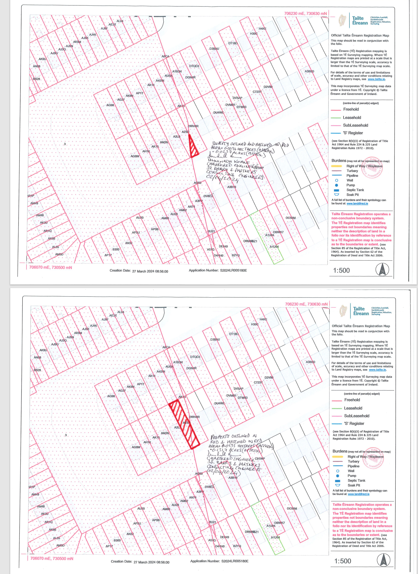

Councillor W. Carey raised a query in relation to the history of the plot of land.

Mr. J. Frehill, Director for Economic Enterprise and Tourism Development, responded to the member’s query.

The report was proposed by Councillor Baby Pereppadan, seconded by Councillor W. Carey, and AGREED.

H7(B)(i) Proposed disposal of plot of land at 7 St Patrick’s Cottages, Grange Road, Rathfarnham, Dublin 14

COMHAIRLE CONTAE ÁTHA CLIATH THEAS
SOUTH DUBLIN COUNTY COUNCIL

MEETING OF SOUTH DUBLIN COUNTY COUNCIL
DATE
HEADED ITEM NO.H7b)
The following have applied, in accordance with the provisions of the Landlord and Tenant (Ground Rent) (No 2) Act, to acquire the fee simple in the property
ADDRESS | LESSEE(S) | PURCHASE PRICE
7 St. Patrick’s Cottages, Grange Road, Rathfarnham, Dublin 14 | Ronald and Denise Coleman | €43.02
It is proposed, in accordance with the provisions of the landlord and Tenant (Ground Rents) (No 2) Act, 1978 and subject to the provisions of Section 183 of the Local Government Act 2001, to dispose of the fee simple in the site listed above.
Colm Ward
Chief Executive

H7(B)(ii) Map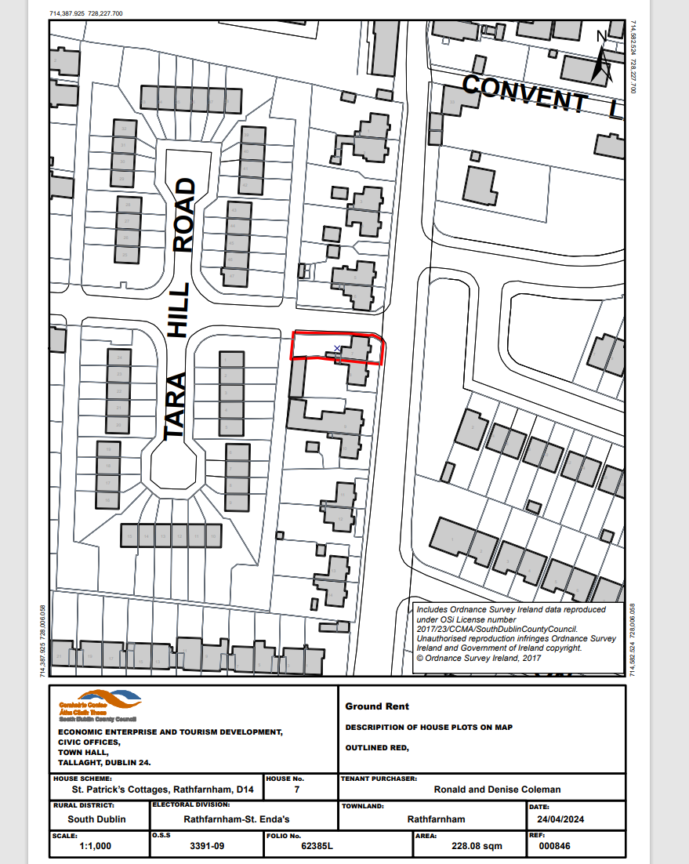

The report was proposed by Councillor Baby Pereppadan, seconded by Councillor R. McMahon, and AGREED.

H7(C)(i) Proposed disposal of plot of land at 43 Avonbeg Road, Tallaght, Dublin 24

COMHAIRLE CONTAE ÁTHA CLIATH THEAS
SOUTH DUBLIN COUNTY COUNCIL
MEETING OF SOUTH DUBLIN COUNTY COUNCIL
DATE
HEADED ITEM NO.H7b)
The following have applied, in accordance with the provisions of the Landlord and Tenant (Ground Rent) (No 2) Act, to acquire the fee simple in the property
ADDRESS | LESSEE(S) | PURCHASE PRICE
43 Avonbeg Road, Tallaght, Dublin 24 | Michael Macken | €43.02
It is proposed, in accordance with the provisions of the landlord and Tenant (Ground Rents) (No 2) Act, 1978 and subject to the provisions of Section 183 of the Local Government Act 2001, to dispose of the fee simple in the site listed above.
Colm Ward
Chief Executive

H7(C)(ii) Map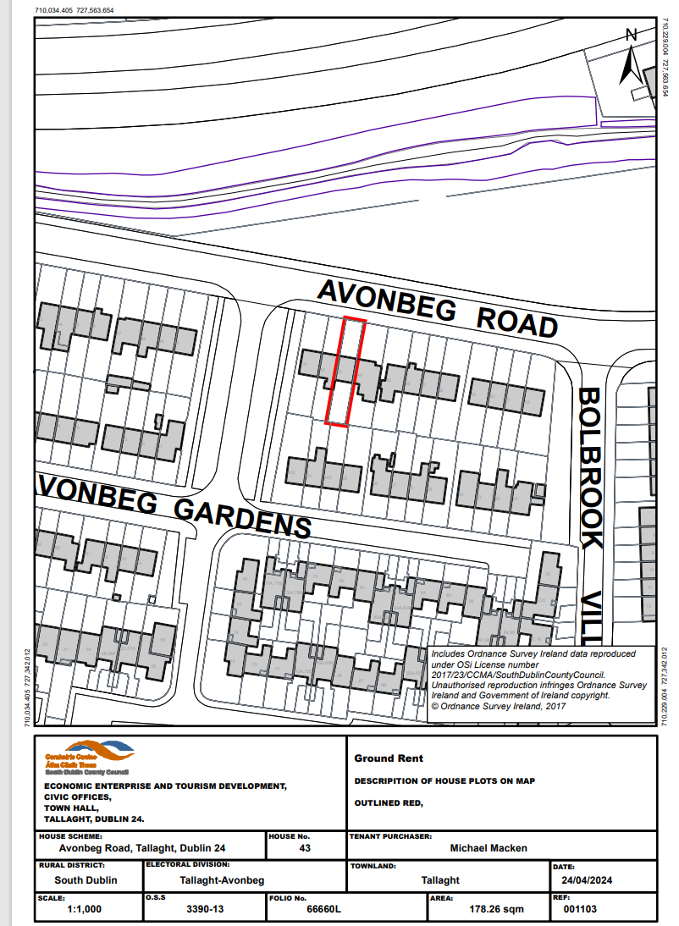

The report was proposed by Councillor Baby Pereppadan, seconded by Councillor M. Duff, and AGREED.

H7(D)(i) Proposed disposal of plot of land at 133 St. Maelruans Park, Tallaght, Dublin 24

COMHAIRLE CONTAE ÁTHA CLIATH THEAS
SOUTH DUBLIN COUNTY COUNCIL
MEETING OF SOUTH DUBLIN COUNTY COUNCIL
DATE
HEADED ITEM NO.H7b)
The following have applied, in accordance with the provisions of the Landlord and Tenant (Ground Rent) (No 2) Act, to acquire the fee simple in the property
ADDRESS | LESSEE(S) | PURCHASE PRICE
133 St. Maelruan’s Park, Tallaght, Dublin 24 | Gary Hernon and Nadine Bevins | €43.02
It is proposed, in accordance with the provisions of the landlord and Tenant (Ground Rents) (No 2) Act, 1978 and subject to the provisions of Section 183 of the Local Government Act 2001, to dispose of the fee simple in the site listed above.
Colm Ward
Chief Executive

H7(D)(ii) Map

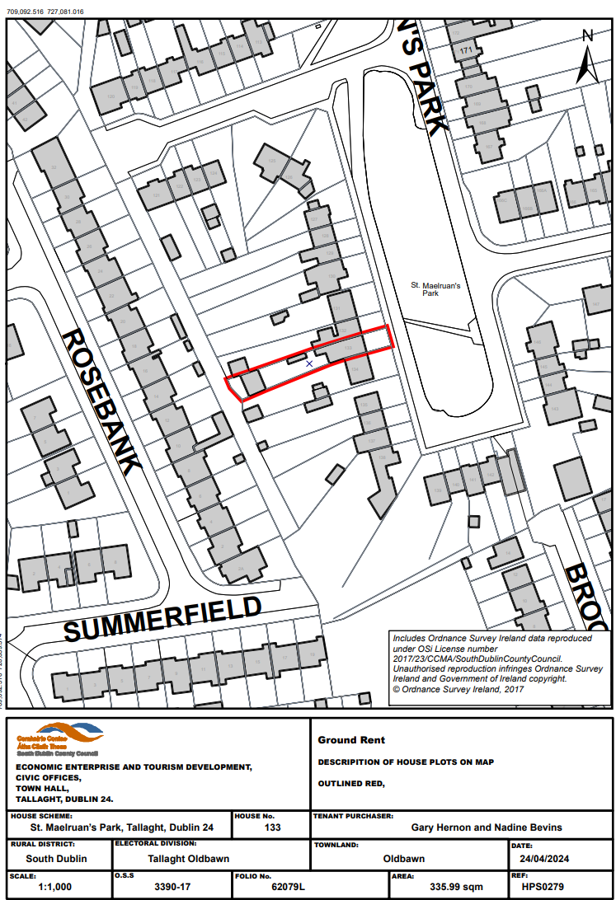

The report was proposed by Councillor Baby Pereppadan, seconded by Councillor T. Costello, and AGREED.

H7(E)(i) Proposed disposal of plot of substation site to ESB for Intergenerational Centre, Tymon Park, Dublin 6W

COMHAIRLE CHONTAE ÁTHA CLIATH THEAS
SOUTH DUBLIN COUNTY COUNCIL

MEETING OF SOUTH DUBLIN COUNTY COUNCIL
Monday, 8th July 2024
H-I 7 (e)
LD 1598 Proposed disposal of plot of land to ESB to facilitate power supply to Intergenerational Centre, Tymon Park, Dublin 6W

Part VIII Public Consultation Process for new community facility, an Intergenerational Centre in Tymon Park which is currently at construction stage, was approved at Council meeting on 14 June 2021 – Certified Minute No. H11/0621 refers.

In order to facilitate power supply to the Intergenerational Centre, the ESB have made an application to acquire the freehold interest in a plot of land for a substation at the above address. The subject plot is outlined in red on attached Drawing No. LR-ASD-2024-20014-01 – Council Folio DN23878F refers.

Accordingly, I recommend that the Council disposes of its freehold interest in the plot of land outlined in red on Drawing No. LR-ASD-202420014-01, to the ESB in accordance with Section 211 & 212 of the Planning and Development Act, 2000 and subject to the provisions of Section 183 of the Local Government Act, 2001 subject to the following terms and conditions: -

That the Council disposes of its freehold interest in the plot of land outlined in red, comprising 9.01 square metres or thereabouts, on Drawing No. LR-ASD-2024-20014-01.

That the total consideration shall be the sum of €1 (one euro) plus VAT (if applicable). The consideration figure is exclusive of accommodation works, fees and reinstatement costs.

That the ESB shall have access to inspect, repair, and maintain the underground cables and shall complete reinstatement works to the satisfaction of Council.

That the works are carried out in an efficient and reasonable timeframe once entry is made on site. All works to be carried out with minimum disruption to the Council and members of the public. All works and work procedures shall comply with Health and Safety regulations.

That the ESB shall pay a contribution in respect of the Council’s legal fees in the amount of €750.

That in the event of any name change to Applicant prior to formal completion of the legal transfer, the Applicant must provide documentary evidence to the Council proving that the new named party is one and the same as the named Applicant heretofore to enable the transfer to complete.

That each party shall use their best endeavours to complete the transaction within a reasonable timeframe following adoption of the disposal resolution.

That the Law Agent shall draft the necessary documents and include any further terms deemed appropriate in Agreements of this nature.

That no contract enforceable at law is created or intended to be created until such time as contracts have been exchanged.

That the disposal is subject to the necessary approvals and consents being obtained.

The lands being disposed of form part of ands acquired from Kennedy Brothers in 1980 for open space purposes.

Colm Ward
Chief Executive

H7E(ii) Map

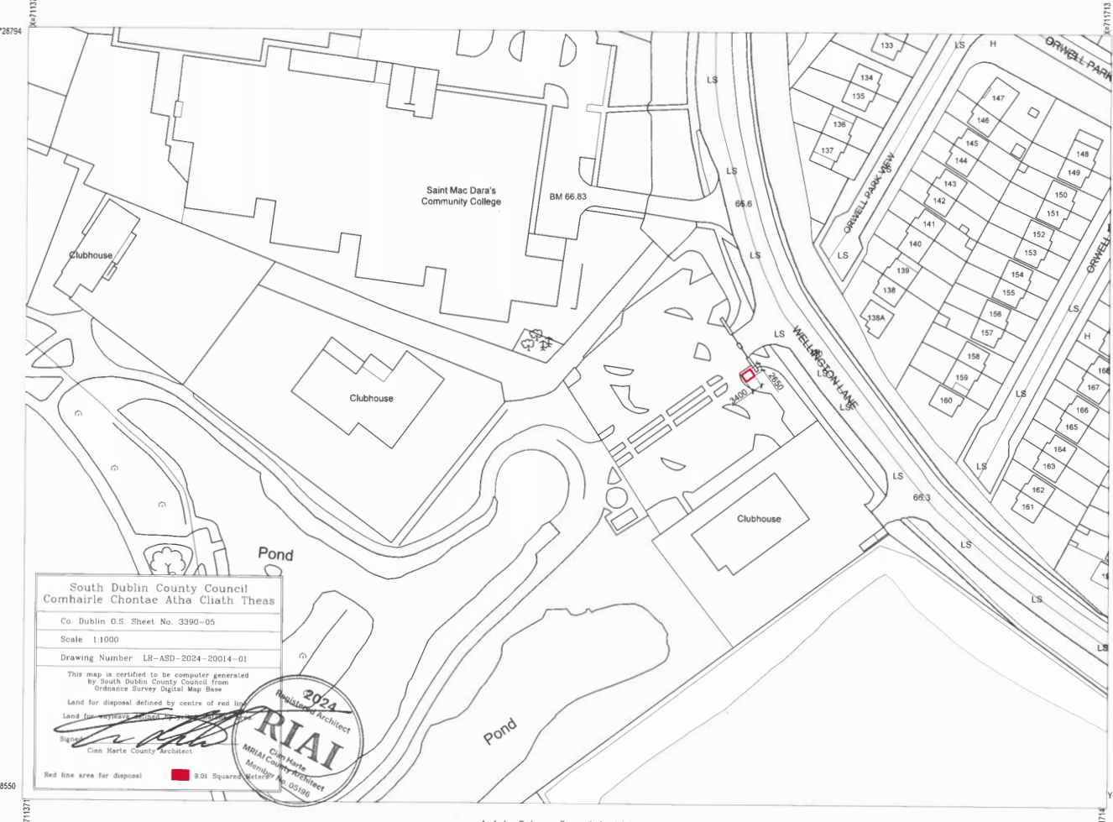

The report was proposed by Councillor Baby Pereppadan, seconded by Councillor P. Kearns, and AGREED.

H8/0724 MANAGERS REPORT & CAPITAL PROJECTS PROGRESS REPORT - FOR NOTING

The following reports by the Chief Executive, which had been circulated, were presented by Mr. C. Ward, Chief Executive, and were CONSIDERED

HI 8 a) Chief Executive's Report
HI 8 b) Capital Progress Report

H8(C)/0724 FINANCE REPORT
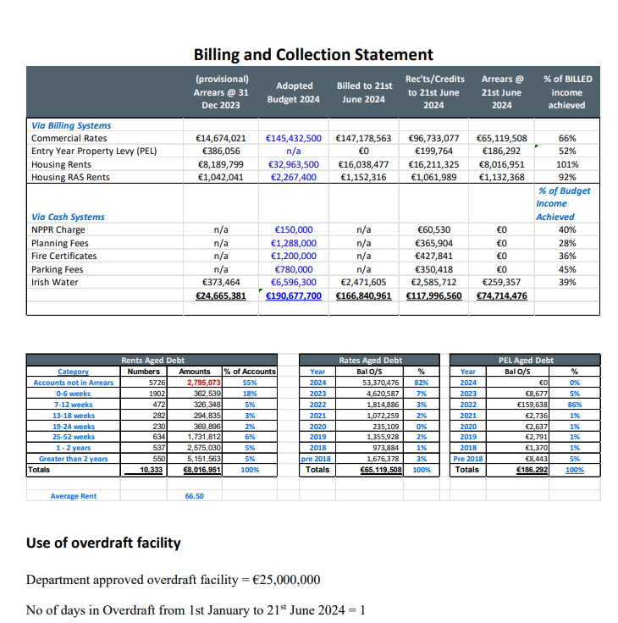
HI 8 d) May 2024 Statistics Report
HI 8 e) June 2024 Statistics Report
A discussion followed with contributions from Councillors P. Gogarty, L. O’Toole, M. Johansson, A. Edge, R. McMahon, T. Costello, F. Timmons, B. Lawlor, W. Carey, M. Duff, S. Moynihan, D. Adelaide, J. Spear, K. Keane, L. de Courcy, N. Whelan, E. Murphy, J. Tuffy, S. O’Hara, C. Brady, C. Ahern, P. Kearns, L. McCrave and Y. Collins.

Queries were raised in relation to Lucan Swimming Pool, Lucan House, Balgaddy Community Centre, Griffeen Park, Corkagh Park, public WI-FI in villages, housing allocations, maintenance and upgrades, Clonburris, Rathcoole, Castlefield, Oldcastle, Stocking Lane and Age Friendly housing developments. The Dublin Mountains project, Tenant in Situ scheme, N81 landscaping, Dodder Greenway, provision of astro pitch east of M50, Active Cycle Oldbawn to Ballyboden, Corkagh Park, access route into development site at Alpine Heights, outdoor markets, the Pitch Strategy, communication regarding cycle lanes, Citywest Community Centre, Rathfarnham Castle. Affordable housing, long term leasing, Irish language signage, pavilions, Marlay Park events, Park Rangers, Ballyroan Library and Rosemount Development.

Mr. C. Ward, Chief Executive responded to the members queries.

The Report was NOTED.

H9/0724 12TH LOCK PART 8 – FOR APPROVAL
The following reports by the Chief Executive, which had been circulated, were presented by Mr. J. Frehill, Director for Economic Enterprise and Tourism Development, and were CONSIDERED.

H9 (A)(i) 12th Lock - Part 8 Report
H9 (A)(ii) 12th Lock - Presentation
H9 (A)(iii) 12th Lock - EIA Report
H9 (A)(iv) 12th Lock - AA Screening

A discussion followed with contributions from Councillors L. O’Toole, P. Gogarty, V. Casserly, S. Moynihan, M. Johansson, J. Tuffy, D. Adelaide, W. Carey and P. Holohan. Queries were raised in relation to construction traffic, stakeholder consultation, creche, public transport, car parking, a Changing Place facility, the design and tender process, CCTV, and links to nearby institutes of further education.

Mr. J. Frehill, Director for Economic Enterprise and Tourism Development responded to the members queries.

The report was proposed by Councillor Baby Pereppadan, seconded by Councillor V. Casserly, and AGREED.

H10/0724 GRANGE COTTAGE AT 12TH LOCK, GRAND CANAL – FOR APPROVAL
The following reports by the Chief Executive, which had been circulated, were presented by Mr. J. Frehill, Director for Economic Enterprise and Tourism Development, and were CONSIDERED.

H10 (B)(i) Grange Cottage - Part 8 Report
H10 (B)(ii) Grange Cottage - Presentation
H10 (B)(iii) Grange Cottage - EIA Report
H10 (B)(iv) Grange Cottage - AA Report

A discussion followed with contributions from Councillors W. Carey and J. Tuffy with queries raised in relation to arts and crafts spaces throughout the county and childcare facilities.

Mr. J. Frehill, Director for Economic Enterprise and Tourism Development responded to the members queries.

The report was proposed by Councillor Baby Pereppadan, seconded by Councillor S. Moynihan, and AGREED.

H11/0724 APPROVAL FOR THE CHIEF EXECUTIVE TO DEFEND A JUDICIAL REVIEW TAKEN AGAINST THE COUNTY DEVELOPMENT PLAN (JONES INVESTMENT LIMITED V SDCC [2022/686JR] - FOR APPROVAL
The following report by the Chief Executive, which had been circulated, was presented by Mr. M. Mulhern, Director for Land Use, Planning and Transportation, and was CONSIDERED.

HI 11 Authorisation under Section 153 LG Act 2001

A discussion followed with contributions from Councillors V. Casserly, R. McMahon, L. Dunne, W. Carey, P. Kearns, P. Holohan, and R. Mannion. Queries were raised in relation to school sites in the county, the role of the Department of Education in the Judicial Review and funding of same, and timeframe for construction of a school on the site.

Mr. M. Mulhern, Director for Land Use, Planning and Transportation responded to the members queries.

The report was proposed by Councillor Baby Pereppadan, seconded by Councillor V. Casserly, and AGREED.

H12/0724 DRAFT SPC SCHEME - FOR APPROVAL
The following report by the Chief Executive, which had been circulated, was presented by Ms. L. Maxwell, Director for Corporate Performance & Change Management, and was CONSIDERED.

The statutory basis for Strategic Policy Committees (SPCs) is set out in Section 48 of the Local Government Act 2001, as amended by Section 41 of the 2014 Act. The making of an SPC scheme is a reserved function.

SPCs are intended to be strategic in nature while the operational matters are mainly dealt with at Area Committees. The Council is, and remains, the decision making authority and the final decision on strategic issues rests with the full Council.
On approval of the draft Scheme in July, it will go to a 4 week public consultation over July - August and a report on that consultation together with any proposed changes to the draft scheme will be presented to the September Council meeting for adoption. Following adoption of the Scheme, all Councillors will be asked to express their top 3 preferences for the SPC's and Corporate will assess the proposed membership. The PPN and other named sectoral interests will be advised of the adopted scheme and invited to nominate their members to the SPC's as relevant. There will be a 4 week period in which to confirm the membership which will again be proposed to the Council for approval, and the inaugural meetings can commence. The inaugural meetings under the new scheme should all take place before the year end.

HI 12 b) Draft SPC Scheme 2024 - 2029
A discussion followed with contributions from Councillors S. Moynihan, and M. Johansson who raised queries regarding SPC sub-committees and the number of SPC meetings annually.

Ms. L. Maxwell, Director for Corporate Performance & Change Management responded to the members queries.

The report was proposed by Councillor Baby Pereppadan, seconded by Councillor S. Moynihan, and AGREED.

H13/0724 COMMUNITY GRANTS REPORT - FOR NOTING
The following report by the Chief Executive, which had been circulated, was presented by Ms. E. Leech, Director for Housing and Community Development, and was CONSIDERED

The online rolling application process provides community and voluntary groups who are responding to locally identified needs within their communities with the opportunity to apply for assistance from the Council under the following categories:

- Community Development Grants
- Community Events Funding
- Summer Projects Funding
- Sports Development Grants

Applications are assessed by the Community Development Team under the following criteria:
- Impact on local community and local community involvement.
- Proven track record of project delivery and non-duplication of activities in the local area.
- Sustainable and value for money projects with clear/accurate costings.
- Existing funds available to the group/alternative funding sources.

Following the assessment process and having regard to the available budget 102 grants totalling €191,756.31 were approved for 82 local groups summarised as follows:

Category | No: | Amount
Community Development Grants | 35 | €39,101.31
Community Events Funding | 20 | €33,662.00
Summer Project Funding | 26 | €77,753.00
Sports Development Grants | 21 | €41,240.00
Total | 102 | €191,756.31
The final list of approved grants together with their respective approved grant amounts is as follows:
Name of Group | Funding Category Applied For | Sub-Category of Grant | Amount
Bodearg | Community Development Grant | Running Costs | €295.00
Brittas Community Association Limited | Community Development Grant | Major Equipment | € 5000.00
College and Wainsfort Residents Association | Community Development Grant | Environmental Improvement Grant | €500.00
Clondalkin Travellers Development Group | Community Development Grant | Minor Equipment | €752.00
Clondalkin Ladies Shed | Community Development Grant | Running Costs | €400.00
Crannagh and District Resident Association | Community Development Grant | Start Up Costs | €500.00
Dominic's Active Men's Social | Community Development Grant | Running Costs | €1000.00
Eblana Beekeeping Association | Community Development Grant | Minor Equipment | €747.00
Green Lane Manor Rathcoole Residents Association | Community Development Grant | Running Costs | €890.00
IACI - Integration of All Children In Ireland | Community Development Grant | Major Equipment | €4000.00
IACI - Integration of All Children In Ireland | Community Development Grant | Running Costs | €500.00
IACI - Integration of All Children In Ireland | Community Development Grant | Community Activity | €250.00
IACI - Integration of All Children In Ireland | Community Development Grant | Community Activity | €600.00
IrishBongs | Community Development Grant | Running Costs Grant | €1000.00
Killinarden Family Resource Centre | Community Development Grant | Running Costs | €1000.00
Killinarden Community Council | Community Development Grant | Community Centre Based I.T. Infrastructure | €443.00
Kilnamanagh Sister Shed | Community Development Grant | Community Activity | €1000.00
Kilnamanagh Sister Shed | Community Development Grant | Running Costs | €1000.00
Lucan Concert Band | Community Development Grant | Running Costs | €700.00
Newcastle Ladies Club | Community Development Grant | Major Equipment | €3301.41
North Clondalkin Community Choir | Community Development Grant | Minor Equipment | €2000.00
Oakdale Residents Association | Community Development Grant | Running Costs | €700.00
Quarryvale Family Resource Centre | Community Development Grant | Environmental Improvement Grant | €500.00
Quarryvale Family Resource Centre | Community Development Grant | Community Centre Based I.T. Infrastructure | €1000.00
Quarryvale Family Resource Centre | Community Development Grant | Running Costs | €300.00
Rossfield & Brookfield Women's Club | Community Development Grant | Running Costs | €1000.00
Scholarstown Wood Residents Association | Community Development Grant | Environmental Improvement Grant | €500.00
Scholarstown Wood Residents Association | Community Development Grant | Running Costs | €670.00
Sruleen Community Development Association | Community Development Grant | Running Costs | €395.00
StartBright ELC | Community Development Grant | Major Equipment | € 3945.00
Tallaght Travellers Youth Service | Community Development Grant | Community Centre Based I.T. Infrastructure | €1000.00
The Unforgettable Women’s Network - TUWN | Community Development Grant | Running Costs | €900.00
Tymonville Residents Committee | Community Development Grant | Minor Equipment | € 1055.00
Women’s Collective Ireland Tallaght | Community Development Grant | Running Costs | €427.90
Women's Shed @ The Park | Community Development Grant | Minor Equipment | €830.00
Adamstown Community Summer Camp | Community Events Funding | Africa Day Event | €2000.00
Bohernabreena Classic Car Show | Community Events Funding | Village / Community Festival | €5000.00
Clondalkin Women's Network | Community Events Funding | Bealtaine Festival | €879.00
Clondalkin Village Festival | Community Events Funding | Village / Community Festival | €7000.00
Crannagh and District Resident Association | Community Events Funding | Family Fun Day | €950.00
Cypress Residents' Association | Community Events Funding | Family Fun Day | €1000.00
Glenasmole Community Association | Community Events Funding | Village / Community Festival | €3150.00
ICA Lucan | Community Events Funding | Bealtaine Festival | €380.00
Killinarden Family Resource Centre | Community Events Funding | Family Fun Day | €950.00
Knockmitten Youth and Community Centre | Community Events Funding | Family Fun Day | €500.00
Knockmitten Youth and Community Centre | Community Events Funding | Youth Leadership Event | €500.00
Quarryvale Community and Leisure Centre | Community Events Funding | Bealtaine Festival | €850.00
Rathfarnham Wood Residents' Association | Community Events Funding | Family Fun Day | €768.00
Retired Active Men's Social (RAMs) | Community Events Funding | Family Fun Day | €200.00
Russell Square Residents Committee | Community Events Funding | Family Fun Day | € 1585.00
Scholarstown Wood Residents Association | Community Events Funding | Family Fun Day | €200.00
Sinnea Entertainment | Community Events Funding | Africa Day Event | €2000.00
St. Finian's GAA Club Newcastle | Community Events Funding | Family Fun Day | €2750.00
The Unforgettable Womens Network - TUWN | Community Events Funding | Africa Day Event | €2000.00
Willington, Osprey, Rushbrook and Kennington (WORK) Residents Association | Community Events Funding | Family Fun Day | €1000.00
Adamstown Community Summer Camp | Summer Project Funding | Summer Project Funding | €2000.00
Balgaddy Summer Project | Summer Project Funding | Summer Project Funding | €3000.00
Ballyboden Whitechurch Summer Programme | Summer Project Funding | Summer Project Funding | €4000.00
Bawnogue Youth and Community Centre | Summer Project Funding | Summer Project Funding | €1386.00
Citywise Education | Summer Project Funding | Summer Project Funding | €2000.00
Crosscare - Bawmogue/Deansrath Summer Project | Summer Project Funding | Summer Project Funding | €2000.00
Crosscare – Clondalkin Youth Service | Summer Project Funding | Summer Project Funding | €1996.00
Crosscare Lucan Youth Service | Summer Project Funding | Summer Project Funding | €1963.00
Crosscare – Ronanstown Youth Service | Summer Project Funding | Summer Project Funding | €2000.00
Fettercairn Community and Youth Centre | Summer Project Funding | Summer Project Funding | €4969.00
Holy Spirit Summer Project | Summer Project Funding | Summer Project Funding | €4000.00
IACI - Integration of All Children In Ireland | Summer Project Funding | Summer Project Funding | €2000.00
Killinarden Community Council | Summer Project Funding | Summer Project Funding | €7000.00
Killinarden Family Resource Centre | Summer Project Funding | Summer Project Funding | €1650.00
Kilnamanagh Family Recreation Centre | Summer Project Funding | Summer Project Funding | €3000.00
Knockmitten Youth and Community Centre | Summer Project Funding | Summer Project Funding | €2914.00
Lucan Youth Fun | Summer Project Funding | Summer Project Funding | €3500.00
Rossfield & Brookfield Women's Club | Summer Project Funding | Summer Project Funding | €4000.00
Saggart School House Community Centre | Summer Project Funding | Summer Project Funding | €1450.00
Sensory Fun with Friends | Summer Project Funding | Summer Project Funding | €3905.00
St. Kevin's Family Resource Centre | Summer Project Funding | Summer Project Funding | €2620.00
St. Marks Youth Club | Summer Project Funding | Summer Project Funding | €2000.00
St. Pius Summer Project | Summer Project Funding | Summer Project Funding | €4000.00
Tallaght Travellers Youth Service | Summer Project Funding | Summer Project Funding | €2000.00
The Park Community Centre | Summer Project Funding | Summer Project Funding | €4000.00
The WEB Project | Summer Project Funding | Summer Project Funding | €4400.00
Citywest Basketball Club | Sports Development Grant | Equipment | €1000.00
Citywest Badminton Club | Sports Development Grant | Equipment | €500.00
Clondalkin Cricket Club | Sports Development Grant | Equipment | €2000.00
Eanna Basketball club | Sports Development Grant | Equipment | €4000.00
Eanna Basketball club | Sports Development Grant | Coach Training | €500.00
Firhouse Notre Dame Ladies Basketball Club | Sports Development Grant | Equipment | €4000.00
Glenanne Hockey Club | Sports Development Grant | Equipment | €3000.00
Jobstown Boxing Club | Sports Development Grant | Equipment | €2750.00
Lucan Harrier Athletic Club | Sports Development Grant | Equipment | €2000.00
Mens Shed Lucan | Sports Development Grant | Coach Training | €240.00
Neilstown Boxing Youth Club | Sports Development Grant | Programme Delivery | €1000.00
Newlane Football Club | Sports Development Grant | Equipment | €1000.00
Peamount United | Sports Development Grant | Equipment | €7500.00
Rathcoole Boys FC | Sports Development Grant | Equipment | €4000.00
Sacred Heart JNS | Sports Development Grant | Equipment | €750.00
St Bernadette's S.N.S. | Sports Development Grant | Coach Training | €500.00
Tallaght Community National School | Sports Development Grant | Programme Delivery | €1000.00
Tallaght Drug and Alcohol Task Force | Sports Development Grant | Programme Delivery | €1000.00
Tallaght Rehabilitation Project CLG | Sports Development Grant | Equipment | €2500.00
Tallaght Rugby Club | Sports Development Grant | Equipment | €1000.00
This Is Me Neurodiversity | Sports Development Grant | Programme Delivery | €1000.00

The Report was NOTED.

REPLIES, ACKNOWLEDGEMENTS & CORRESPONDENCE

Replies
H15(A) RESPONSE FROM MINISTER FOR MENTAL HEALTH AND OLDER PEOPLE RE ADHD UMAAP PROGRAMME

Acknowledgements

Correspondence
H15(B)(i) ARCHIVAL PREPARATIONS FOR THE NATIONAL CENTRE FOR RESEARCH AND REMEMBRANCE
H15(B)(ii) ARCHIVAL PREPARATIONS FOR THE NATIONAL CENTRE FOR RESEARCH AND REMEMBRANCE
H15(C) FINGAL COUNTY COUNCIL MOTION -FOSSIL FUEL NON-PROLIFERATION TREATY (1)
H15(D) WICKLOW COUNTY COUNCIL MOTION TO EMPLOY FULL TIME ROAD SAFETY OFFICER
H15(E) MONAGHAN COUNTY COUNCIL MOTION PASSED RE FREE EDUCATION SCHEME

Correspondence was NOTED.

M1/0724 ELECTION/REFERENDUM/PUBLIC MEETING POSTERS

It was proposed by Councillor F. Timmons and seconded by Councillor E. Murphy:

That this council lead by example and introduce designated poster area zones in each LEA in consultation with Tidy Towns groups ( either billboard type or electronic screen type ) to eliminate the use of one use cable ties and poster waste

REPORT:
Election / Referendum / Public Meeting posters are governed by a suite of relevant legislation including:

- Litter Pollution Act 1997, amended by the Electoral (Amendment) (No. 2) Act 2009
- Protection of the Environment Act 2003
- Planning and Development Regulations 2001-2013
- European Parliament Elections Act 1997
- Local Elections Regulations 1995
- Referendum Act 1994
- Electoral Act 1992
- Road Traffic Act 1961

Posters for elections can be displayed either
- A) 30 days before the poll day or
- B) From the date the Minister makes the polling order appointing the polling ……….whichever provides the shorter period of time

Posters for referendum can be displayed from the date on which the Minister makes the polling day order appointing the day on which the referendum shall be held. Section 19 of the Litter Pollution Act 1997, as amended, and Section 9 of the Electoral (Amendment) (No. 2) Act 2009 require that all posters/advertisements relating to an election / referendum must be removed within 7 days of date of polling day.

Posters for public meetings can be displayed in accordance with Section 19(7) of the Litter Pollution Act which provides that an advertisement advising of a public meeting can be in place for up to 30 days before and within 7 days after a public meeting.

Reforming the way election candidates reach the public may require political will and legislative change. National legislation permits election posters and does not (subject to road safety) put restrictions on where they should be erected, but rather when they can be erected and when they should be removed.

A working group of a former Environment SPC previously developed a voluntary code of practice to which election candidates in Local Elections in Lucan, Clondalkin and Palmerstown agreed not to erect posters in those villages at the request of the local Tidy Towns groups. Notwithstanding the above there is currently no legislative provision to enforce a voluntary code, and it was only relative to Local Elections, thereby not applying to other elections and Referenda which were held at that time.

The matter was further considered by the Environment SPC in 2016 when desktop research was carried out on best practice internationally as part of the work of the subcommittee established to look at options/recommendations.

It was noted from that study that many European countries apply different mechanisms to facilitate communication between election candidates and voters. Some place limits on the number of posters and where they may be placed, restricting them, for instance, to designated municipal hoardings. It is also known that in some countries candidates get an equal amount of posters and can post in designated areas only.

Any meaningful change will require legislative change and ministerial direction. The members, if agreed, can refer the matter to the incoming Environment SPC for further examination.

A discussion followed with contributions from Councillors T. Costello, E. Murphy, Y. Collins, J. Tuffy, P. Kearns, D. Adelaide, R. McMahon, C. Ahern, W. Carey, P. Gogarty and V. Casserly.

Ms. T. Walsh, Director of Environment Water & Climate Change responded to the Members.

The Mayor, Councillor Baby Pereppadan, then called for a ROLL CALL VOTE, and the Members AGREED, the result of which is as follows:

FOR: 9 (NINE)
Councillors D. Adelaide, C. Ahern, Y. Collins, P. Gogarty, A Hayes, M. Johansson K. Keane, J. Spear, F. Timmons

AGAINST: 16 (SIXTEEN)
Councillors S. Barnes C. Brady, W. Carey, V. Casserly, T. Costello, L. de Courcy, L. McCrave, R. McMahon, G. Moore, S. Moynihan, E. Murphy, Baby Pereppadan, Britto Pereppadan, D. Richardson, J. Tuffy, N. Whelan

ABSTAIN: 1 (ONE)
Councillor R. Mannion

As a result of the Roll Call Vote, the Motion was NOT AGREED.

Meeting finished@ 19:05

Motions not reached

(M2) PITCHES
Councillor J. Sinnott
This Council notes with concern the increasing number of sports pitches deemed unplayable over the course of winter and spring and the negative impact on local sports clubs and participants. In light of this growing issues this Council requests Council management to investigate further means to improve drainage and the possibility of increasing the number of all-weather pitches available in the County.

(M3) VIOLENT ASSAULTS
Councillor P. Gogarty
That this Council, sharing the public outrage at suspended sentences being applied for a succession of extremely violent assaults, calls on the Minister for Justice, the Law Reform Commission and the Judicial Council to ensure that there are meaningful consequences for such behaviour in the future.

(M4) LOW PAY COMMISSION
Councillor K. Keane
That the Chief Executive write to the Minister for Enterprise, Trade and Employment Peter Burke calling on him to implement the recommendations of the Low pay Commission and end sub-minimum wage rates for workers under the age of 20.

(M5) STRATEGIC PLAN FOR HOUSING PEOPLE WITH A DISABILITY
Councillor A. Edge
That this Council agrees that the Housing SPC develop a policy for community based supported living for adults with disabilities.

(M6) BRING BANK SITES
Councillor N. Fennell
This council calls on the Chief Executive to increase the number of bottle banks in the county.

(M7) APARTHEID FREE ZONE - BOYCOTT ISRAELI GOODS
Councillor J. Spear
That Council agrees to make South Dublin County Council an apartheid-free zone and boycott all Israeli goods.

(M8) DERELICT SITES
Councillor M. Johansson
That the Chief Executive initiate Compulsory Purchase Order proceedings on all sites that are on the Derelict Sites Register (as published 20/06/2024)

(M9) REMOVAL OF LITTER BINS
Councillor N. Whelan
This council calls on the chief executive to immediately reverse the policy of removing public bins from this county as a method of reducing illegal dumping of domestic waste and requests that all public bins removed for this reason are replaced as a matter of urgency.

(M10) PUBLIC HEALTH NURSES
Councillor D. Adelaide
That the chief executive to write to the Minister for Health, Stephen Donnelly, calling on him to meet with local representatives regarding the lack of public health nurses in the south Dublin County area.

(M11) COMMUNICATIONS BOARDS
Councillor R. Mannion
This Council welcomes and commends the roll out of Communication Boards at playing facilities in SDCC which aim to improve accessibility and inclusive play for children with language difficulties, and calls on the Chief Executive look at the feasibility of their inclusion in other parks, pitches or play facilities where appropriate.

(M12) HOUSING ADAPTATION GRANTS
Councillor Y. Collins
That this Council writes to the Department of Housing asking that, when assessing eligibility for Housing Adaptation Grants, that the income of the whole household, as opposed to the individual seeking assistance, should not always be taken into account, and that there be flexibility to determine each application on a case by case basis to prevent undue hardship

(M13) COMMUNITY BENEFIT SCHEME
Councillor W. Carey
That this Council calls on the Minister for Enterprise, Trade and Employment to introduce a community benefit scheme to be paid into by companies and business interests that use extensive state resources but offer a low worker/job ratio comparative to industrial norms.

Signed: _____________________
Mayor
Date: _________________

