1COMHAIRLE CONTAE ÁTHA CLIATH THEAS
SOUTH DUBLIN COUNTY COUNCIL



MEETING OF SOUTH DUBLIN COUNTY COUNCIL

Monday, 8th September 2025

HEADED ITEM NO. 10

Chief Executive’s Report on Public Consultation for Proposed Development at the Existing Ballyroan Community & Youth Centre, Marian Road, Rathfarnham, Dublin 14 in the Curtilage of the Church of the Holy Spirit [Protected Structure, RPS 264] and Minor Alterations to Existing Storage Unit at Ballyroan Public Library, Orchardstown Villas, Rathfarnham, Dublin 14.

1.0 Introduction & Legislative Background

In accordance with the requirements of Part XI Planning and Development Act, 2000 (as amended) (the Act) and Part 8 of the Planning and Development Regulations, 2001 (as amended) (the Regulations), South Dublin County Council is seeking planning consent to carry out a proposed development at the Existing Ballyroan Community & Youth Centre, Marian Road, Rathfarnham, Dublin 14 in the curtilage of the Church of the Holy Spirit [protected structure, RPS 264] and minor alterations to existing storage unit at Ballyroan Public Library, Orchardstown Villas, Rathfarnham, Dublin 14.

Section 179 (3) (b) of the Act, requires that the Chief Executive shall, after the end of the public consultation period, prepare a written report in relation to the proposed development and submit the report to the Elected Members of the Council.

Section 179 (3) (b) of the Act outlines that a report shall—
- Describe the nature and extent of the proposed development and the principal features thereof, and shall include an appropriate plan of the development and appropriate map of the relevant area;
- Evaluate whether or not the proposed development would be consistent with the proper planning and sustainable development of the area to which the development relates, having regard to the provisions of the Development Plan and giving the reasons and the considerations for the evaluation;
- List the persons or bodies who made submissions or observations with respect to the proposed development;
- Summarise the issues, with respect to the proper planning and sustainable development of the area in which the proposed development would be situated, raised in any such submissions or observations, and give the response of the Chief Executive thereto; and,
- Recommend whether or not the proposed development should be proceeded with as proposed, or as varied or modified as recommended in the report, or should not be proceeded with, as the case may be.

Under Section 179(4) of the Act, the Elected Members shall, as soon as practicable, consider the proposed development and the report of the Chief Executive. Following the consideration of the Chief Executive's report, the proposed development may be carried out as recommended in the Chief Executive's report, unless the local authority, by resolution, decides to vary or modify the development, otherwise than as recommended in the Chief Executive's report, or decides not to proceed with the development. A resolution must be passed not later than six (6) weeks after receipt of the Chief Executive's report.

The purpose of this Chief Executive’s Report is to present the outcome of the consultation programme carried out on the proposed development, to respond to the submissions made during the consultation period and to make recommendations in relation to the proposed development where appropriate.

1.0 Part 8 Proposal

1.1 Site Description
The community centre site is located within Ballyroan parish lands. The parish lands has a total site area of approximately 0.77 hectares and is bounded to the east by the Rosemount District Centre Plaza; to the south by the Anne Devlin Park Road; to the north by the commercial units of the Rosemount District Centre and the Ballyroan Library (including public car park); and to the west by Orchardstown Villas road. The parish land site is occupied by the Ballyroan Church of the Holy Spirit [Protected Structure, RPS 264] located centrally on the site; the Ruah Pastoral Centre to the north-west corner of the site and the Ballyroan Community & Youth Centre and subject of this Part 8 application on the north-east corner.

The Ballyroan Community & Youth Centre is a self-contained development within the Ballyroan parish lands and occupies a site area of approximately 0.08 hectares, which includes a screened external play area to the west of the centre, which is used by the childcare facility within the centre.
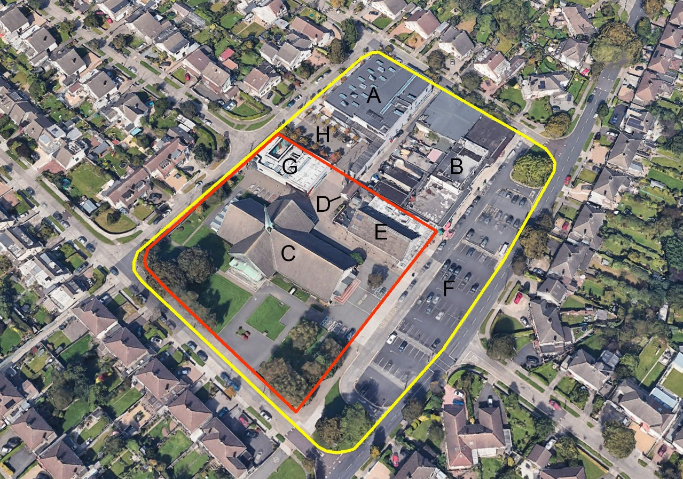

Fig. 1.0: Aerial Photograph taken from Google Maps of the Rosemount District Centre today, the Rosemount District Centre outlined in yellow and Parish lands outlined in red. Buildings indicated, include (A) Public Library, (B) shop units, (C) Church, (D) Church boiler house, (E) Ballyroan Community & Youth Centre, (F) Public car park, (G) Pastoral Centre, (H) Library car park.

The history of the community centre, the Church of the Holy Spirit and the Rosemount District Centre is set out in detail in the Architectural Impact Assessment Report prepared by SDCC Architects’ Department.

Records indicate the Rosemount District Centre development, including parish lands, was developed on a greenfield site to serve as a commercial, civic and pastoral hub for the new suburbia planned for the Ballyroan area in the mid-1960s and was master planned to include: a public library to the northwest; a row of privately owned shop units with street frontage to the northeast; a new church with boiler house and parish hall constructed on parish lands to the south; and a strip of public carparking along the eastern boundary, off Marian Road.

Constructed in 1967, ‘The Church of the Holy Spirit’, designed by Irish architect Raymond F. Mac Donnell (-2014) remains a visually prominent landmark in the Ballyroan neighbourhood and is one of the youngest protected structures in Ireland (R.P.S. No. 264) and received protected status due to its highly technical and imaginative design. The parish hall and subject of this Part 8 application was constructed c.1970, also by Raymond F. Mac Donnell. The proportions, incline and design of the clay pitched roof of the hall carefully echo the roof design of the neighbouring church, which together form an attractive composition on the street front.

In 2008, Box Architects were commissioned by South Dublin County Council to carry out development and upgrade works to the area, to include:

- The upgrade and extension of the Parish Hall to become the new Ballyroan Community & Youth Centre,
- Construction of a new Pastoral Centre,
- The extension /upgrade of Ballyroan Library.

This works also included public realm enhancement works, consisting of new pedestrian link and civic space on parish lands and upgrade of the Ballyroan Library car park.

1.2 Nature and Extent of Proposal
The existing Ballyroan Community & Youth Centre (area GFA 575 m²) provides essential community services for the Ballyroan community and includes a community hall; community café; meeting rooms; childcare facilities including external play area; staff office; sanitary facilities and a meals-on-wheels kitchen. Due to a growing demand for community services in the area, the existing community centre building is under significant pressure and requires upgrade, accessibility enhancement and extension works, with additional space needed for additional staff offices, meeting rooms and childcare accommodation to meet local needs and to continue to serve the widest possible number of users.

Proposed works to comprise of:
- Rearrangement /upgrade of the community centre interior - to create a new meeting room and reception area at the building entrance, new accessible WC and additional office space.
- New single-storey flat roof extension (area GFA 75 m²) – for additional childcare accommodation, designed to meet Tusla requirements.
- Accessibility enhancement works to the existing community centre entrance – to comply with current Building Regulations (Part M) requirements, and new accessible entrance to the rear of the centre (subject to landowner consent) – to serve the proposed childcare accommodation.
- Minor alterations to existing parish boiler house.
- New external screened community centre bin store – to relocate existing bins out of the children’s play area to accommodate the new extension.
- New solar panels to south facing pitched roof – to help meet SDCC climate targets for 2030.
- Refurbishment /upgrade of the existing concrete pavers to the south and west of the community centre building (subject to landowner consent and final details to be agreed with the relevant SDCC internal departments).
- All associated ancillary site works as may be required in adjacent lands but not limited to foul and surface water drainage and utility supplies.

Detailed plans, drawings, and reports in relation to the proposed development are available at the following link:

01_County Architects Report
02_Site Notice
03_Newspaper Notice
04_Newspaper Notice in Tallaght Echo
05_Architectural Impact Assessment
06_AA Determination
07_AA Screeening Report
08_EIA Determination
09_EIA Screening Report
10_Drainage Design Statement
11_Ballyroan Parish_Letter of Consent
12_Drawing Issue Register
Sheet P01_Site Location Plan
Sheet P02_Site Layout Plans
Sheet P03_Floor Plan_Existing
Sheet P04_Floor Plan_Proposed
Sheet P05_Elevations_Existing
Sheet P06_Elevations_Proposed
Sheet P07_3D Images_Proposed
Sheet P08_Minor Works to Library
Sheet P09_Roof and SW Drainage Plans

1.3 Site Constraints
The proposed development concerns upgrade and extension to an existing community centre building. The existing site is generally level. Records indicate that all relevant services are available, and the proposed development has been considered as part of the overall planning/zoning for the area. The proposed development will avail of the existing service connections on site, currently serving the existing centre.

2.0 Policy Context and Project Background.

2.1 Planning /Zoning for the site
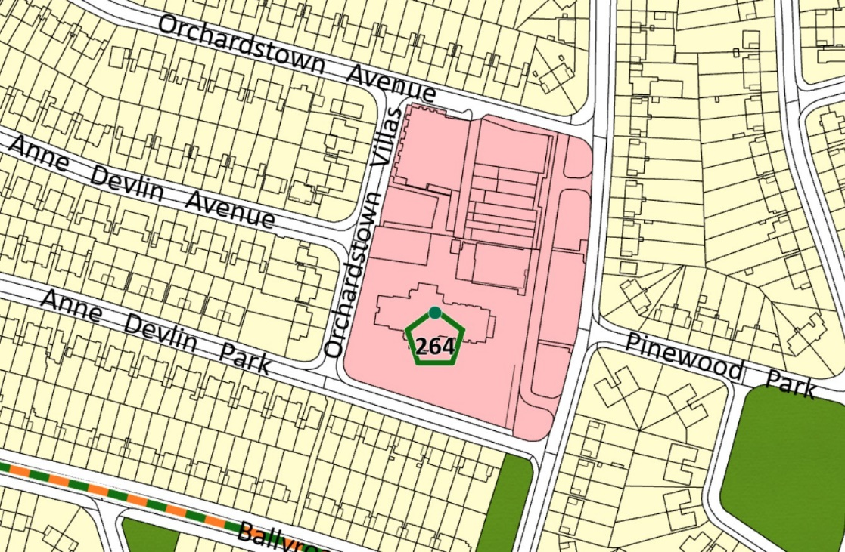
The Ballyroan Community & Youth Centre site is located in the Rosemount District Centre. Under the “South Dublin County Council Development Plan 2022 – 2028”, these lands are zoned ‘To protect, improve and provide for the future development of Local Centres’ (Objective LC). Lands uses that are listed as ‘permitted in principle’ include ‘Childcare Facilities’, and ‘Community Centres’.

The Ballyroan Community & Youth Centre site is also located within the curtilage of The Church of The Holy Spirit, which is included on the Council’s Record of Protected Structures with reference number 264, and is afforded protection under the Planning and Development Act (2000), as amended. The church is also mentioned in the National Inventory of Architectural Heritage (NIAH) survey of South Dublin County Area, under Registry Number 11216039. Fig. 2.0: Zoning Map.

The development plan policies which are relevant to the site include:

Policy NCBH19: Protected Structures
Conserve and protect buildings, structures and sites contained in the Record of Protected Structures and carefully consider any proposals for development that would affect the setting, special character or appearance of a Protected Structure including its historic curtilage, both directly and indirectly.

NCBH19 Objective 1:
To ensure the protection of all structures (or parts of structures) and their immediate surroundings including the curtilage and attendant grounds of structures identified in the Record of Protected Structures.

NCBH19 Objective 2:
To ensure that all development proposals that affect a Protected Structure and its setting including proposals to extend, alter or refurbish any Protected Structure are sympathetic to its special character and integrity and are appropriate in terms of architectural treatment, character, scale and form. All such proposals shall be consistent with the Architectural Heritage Protection Guidelines for Planning Authorities, DAHG (2011 or any superseding documents) including the principles of conservation.

Policy COS1: Social Inclusion and Community Development
Promote social inclusion and community development and encourage active participation and social integration of minority and marginalized groups, consistent with RPO 9.1 and RPO 9.2 of the RSES.

COS1 Objective 1:
To provide appropriate and accessible community facilities to meet the needs of all citizens of the County, comprising of a fast-growing young population and including an ageing population, consistent with NPOs 28 and 30 of the NPF.

COS1 Objective 4:
To support the improvement, maintenance, upgrade and refurbishment of existing community based facilities and changing rooms within the County to meet current and future needs.

Policy COS2: Social /Community Infrastructure
Support the planned provision of a range of universally accessible and well-connected social, community, cultural and recreational facilities, close to the communities they serve, consistent with RPO 9.14 of the RSES. (See also Chapter 5: Quality Design and Healthy Placemaking)

COS2 Objective 3:
To protect and enhance existing community facilities, and to support the development and expansion of new and existing facilities and services, in proximity to the populations they serve, where their need is identified.

COS2 Objective 5:
To promote accessible and inclusive social infrastructure for a range of users by adopting a universal design approach where feasible and to provide for an age friendly society in which people of all ages can live full, active, valued and healthy lives, consistent with RPO 9.12 and RPO 9.13 of the RSES and having regard to Building for Everyone: A Universal Design Approach – Planning and Policy’ (2012).

COS2 Objective 6:
To ensure that social, community, cultural and recreational facilities are provided in a manner which reduces climate impact by supporting and promoting the following measures:
- Provision of facilities within walkable distances of communities and on public transport routes;
- Promotion of walking and cycling and use of public transport via permeability and mobility management measures;
- Co-location, clustering and sharing of community facilities to increase efficient use and reduce trips;
- Location, siting and design to promote climate mitigation and adaptation for example, taking advantage of solar gain;
- Sourcing power from renewables such as wind and solar energy;
- Use of alternative energy technologies such as heat pumps;
- Energy-proofing of community buildings;
- Additional tree planting and adapting management regimes in parks and public open spaces to allow more wild areas in order to increase opportunities for carbon sequestration.

Policy COS3: Community Centres
Ensure that communities across the county have access to multifunctional and intergenerational community centres that provide a focal point for community activities.

COS3 Objective 1:
To investigate, where new provision is required to meet the needs of the population, the feasibility of extending existing community centres on suitable sites, where siting, layout, design, access and other planning considerations allow.

COS3 Objective 4:
To ensure that community buildings are multi-functional and adaptable, can be used by all age cohorts (intergenerational), providing for indoor and supporting outdoor use, for example, café seating areas, and are accessible to as many different users as possible including our teens and young people.

2.2 Conclusion
The development is consistent with the above policies and supports SDCC’s objective to carefully consider any proposals for development that would affect the setting, special character or appearance of a Protected Structure including its historic curtilage, both directly and indirectly. Further details on this and the measures taken to meet this objective, can be found in the Architectural Impact Assessment Report prepared by SDCC Architects Department, which the Council’s Architectural Conservation Officer has noted in their conservation report to be consistent with SDCC conservation policy and best practice.

The proposed extension, accessibility enhancement works and internal reordering works of the existing Community Centre will enhance the existing childcare and community facilities provided at the centre, which is consistent with the permitted land uses and zoning under South Dublin County Council Development Plan 2022–2028 for the site, ‘To protect, improve and provide for the future development of Local Centres’ (Objective LC) and the above policies and objectives to provide appropriate and accessible community facilities to meet the needs of all citizens of the County and to support the development and expansion of new and existing facilities and services, in proximity to the populations they serve, where their need is identified.

The design of the proposed childcare accommodation for the centre has been reviewed by South Dublin County Childcare Committee (SDCCC), who have confirmed the proposed accommodation is compliant with Tusla requirements.

Existing road’s access and capacity to the centre are within acceptable and safe limits. The existing centre fronts onto the recently upgraded Rosemount District Centre Plaza, with ample car parking available for staff and visitors to the centre.

As such, the proposed development is consistent with SDCC’s planning and development policies.

3.0 Screening Determinations /Part 8 Process

3.1 Screening Determinations
The proposal has undergone Appropriate Assessment (AA) Screening under the Habitats Directive (92/43/EEC). South Dublin County Council has determined that the implementation of the proposed development would not likely to have significant adverse effects on the integrity or conservation objectives of any Natura 2000 network of sites.

The proposal has also undergone Environmental Impact Assessment (EIA) Screening under the EIA Directive 2014/52/EU. South Dublin County Council has determined that there is no real likelihood of significant effects on the environment arising from the proposed development and a determination has been made that an EIA is not required.

3.2 Public Notices and Consultation Process
On the 26th June 2025, South Dublin County Council (SDCC) gave notice that it had prepared a Part 8 for the proposed development at the Existing Ballyroan Community & Youth Centre, Marian Road, Rathfarnham, Dublin 14 in the curtilage of the Church of the Holy Spirit [Protected Structure, RPS 264] and minor alterations to existing storage unit at Ballyroan Public Library, Orchardstown Villas, Rathfarnham, Dublin 14.

The proposed development would consist of the following:

- Rearrangement /upgrade of the community centre interior.
- New single-storey flat roof extension (area GFA 75 m²).
- Accessibility enhancement works to the existing community centre entrance and new accessible entrance to the rear of the centre (subject to landowner consent).
- Minor alterations to existing parish boiler house.
- New external screened community centre bin store.
- New solar panels to south facing pitched roof.
- Refurbishment /upgrade of the existing concrete pavers to the south and west of the community centre building (subject to landowner consent and final details to be agreed with the relevant SDCC internal departments).
- All associated ancillary site works as may be required in adjacent lands but not limited to foul and surface water drainage and utility supplies.

The Public consultation period took place from the 26th June to 11th August 2025 inclusive (a period of 6 weeks) during which time information on the Proposed Part 8 Development and environmental reports were disseminated to the public and submissions were invited.

The public consultation on the proposed development included the following statutory and non-statutory elements:
  - Newspaper Notice in The Echo;
  - Site Notices (6no. erected);
  - SDCC Online Consultation Portal https://consult.sdublincoco.ie
  - Emails notifying the relevant SDCC Department’s including the council’s Architectural Conservation Officer, Library Section, Water and Drainage, Roads Maintenance;
  - Emails notifying the Minister for Housing, Local Government and Heritage and the relevant prescribed bodies;
  - Emails notifying South Dublin County Childcare Committee concerning the proposed expansion of childcare facilities at the centre;
  - Plans and particulars of the proposed scheme were available for inspection or purchase at the Planning Department counter in the offices of South Dublin County Council, County Hall
  - Hard copies of the plans were also available for inspection at the Ballyroan Community & Youth Centre, Marian Road, Rathfarnham, Dublin 14.

4.0 Outcome of the Public Consultation Programme
The number of submissions that were received during the public consultation period came to 9. All submissions were read, analysed and summarised. A list of all the persons /bodies that made submissions within the public consultation period is provided in Table 1 below.

Person | Company (if Applicable)
Cllr. Paddy Cosgrave | Elected Member
Mr. Alan M Long | Ballyroan Men’s Shed
Mr. Patrick D Malone | Ballyroan Men’s Shed
Mr. Sean O’ Connor | Ballyroan Men’s Shed
Cllr. Yvonne Collins | Elected Member
Mr. Martin Sheehan
Mr. O’Flaherty
Mr. Dermot Phelan | Uisce Éireann
Ms. Caroline O’Connor Hearne | South Dublin County Childcare Committee
Table 1: List of Persons /Bodies that made Submissions

All 9 of the valid submissions received by the Council during the public consultation period were read, summarised and analysed. Submissions received from Uisce Éireann and South Dublin County Childcare Committee were technical in nature and indicated no objections to the proposals. Of the remaining 7 valid submissions received, all issues raised concerns regarding the potential impact of the proposed external screened bin store on Ballyroan Men’s Shed (BMS), who are operating out of the existing SDCC library storage unit as noted in Table 2 below.

Issue Topic | Number of Times Raised
Objection toward the location of the proposed external screened bin store and it’s potential negative impact on Ballyroan Men’s Shed. | 7
Table 2: Breakdown of issues raised in submissions received

5.0 Summary of Issues Raised and Chief Executive’s Response
This section presents an analysis of the submissions and includes a summary of each of the issues raised and the responses and recommendations of the Chief Executive. The responses and recommendations of the Chief Executive have been framed in a manner that takes account of proper planning and sustainable development of the area to which the development relates while having regard to the provisions of the County Development Plan, and the relevant guidelines.

5.1 Concerns over the location of the proposed bin store, and impact on Ballyroan Men’s Shed (BMS).

- The Ballyroan Men’s Shed (BMS) have operated from the Ballyroan Library storage unit (approx. 15m²) since 2013. Due to limited space, they frequently use the external paved area of the proposed bin store as an external works space, event space and a space to display their work to the public. The loss of this space will negatively impact the BMS.
- The existing storage unit is very small (lack of room), and the BMS would like a small extension for extra storage. I would like to propose this in the works program for the Community Centre development.
- Can the library storage unit be extended for the Men’s Shed group as part of the proposed Community Centre works as an expansion of the existing facility?
- The Ballyroan Men’s Shed were not consulted at pre-Part 8 stage.
- Can the proposed bin store be relocated to the adjacent lane to the rear of the Rosemount District Centre commercial units?
- Can the proposed bin store be relocated beside the proposed accessible entrance to the childcare facility?

Chief Executive’s Response:
The Ballyroan Community & Youth Centre, currently keep their bins behind a secure screen in the northern section of the children’s play area within the community centre site boundary. As this area sits within the footprint of the proposed community centre extension, the bins need to be relocated to a new location. Multiple options for the relocation of the bins were considered by SDCC during the pre-Part 8 stage, however, due to numerous site constraints, the area to the south of the library storage unit is the only practical option available to the Council at this time.

The erection of the screened bin store is a necessary element of the proposed development to ensure the community centre expansion and upgrade works can proceed, for the benefit of a broad sector of the Ballyroan community. It is also important that the bins for the centre, are stored in a safe, hygienic and compliant manner, in a discreet location to avoid visually detracting from the special character and setting of the Church of the Holy Spirit, which is a Protected Structure. The relocation of the doors of the library storage unit to the west facing elevation, will ensure that the internal floor area of the storage unit is not diminished by the proposed development.

While the Chief Executive notes the Ballyroan Men Shed’s use of the library storage unit and the paved area to the south has been longstanding, this activity has only been agreed through an informal arrangement with the Ballyroan Public Library. While the expansion of the storage unit to meet the men’s sheds needs is outside the scope of this Part 8 development, SDCC are happy to explore options with the Men’s Shed representatives as a separate future project. The development of the proposed bin store to the south of the library storage unit, does not preclude other options for the future use of this space that may arise if progressed through proper statutory planning procedures.

It is noted the Men’s Shed representatives were not consulted prior to proceeding to Part 8, however SDCC Library Section, who have responsibility for the storage unit were consulted and had no objections to the proposals.

The option of storing the community centre bins in the rear lane as suggested in the observations received was explored with SDCC Roads Maintenance Section at pre-Part 8 stage and was rejected due to fire safety concerns.

The land outside the proposed dedicated accessible entrance to the children’s play area to the west of the community centre is in the ownership of Ballyroan Parish and SDCC do not have authority to relocate the bins to this area. It is also a visually prominent location and could significantly detract from the special character and setting of the Church, which is a Protected Structure.

As noted above, multiple options for the relocation of the bins were considered by SDCC during the pre-Part 8 stage, however, due to numerous site constraints, the area to the south of the library storage unit is the only practical option available to the Council at this time.

Chief Executive’s Recommendation
Having regard to the nature and extent of the proposed development, it is considered that the proposed development is in accordance with the proper planning and sustainable development of the area and is consistent with the South Dublin County Development Plan and its objectives.

It is therefore recommended that the Council adopt the following Motion:

“That this Council approves of the proposed Development at the Existing Ballyroan Community & Youth Centre, Marian Road, Rathfarnham, Dublin 14 in the Curtilage of the Church of the Holy Spirit [Protected Structure, RPS 264] and Minor Alterations to Existing Storage Unit at Ballyroan Public Library, Orchardstown Villas, Rathfarnham, Dublin 14, it being in accordance with the proper planning and sustainable development of the area.”

Colm Ward
Chief Executive
28th August 2025

