COMHAIRLE CONTAE ÁTHA CLIATH THEAS SOUTH DUBLIN COUNTY COUNCIL


MEETING OF SOUTH DUBLIN COUNTY COUNCIL
Monday, 14th July 2025

Headed Item HI -12
Chief Executive’s Report on Public Consultation for Proposed Castle Stables and Courtyard at Rathfarnham
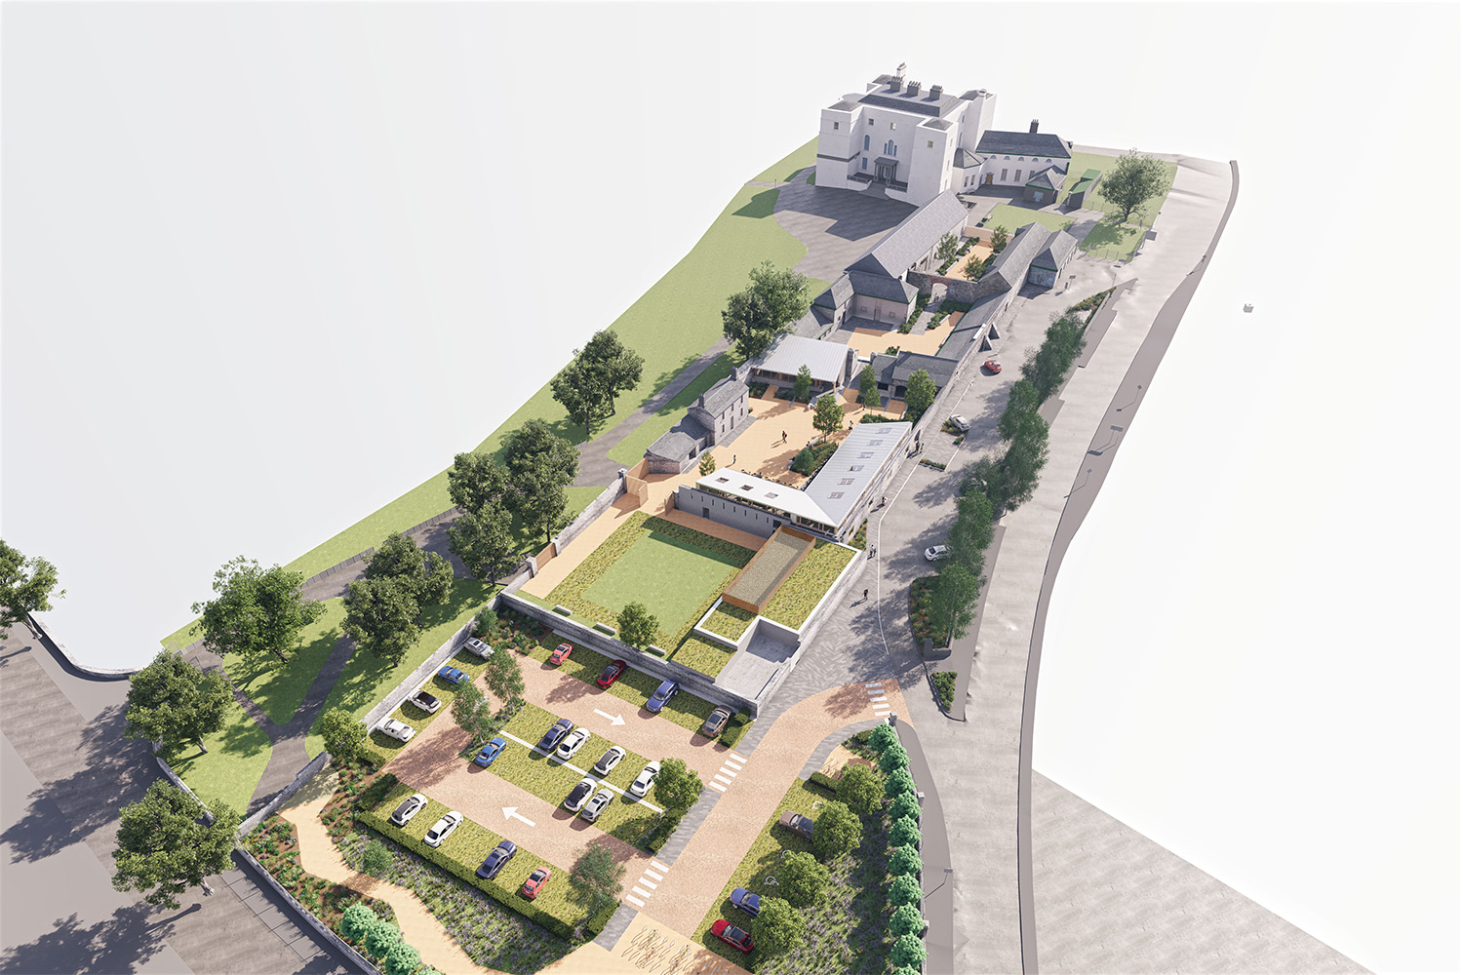

Aerial View of proposed Development

Planning Report in Accordance with Section 179 of the Planning and Development Act 2000 (as amended) and Part 8 of the Planning and Development Regulations 2001 (as amended)

Introduction & Legislative Background

In accordance with Section 179 (3) (a) of the Act, the purpose of this Chief Executive’s Report is to present to the Elected Members of the Council the outcome of the consultation, to respond to submissions made during the consultation period and to make recommendations in relation to the proposed development where appropriate.

As per Section 179 (3) (b) of the Act this report includes a summary of the public consultation in relation to the proposed development:
- Describes the nature and extent of the proposed development and is accompanied by an appropriate plan of the development and appropriate map of the relevant area
- Evaluates if the proposed development would be consistent with the proper planning and sustainable development of the area to which the development relates, having regard to the provisions of the development plan and giving the reasons and the considerations for the evaluation.
- Is accompanied by the screening determination on why an environmental impact assessment is not required and specify the features of the proposed development and the measures to avoid or prevent adverse effects on the environment of the development.
- List the persons or bodies who made submissions or observations.
- Summarises the issues, with respect to the proper planning and sustainable development of the area in which the proposed development would be situated, raised in submissions and observations, and give the responses of the Chief Executive; and
- Recommends whether or not the proposed development should be proceeded with as proposed, or as varied or modified.
APPENDIX A; technical response by RIAI Grade 1 accredited Conservation Architect to selected queries.
APPENDIX B; technical response by Consulting Planning Consultant Doyle Kent to selected Planning policy queries.

Under Section 179(4) of the Act, the Elected Members shall, as soon as practicable, consider the proposed development and the report of the Chief Executive. Following the consideration of the Chief Executive’s report, the proposed development may be carried out as recommended in the Chief Executive’s report, unless the local authority, by resolution, decides to vary or modify the development, otherwise than as recommended in the Chief Executive’s report, or decides not to proceed with the development.

A resolution must be passed not later than six (6) weeks after receipt of the Chief Executive’s report.

- Part 8 Proposal

1.1 Site Description
The subject site is located at the former South Dublin County Council Depot, at the Stables and Courtyards of Rathfarnham Castle and the adjoining Seán Keating Garden, Grange Road/Rathfarnham Road, Dublin 14 (D14 FC62 & D14 XT02), Rathfarnham Castle (Protected Structure RPS. 221) Grange Road, Rathfarnham, Dublin 14, on a development site of 1.1725 hectares. The site is bounded by Castleside Drive to the north, Rathfarnham Road to the west and Rathfarnham Castle and its grounds to the south and east.

Figure 1 - Aerial image of site from West

The history of the Castle and demesne is set out in detail in the Architectural Heritage Impact Assessment and Design Statement prepared by Howley Hayes Cooney Architects.

The Castle was purchased by the Office of Public Works in 1987, including lands (c.1.24 ha) immediately adjoining the building and the remaining lands (c.5.49ha) were brought under the control of Dublin Corporation. Over time, a full complex of farm buildings, stables and yards had been developed in close proximity to the Castle. Although many of the original gardens and associated structures no longer exist, a number of structures still remain within enclosed yards located to the north of the Castle. This complex contains four walled courtyards, stretching northwards from the rear of the Castle and with a combined area of 4,586sqm.

Conservation works to the Castle by the OPW facilitated the opening of the building to the public over several years, including a small café. A public car park was developed to the west, between the bypass road and the farmyard complex. However, the farmyards and farm buildings remain closed to the public and have in the past been used in part as a depot by South Dublin County Council.

By 2018, the farm buildings had fallen into considerable disrepair. South Dublin County Council undertook a programme of repair and renewal, including replacement of roofs.

1.2 Nature and Extent of proposal

South Dublin County Council now intends to carry out development on these lands bringing the disused buildings back into use, extending sensitively to allow for sustainable reuse and open the courtyards to the public on a development site of 1.1725 hectares. The site is bounded by Castleside Drive to the north, Rathfarnham Road to the west and Rathfarnham Castle and its grounds to the south and east.

The development will consist of the refurbishment and change of use of the former stable buildings and former council depot yards, to provide mixed-use cultural/arts/cafe/ restaurant uses together with retail use, WC’s, storage areas and a switch room. Works to the building to the north of the castle known as Cromwell’s Fort (GFA 269m2), and its change of use to two multi-purpose cultural use spaces and associated lobby areas. Works to the existing single storey former stable buildings (GFA 591m2) within the existing courtyards to the north of the Castle and change of use to cultural/arts spaces, retail, café/restaurant, garden centre and public toilets and ancillary lobby, storage and services spaces. The provision of a new single storey café and restaurant and ancillary support space (area GFA 528 m2) within the former council depot yards. The provision of new, single storey, slated roof structures to the existing structures (GFA 33m2) to the north of the building known as the Seismograph Building consisting of bin and bike storage. The demolition and reconstruction of the walls to the north and west of the northernmost former depot yard. The provision of a new car park (54 car and 42 bicycle parking spaces) and on part of the Seán Keating Garden adjacent to the boundary with Castle side Drive, with entry from the existing Rathfarnham Road car park. The reconfiguration of the existing pedestrian entrance gate and new hard and soft landscaping to the north-west corner of the site to facilitate improved pedestrian access. Along with all associated site services, site development works and landscaping.

The former council depot yards and former stable buildings fall within the zone of notification for Rathfarnham Castle, a National Monument (RMP DU022-014, Nat.Mon. 628) and a Protected Structure (RPS. 221)

Site area area
The overall site area is 1.1725 ha. The courtyard complex contains four walled courtyards, stretching northwards from the rear of the Castle, with a combined area of 4,586 m2.

Proposed Development Area
The proposed development at the Stables and Courtyards of Rathfarnham Castle and the adjoining Seán Keating Garden, is of modest scale. It will have a floor area of 1,520sqm (both existing and proposed) comprising existing floor area of 873sqm and 647sqm of new accommodation. The scheme will also unlock an additional 2460sqm of new public open space in the existing courtyards.

The proposed development entails reinstatement of the existing buildings, with new uses, and some new structures, which are designed to harmonise with the existing pattern of development in scale and layout, located within the existing boundary walls of the courtyard environment. A highly conservative approach has been taken to demolition which is kept to the minimum. A full conservation plan was prepared by an RIAI Grade 01 Conservation Architect on behalf of SDCC and in consultation with the Department of Environment and SDCC’s Conservation Officer. This plan has informed the design development.

The Architectural Design Statement prepared by Howley Hayes Cooney Architects and the EIA Screening Report prepared by Doyle Kent Planning Partnership Ltd contain a comprehensive description of the proposed development, its design intent and influences and a description of how the proposed development has been considered to site within its context. SDCC intends to make Castle Courtyards and Stables at Rathfarnham more attractive and accessible as a visitor destination, to increase the economic benefit to Rathfarnham village, to improve the public park, and improve the connection between the park, Castle and the village. As part of these objectives, the council wishes to adapt the redundant former yards and outbuildings of Rathfarnham Castle into an economically viable mixture of appropriate public and visitor uses.
The Design Statement outlines an overall strategy for the re-use of the farmyard courtyards and buildings. It states that the courtyards should be preserved and brought back into use for community benefit, providing spaces to gather, socialise and interact with others. Historic boundary walls should be kept relatively intact, to ensure the quality and character of these enclosed spaces is maintained, though new openings could be considered, to improve connectivity with the park and village.

Figure 2 – Proposed Site Layout Plan - Not to scale

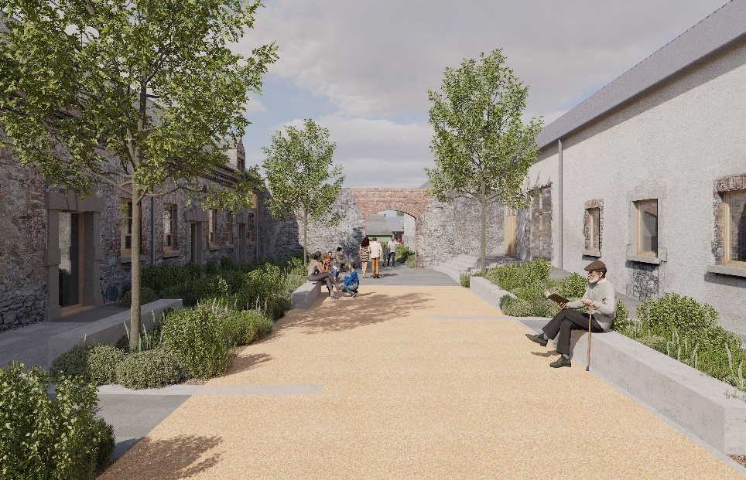
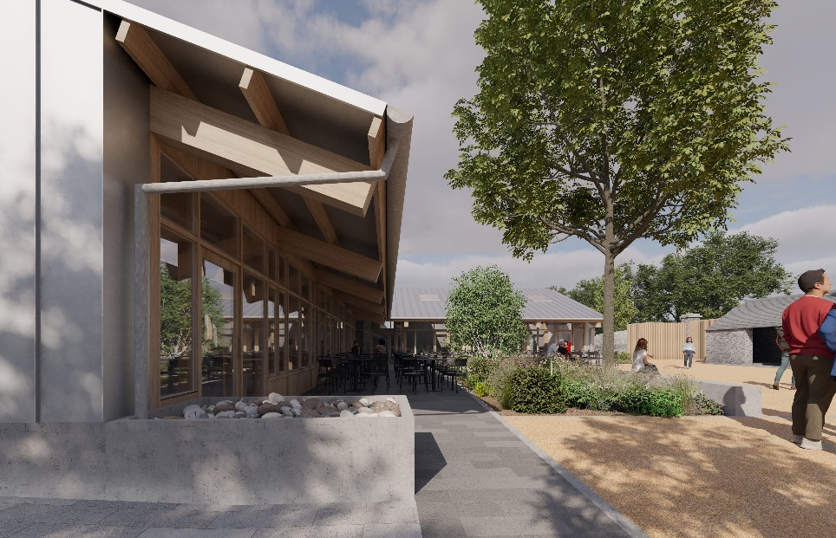
Figure 3 &4- CGI view of New Restaurant, and South Courtyard towards the Castle

Detailed plans, drawings, and reports in relation to the proposed development are available at the following link:
Castle Stables and Courtyard at Rathfarnham

1.3 Site Constraints

All required services are available on the subject site, and the proposed development has been considered as part of the overall planning/zoning for the area. The overall site rises gradually from Seán Keating Garden towards the Castle however no significant slope or other topographic constraint was identified. Existing topographic and utilities surveys have been carried out on the site. Access has been considered as part of the design and will be brought forward at detail design to ensure the issue is considered in all elements of the design.

A Tree Survey was carried out in January 2025. There are no trees or vegetation within the four courtyards. A bat survey was undertaken in February 2025, with no bat roosts identified in any of the existing buildings and onsite trees or tree lines. NRB Consulting Engineers have carried out an analysis of the local road network, aided by survey work, to establish the capacity and safety of this in relation to the proposed development. This is shown to be satisfactory as described in the Traffic & Transport Assessment Report.

As set out in the report by IAC Archaeology, nothing of archaeological significance was identified during the investigations. IAC further state that it is clear from the results and from analysis of the historic mapping, that the farmyard complex has been subject to ongoing development throughout its lifetime. Further archaeological monitoring will be required as the project develops through the construction stages.
Figure 5 - Site Layout Plan with existing condition - Not to scale

Further site investigations will be carried out post-planning stage to ensure all constraints have been identified and that any impacts on the design of the proposed development will be considered and considered prior to construction.

2.0 Policy Context and Project Background

2.1 Planning / Zoning for the site

The subject site falls within the zone of notification for Rathfarnham Castle which is a National Monument (Nat. Mon. 628) and is listed on the Record of Monuments and Places (DU022-014). It is also subject to a preservation order (PO no. 2/1986). It is afforded a degree of protection under the National Monuments Act (2004), as amended. The Castle is in State ownership while the stables and yards are in the ownership of South Dublin County Council. The Castle is also included on the Council Record of Protected Structures with reference number 221, and as the stable yard sits within its curtilage it is afforded protection under the Planning and Development Act (2000), as amended. It is also mentioned in the National Inventory of Architectural Heritage (NIAH) description of Rathfarnham Castle (11216007). The site is located on OS zoned lands.
Figure 6 - Zoning Map

Local Plans and Policy
South Dublin County Council is the planning control authority for Rathfarnham Castle Park, including the stables and yards site. Rathfarnham Castle Park is zoned ‘Open Space’ within the South Dublin County Council Development Plan (2022-2028) which states that the objective of the Open Space zoning is ‘to preserve and provide for open space and recreational amenities.’
Land uses that are listed as ‘permitted in principle’ are as follows: Allotments, Community Centre, Cultural Use, Open Space, Recreational Facility, Sports Club / Facility.
Land uses that are listed as ‘open for consideration’ are as follows: Agriculture, Bed & Breakfast, Camp Site, Car Park, Cemetery, Childcare Facilities, Crematorium, Education, Garden Centre, Guest House, Home Based Economic Activities, Hotel / Hostel, Housing for Older People, Outdoor Entertainment Park, Place of Worship, Public Services, Recycling Facility, Residential, Restaurant / Café, Shop-Local, Stadium, Traveller Accommodation.

Built Heritage Policies within the Development Plan include:
Policy NCBH19: Protected Structures
Conserve and protect buildings, structures and sites contained in the Record of Protected Structures and carefully consider any proposals for development that would affect the setting, special character or appearance of a Protected Structure including its historic curtilage, both directly and indirectly.

NCBH19 Objective 1:
To ensure the protection of all structures (or parts of structures) and their immediate surroundings including the curtilage and attendant grounds of structures identified in the Record of Protected Structures

NCBH19 Objective 2:
To ensure that all development proposals that affect a Protected Structure and its setting including proposals to extend, alter or refurbish any Protected Structure are sympathetic to its special character and integrity and are appropriate in terms of architectural treatment, character, scale and form. All such proposals shall be consistent with the Architectural Heritage Protection Guidelines for Planning Authorities, DAHG (2011 or any superseding documents) including the principles of conservation.

NCBH19 Objective 3:
To address dereliction and to welcome, encourage and support the rehabilitation, renovation, appropriate use and sensitive re-use of Protected Structures consistent with RPO 9.30 of the RSES.

NCBH19 Objective 4:
To support alternative uses for Protected Structures including former institutional sites in order to provide continued security of the heritage value of these buildings, attendant grounds and associated landscape features.

Rathfarnham Village ACA
Rathfarnham village is identified as an Architectural Conservation Area. The development of the village being closely linked with that of Rathfarnham Castle is noted in the development plan.

2.2 Conclusion
The development is consistent with the above policy. In particular the development supports SDCC’s objective to support sensitive reuse of Protected structures and welcome rehabilitation of derelict Protected Structures. In consideration of the above NCBH objectives, the Council’s Architectural Conservation Officer prepared a conservation report as part of the consideration process, which finds the proposed development to be consistent with SDCC conservation policy and sectoral best practice.

The lands OS zoning identifies the proposed uses of restaurant, café, shop- local and garden centre as open for consideration. The proposed uses will support and enhance the amenity at the park and castle and as such are considered appropriate uses. It should be noted as a clarification on the published Part 8 that the 160 sqm identified for retail will operate as a garden centre, and the total provision of retail will be limited to 100 sqm.

The parking provision on the site has been carefully considered against SDCC’s Development standards and more detail on this is provided in Section 5.2 of this document.

As such the proposed development is consistent with SDCC’s policy.

3.0 Screening determinations/ Part 8 process

3.1 Screening determinations

The proposed Part 8 development has undergone Appropriate Assessment (AA) Screening under the Habitats Directive (92/43/EEC) and an Environmental Impact Assessment (EIA) Screening under Planning and Development Regulations 2001 (as amended). No likely significant effects were identified during the AA and EIA Screening processes, or during an Ecological Impact Assessment (EcIA) prepared for the proposed development. Therefore, there is no requirement to proceed to the next stage of AA or for a Natura Impact Statement (NIS) to be produced. In addition, the proposed development is not a type of development that triggers the requirement for an EIA and subsequent preparation of an EIA Report as per the prescribed classes of development and thresholds set out in Schedule 5 of the Planning and Development Regulations 2001 (as amended).

Screening determinations were prepared and approved by SDCC. The relevant determinations were placed on public display along with the overall Part 8 proposal.

3.2 Public Notices and Consultation Process
A public notice in respect of this Part 8 was placed in the Echo on the 8th May 2025 and site notices were also erected on the subject lands in accordance with legislative requirements.
The proposed Part 8 was placed on public display during the period 8th May 2025 to 6th June 2025 (both dates inclusive) at the following locations:
- SDCC Consultation Portal https://consult.sdublincoco.ie
- Digitally displayed in County Hall, South Dublin County Council, County Hall Tallaght, Dublin 24, D24 A3XC. Hard copies were also available for inspection at the planning counter in County Hall.
- Ballyroan Library, Orchardstown Avenue, Dublin 14, D14 Vy33
Submissions were invited from Thursday 8th May 2025 up to and including 20th June 2025 (both dates inclusive).

A pre-Part 8 consultation briefing was held with the Rathfarnham Area Committee on 8th April 2025. In addition, the application was referred to the Council’s Conservation, Water and Drainage, Parks, Public Realm, Planning and Roads Departments as well as various prescribed public bodies including
  - An Taisce
  - An Chomhairle Ealaíon,
  - Minister under the National Monuments Acts, 1930 to 1994
  - Department of Defence
  - Department of Housing, Local Government & Heritage
  - Environmental Protection Agency
  - Fáilte Ireland
  - Heritage Council
  - Inland Fisheries Ireland
  - Irish Aviation Authority
  - Uisce Eireann
  - EPA
  - National Transport Authority
  - Regional Planning Authority
  - Sustainable Energy Ireland
  - Transport Infrastructure Ireland
  - Waterways Ireland

In response to this, submissions were received from Uisce Eireann indicating no objections to the proposals.

A technical report was prepared by the Council’s Architectural Conservation Officer in advance of this CE report, which outlined overall support for the proposals.

Engagement with the NIAH team has been ongoing throughout this process and they have welcomed proposals to date. An application for ministerial consent will be accepted for consideration upon approval of this Part 8 application- but discussions relating to the proposed protection of the historic courtyards and location of proposed parking at Seán Keating Gardens has been accepted in principle as the appropriate response.

South Dublin County Council commissioned Lorne Consulting to lead a public consultation on a new master vision for the Castle Stables and Courtyards at Rathfarnham. A non statutory public consultation took place over a number of weeks in March 2024. Over 1,000 people engaged with this process through walking tours of the courtyards, a survey, and focus groups. A findings report was informed through those interactions and the vision is detailed in the “Castle Stables and Courtyards Master Vision Report and Public Consultation” document included in the Part 8, completed in July 2024, as well as the memo prepared by SDCC stating responses to the key topics raised.

4.0 Record of submissions or observations received.
A total of 179 (one hundred and seventy-nine) submissions/observations were received. 172 no. were online submissions/ observations, and 5 no. were made by post and 2 no. by email. All submissions have been considered and are summarised later in this report.

A breakdown of the issues raised in the submissions received for all categories is outlined below noting that submissions may have referenced more than one category.

 | Category of Submissions | Number of Times Raised (approx)
5.1 | Expression of support (in part) for the Part 8 proposal | 91
5.1 | Expression of support (in full) for the Part 8 proposal | 5
5.2 | Concern over impact of proposal on Seán Keating Garden/ location of parking | 154
5.2 | Support for the RCRA alternative proposal | 80
5.2 | Scale of car parking provision | 31
5.3 | Impact on Rathfarnham Village | 36
5.3 | Concerns over proposed phasing of works | 15
5.3 | Objection to proposed scale of commercial use | 28
5.3 | Query on governance of operations/ business plan | 10
5.4 | Queried procedure/ approach to conservation best practice | 8
5.5 | Traffic/ Access | 8
5.3 | Proposed more focus on cultural/ heritage/ community uses | 10
5.5 | Existing access and egress from R114 Rathfarnham Road | 8
5.5 | Concerns around Part 8 compliance with SDCC policy including transport and zoning | 28
5.5 | Queries around bicycle parking provision | 2
5.3 | Suggestions for other uses be considered for proposal including community centre, storage for running club, cycling club, interpretive centre, dog park, performance + cultural space, sports hall, arts & crafts spaces, theatre group space, farmers market. | 10
 | Other | 9

5.0 Summary of Issues Raised and Chief Executive’s Responses and Recommendations
This section summarises the issues identified through the submissions received, with respect to the proper planning and sustainable development of the proposed development and gives the responses of the Chief Executive followed by recommendations. The summaries, responses, and recommendations are collated and categorised under relevant headings. The responses and recommendations of the Chief Executive have been framed in a manner that takes account of proper planning and sustainable development of the area to which the development relates while having regard to the provisions of the County Development Plan, and the relevant guidelines.

5.1 Expressions of support in part or in full for the Part 8 proposal
Submissions supporting the refurbishment and redevelopment of the derelict courtyards and stables at Rathfarnham and welcoming the investment proposed. Submissions have expressed and welcomed the very significant engagement and incorporation of the public feedback in respect of the existing stables and courtyard structures. Many expressed supports for the proposal but highlighted their concern over the removal of Seán Keating Gardens for car parking provision.

5.2 Concerns over location of proposed carparking, associated loss of amenity (154) and scale of parking provision .
154 of the total 179 submissions noted concerns over the loss of amenity at Seán Keating Park, and reservations about the proposed location and scale of parking. This was overall the most frequently raised issue.

Response;

Scale of Parking

The issue of location and scale of parking was a key consideration in the design of this proposal. The Part 8 application seeks to unlock the currently closed off amenity of the open space within the stables complex, as well as bringing the historical buildings back into use. In order to support the development of these disused structures SDCC sought to bring forward an appropriate number of additional spaces to support the overall offering at this location. The parking on completion of this proposed scheme will support visitors to the Castle, the existing park, associated playground, and amenity as well as the newly accessible courtyard open space and the proposed uses within the stable buildings and new additions. Together the synergies of these uses will prove a great amenity for visitors to this and nearby attractions including the Dodder Greenway and Rathfarnham Village.

Consideration was given to existing parking provision in Rathfarnham, the existing parking at the Castle as well as current and additional amenities at the subject site. Traffic consultants were appointed to survey existing traffic volumes on the site. They carried out surveys of footfall to Seán Keating Park as well as volumes of traffic using the existing car park.

The results of two separate surveys in January 2024 and November 2024 provided the following conclusions based on the traffic numbers counted.

In terms of car parking, the consulting engineers noted the following:

In both the January and November 2024 studies: The Car Park was most heavily used on Saturday afternoon. We would suggest that the parking area is likely busier during the Summer Months. However, a more accessible and larger capacity car park will make the Castle a more attractive destination for Leisure use at weekends.

Assessment of the existing spaces found that while midweek use of the parking was low, at peak periods, the existing parking on site and in the overall area was not sufficient for the existing uses. In consideration of sustainable development, SDCC now seeks to extend the existing parking in line with SDCC’s development plan for the stated uses at this location.

The parking provision of the proposed scheme retains 30 of the 35 car spaces to the existing car park, relocates these 5 spaces along with 44 additional spaces in the new car parking area. This will deliver a total of 79 spaces on site, which includes for a reduction of 5no. spaces from the published Part 8 in response to submissions. This will allow for the additional capacity identified above along with the additional uses.

South Dublin County Council Development Plan parking standards generate a maximum parking requirement of 51 spaces for the new uses along with the existing 35 spaces which has been assessed to be marginally too low. These standards allow for parking of up to 86 spaces. SDCC note the proposed generous provision of bicycle parking along with the good transport links including the upcoming bus connects. As such SDCC now seeks to deliver a total of 79 spaces which is reflective of the development plan guidelines against existing active transport links to the site.

Location of Parking

The location of the parking was considered in multiple locations, however access to the park to the south is bounded by mature woodland, whilst locations on the approach avenue, and closer to the Castle would not be appropriate. As such the most northerly location on site, which breaks with the historical geometry and does not have existing historical fabric, was assessed to be the most appropriate location.

The traffic consultants survey of Seán Keating Park provided the following conclusion.

In January 2024 “In term of our observations, this is a very low number of pedestrians or “low footfall” …. We suggest that it is likely most used by Residents of Castleside Drive”. Further surveys in November 2024; “In term of our observations, this remains a low number of pedestrians or “low footfall”, with the maximum of 290 over a 12-hour period equating to 24 in an hour using, or walking through, the park. The survey conclusion remains that it is not a well-used …. area for pedestrians”.

RCRA proposal.

A considerable number of submissions referred to the RCRA (Rathfarnham Castle Residents’ Association) proposal which sets out a number of considerations or variations from the proposed scheme. The key amendment proposed relates to the location of the parking and seeks to move approximately half of the parking from Seán Keating Garden into the most northly Courtyard (4). SDCC undertook an analysis of the proposed amendments and after careful consideration of the amendments note the following points.
- The alternative proposal from the Rathfarnham Castle Residents’ Association to locate half of the car parking provision in Courtyard 4 and retain half of the car parking provision in the Seán Keating Garden would result in parking in both the Seán Keating Park and Courtyard 4. The consulting Grade 1 Conservation Architect strongly supported reinstating the historical grid of the Castle and locating the parking in the least historically significant area of the site in their report and SDCC’s Conservation Officer endorsed this approach as appropriate.
- Courtyard 4 is currently inaccessible. When works are complete an additional c. 750 sqm of public open space will be made available for general amenity as well as events programmed by SDCC. The Council has considered the public concern for the loss of amenity and undertake to review the design of the courtyard to include additional seating in this space, along with a landscape design to support the use of the Courtyard as a contemplation space for the public, qualities identified by submission in relation to Seán Keating Gardens.
- As the newest and less historically significant component of the subject site, the Part 8 proposes to restore the former garden path layout in the garden space between Courtyard 4 and Castleside Drive as evident in the 1865 map and set a new car park extension within a new landscape setting, minimising the visual impact from the park and surrounding street through the use of material and extensive planting.
- The Council accepts the amenity loss in Seán Keating Garden is regrettable, however on balance the submitted Part 8 design endeavours to retain c.1,600sqm of open space amenity at the Seán Keating Garden, while retaining Courtyard 4 for park users. Therefore, allowing cars into only one of the spaces, on balance, presents the best use of the space.

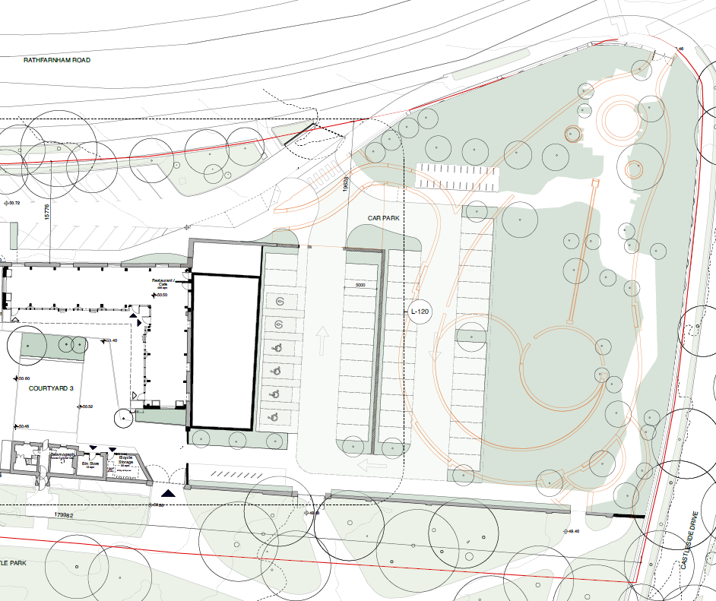

Figure 07 -showing extent of impact of RCRA scheme on Seán Keating Park including loss of pond and looped walkway.

Impact on Seán Keating Gardens

A high number of the submissions were concerned about the loss of Seán Keating Garden and while most also welcomed development of the stables , accepted a suitable provision of parking was required.

A letter was received from Seán Keating’s family supporting the proposal. In accommodating the proposed parking, the Council note that in both the proposed Part 8 scheme and the RCRA scheme a considerable section of the Seán Keating Garden is impacted- including the loss of the pond. SDCC suggests that whether approximately 1,600sqm is retained (Part 8 proposal) or approximately 2,400sqm are retained (RCRA proposal) the existing pond and looped walk will be removed, and a redesign will be required. The retained area in both proposals will be bounded by road on two sides and parking on the third. The proposal to extend the parking into Courtyard 4 would ultimately mean both the courtyard and Seán Keating Garden would be impacted by parking.
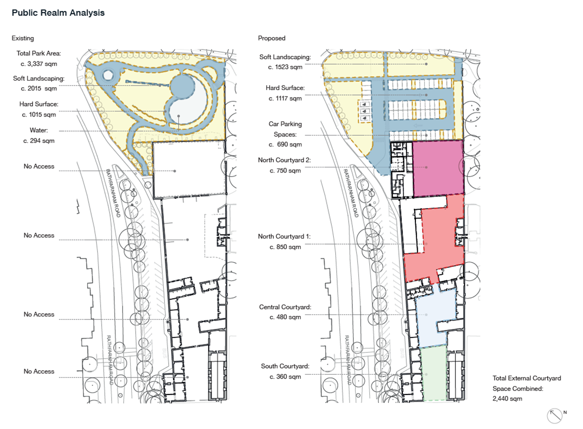Figure 08- showing existing amenity at Seán Keating Gardens is 3,337 sqm and proposed scheme will delivery in excess of 4,000sqm of public open space.

Chief Executive’s conclusion

In developing this ambitious scheme to open the existing courtyards to the public and bring the existing stables back into use, along with sensitive proposals for new building within the stables and courtyard, SDCC has sought to comply with their own development standards and adopted plans. In meeting these guidelines, a suitable quantum of car, bike, accessible, and EV parking is required to support and enhance the overall amenity and accessibility of the existing and proposed uses. Extensive consideration of the location of the parking has been undertaken and ultimately, the Council propose to provide car parking at the proposed location in Seán Keating Garden. In order to address the concerns raised in the submissions received, the proposed Part 8 shall be modified in the following respects:

- The proposed Seán Keating Garden space and car-parking area shall be modified to provide for a more uniform public open space design, where the proposed park element shall be enlarged in a northern and southern direction, thereby reducing the northern and southern directional footprint of the proposed car park. This will serve to increase the usable footprint and functionality of the open space, providing for an enhanced level of public amenity.
- Following this change, the proposed car parking area shall be reconfigured accordingly, with the access arrangements and parking situated on the most southern and western sides of the redesigned Seán Keating Garden area.
- Prior to commencement of development, full details of the revised Seán Keating Garden and parking design shall be agreed with the Planning Authority.
- Reduce the proposed additional carparking provision by 4no. spaces to a total of 50no. spaces in the location of the Seán Keating Garden to increase the amenity of retained area of Seán Keating Garden. A sample layout of how this can be achieved is set out in Fig 9 below but a detailed design will be developed to ensure green amenity and pedestrian paths are considered.
- Include additional benches and seating opportunities within the walled Courtyard 4 to encourage use.
- Include a commemoration plaque or similar (to be agreed with Seán Keating Family) within the courtyards.
- Overall, the scheme will deliver 2,440 sqm of public open space within the courtyards, and retain a more uniform public open space at the Seán Keating Garden (these figures exclude the car parking areas)

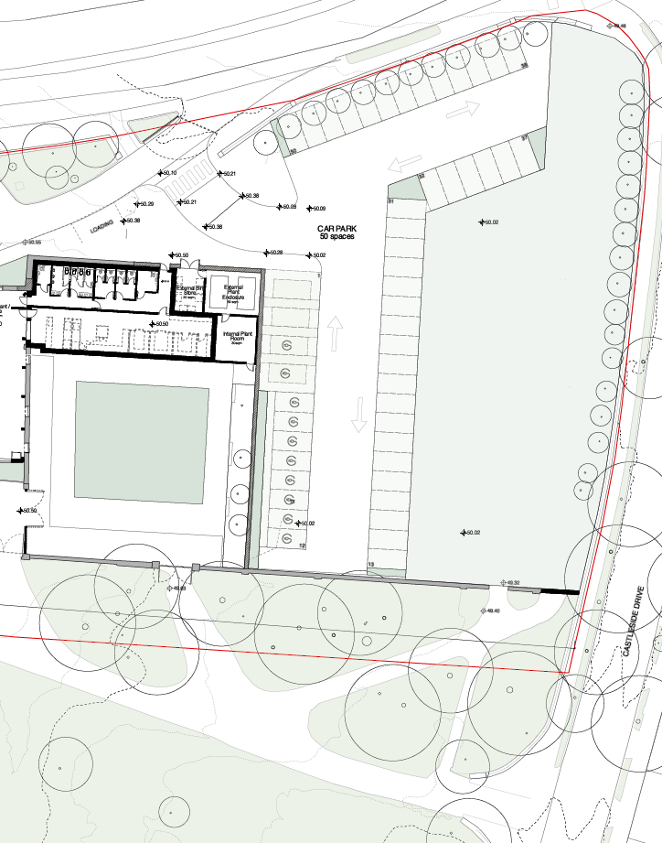

Figure 9- showing sample amended parking layout reducing parking provision to 50.

5.3 Commercial Operator, Project Phasing and Impact on the Village
Submissions raised objections to the inclusion and scale of commercial use, impact on Rathfarnham village and the phasing and financing of the project.
Submissions raised concerns about the proposed phasing and financing of the construction.

Chief Executive’s response;
SDCC has identified the Castle Stables and Courtyards at Rathfarnham for redevelopment as part of its tourism strategy. The vision is to transform the site into a vibrant public amenity, with retail, food and leisure offerings.

Between April and June 2024, SDCC conducted a non-statutory public consultation. Over 1,000 people engaged through walking tours of the courtyards, a survey, and focus groups. Feedback emphasised a strong desire for spaces that celebrate community, heritage and culture. These themes have been incorporated into the Part 8 development plans.

The development of Cromwell’s Fort in Courtyard 1 as a multi-use internal event space (two spaces with an event space entrance lobby) lends itself to be used for recitals, theatre group performances, readings and talks. The location for artist studios/maker spaces identified in the buildings opposite Cromwell’s Fort in Courtyard 1, is a further example of the integrated community, heritage and culturally uses within the Part 8. Furthermore, Courtyard 4 lends itself as a multi-functional outdoor programmable space for the likes of summer music performances, outdoor food and craft markets/farmers markets, outdoor cinema, and other leisure, community, and cultural events. Courtyard 2 contains accessible public toilets and a Changing Places WC. SDCC has engaged with the family of the late Seán Keating. SDCC will pursue proposals to commemorate Seán Keating within the courtyards and has committed to working with the family on this. The family is supportive of this proposal and look forward to engaging with SDCC as the project advances.

This development opens up to the public for the first time new public amenity spaces (Courtyard 1- c.360 sqm, Courtyard 2– c.480 sqm, Courtyard 3 - c.880 sqm and Courtyard 4 – c.750 sqm). These spaces are comparable in scale to other notable public amenity spaces such as the Red Stables Courtyards, St Anne’s Park (c.860 sqm), Meeting House Square, Temple Bar (c.590 sqm) and Trinity College Rose Garden (c.550 sqm). On balance, SDCC considers that there is a balance of hospitality, retail, leisure, cultural, community and heritage use throughout the whole proposed development. It is considered that the variety of public use and amenities/facilities will allow long term viability to the existing buildings and complex as a whole.

To address concerns about the village, SDCC has allocated:
• €100k in its 2025 budget for a Rathfarnham village economic plan
• €50k for a Rathfarnham Village Physical Enhancement Feasibility Study, focusing on pedestrian connectivity between the village and the Castle Courtyards.

The design aims to open up the previously closed off courtyards, improving integration with the village, and enhancing links with the Dodder Greenway through clear wayfinding. The proposals allow greater permeability by creating an alternative walkway to the Castle through considered soft and hard landscaped courtyards, with additional planting and rest places (seating, benches etc).

To support the full delivery of the project, SDCC has applied for €7 million under the Government’s Thrive Initiative (Town Centre First Heritage Revival Scheme). This would supplement existing capital funding. A decision is expected during the summer. SDCC is committed to developing the entirety of the masterplan which will be subject to funding. The Council seeks to ensure the coherent development of the overall stables project on a sequential basis.

Management of the wider campus and the community, arts, cultural, and event spaces, such Cromwell’s Fort and Courtyard 4 outdoor event space, would be undertaken by SDCC or a separate entity controlled by SDCC as is the case with heritage properties in other local authority areas. Therefore, SDCC is exploring suitable operational models based on best practice for managing local authority owned cultural and heritage assets. The chosen model will ensure effective governance, management, operations and maintenance. All due diligence was undertaken as part of SDCC’s capital project governance.

Final operating hours for the cultural, arts, hospitality, and retail spaces will align with standard business and cultural norms and will be conformed after the Part 8 process concludes.

5.4 Historical Context and good practice in relation to protected structure and National Monument.

A number of queries were raised in relation to best practice and statutory procedure. A grade one conservation architect was appointed as part of a multi-disciplinary design team including design architects, planning consultants, structural engineers and M+E engineers all who demonstrated experience of delivering projects in sensitive historic environments. A more detailed response to the principal points raised is set out in the appendix A to this document.

Chief Executive’s Response:
SDCC is satisfied that proper procedures were followed on this project. SDCC’s Conservation Officer has assessed the proposed Part 8 application as part of the consideration process and concluded the proposals were balanced and appropriate and “the wider proposals and the overall design ethos, rationale and level of interventions being low to moderate, the proposals have been well considered.”

5.5 Transportation, Parking, Access and Accessibility
Submissions variously raised the existing access/ egress from R114 Rathfarnham Road. They queried the provision of bicycle parking numbers. Separately submissions queried the car parking provision. Submissions expressed requirement for accessibility and dedicated parking provision.

Chief Executive’s Response:
The proposed development proposes to provide 42 bicycle parking spaces along with 10 secure bike parking spaces. Access to the Castle will be improved by creating new pedestrian and active travel path to and through the courtyards. Historically the stables created an impermeable block between Rathfarnham Park and the village. The dual carriageway is a busy thoroughfare which further creates a barrier. Opening up new links and uses through the stables and courtyards will improve connections and accessibility to the amenities existing and proposed surrounding Rathfarnham Castle.

Access from Rathfarnham Road is by means of the existing junction and will be further considered as part of SDCC’s Rathfarnham Village Physical Enhancement Feasibility Study. A traffic engineer has been engaged on this project and SDCC Roads Department have input into the proposals.

6.0 Chief Executive Conclusion and Recommendation.

Having regard to the nature and extent of the proposed development, it is considered that the proposed development subject to the following amendment is in accordance with the proper planning and sustainable development of the area and is consistent with the South Dublin County Development Plan and its objectives:

The proposed Seán Keating Garden space and car-parking area shall be modified to provide for a more uniform public open space design, where the proposed park element shall be enlarged in a northern and southern direction, thereby reducing the northern and southern directional footprint of the proposed car park. This will serve to increase the usable footprint and functionality of the open space, providing for an enhanced level of public amenity. Following this change, the proposed car parking area shall be reconfigured accordingly, with the access arrangements and parking situated on the most southern and western sides of the redesigned Sean Keating Garden area. Prior to commencement of development, full details of the revised Seán Keating Garden and parking design shall be agreed with the Planning Authority.

It is therefore recommended that the Council adopt the following Motion:

“That this Council approves the proposed Castle Stables and Courtyard at Rathfarnham development subject to the aforementioned design amendment, it being in accordance with the proper planning and sustainable development of the area.”

Colm Ward
Chief Executive
14th July 2025

APPENDIX A- RESPONSE TO TECHNICAL QUERIES
RIAI Grade 1 Conservation Architect response to queries relating to procedures and best practice.

1. Part 2 : Criteria for determining development in Building Conservation – overall historical analysis on the impact of the Rathfarnham By-pass route.
The Conservation Management Plan includes in “3.0 Statement of Significance” reference for its analysis of conservation significance the “Burra Charter” (Australia 1979) - a best practice standard for managing cultural heritage places in Australia).
The Burra Charter is internationally applicable guidance (not only for Australia) and is widely accepted and used within the Irish heritage community as the guidance for assessment and management of historic sites. It is referenced in the Architectural Heritage Protection Guidelines (2011) published by the Department of Housing, Local Government and Heritage, and in numerous other Irish guidelines on heritage management, including many of the county council websites. The Burra Charter and its contents are part of the curriculum of all conservation accreditation courses in Ireland, so its use in this country is beyond question. It should also be noted that the Burra Charter is referenced in the Shaffrey report where it is stated that “Consideration of and application of relevant international conservation charters have underpinned the principles set out in this report - of particular relevance being the Burra Charter: The Australia ICOMOS Charter for Places of Cultural Significance: 1988 and 1999”.

Executive Summary
Any “replacement” wall, without historical integrity, is valueless rendering such an enclosure as historically meaningless in this context.
Reconstruction is considered good conservation practice when the evidence of what is to be reconstructed is available and accurate. This evidence can be photographic, drawn or based on survey prior to deconstruction. As this process involves dismantling an existing historic wall and rebuilding it, we can ensure that the reconstruction of the wall will be as accurate as possible. Reconstruction in this instance is far preferable to the permanent loss of the wall, as permanent loss of this wall would impact negatively on the character of these historically enclosed spaces.
Extracted from the Burra Charter:
Article 20. Reconstruction
20.1 Reconstruction is appropriate only where a place is incomplete through damage or alteration, and only where there is sufficient evidence to reproduce an earlier state of the fabric. In some cases, reconstruction may also be appropriate as part of a use or practice that retains the cultural significance of the place.

Part 1: Rathfarnham Castle Designated a National Monument in 1986
The Part 8 documentation includes an agreement from the Office of Public Works to allow a proposal to be assembled for works within the area of the castle that is under the control of that body. There is no published comment from that organisation on the proposal on any impact of the development that may require the consent of the relevant Minister – as is the case for designated monuments.
As noted in the Archaeological Assessment at the Stables and Courtyards of Rathfarnham, submitted as part of the Part 8 documentation, the works at the stables and courtyards will require Ministerial Consent. Ministerial consent and / or notification for works to or in the vicinity of a National Monument is a separate process, which is required under the National Monuments Act. This consent process is administered by the National Monuments Service (NMS) within the Department of Housing, Local Government and Heritage, and consent is granted by the relevant Minister. Ministerial consent, in a similar vein to Planning Permission, is required before any works can commence on site. As part of the Part 8 planning process, the OPW was consulted in advance of the submission, as they are custodians of the Monument. Ministerial consent for the works will be applied for following completion of the planning process.

Part 2: Criteria for determining development in Building Conservation Rathfarnham Castle designation as a National Monument. Described in detail at the beginning of this submission, with accompanying Order and Map, it is a fundamental issue to be used under this heading. These details, maps and documents, are absent from the Part 8 proposal nor are they referred to. The designation boundary has a fundamental effect on delineating the extent of the significant historic fabric – within which the permissible development criteria assessment must be formulated.
The “details, maps and documents” referred to above are the Order and Map prepared by the OPW in 1986 when Rathfarnham Castle was first designated as a Monument. The outline presented in this map was generated almost forty years ago, when the Monument was first designated. Since that time there has been a considerable amount of further study, investigation and understanding of this National Monument. For that reason, the archaeologist and Grade 1 conservation architect would not be held only to this boundary line, to define what is of historic importance on the site. Rather the assessment of what is historically significant on the site is based on a much more detailed study of the area in question and takes account of all further works or studies following the 1986 designation. It should also be noted that Rathfarnham Castle is also a Protected Structure, afforded protection under the Planning Act (separate to the National Monuments Act) and that protection includes for the curtilage of protected structures. Therefore the extent of the significant historic fabric is also assessed under the Protected Structure status of the Castle.

Part 2 : Criteria for determining development in Building Conservation
The absence of the historical delineation of the National Monument and the absence of the “Shaffrey Report” are fundamental flaws in background and justification in the assembly of the development proposal.
The Shaffrey report is referenced in our assessment. The historical delineation of the National Monument, as mentioned above, was established in 1986 and is on file at the National Monuments Service. When assessing the proposals to the site, under the Ministerial Consent process, the National Monuments Service will review the zone of protection around the monument. It should be noted that areas outside of the 1986 are not necessarily “unprotected” or not of historic importance. There are other structures of note within the wider Rathfarnham Estate which are of historic importance, which are not within the Monument delineation map of 1986.

Part 3 : Analysis of the Proposal and Alternative Proposed.
The absence of reference to or presentation of the material on the National Monument designation together with the missing “Shaffrey Report” represent a significant failure to demonstrate any development of a conservation strategy as outlined in Part 2 above.
Without these is impossible to discern or interpret the expert opinion of this specialist conservation practice on the full extent of what or how retention of buildings and structures, the extent of permissible intervention the prioritising of maintenance and strategies to minimise intervention / alteration to ensure the integrity of this assembly of buildings and created places arising from their historical significance.
The Shaffrey report is referenced in the current report and was referred to during this process. The conservation strategy was prepared by Howley Hayes Cooney Architecture, by an RIAI Grade 1 accredited architect and all preceding documentation including the Shaffrey Report (prepared 6 years ago), was reviewed by the design team. It should be noted again that the Shaffrey report is not a statutory document, but a previous study of the site. In reference to the National Monument designation, a separate Archaeological Assessment was prepared by IAC assessing impact on the National Monument. Also see answer to item 4.

Part 2: Criteria for determining development in Building Conservation “Rathfarnham Castle Outbuildings Conservation Development Strategy, Shaffrey Associates Architects, July 2018.”
The Conservation Report refers to this, but this document is not available in its entirety but rather is referenced and summarised in the Conservation Strategy document.
This is not a statutory document, but a previous study of the site carried out in 2018. There is no reason to include it in its entirety in the Part 8 Planning submission.

Part 2 : Criteria for determining development in Building Conservation – overall historical analysis on the impact of the Rathfarnham By-pass route.
While these are the relevant comments under the heading Significance, it is puzzling in this context that the assessment does not introduce any analysis of the conservation categorisation of “Curtilage” or whether these are “Attendant grounds”, another lesser categorisation used in conservation of buildings and places.
We are not required to strictly define the curtilage or attendant grounds around a protected structure within a planning application submission, but we do state what structures we consider to be within the curtilage of the protected structure (we note this within Section 5.0 Planning and Legislation of the Architectural Design Statement and Heritage Impact Assessment). “Curtilage is an important legal concept”, but “has never been defined in law and so its meaning is open to interpretation” (Architectural Heritage Protection Guidelines).
Protection of a protected structure includes “the land within its curtilage and other structures within that curtilage” (AHPG). An example of what structures would be considered to be within the curtilage of a protected structure, are structures which directly served the protected structure, for e.g “couch-house, stores and the like” (AHPG). We consider the remaining historic stable-yards and their associated structures to be within the curtilage of the protected structure, Rathfarnham Castle. This includes the walls of Courtyard 4. As the site proposed for development sits within the curtilage of the protected structure, we have not referred to attendant grounds, which sit beyond this area. An objective of the current SDCC Development Plan (2022-2028) is NCBH19 which states the Council will “ensure the protection of all structures (or parts of structures) and their immediate surroundings including the curtilage and attendant grounds of structures identified in the Record of Protected Structures”. The SDCC Development Plan is a statutory document.

As Courtyard 4 - more accurately referred to as a simple yard - is less a structure (excepting its walls) and more an enclosure whose use is not now historical determinable but appears likely used to marshal and store agricultural vehicles and machinery serving the adjoining outbuildings, the demesne and the castle uses.
Historic walls are considered to be structures, and if removed permanently, result in permanent loss of historic fabric. Repair and reconstruction of historic walls, which is evidence based (as noted in item 1), is considered best conservation practice. As evidenced on the overlay included in the RCRA response, Courtyard 4 was present on the 1865 map, and is also on the first edition map from 1837, and is very much part of the stable yard complex. It physically adjoins the rest of the stable yard, and it was constructed at a similar time, as indicated on the historic maps. In reference to the Guidelines Section 13.1.5 of the Architectural Heritage Protection Guidelines, when establishing protected structures within the curtilage of a protected structure; there is a functional connection between courtyard 4 and the other yards and structures, as they were all interconnected; it is part of the stableyard complex of Rathfarnham Castle and it served the Castle in this regard, and, it would have also been in the ownership of the Castle.

Proposed removal of walls and mature planting, and infill of pond for car park—no Ministerial/OPW approval, violating National Monuments curtilage rules.
As noted in the Archaeological Assessment at the Stables and Courtyards of Rathfarnham, submitted as part of the Part 8 documentation, the works at the stables and courtyards will require Ministerial Consent. Ministerial consent and / or notification for works to or in the vicinity of a National Monument is a separate process, which is required under the National Monuments Act. This consent process is administered by the National Monuments Service (NMS) within the Department of Housing, Local Government and Heritage, and consent is granted by the relevant Minister. Ministerial consent, in a similar vein to planning permission, is required before any works can commence on site. As part of the Part 8 planning process, the OPW and the Department of Housing, Local Government and Heritage were both consulted in advance of the submission. Ministerial consent for the works will be applied for following completion of the planning process.

The proposal lacks an appropriate Architectural Heritage Impact Assessment and does not follow 2011 guidelines. The Seismograph House, Turner glasshouse, and courtyard walls are ignored in plans and heritage reviews.
It is unclear what is meant by “2011 guidelines” though we have assumed this to mean the Architectural Heritage Protection Guidelines published in 2011.
The Seismograph House is included in the plans and heritage reviews. It has been described, and its significance established in the Conservation Management Plan and the AHIA. In the AHIA the retention and repair of the exterior of this structure is proposed as part of the works. Its future use is to be a cultural use, and in the meantime, it will be safeguarded and fully conserved. The Turner glasshouse originally sat in a different part of the Rathfarnham Estate, and it was removed when the by-pass was built. Though reinstatement of it in general would be positive, there is no requirement within the 2011 guidelines that this glasshouse be reconstructed in the stable-yard complex, particularly as this would be a new location for this glasshouse. The courtyard walls are all being retained and repaired, with new openings introduced in certain locations, to facilitate the operation of the site. The 2011 guidelines outline the importance of the management of change on a historic site, as change is often required to ensure the preservation of these characterful historic spaces into the future.

Change, in the form of alterations to the walls, should be appropriate and not negatively impact the cultural significance of the place. This has been dealt with in the AHIA.

APPENDIX B- PLANNING RESPONSE TO TECHNICAL QUERIES
Consulting Planning consultant -Doyle Kent Planning response to selected issues relating to planning procedures and policy.

Rathfarnham Castle Project Specific Issues
Car Parking
A number of submissions have criticised the amount of car parking now proposed.
In response, note that the existing parking is limited and not especially well laid out. This area is a sliver of land between the public road and the farmyard complex, which was left over from construction of the new public road in the 20th century.
The proposed additional car parking has been designed in accordance with the current County Development Plan standards, which limit the amount of parking in any particular development (see over)
Table 12.25 Development Plan
Maximum Parking Rates - (The proposed development is located in Zone 2 non residential)
Building 1 | Events( Cultural Use) | 270 sq.m | Civic Community  (1 per50sqm GFA) | 5
Building 2 | Arts / Culture | 207sq.m | Civic Community  (1 per 50sqm GFA ) | 4
Building 3 | Pizza Restaurant | 93sq.m | Cafe/Restaurant (1 per 20sqm GFA) | 5
Building 4 | Garden Centre | 166 | Based calculation on 1 per 25sqm as per retail use GFA | 7
Building 5 | Retail | 110 | Retail (1 per 25 sqm GFA) | 4
Building 6 | Storage and Toilets | 110+59 =159 Not included in calcs | _ | _
Building 7 | Seismograph Building | 40sqm Not part of application | _ | _
Building 8 | Cafe/ restaurant + Back of House | 526 sq.m | Cafe/Restaurant (1 per 20sqm GFA) | 26
 | Building - future use | 40sqm Not included in calcs | _
Total Max Requirement |  |  |  | 51
Appendix 6 - Definition of use classes
Restaurant/Café A building or part thereof where the primary function is the sale of meals and refreshments for consumption on the premises.
Garden Centre The use of land, including buildings, for the cultivation, storage and/or the display and sale of horticultural products and the display and sale of related goods and equipment.
Shop Local-100sqm A local shop that primarily serves a local need and does not generally attract business from outside the local area. They will primarily serve a ‘walk-in’ population and will typically have limited carparking.
Cultural Use A building or part thereof or land for cultural purposes (such as educational lectures, the communication of heritage information, concerts, music recital, performance and the display or exhibition of items of interest) to which the public may be admitted on payment of a charge or free of charge.

Open Space Zoning

The Open Space zoning provides for certain uses which are either permitted in principle or open for consideration. The proposed development is ancillary and complementary to the existing facilities zoned Open Space i.e. the wider parkland/demesne lands and the Castle. The uses proposed are permitted or open for consideration and accord with the Development Plan.
The development site is only a relatively small part of the overall remaining Castle grounds, which now are a public park.
The area of open space to be replaced by car parking is modest at approx. 0.35ha out of a total park/demesne area of approx. 6.6Ha (including outbuildings and castle). The car park is to serve a relatively modest scale of development, as required by the Development Plan, of which reinstatement and reuse of existing derelict buildings of heritage value is a central element.

Table 12.15 Zoning Objective OS
Use Classes Related to Zoning Objective OS
Permitted in principle | Allotments, Community Centre, Cultural Use, Open Space, Recreational Facility, Sports Club / Facility.
Open for consideration | Agriculture, Bed & Breakfastª, Camp Site, Car Park^{h}, Cemetery^{e}, Childcare Facilities, Crematorium, Education, Garden Centre, Guest Houseª, Home Based Economic Activities, Hotel / Hostel, Housing for Older People*, Outdoor Entertainment Park, Place of Worshipª, Public Services, Recycling Facility, Residential*, Restaurant / Café, Shop-Local, Stadium, Traveller Accommodation.
a In existing premises
h For small-scale amenity or recreational purposes only
e If provided in the form of a lawn cemetery
* Only where this accords with H3 Objective 4

Climate Policy

The South Dublin County Development Plan, 2022-2028 is strongly focused on Climate Change, including in relation to issues such as zoning, settlement and transportation. The proposed development accords with the provisions of the Development Plan, including in respect of parking provision.
The Council’s Climate Action Plan 2024-2029 sets out a strategy to reduce carbon emissions in accordance with the national Climate Action Plan. Policy favours improving facilities for public transport and cycling. In the case of Rathfarnham improved bus services will be achieved by BusConnects and improved cycling facilities have been provided with more to come. Another aspect of the Climate Action Plan for South Dublin is the provision of charging facilities for electric vehicles. The Council aims to foster sustainable travel methods. Such will include electric cars, which are steadily replacing internal combustion driven vehicles.
In this context, the relatively modest scale of emissions associated with the proposed car park at Rathfarnham Castle farmyard is considered reasonable.

Examination of Planning issues raised in selected submissions

Main Submission Points | Comment
- Non compliance in respect of  - planning status of the existing S. Keating park  - AHIA sub-standard  - Whitechurch River not included in EIAR or “NIS”  - No assessment cumulative impacts in EIA  - Combined effects of BusConnects and car park not assessed  - Irish Water capacity not confirmed  - Art 6 Aarhus not honoured  - Misinformation  - Cultural + Heritage Vision Resurrect Irish Science + Horticulture Legacy  - Restore Seismograph House  - Install telescopes  - Create heritage planting scheme  - Restore Turner Glasshouse  - Scale back retail, parking and café  - Strengthen connections to village  - Commission revitalisation plan for village  - Policy alignment/best practice  - Demonstrate compliance with heritage protection, EIA, Aarhus, National Monuments Act and planning law  - Recommended conditions  - Defer Part 8 process until Section 5 determined  - Obtain ministerial consent for changes to S. Keating Pk  - Require the changes outlined in 3 above  - Additionalities and context  - Defer Part 8 process until Section 5 determined  - Require pedestrian-first connections between the Castle, the Village, and BusConnects stops.  - Require a Town Centre Health Check for the village | The proposal complies with legislative requirements  - No evidence submitted and N/A  - AHIA is of a very high standard  - Whitechurch River is part of the Dodder system, considered in EIAR and AA screening reports  - Cumulative effects in the EIA Screening at pages 14 + 17  - Access designed to be safe in relation to public road traffic  - UE confirmed a connection application will be required as is standard. No concerns raise in UE submission  - Art 6 adhered to  - No evidence of misinformation  - Seismograph House restoration in medium term  - Interesting idea  - Excellent idea  - Will investigate  - Design team of a different opinion scale of development  - Refer to executive summary- Section 5  - Refer to executive summary- Section 5  - We are satisfied it complies with relevant legislation  - No Section 5 on record  - Ministerial consent a separate issue  - Changes are commented on above  - No S5 on record  - Refer to executive summary- Section 5  - Refer to executive summary- Section 5
Supports upgrading of castle grounds, good expansion of local amenities and increasing interlinkage with other amenities/parks. Against development of Seán Keating Park into car park, this inconsistent with the provisions of Section 7 of the County Development Plan, which actively promotes sustainable travel modes. Also refers to section 4, Green Infrastructure, policy Gl1 and objectives. Of particular relevance is Policy GI1, and associated Objectives –  “Protect, enhance and further develop a multifunctional GI network, using an ecosystem services approach, protecting, enhancing and further developing the identified interconnected network of parks, open spaces, natural features, protected areas, and rivers and streams that provide a shared space for amenity and recreation, biodiversity protection, water quality, flood management and adaptation to climate change.  And this is a key point we would request SDCC to have careful regard to: given this will remain a local amenity space, the loss of existing amenity space within Rathfarnham Castle Park to facilitate a public car park is, in our view, entirely inconsistent with the overall cultural and amenity enhancement of the Castle Park and its setting.”  Points out problem with current garden is access and no magnet to attract people to this park area, this would change with castle and yards development. Car park places too much emphasis on driving as transport, accessibility requirements can be served from existing spaces. If additional parking is necessary, it can be served adjacent to the existing car parking area in the vicinity of the “red bridge” on Dodder Park Road.  Has detailed proposals on placement for additional parking and bike infrastructure on Dodder Park Road. Otherwise supports development and upgrading of this site by SDCC. | The existing car parking facility at Rathfarnham Castle is very modest.  Some additional provision will be needed, notwithstanding proximity to the Bus Connects route and to the village.  Alternative car park suggestions are relatively remote and require crossing busy road.  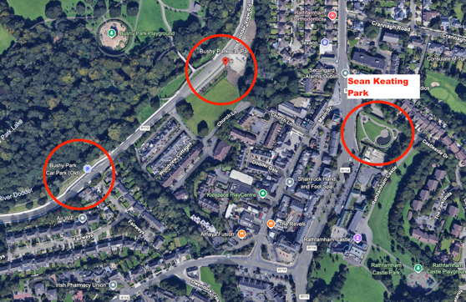
Key Objections:  - Undermining of the BusConnects Core Bus Corridor (Rathfarnham to City Centre):  The proposed car park sits at a critical pinch point on Rathfarnham Road, one of the narrowest and most congested sections of the corridor. Bus Connects seeks to prioritise sustainable public transport through improved frequency and reliability, yet this development risks introducing more private car traffic precisely where road space is most constrained.  - Conflict with Climate and Transport Policy:  Adding new car parking at this location is in direct contradiction with South Dublin County Council’s stated climate objectives and Ireland’s Climate Action Plan, which seeks to reduce car dependency and promote modal shift to public transport, walking and cycling.  - Neglect of Active Travel Needs:  The development provides space for just 10 bicycles, a token gesture in an era where active travel must be prioritised. No dedicated cycling infrastructure or pedestrian-first designs are included, nor is there safe access for vulnerable road users.  - Increased Local Emissions and Congestion:  The proposed car park will only exacerbate traffic congestion, emissions, and noise pollution in an area already heavily burdened by traffic funneling through Rathfarnham Road, Terenure, and Nutgrove.  - Commercialisation of a Heritage Asset:  Rathfarnham Castle is a significant cultural and historical asset. Commercialisation through expanded car access threatens its setting and public value. Community-focused, low-impact development would be more appropriate.  We therefore respectfully request that:  - The car park component be removed from the proposed development.  - The scheme be redesigned to prioritise public transport, pedestrians, and cyclists, in line with the BusConnects corridor design.  - South Dublin County Council reaffirms its commitment to climate-conscious planning and heritage-sensitive development. | The NTA has made no submission to SDCC on this point.  The Bus Connects design makes provision for the existing access points to the Castle car park. The proposed development does not materially alter these access points but makes use of them.  Non-provision of parking will not dissuade visitors from using a car, with possible overspill onto nearby residential roads causing a hazard.  The South Dublin County Development Plan, 2022-2028 is strongly focused on Climate Change, including in relation to issues such as zoning, settlement and transportation. The proposed development accords with the provisions of the Development Plan, including in respect of parking provision. The Council’s Climate Action Plan 2024-2029 sets out a strategy to reduce carbon emissions in accordance with the national Climate Action Plan. Policy favours improving facilities for public transport and cycling. In the case of Rathfarnham improved bus services will be achieved by Bus Connects and improved cycling facilities have been provided with more to come. Another aspect of the Climate Action Plan for South Dublin is the provision of charging facilities for electric vehicles. The Council aims to foster sustainable travel methods. Such will include electric cars, which are steadily replacing internal combustion driven vehicles.  In this context, the relatively modest scale of emissions associated with the proposed car park at Rathfarnham Castle farmyard is considered reasonable.  The development provides for 10 secure long term storage spaces + 1 cargo bike space together with 42 Short Stay bike parking spaces. NRB report  Assessment of the bicycle parking by NRB indicates a requirement for a Minimum of 26 No. spaces. The development includes the provision of a total of 52 spaces, which is double the requirement of the SDCCDP.  The public road has ample capacity to cater for the additional traffic movements generated in association with the proposed development.  The proposed development is designed to raise public awareness of Rathfarnham Castle. It includes reinstatement of several farm buildings and provision of new, low impact uses.  The proposed development has very little effect on the setting of the Castle.
Welcome the development in part.  But opposed to loss of the Seán Keating garden and proposed “inappropriate retail use” - negatively impact the area.  Public Consultation  The Council’s consultation portal did not display all documents until the day before the end of the consultation period. The EcIA and the Conservation Management Plan were these.  Zoning of the Site  Development is not in accord with the Open Space zoning in the County Development Plan. Most (70% of the floorspace) of the uses proposed are only “open for consideration” e.g. retail. Loss of significant open space and the introduction of significant retail floorspace and car parking is incompatible with the zoning objective. Such uses may only be permitted where they do not materially conflict with other aspects of the County Development Plan, which has not been demonstrated.  The proposed redevelopment of the stable buildings could act as an opportunity for the further better use of the Seán Keating garden, rather than for its destruction.  Car Parking  The County Development Plan states that car parking is only open for consideration under the zoning for the site for “small-scale amenity or recreational purposes only”. The proposed uses provided for in the application are not small-scale amenity or recreational uses.  No justification provided in relation to the need for the proposed additional parking spaces being provided (54 no. new spaces giving total of 96 spaces).  Policy SM7 of the County Development. Plan is to:  “Implement a balanced approach to the provision of car parking ………………… to promote a transition towards more sustainable forms of transportation, while meeting the needs of businesses and communities.”  The proposed additional car parking does not promote transition towards sustainable forms of transportation and the quantum has not been justified.  The County Council should be promoting the use of sustainable modes of transport.  Retail Floor Space  The Open Space zoning for the site provides for only local shops to be open for consideration. Appendix 6 of the CDP : ‘A local shop of not more than 100 sq.m. that primarily serves a local need and does not generally attract business from outside the local area. They will primarily serve a ‘walk-in’ population and will typically have limited carparking’.  The proposed development provides for c263sqm of retail floorspace across four units and this is considered project splitting.  The appropriate location for such retail uses, as set out in the zoning for the area, is Rathfarnham Village, which is zoned VC to protect, improve and provide for the future development of retail centres. To provide for competing retail uses outside of the Village Centre would be contrary to the objective to protect such village centres as set down in the County Development Plan.  Conclusion  The proposed development should be amended to omit the removal of the Seán Keating garden, omit the proposed retail use and reduce the scale of proposed car parking. | Documents were available on the consultation portal during the consultation period. Hyperlinks were sent from the consultation portal to observers as early as 16/06/25.  The proposed development is ancillary and complementary to the existing facilities zoned Open Space i.e. the wider parkland/demesne lands and the Castle. The uses proposed are permitted or open for consideration and accord with the Development Plan.  The development site is only a relatively small part of the overall remaining Castle grounds, which now are a public park.  The area of open space to be replaced by car parking is modest at approx. 0.35ha out of a total park/demesne area of approx. 6.6Ha (including outbuildings and castle).  The proposed development is for a relatively small scale amenity development ancillary to the park and Castle.  The existing public car park is very modest and additional parking is required to ensure no overspill onto adjacent roads.  It is justifiable on the basis of the Development Plan standards and is below the maximum parking provision set out in the Development Plan. The Development Plan was made consistently with national and regional policy, including in respect of car parking.  The site of the buildings, existing and proposed, is currently a dilapidated brownfield location.  The proposed development seeks to reinstate existing farm buildings which have lost any use.  The proposed new uses are all open for consideration and will strengthen the overall level of amenity provided to visitors to Rathfarnham Castle and its(remaining) demesne.  In this context, two buildings are highlighted as retail in the plans. To note Building No 4 is proposed as a small garden centre (166sqm) and Building 3 is proposed as a small-scale retail use (110sqm) which are both permitted within the OS zoning and are reasonable uses at this location and not of any substantial scale.  The character of the retail offer will be such that it does not provide any competition to the village shops.  The removal of additional parking would significantly impact the viability of this project to reinstate the farmyard complex.
Welcomes very positive aspects of the proposed development. But firmly opposed to the loss of Seán Keating Park.  - The Seán Keating Garden is a valuable community asset and is utilised as an area of recreation and solace by local residents.  - The National Transport Authority proposes to acquire part of the Woodlands at the other end of Rathfarnham Castle Park. This will further reduce the green space in our area.  - Ample existing bus services serving the area. A new Bus Connects core will pass by the Castle courtyards and stables. Given policies in respect of modal shift included in Chapter 7 of the South Dublin County Development Plan 2022-2028, yet SDCC is persisting with increasing car parking spaces at this location at the expense of existing green space.  - The proposed development area is zoned Zoning Objective OS, “to preserve and provide for open space and recreational amenities”. Paving over what is currently an open space runs contrary to this designation.  - if additional parking spaces are to be provided, I would support the location and configuration of Courtyard 4 put forward by the RCRA in their submission.  - The RCRA proposal would allow for the retention of the majority of Seán Keating Garden.  - The Seán Keating Garden was opened in 2012 and named as such in 2013. To pave over the majority of the Garden less than 15 years after it was opened would represent a considerable waste of public funds. | The overall proposed development would also constitute an asset for the community and would protect part of its heritage by reinstating the derelict farm buildings of Rathfarnham Castle. It would also improve the amenity value of the Castle Park.  The bus services are being improved, but people, including families, will continue to also use private cars to visit the Castle and associated facilities.  Parking is proposed in line with Development Plan standards.  The development will deliver an additional 750sqm of open space amenity.  This alternative has been examined and found unsatisfactory.
I am deeply concerned that the proposal contradicts multiple objectives related to the preservation of public open space, sustainable transport, biodiversity protection, and community wellbeing.  1. Protection and Enhancement of Public Open Space, Parks, and Green Infrastructure  site is zoned under Land Use Zoning Objective OS – “To preserve and provide for public space recreational amenities.” This designation clearly opposes the construction of a car park.  Supporting policies and strategies include:  - South Dublin County Development Plan 2022–2028  - Chapter 8, Table 8.1 recognizes the value of small parks (0.2–2 ha) for passive recreation and serving nearby residential areas within 300m (p.310). Seán Keating Park qualifies under this criterion.  - The Green Infrastructure Strategy promotes the enhancement of green corridors, open space connectivity, and biodiversity (p.314).  - Tree and Hedgerow Protection policies emphasize safeguarding mature vegetation that supports biodiversity and landscape quality (p.315).  (Full Written Statement of the County Development Plan)  - National Biodiversity Action Plan (4th Edition): Commits to protecting urban green infrastructure and maintaining habitat connectivity, warning against the fragmentation caused by developments such as surface car parks.  (Link to Biodiversity Plan PDF)  2. Sustainable Movement, Connectivity, and Pedestrian-Friendly Environments  The development undermines the movement vision of both local and national strategies, which emphasize walkability, cycling, and public transport over private car use.  Supporting policy references:  - South Dublin Development Plan  - Chapter 7 – Sustainable Movement Vision (p.249) aims to encourage modal shift toward walking, cycling, and transit.  - Policy SM2 (Walking and Cycling, p.263–264) stresses connectivity, permeability, and comfort for non-motorized users.  - Greater Dublin Area Transport Strategy 2022–2042: Advocates for reduced car dominance and compact, connected communities served by sustainable transport.  (Link to GDA Transport Strategy)  - The location already benefits from existing public transport access, including a bus stop directly outside Rathfarnham Castle, making a car park unnecessary and inconsistent with these goals.  3. Discouragement of Increased Car Parking and Private Car Use  Both local and national frameworks recommend limiting parking capacity in urban areas to reduce car dependency.  Relevant policy documents:  - South Dublin Development Plan – Chapter 7.10 (p.285–286): Stresses managing parking availability to discourage car usage and support modal shift.  - National Climate Action Plan 2025: Strongly supports reducing greenhouse gas emissions by curbing car journeys and investing in sustainable mobility infrastructure.  (Link to Climate Action Plan)  - Sustainable Residential Development Guidelines (2009): Recommend minimal parking provision in areas with good public transport access to facilitate modal shift.  (Link to Guidelines PDF)  4. Impact on Community and Public Amenities  Seán Keating Park is a core community asset. Removing it diminishes opportunities for informal play, recreation, and social wellbeing.  - South Dublin Development Plan, Chapter 8: Highlights the importance of accessible, high-quality public spaces for supporting healthy, inclusive communities (p.309–311).  5. Personal Impact and Community Value  As a resident of this area since 2020, I have found peace and tranquillity in Seán Keating Park. It is where I enjoy precious moments with my 1-year-old daughter. This space provides not just physical greenery but emotional and mental wellbeing that no parking lot could ever replace. It is beyond my acceptance that anyone could consider converting such a valuable and well-used open space into a car park.  6. Recommendation for Enhancement Instead of Removal  Instead of removing Seán Keating Park, I strongly urge the Council to prioritize its improvement. Initial steps should include:  - Cleaning the pond, which is currently suffering from severe algae overgrowth  - Repairing the non-functioning fountains  - Adding seating and shaded benches for the elderly, parents, and other visitors  - Planting additional native trees to enhance biodiversity, shade, and air quality  These upgrades would better align with the Council's own Green Infrastructure, Climate, and Community Wellbeing strategies.  Conclusion and Request  In summary, the proposed removal of Seán Keating Park to facilitate additional car parking:  - Contradicts key zoning objectives (Zoning Map)  - Undermines sustainable transport and climate strategies  - Reduces biodiversity and community health outcomes  - Disregards the lived experience and needs of local residents. | The zoning provides for car parking ancillary to other uses.  The Castle park provides a substantial amenity of historic origin equally accessible to nearby residential areas.  The Seán Keating Park is ancillary to this and is of recent origin.  The derelict farmyard buildings and associated open areas are not green corridors, but disused brownfield lands.  The proposed development does not conflict with these policies.  As per above  As per above  Proposed development provides for a limited amount of parking in accordance with Development Plan standards.  The amenity value of the proposed development is a worthy use of the lands of the Seán Keating Garden.  These suggestions do not provide a solution to reuse and reinstatement of the derelict farmyard complex, which exceeds the Seán Keating Park in area.

