COMHAIRLE CONTAE ÁTHA CLIATH THEAS
SOUTH DUBLIN COUNTY COUNCIL

MEETING OF SOUTH DUBLIN COUNTY COUNCIL
Monday, July 14, 2025
QUESTION NO.21

QUESTION: Councillor N. Fennell
To ask the Chief Executive what parks in the county are being considering for upgrades, including an expected timeframe and broken down by LEA.
REPLY:

UPGRADES TO PARKS, SOUTH DUBLIN COUNTY COUNCIL
In recent years SDCC have progressed several existing park upgrades, including projects integrating new facilities into existing parks to provide for upgraded and enhanced recreational amenity, both passive and active. In recognition of this and similar work, South Dublin County Council won 6 Awards across multiple categories at the 2024 Irish Landscape Institute Design Awards. This work continues, with some additional phases of previous works progressing, and new projects to upgrade and enhance existing parks being planned.
Recently completed and currently planned projects to upgrade parks across the county are set out below:

Killinarden Park Phase 1 (Tallaght South LEA)
SDCC’s major renovation of this significant park was informed by an intensive period of consultation with local communities and stakeholders living and working around the park. The new facilities include playspaces, exercise equipment, Multi-Use Games Areas (MUGAs), skate facilities, upgraded sports pitches, accessible pathways, high-quality entrances and plazas, improved signage and lighting, and ecological enhancements. Opened last year, the park’s €6.8m redevelopment has revitalised this space as a community hub with the park quickly becoming a new focus of community activity and interaction.
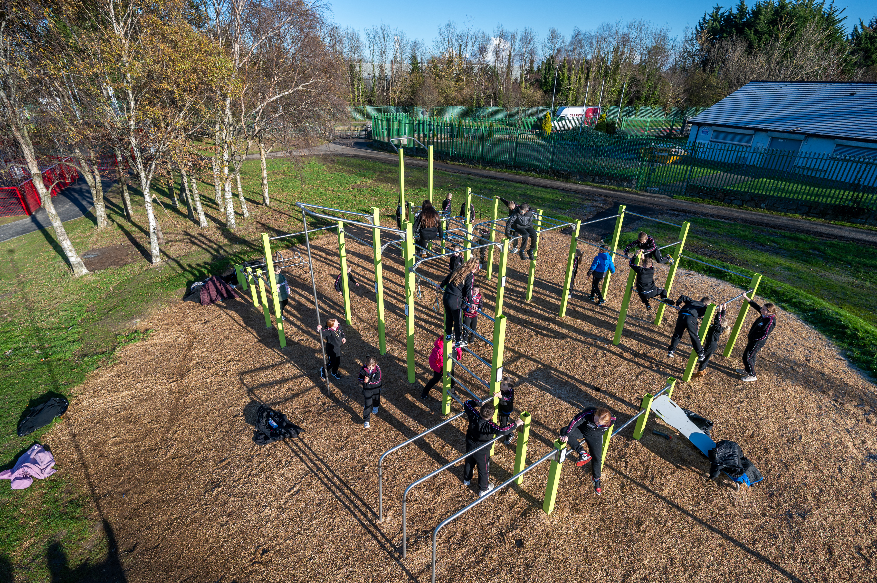
Fig 1: Killinarden Park Facilities

Killinarden Park Phase 2 (Tallaght South LEA)
This project completes the Part 8 plans for the regeneration of Killinarden Park and includes a Greenway link along the Whitestown Stream; from Killinarden Park to Whitestown Road, this project is currently in tender stage and will progress in Q4 2025 into 2026.

Jobstown Park (Tallaght South LEA)
The €2.5 million transformation of Jobstown Park includes focal entrances, a teen space, an outdoor callisthenics area, a pump track, a natural playground, a dog park, a footpath exercise loop, and a Cycle South Dublin link connecting to wider cycling infrastructure. Biodiversity enhancements included planting 300 mature trees. The response from the local community has been very positive with the park full of new visitors. Plans include upgrading two pitches and the existing MUGA, funded through a Sports Capital Grant, with works expected to occur in 2025.
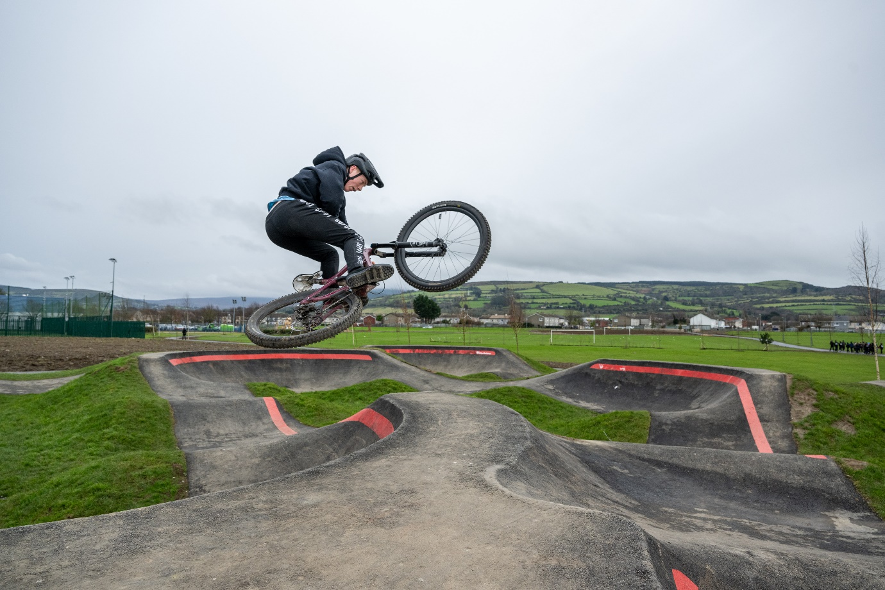
Fig 2: Jobstown Park Pump Track

Pitch / Track / Club Sport Upgrades
The upgrade of an existing sports pitch in Jobstown Park (Tallaght South LEA) is planned for 2025/2026 is and this work is currently at tender stage. This is funded by Sports Capital Grant funding and several other pitch and track upgrades are also being planned in this timeframe including:
- Bancroft Park athletics track upgrade (Tallaght Central LEA)
- Lucan athletics track upgrade (Lucan LEA)
- Upgrade of 3 pitches in Tymon Park (Rathfarnham Templeogue LEA)
A new bowling green is also planned for Sean Walsh Park (Tallaght Central LEA) and €400,000 is allocated for this project.

Whitestown Stream Park (Tallaght South LEA)
Whitestown Stream Park represents a €2.5 million investment in community spaces. Once an under-utilised green area, the 8-acre park has been thoughtfully redesigned to foster stronger connections between people and nature. The park upgrade is part of a broader initiative aimed at creating a network of interconnected green spaces that promote pedestrian and cycle access, encourage biodiversity, and enhance the overall quality of life for residents. The park now features improved entrances, new paving, bridges, signage, and a row of trees along the stream bank. Exercise areas, seating, cycle routes and kick-around areas have been added, with dedicated spaces to support local biodiversity. Completed in May 2024, this project has had a positive impact on the local community.
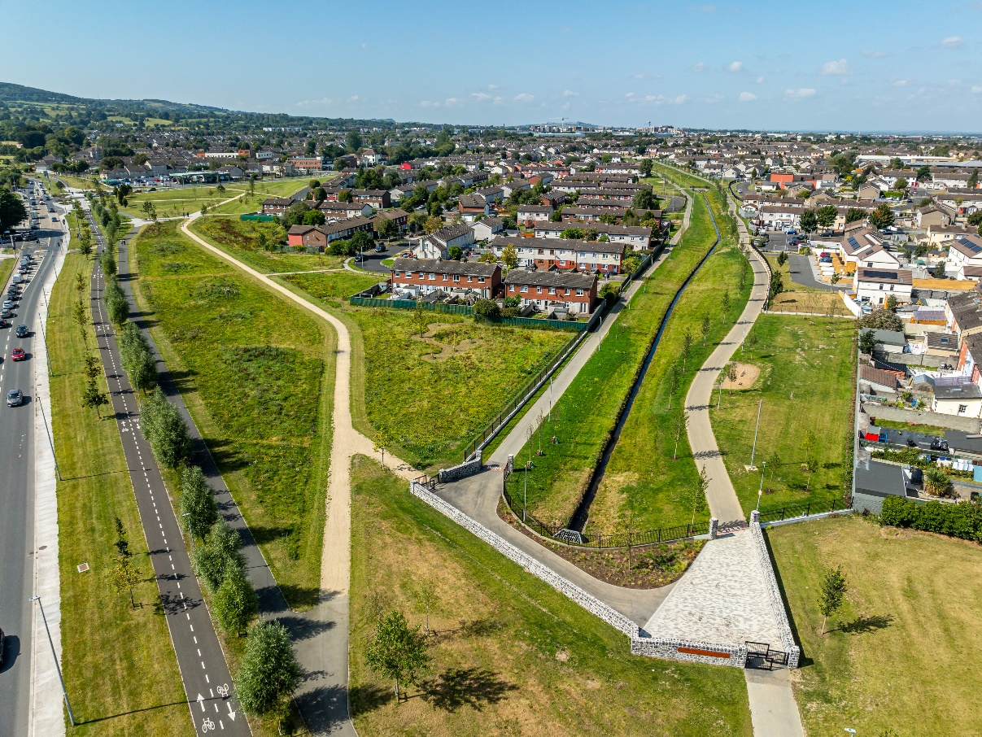
Fig 3: Whitestown Stream Park
Quarryvale Park (Palmerstown Fonthill LEA)
A €1.8m investment delivered the recently completed upgrade in early 2025 saw a complete renovation of this park with new illuminated pathways, a teenspace featuring a full Calisthenics Gym and Music Post as well as a playground and relocated, full size Soccer Pitch. New and improved entrances, exits and street furniture have helped to complete the space.
Further upgrades are planned later this year with the implementation of a dog park and a Sports Capital Grant funded basketball court.

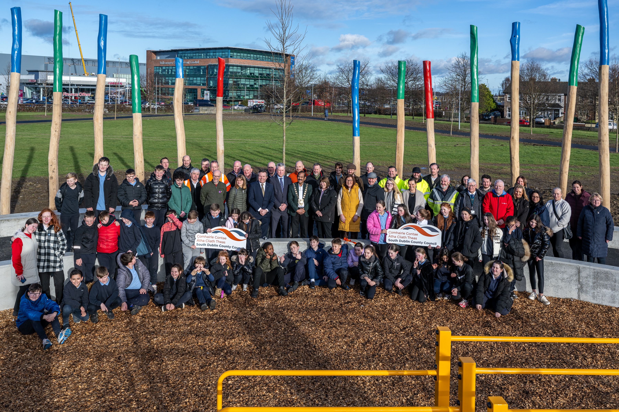
Fig 4: Quarryvale Park Opening

Butler Mc Gee Park Upgrade (Tallaght South LEA)
SDCC have made budgetary provision of €100,000 for the initial consultation and feasibility stage (leading to preliminary design) for the upgrade of Butler McGee. A tender process to procure landscape architect consultancy services for the proposed upgrade of Butler McGee Park has commenced. This process will be concluded in the coming weeks, and it is expected that the project will go to public consultation early in the new year.

Ely Arch Park (Rathfarnham Templeogue LEA)
An upgrade completed for this park in 2024 transformed the arch and removed railings and other visual clutter. The associated park has been turned into a multifunctional space, with a picnic area, boundary improvements, tree planting, and paved plaza and entry areas. Marking the junction of the Dodder Greenway as it passes from SDCC into Dublin City and Dun Laoghaire-Rathdown County Councils, Ely Arch & Park serves as a fantastic local amenity and is envisioned to become a focal tourism destination along the Dodder Greenway.
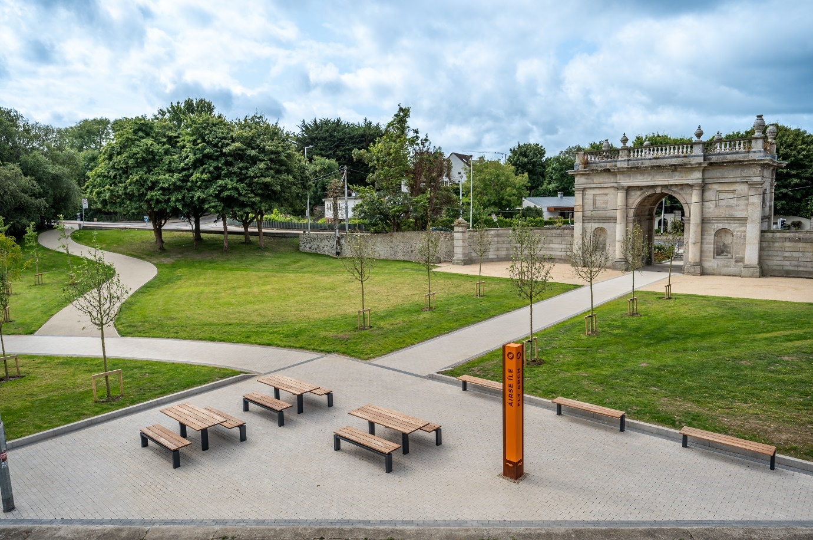
Fig 5: Ely Arch Park

St Cuthbert’s Park (Clondalkin LEA)
The upgrade of St. Cuthberts Park in accordance with the Part 8 proposals is currently underway with the construction of playgrounds, teenspace area, MUGA, upgrade of the grass pitch and implementation of lit walking and cycling routes. The investment at the construction stage is €1.9m and this phase of the upgrade will be complete by year end.
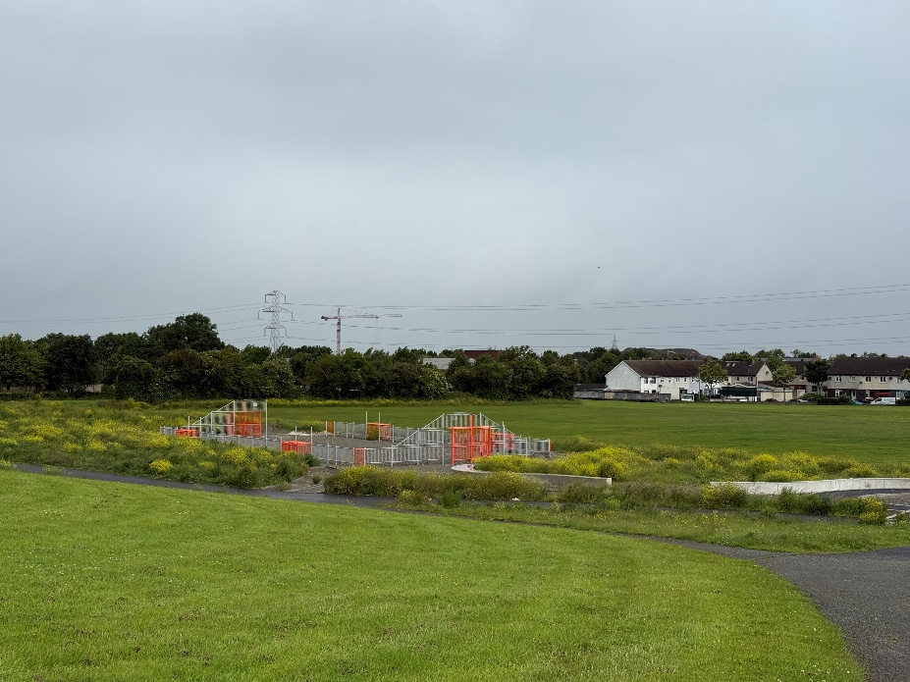
Fig 6: St. Cuthberts Park under construction

Kiltipper Park (Firhouse Bohernabreena LEA)
Kiltipper Park Phase 2 is currently under construction with the delivery of grass pitches, expanded car parking, seating, signage and other parks facilities to support visitors to this beautiful park at the edge of the Dublin Mountains, the current phase under construction sees an investment of €3.7m and it will be complete towards the year end.
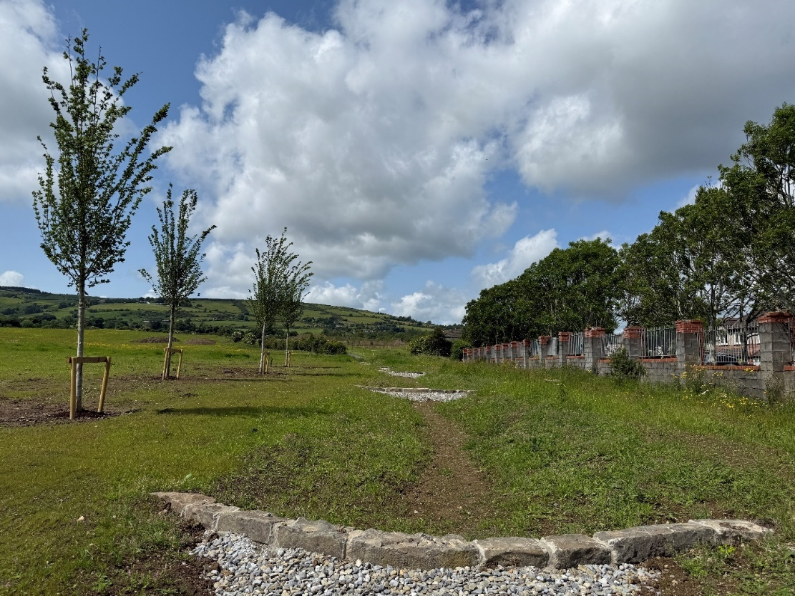
Fig 7: Natural Drainage System at Kiltipper Park to take run off from the mountains.
Intergenerational Centre (Rathfarnham Templeogue LEA)
The Intergenerational Centre at Tymon Park will support the integration of multi-generational uses and facilities into the park with flexible-use space, café, terrace and associated facilities by the lake in Tymon Park. Funded by SDCC in the sum of €2.7m it will open in 2025.
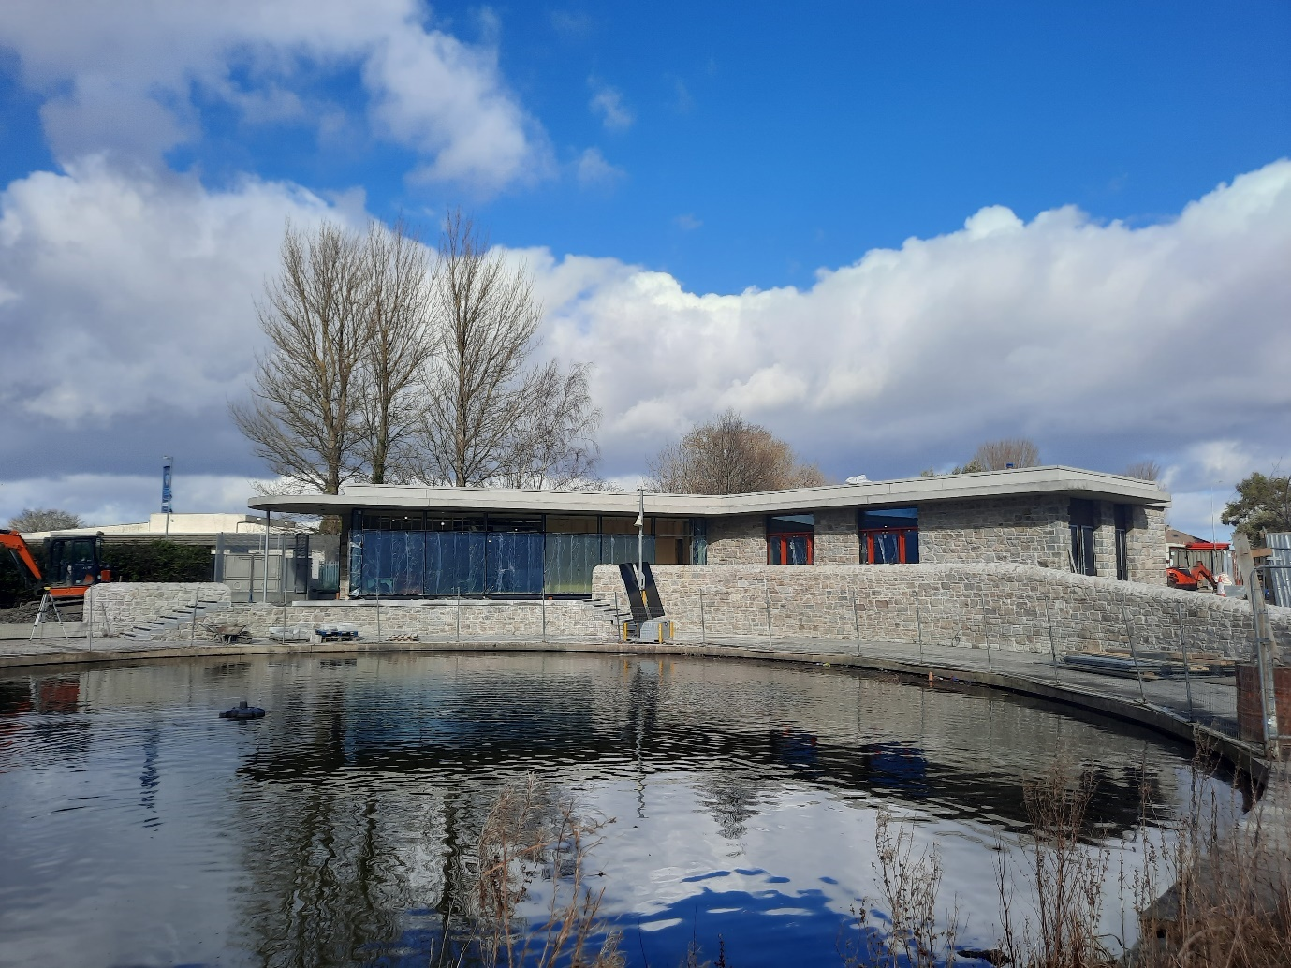
Fig 8: Tymon Park Intergenerational Centre under construction

Corkagh Park Masterplan upgrade delivery (Clondalkin LEA)
SDCC have allocated 5m in the current 3-year capital programme to complete the current upgrades underway at Corkagh park as set out in the masterplan, including upgrades to the car parks, fairy woodland, provision of a café and plaza area as well as play facilities and way finding and other information signage. The upgrade will complete in 2025.
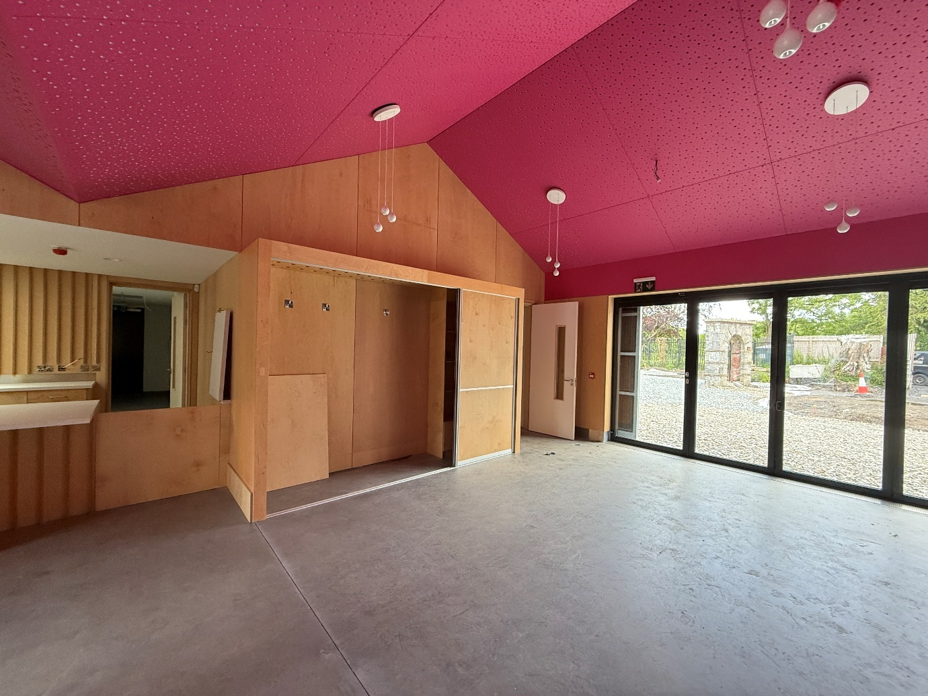
Fig 9: Corkagh Park café under construction.

3G pitch programme
The delivery of 5 3G pitches as set out in SDCC’s Sports Pitch Strategy is underway, with new pitches planned in the Clonburris SDZ (Lucan LEA, Clondalkin LEA and Palmerstown-Fonthill LEA) area as well as pitches in the east and west of the county (exact LEA locations TBC). SDCC have provided 6m in the current capital budget to fund this programme.
3G pitches have been delivered at Sean Walsh Park (Tallaght Central LEA) and Airlie Park (Lucan LEA)
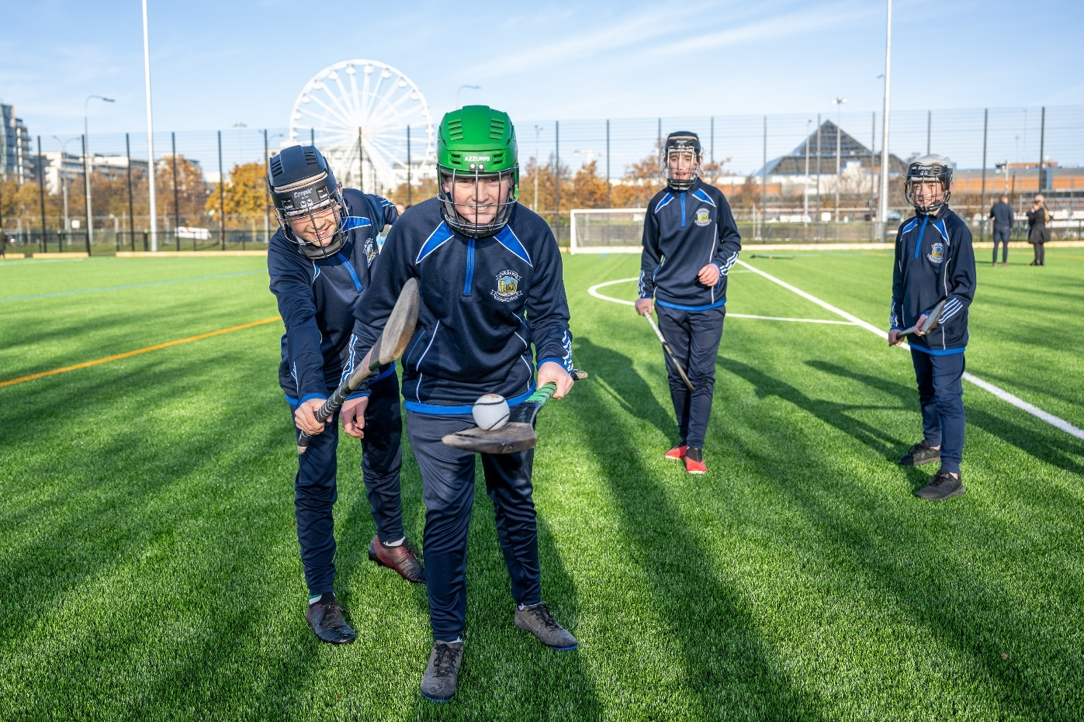
Fig 10: Sean Walsh Park 3G pitch

Pavillion Programme
The delivery of 10 planned pavilions across the county will upgrade the ancillary sports facilities being provided in our parks to ensure that individuals, groups and clubs have access to adequate changing facilities and some secure storage. €10m has been provided within SDCC’s capital budget with the tender for the manufacture and delivery of the modular units just completed and at standstill stage
The locations planned are as follows:
- Griffeen Valley Park (Lucan LEA)
- Corkagh Park ORR (Clondalkin LEA)
- Collinstown Park (Palmerstown Fonthill LEA)
- Kilnamanagh Open Space (Tallaght Central LEA)
- Dodder Valley Mt Carmel (Firhouse Bohernabreena LEA)
- Griffeen Valley / Arthur Griffith Park (Lucan LEA)
- Tymon Park South (Tallaght Central LEA)
- Sean Walsh Park Artificial Pitch (Tallaght Central LEA)
- Kiltipper Park (Firhouse Bohernabreena LEA)
- Willsbrook Park (Lucan LEA)

Clonburris Strategic Development Zone (Lucan LEA, Clondalkin LEA and Palmerstown-Fonthill LEA)
The Clonburris Strategic Development Zone is primarily a green field site, and its development and upgrade includes the delivery of parks and active recreational facilities. The Scheme delivery is well underway with planning applications imminent for the 3 large parks in 2025. These parks will deliver a variety of active recreational facilities including All Weather pitches, grass pitches, walking and cycling routes, playspaces, playgrounds as well as other ancillary facilities.

Dodder Greenway (Tallaght South, Tallaght Central, Firhouse- Bohernabreena, Rathfarnham-Templeogue LEAs)
This project has seen the completion of 8km of Greenway along the banks of the River Dodder, extending the network of accessible Greenways through the beautiful parklands of the county. This project is approaching completion with the final phases at or near construction stage. The overall investment in the Dodder Greenway across all 3 counties is estimated to be €20m (major phases also underway in other jurisdictions).

Grand Canal to Lucan Urban Greenway (Lucan LEA)
Greenways are also at various stages of delivery in other parts of the County including Griffeen Valley Park (Grand Canal to Lucan) (Lucan LEA)- Phase 1A (Grand Canal to N4) This Greenway is currently under construction with an expected completion date at the end of 2025. The construction value is €2.8m. The plans include shared walking and cycling routes and enhanced access points into the parks and upgrades to the park entrances and amenity, including planting, as part of the plans.

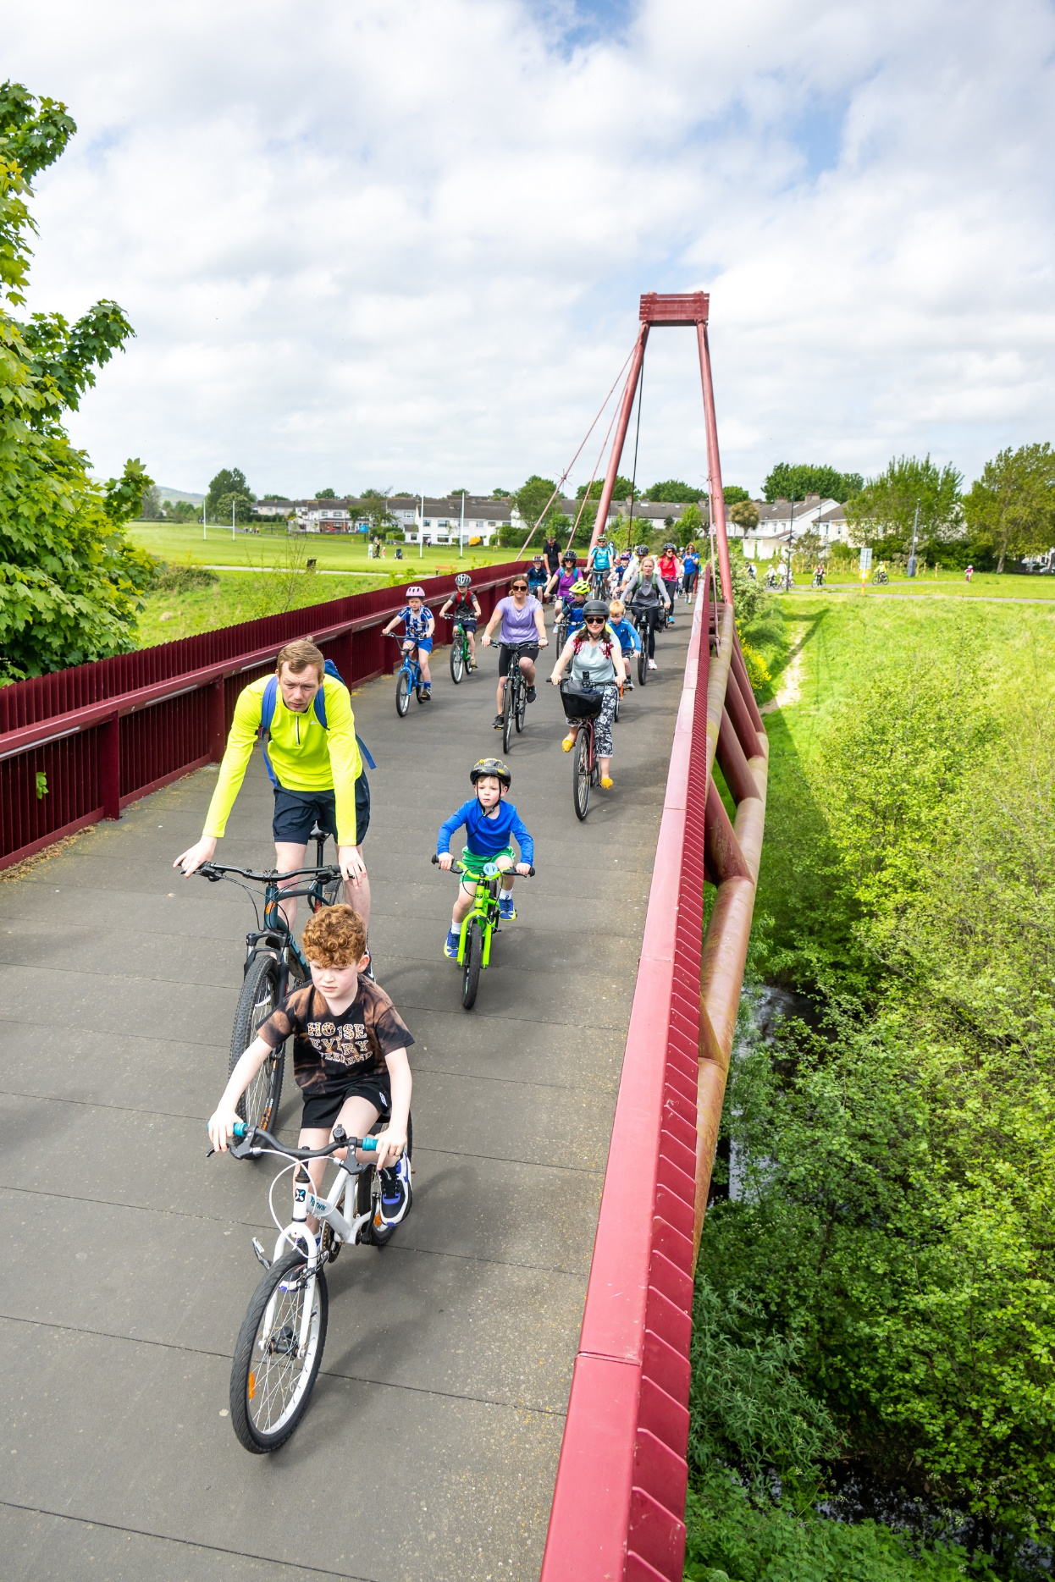
Fig 11: Dodder Greenway

Teenspaces
Teenspaces are currently being delivered across the county with €2.7m being invested across the county to deliver teenspaces. 7 have been completed to date and the following locations are at various stages of delivery at Carrigmore Park (Tallaght South LEA), St Cuthberts Park (Clondalkin LEA), Rathcoole Park (Clondalkin LEA), Clondalkin Park (Clondalkin LEA), Griffeen Park (Lucan LEA), Esker Park (Lucan LEA), Sean Walsh Park (Tallaght Central LEA), Dodder Valley Park (Tallaght Central LEA), Dodder Valley Park (Firhouse Boehernbreena LEA), Whitechurch (Firhouse Bohernabreena LEA)
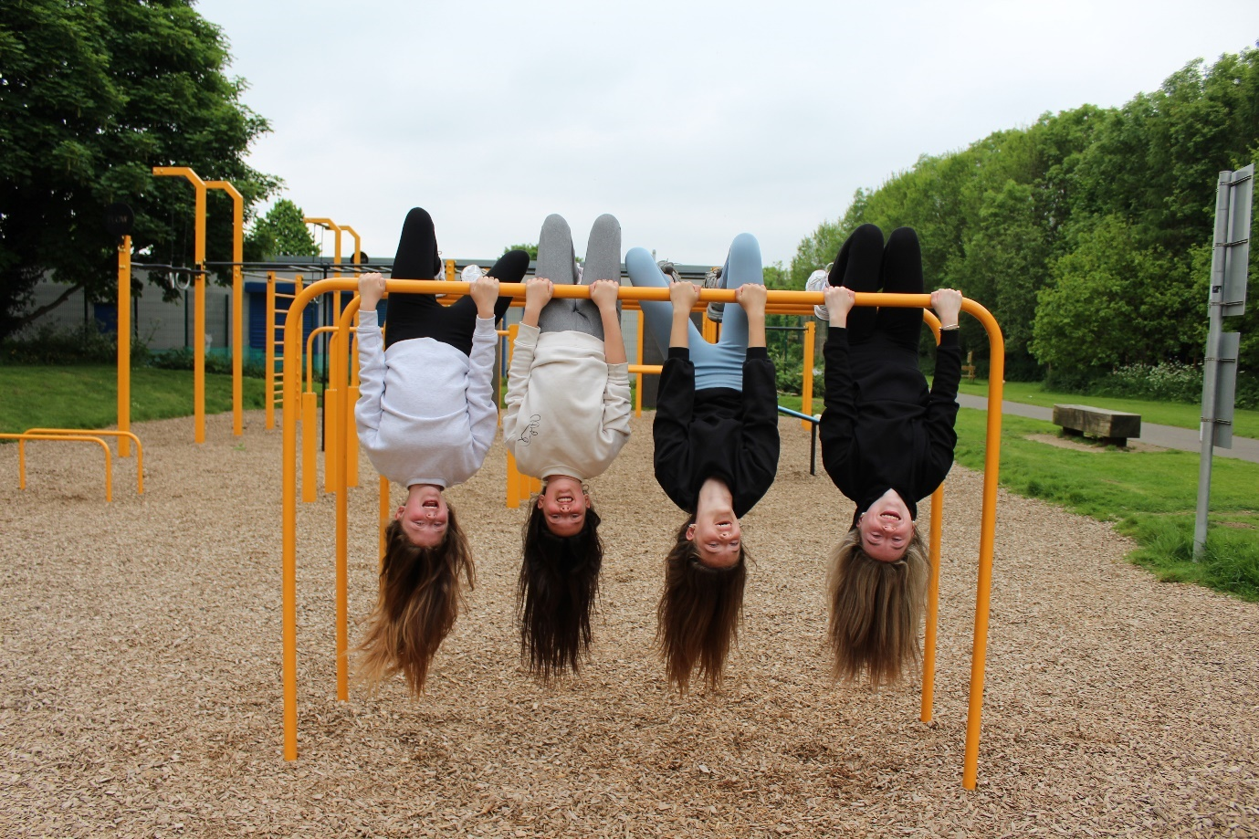
Fig 12: Teenspaces

Upgrading parks for biodiversity, access to nature and health and well-being
Providing, maintaining and ensuring access to nature is recognised as an important contributor to maintaining good health and wellbeing.
SDCC was awarded Green Flag Awards for five parks during 2024: Waterstown Park (Palmerstown Fonthill LEA), Sean Walsh Park (Tallaght Central LEA), Tymon Park (Tallaght Central and Rathfarnham Templeogue LEAs), Corkagh Park (Clondalkin LEA), and Rathfarnham Castle Park (Rathfarnham Templeogue LEA). These awards recognise maintenance of high standards in amenity provision, park management, environmental sustainability, and community engagement.
Tymon Park (Tallaght Central and Rathfarnham Templeogue LEAs) and Waterstown Park (Palmerstown Fonthill LEA) were highly commended in the 2024 All Ireland Pollinator Award recognising the enhancement of these parks in terms of natural landscapes.
As part of the Councils’ ambitious Climate Change Plan, the Council has invested in a SDCC’s Mini Woodland Programme across the county, to increase the county’s tree canopy cover, which has proven to be very popular with community groups and is actively combating climate change and enhancing biodiversity in our county.
SDCC continue to expand its meadowland programme with over 190ha of grassland being specially managed to provide enhanced support for biodiversity and provide food for bees, butterflies and other insects across the county. Tymon Park (Tallaght Central and Rathfarnham Templeogue LEAs) was one of just 9 nationwide sites listed as Ireland’s Grasslands Trail in 2024, chief highlights include native cowslips, and a variety of orchids found among colourful flowering meadows:
https://www.greatirishgrasslands.ie/the-grasslands-trail/

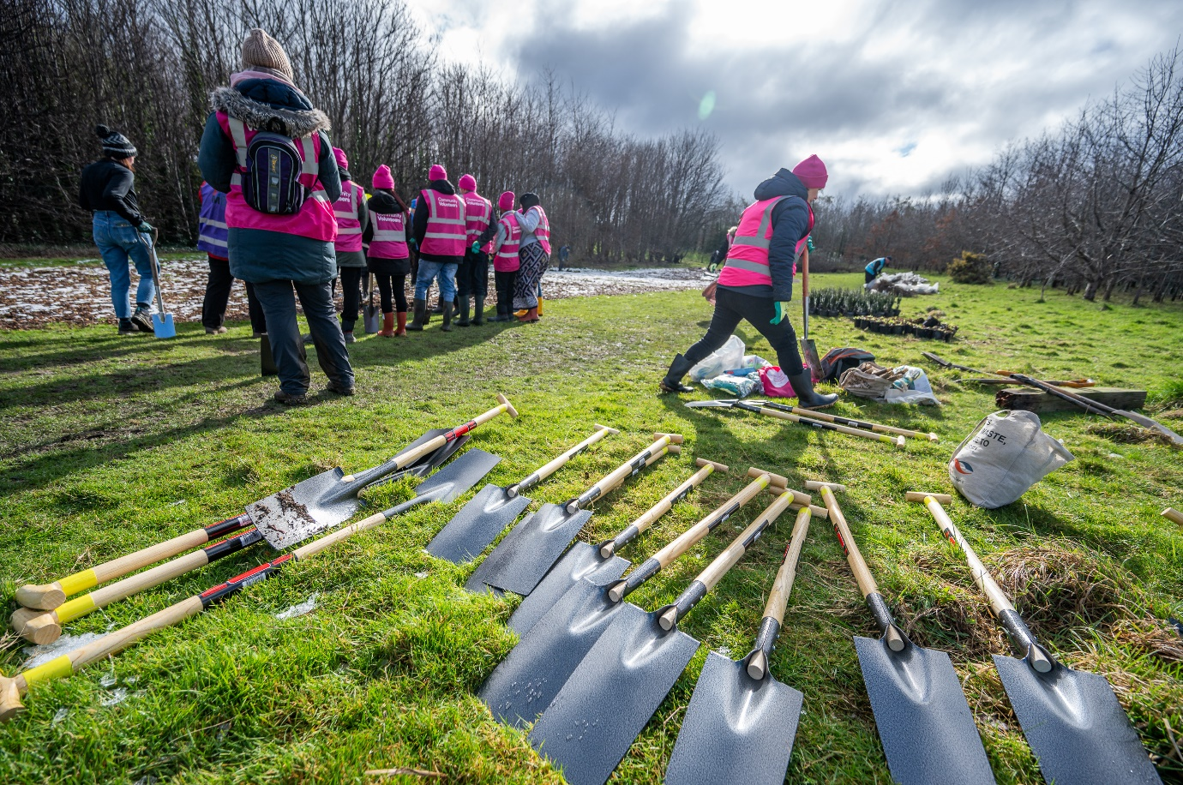
Fig 13: Mini Woodlands planting day

