**South Dublin County Local Community Development Committee**

**Annual Report 2024**



## **Content**

## Foreword by Local Community Development Committee Chairperson Tricia Nolan

## Members of the South County Dublin Local Community Development Committee

## Membership and Organisational structure of the South Dublin County Local Community Development Committee

## Report of Local Community Development Committee meetings in 2024

## Local Economic and Community Plan 2024-2030

## Report of Social Inclusion Community Activation Programme (SICAP)

## LEADER

## Local Community Development Committee Funding 2024

## Healthy Ireland

## Sláintecare Healthy Communities (SHC)

Appendices

Appendix 1

Membership of South Dublin County Local Community Development Committee and attendance for 2024

Appendix 2

Local Enhancement Fund 2024

Glossary

**1 | Foreword**

by Local Community Development Committee Chairperson Tricia Nolan

**2024: A Year of Progress and Partnership for the LCDC in South Dublin**

2024 was a dynamic and productive year for the Local Community Development Committee (LCDC) in South Dublin. We successfully approved the new Local Economic and Community Plan (LECP), managed the first year of the SICAP 2024-2028 programme, and administered vital grant schemes to support local communities.

**Delivering Funding and Strengthening Communities**

Our **2024 Annual Report** reflects our dedication to fostering local and community development amid evolving challenges and opportunities. As a key distributor of funding in South Dublin County, the LCDC upholds the highest standards of governance in all decision-making.

* The **LCDC Funding Subcommittee** directly managed the **Local** **Enhancement Programme**, prioritising disadvantaged areas and allocating dedicated funding for women’s groups.
* Where we couldn’t meet specific needs, we guided groups toward alternative funding streams.

**A New LECP for South Dublin’s Future**

After extensive consultation, we finalised the **2024-2030 Local Economic and Community Plan (LECP)** in November. This strategic roadmap will guide community and economic development across the county, and we look forward to driving its implementation in the years ahead.

**SICAP 2024-2028: A Strong Start**

The **SICAP Oversight Committee** monitored the rollout of the new Social Inclusion and Community Activation Programme, delivered by South Dublin County Partnership.

Our meetings were enriched by insightful presentations on key initiatives, including:

* **Sláintecare**
* **South Dublin County Partnership**
* **Children and Young People’s Services Committee (CYPSC)**
* **Health Assets and Needs Assessment (HANA) in Tallaght**

We extend our gratitude to all who shared their expertise, helping us better understand local needs and opportunities.

**Welcoming New Voices**

2024 brought fresh perspectives to the LCDC, including new **Public Participation Network (PPN) representatives**—**Seán Farrell, John Conroy, and Sharon Harty**. We also bid farewell to **Phil O’Neill (TU Dublin)**, whose leadership and vision left a lasting impact.

**Gratitude to Our Partners and Team**

We sincerely thank all **LCDC members, partner organisations, and volunteers** for their unwavering commitment to community development and inclusion. Special appreciation goes to:

* **Maria Nugent**, who transitioned from Acting Chief Officer but continues as LCDC Coordinator.
* **Edel Clancy**, our new Chief Officer—we look forward to working together in 2025.

Finally, we acknowledge the **dedicated staff of South Dublin County Council** for their invaluable support.

As we reflect on a year of achievement, we’re excited for the opportunities ahead. Here’s to an even busier and more impactful **2025!**

## **2** | **Members of the LCDC 2024**

|  |  |
| --- | --- |
| **Representative** | **Sector** |
| **Private** |  |
| Simon Monds | South Dublin County Partnership |
| Tricia Nolan | Chair, South Dublin Volunteer Centre |
| Seán Farrell | PPN Community Pillar |
| John Conroy | PPN Community Pillar |
| Vacant | PPN Environment Pillar |
| Noreen Byrne | PPN Social Inclusion Pillar |
| Sharon Harty | PPN Social Inclusion Pillar |
| Andy Leeson | Youth Services |
| Dr. Noel McCarthy | Community Representative, TCD |
| Vacant | Community Representative |
| **Public** |  |
| Cllr Alan Hayes | Elected Members, SDCC |
| Cllr Yvonne Collins |
| Cllr Sarah Barnes |
| Margaret McQuillan | Health Service Executive |
| Valerie Hogg | Dublin Dun Laoghaire Education &Training Board |
| Eugene Donnelly | Department of Social Welfare |
| Thomas Rooney | Local Enterprise Office |
| Elaine Leech | A/Director of Housing, Social and Community Development, SDCC |
| Maria Nugent | LCDC Chief Officer, SDCC |
| Edel Clancy | Senior Executive Officer, SDCC |

The following members left the LCDC in 2024. The Committee express sincere thanks to them for their valuable contributions during their membership:

* Cllr David McManus
* Cllr Kieron Mahon
* Larry O’Neill, South Dublin County Partnership
* Dr. Phil Mulvaney, Community Representative

## **3** | **Membership and Organisational Structure**

## **Membership and Organisational Structure of the South Dublin County LCDC**

The membership of the South County Dublin LCDC is drawn from community representatives, state agencies and local authority elected members. The membership of the LCDC and attendance at meetings is set out in Appendix 1.

#### Role and Function of South Dublin County LCDC

The role and functions of the South Dublin County LCDC in accordance with the functions detailed in the Act, have primary responsibility for co-ordination, planning and oversight of local development spend, whether that spend is delivered by local authorities or on behalf of the State or by other local development agencies and structures.

LCDC’s will bring a more coherent approach to the implementation of local and community development programmes and interventions, seeking to ensure an integrated approach to local community and local development services between providers and delivery structures; LCDC’s will drive meaningful citizen and community engagement in the scoping, planning, delivery and evaluation of local and community development programmes.

* LCDC’s will ensure a more efficient administration of local and community programmes and delivery structures, the appropriate matching of resources to priorities and the achievement of value-for-money in the delivery and governance of programmes and the management of local delivery arrangements.
* LCDC’s will develop approaches that focus on learning and feedback, enhancing the links between practice and policy development, and
* LCDC’s will explore and pursue opportunities for additional funding resources for the area, whether Exchequer, EU, private or other sources.

Section 128B of the Local Government Act 2001 (inserted by Section 36 of the 2014 Act) sets out the functions of LCDCs. These functions are –

* To prepare the community elements of a 6-year Local Economic and Community Plan.
* To implement or arrange for the implementation of the community elements of the Plan.
* To review the community elements of the Plan at least once within the period of 6 calendar years and if necessary, to amend the community elements of the Plan.
* To monitor and review on an on-going basis the implementation of the community elements of the Plan and, if appropriate, to revise the actions and strategies set.
* To achieve the objectives of the community elements of the Plan,
* To co-ordinate, manage and oversee the implementation of local and community development programmes that have been approved either by the relevant local authority or by agreement between the LCDC and a relevant public authority (e.g., Government Department, State agency)
* To seek to ensure effectiveness, consistency, co-ordination and avoidance of duplication between public funded local and community development programmes, in addition to public funded programmes, to pursue the co-ordination generally of all local and community development programmes within the functional area of the Committee,
* To consider and adopt a statement for consideration of the Council in respect of the economic elements of a draft of the Plan prepared by the local authority,
* To prepare an annual report on the performance of its functions.

## **4** | **Report of LCDC Meetings in 2024**

## **There were six meetings of the LCDC in 2024.**

#### LCDC Meetings:

* 14th February 2024
* 20th March 2024
* 17th April 2024
* 03rd July 2024
* 16th October 2024
* 11th December 2024

**Meetings in 2024 covered a range of issues including the following:**

* + Sláintecare
  + Healthy Ireland
  + Comhairle na nÓg
  + Climate Action
  + Local Economic & Community Plan (LECP)
  + Connect 4

#### SICAP

The following reports were presented to the LCDC in 2024:

* 2024 Annual Progress Report
* SICAP 2024 Mid-Year Review
* SICAP: Case Study – Connect 4 Pilot Project.
* 2024 SICAP Annual Plan
* Internal Audit Report: SICAP 2024

#### Funding

* + - Sláintecare Healthy Communities Programme Funding
    - Healthy Ireland Programme Funding
    - Local Enhancement Funding

## **5**| **Local Economic and Community Development Plan (LECP 2024 – 2030)**

**Local Economic & Community Plan (LECP)**

The Local Economic and Community Plan (LECP) is a statutory framework designed to support sustainable development at the county level in Ireland. Governed by the Local Government Reform Act 2014, the LECP is structured to operate over a six-year period and outlines the key objectives and actions necessary to promote both economic and community development within each local authority area. South Dublin County Council formally adopted its LECP in December 2024, marking a significant milestone in local governance. Implementation of the plan is set to commence in 2025.

At its core, the LECP aims to enhance the quality of life for individuals and communities by ensuring a cohesive approach to economic growth, social inclusion, environmental sustainability, and community wellbeing. This is achieved through a dual focus on economic development such as business supports, employment creation, and infrastructure investment and community development, which encompasses social services, education, health, and inclusive participation.

The importance of the LECP lies in its integrated and collaborative design. It brings together a wide range of stakeholders, including public agencies, community organisations, local businesses, and the general public. The creation and execution of the LECP are supported by key structures like the Local Community Development Committee (LCDC) and Strategic Policy Committees (SPCs), ensuring alignment with broader regional strategies, such as the Regional Spatial and Economic Strategy (RSES), and national plans like Project Ireland 2040 and the Climate Action Plan.

The LECP's emphasis on evidence-based planning, public consultation, and shared governance enhances its capacity to address local needs dynamically and responsively. By incorporating the Sustainable Development Goals (SDGs), climate action initiatives, and the Public Sector Equality and Human Rights Duty, the plan aligns local actions with national and global priorities.

South Dublin’s LECP will serve as both a guiding vision and a practical framework for action. The overarching Framework LECP sets out long-term High-Level Goals and sustainable objectives, while a dedicated Implementation Plan will detail the specific, measurable steps to be carried out over the life of the plan. Progress on these actions will be tracked using key performance indicators and monitoring mechanisms, ensuring transparency, accountability, and ongoing refinement.

In summary, the LECP represents a powerful mechanism for community empowerment and economic resilience. For South Dublin, its adoption marks the beginning of a new chapter focused on inclusive growth, environmental stewardship, and collaborative governance.

**6** | **Report of SICAP**

(Social Inclusion Community Activation Programme)

A key responsibility of the South County Dublin LCDC is oversight of the SICAP (Social Inclusion Community Activation Programme). The Social Inclusion Activation Programme (SICAP) aims to tackle poverty, social inclusion and long-term unemployment through local engagement and partnership between individuals, community organisations, public sector agencies and other stakeholders.

South Dublin County Council sought tenders on the 19th July 2023, on e-tenders for SICAP 2024 – 2028, and South Dublin County Partnership CLG were successfully awarded the contract to deliver the SICAP Programme in South Dublin County following this tender process.

South Dublin County Council, South Dublin County Local Community & Development Committee (LCDC) and South Dublin County Partnership CLG signed a funding agreement for the delivery of SICAP on the 15th December 2023.

The SICAP 2024 Annual Plan Budget is €2,695,166 and the New Arrivals 2024 Allocation (International Protection Applicants and Holders of Temporary Protection) is €553,774. The LCDC and South Dublin County Partnership CLG agreed on targets. As you will see, these targets were met and, in some instances, exceeded. This is credit to the dedicated staff and volunteers who work on the various programmes supported by SICAP funding:

|  |  |  |
| --- | --- | --- |
| **Meeting Annual Targets** | **Achieved** | **% Achieved** |
| **Achievement of KPI 1 Target - 90** | **97** | **108%** |
| **Achievement of KPI 2 Target – 1,483** | **1,515** | **102%** |
| **Supported Individuals in Local Priority Target Areas – 70%** |  | **93.92%** |

**Key Performance Indicators 2024/ South Dublin County**  

### 

**KPI 1 South Dublin County (Community Organisations (COs) 3-1) 2024**

**KPI 2: Individuals**

**Individuals participating in a course**

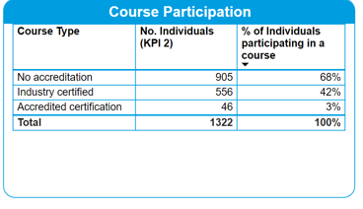

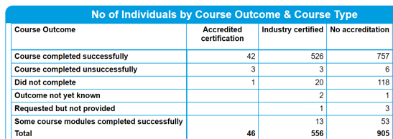

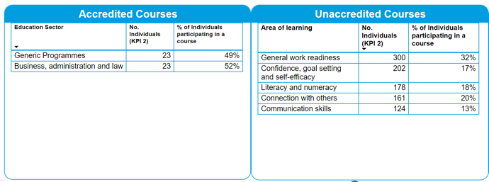

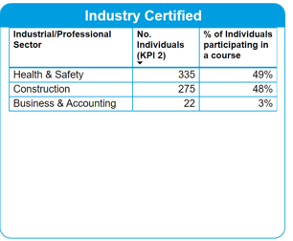

**Individuals progressed into Employment or Self-Employment 2024**

**Individuals Progressed into volunteer/work placements or referred to other services**

**Non-Caseload Events**

**Children & Family Activities**

### **SICAP Case Study for 2024**

### 

### **Sr. Kay Mulhall, founder and current volunteer at The Mountain Park Intercultural Centre**

The Mountain Park Intercultural Centre was established to support the needs of migrants, refugees, and international protection applicants. Initially founded by Sr. Kay Mulhall, a Brigidine sister, to provide English language support, it has since expanded to offer a wide range of services. The centre primarily focuses on newly arrived international protection applicants, beneficiaries of temporary protection, and refugees, it has been supported and managed by the South Dublin County Partnership (SDCP) for over a decade. Supports currently offered include:

* 16 drop-in English classes per week at different levels
* weekly support clinics for advice and advocacy, employment supports and CV support
* employment training delivered in different languages
* cooking sessions for families in direct provision
* women’s groups
* volunteering opportunities
* kickboxing training
* movie screenings
* annual celebration events e.g. Eid and Africa Day
* voter registration drives
* health days with screenings
* sewing classes

## **7** | **LEADER Programme**

## Home - Dublin Rural Leader

The LEADER programme is administered at a local level by [Local Action Groups (LAGs),](https://gov.ie/en/department-of-rural-and-community-development/publications/leader-local-action-groups-contact-details/) which contain local representatives from the community, public and private sector. Each group is responsible for selecting and awarding LEADER funding to projects within their geographical area in accordance with the local development strategies they develop themselves.

The LEADER programme accepts applications based on projects which improve:

**Theme 1 - Economic Development and Job Creation**

* The Green Economy
* Agricultural Diversification
* Rural Tourism & Recreation
* Enterprise Development
* Rural Food Production
* Social, Community & Cooperative Enterprises

**Theme 2 - Rural Infrastructure & Social Inclusion**

* Rural Infrastructure
* Accessible Services
* Optimising Digital Connectivity
* Rural Youth

**Theme 3 - Sustainable Development of the Rural Environment and Climate Change Mitigation and Adaptation**

* Sustainable Development of the Rural Environment
* Climate Change Capacity Building
* Climate Change Mitigation and Adaptation

**Eligibility for LEADER funding**

**Geographical area**

For the purposes of the LEADER programme in Ireland, rural areas are defined as all parts of Ireland with the exception of the areas within the boundaries of the five main cities of Dublin, Cork, Limerick, Waterford and Galway.

**Project eligibility**

In order for a project to be eligible for LEADER funding, it must be compatible with the actions outlined in the approved LDS in the geographical area concerned, and it must comply with the [EU Regulations and Operating Rules](https://gov.ie/en/department-of-rural-and-community-development/collections/leader-operating-rules-and-guidelines/) in place for the programme.

**Project promoter eligibility**

A project promoter is an individual, group or other body (e.g. company) that submits a funding application to the LAG and, where successful, is given a contract to deliver the approved project.

The project promoter must be able to demonstrate that they can provide matching contributions to meet the full costs of the project and ensure that they will be operational as funded for five years from the date of final LEADER grant payment.

Rural areas of South Dublin County include (the electoral districts (EDs)) of Newcastle, Rathcoole, Saggart, Ballinascorney and Bohernabreena. The Dublin Rural Local Action Group (LAG) includes members from South Dublin County Council, Fingal County Council and Dún Laoghaire-Rathdown County Council.

###### South Dublin County LCDC members of the LAG in 2024:

* Elaine Leech, SDCC
* Andy Leeson, Foróige
* Cllr Sarah Barnes

###### Vacant

###### Vacant

LAG Evaluation Committee: This committee evaluates recommendations for funding from the Programme implementer and then makes recommendations to the LAG. Membership is drawn from the three counties.

## **8** | **LCDC Funding 2024**

###### Social Inclusion Community Activity Programme (SICAP)

South Dublin County received an allocation of €2,695,166 in relation to SICAP in 2024 and €553,774 funding towards New Arrivals. SICAP Reporting is a standing agenda item at each LCDC meeting and comprehensive reporting is delivered by South Dublin County Partnership.

###### Local Enhancement Programme 2024

The Local Enhancement Programme (LEP) 2024 including ring-fenced funding for Women’s Groups.

This funding is for the Local Enhancement Programme 2024, launched by the Department on 6th December 2023.

South Dublin County LCDC were allocated:

**€254,979.91** capital funding for the Local Enhancement Programme to use towards carrying out necessary repairs and improvements to facilities, energy efficiency type projects, purchase of equipment etc.

**€50,995.98** capital funding ring-fenced for Women’s Groups.

47 Grant applications were received in total including the 8 women’s group applicants for the ring-fenced funding.

The Funding Subcommittee convened on 19th March 2024 to assess the applications received and presented a preliminary funding report to the LCDC on 20th March, outlining their recommendations. Clarifications were sought on several applications during the review. The Subcommittee met again on 26th March to finalise its recommendations for submission to the LCDC, in line with the Department’s deadline of 28th March 2024.

Successful applicants were notified after the press release from the Department of Rural and Community Development.

A full list of grants awarded are listed in Appendix 2.

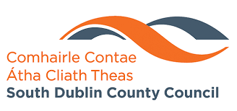 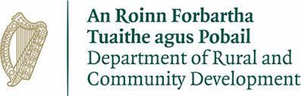

## **9** | **Healthy Ireland**

**Introduction**

Healthy Ireland, the national framework for improved health and wellbeing, partners with South Dublin County Council to deliver on its vision of a healthier Ireland where everyone can enjoy physical and mental health to their full potential. This collaboration reflects a shared commitment to tackling the root causes of ill-health, reducing health inequalities, and promoting environments that support healthier lifestyles across communities.

**Key Messages**

South Dublin County Council plays a key role in advancing the goals of Healthy Ireland at a local level, using its connection to communities and its leadership in local development to implement targeted health and wellbeing initiatives. Through integrated actions across areas such as physical activity, mental health, healthy eating, and social connectedness, this partnership ensures that national policy translates into meaningful local impact.

Healthy South Dublin has two outcome indicators to which funding is allocated:

* Decrease in the unconditional probability of dying (aged 30-70) from cardiovascular diseases, cancer, diabetes or chronic respiratory disease.
* Increase in the percentage of people aged 50+ who feel safe to walk alone after dark in their locality.

Together, Healthy South Dublin and South Dublin County Council are working to create a supportive, inclusive, and health-enabling environment for all residents—empowering people to lead healthier lives and fostering stronger, more resilient communities.

# **Project Updates**

**COPD Support Group**

Healthy Ireland in partnership with the HSE, COPD Ireland, Clondalkin Primary Care Centre and Rowlagh Health Project launched and established a new COPD Support Group in Rowlagh Community Centre. The purpose of the group is to support and provide information to those who are living with COPD or who have a family member who is living with COPD. An exercise programme is delivered by a trained professional at each session, who can tailor the exercises to needs and ability of the group. The pulmonary physiotherapist within Clondalkin Primary Care Centre and any local GP’s can refer patients who have been diagnosed with COPD to the group.

**Health Literacy Pilot Programme**

The aim of the health literacy pilot programme is to address health literacy among people living with long term chronic conditions which will aid understanding prescription instructions, understanding doctor and clinician’s directions including consent forms, and an overall ability to navigate the complex healthcare system. Through providing information and increasing understanding, medical adherence increases and thus reduces hospitalisation.

This six-week pilot programme was delivered in Fettercairn, Rowlagh and Kingswood Community Centre and was designed in partnership with the HSE Self-management Support Coordinator, the Patient and Service User Engagement Officer, DDLETB and South Dublin County Partnership. Guest speakers included local pharmacists and Healthy Homes Officers.

**Community Health and Wellbeing Programme**

Healthy Ireland and South Dublin County Council’s Community Development Team organised a Health and Wellbeing programme in partnership with 15 community centres across the county.

An array of activities took place each week including Tai Chi, Zumba, mindfulness, exercise classes, gardening, arts and crafts and more.

The initiative targeted groups within the community centres such as men’s and women’s sheds, golden circles, and active retired groups. The programme culminated in a tea dance event held in Kilnamanagh Family Recreation Centre, where all the groups came together, providing a fun and inclusive way to celebrate and strengthen the connections built throughout the sessions.

**Intergenerational Programme with Citywise Education**

Healthy Ireland worked with Citywise Education to create an intergenerational programme targeting their young people and older adults based in the Jobstown area. The idea behind the project was to challenge each group’s perceived perceptions and attitudes towards each other. To do this, Citywise Education brought in an author and storywriter from ‘Fighting Words’ to facilitate numerous writing sessions. The group wrote a novel, which was launched in County Library, Tallaght.

**HerSpace Workshops**

Several six-week workshops focusing on women’s physical, mental, and emotional well-being were delivered across the County. HerSpace’s holistic approach combines self-defence training, mindset empowerment, and soothing yin yoga/reiki practice, all tailored to provide a safe space for Her Mind, a safe space for Her Body, and a safe space for Her Energy.

These workshops were delivered in Knockmitten, Firhouse, Saggart and Brookfield Community Centre with a total of 148 women participating in the programme.

**Say Hello Video**

Healthy South Dublin in partnership with Tallaght Drug and Alcohol Task Force and Connect4 created a video to challenge people’s perceptions of young and old. The video was created in a well-known anti-social space in the community and the aim was to turn the perception of this into a pro social space. The 2-minute video was played before every movie screening in Movies @ The Square, for 4 full weeks in December and before Shamrock Rovers football games in Tallaght Stadium. The total admissions for that period to the cinema was 32,783 and the video has been viewed over a total of 35,000 times across South Dublin County Council, South Dublin County Partnership and Tallaght Drug and Alcohol Task Forces’ social media platforms.

**Generation Connection MacUilliam**

Healthy Ireland and Sláintecare Healthy Communities Tallaght applied for the Community Safety Innovation Fund 2023 to support the Generations Connection MacUilliam project. The application was successful and a total of €98,460 was awarded to the project in 2024.

€50,000 was transferred to Public Lighting for the installation of the streetlights around the green in MacUilliam. €36,000 was provided under this fund to Tallaght Community Arts for their Creative Places ‘Lighting up our Streets’ element of the project.

Tallaght Community Arts / Creative Places MacUilliam co-created with artist Tom Meskill & Sofft Productions to “Turn the street into a place of beauty using several different art forms and participatory arts projects with the residents of MacUilliam in celebration of their diversity, their community and the installation of lighting which will enable them to safely enjoy their space”. A large range of workshops with residents and young people took place to prepare for the festival including latern making, upcycling workshops, graffiti classes, headwrapping, vogueing, noise music and patchwork workshops.

€12,460 was allocated to Health and Wellbeing initiatives in MacUilliam delivered through a partner organisations such as Foroige, Barnardo’s and Connect4.

The Lighting Up Our Streets Festival successfully took place from the 27th – 29th September 2024 in MacUilliam.

**Junior Safety Forum**

The Interagency Team within SDCC and Healthy Ireland piloted a Junior Safety Forum Programme throughout 2024. Eight schools from across the electoral areas were invited to take part and attend workshops in County Hall. The first Junior Safety Forum took place in May 2024 in the Council Chamber.

The young people highlighted several important topics and issues relevant to them in their community to Senior Management in SDCC including dumping, scramblers, drug dealing, damaged play equipment and the need for playgrounds in certain areas. Among these, concerns about fast gas and vaping were mentioned multiple times.

In response, Active South Dublin agreed to provide portable goals to Divine Mercy Balgaddy and the link to the Jobstown Park upgrades was forwarded to the school in Jobstown who requested information on the possibility of the reinstallation of a playground in the area. There were numerous guest speakers invited to attend and speak to the students throughout the workshops including Tallaght and Clondalkin Drug and Alcohol Task Forces, An Garda Siochana and Dublin Fire Brigade.

The interagency team asked that each Junior Safety Forum focused on designing a one-page poster in September. The posters were to highlight the dangers and impacts of fast gas and vaping. At the next workshop, the students presented their posters to their peers while an artist facilitated. Artwork from each school was used to create one Junior Safety Forum poster to be launched and circulated in 2025.

**Junior Safety Forum in the Council Chamber**

**Junior Safety Forum Halloween Workshop with An Garda Síochána**

**and Dublin Fire Brigade**

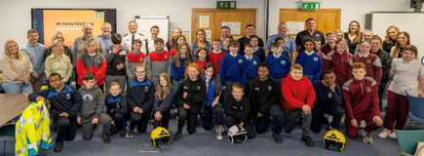

## **10** | **Sláintecare Healthy Communities (SHC)**

**Introduction**

Sláintecare Healthy Communities (SHC) promotes and sustains long-term health and wellbeing in communities facing higher health risks. Health inequalities are deeply connected to broader social determinants such as the environment, housing, food access, education, and employment. These factors are shaped by economic, social, and political systems, significantly influencing health outcomes.

In South Dublin County Council, the SHC Programme works collaboratively with the Local Community Development Committee (LCDC), the HSE, and local community groups. Together, we deliver targeted health and well-being services designed to bring about real, measurable improvements. The programme is led nationally by Healthy Ireland within the Department of Health.

**Key Messages**

* Strong partnerships across government, public services, and local interagency teams to support community wellbeing.
* A targeted approach to addressing health inequalities.  
  Tackling both the social determinants of health and lifestyle behaviors.
* Enhancement of community environments through the Sláintecare Healthy Communities Enhancement Fund (e.g., green spaces, community facilities, walking and cycling tracks).
* Delivery of HSE Health and Wellbeing programmes locally, including Healthy Food Made Easy, Social Prescribing, We Can Quit, Community Food and Nutrition Worker, and Making Every Contact Count.
* South Dublin County Council Local Development Officers working to deliver Healthy Ireland initiatives in areas of greatest need.

**Project Updates**

**St Aengus Community Centre: Changing Place and Sensory Garden**

St Aengus Community Centre received funding from the SHC Enhancement Fund and Tallaght Seed Funding to create a Changing Place facility and a Sensory Garden. The Changing Place offers greater accessibility than standard toilets, providing safe, accessible, and fully-equipped, up to standard, facilities for community centre users such as Cheeverstown House service users.

The Sensory Garden is designed to engage and stimulate the five senses, offering an inclusive, sensory rich environment. Both spaces are available to multiple groups, and will be officially opened in 2025.

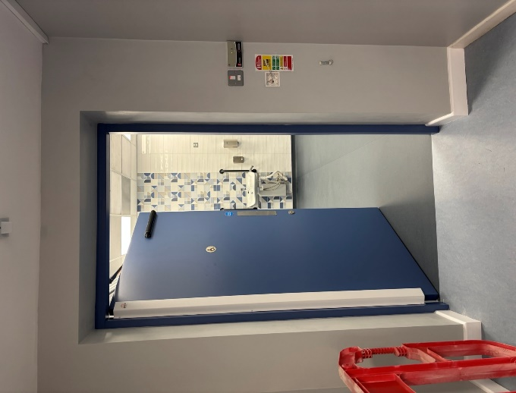 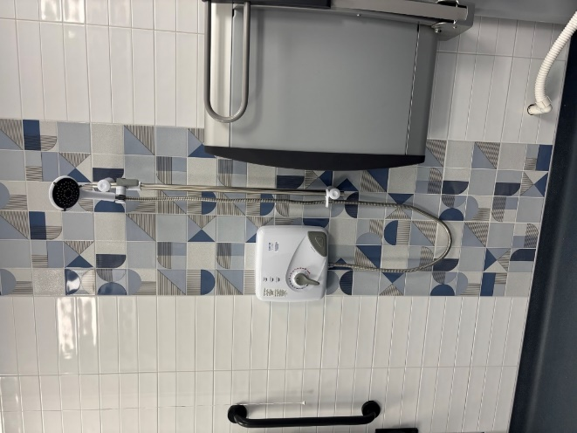

**Energy Use in the Home Programme**

The Energy Use in the Home Programme pilot has completed 42 household visits across Clondalkin and Tallaght. This was the info flyer for participant recruitment:

This bespoke project examined the link between energy poverty and health. Energy poverty, defined as the difficulty in adequately heating homes and managing energy bills, significantly impacts health outcomes. Households facing energy poverty often experience worsening chronic health conditions, creating a negative feedback loop between health and energy costs.

A report by energy auditors outlines the following key findings of this pilot programme:

1. **Damp**

* Noted in 55% of households.
* Caused by leaks, walls, and around windows, as well as from showers and plumbing in need of repair.
* Insufficient insulation.
* Poor ventilation.
* Resulting in Severe damage to fabrics i.e.: paint chipping, plaster crumbling off walls.

1. **Mould and Indoor Air Quality Issues**

* Noted in 24% of the households.
* Residents experiencing poor and worsening health conditions as a result.
* Some rooms in home unlivable due to black mould.
* Residents seal off these rooms to prevent use, and to keep themselves and their families safe.

1. **Aging Boilers and Heating Systems**

* 76% of households rely on outdated, inefficient boilers and heating systems.
* 10-15% are so old, parts and labour can no longer be sourced.
* This creates a severe safety risk for those living in the home.
* These low efficiency systems require higher energy costs to run.
* Some households avoid turning on heating to avoid additional costs.

1. **Home Fabric Updates Needed**

* 82% of households have insufficient fabrics.
* Resulting in High air leakage, felt as cold draughts and spending more on energy bills to stay warm.
* Many households require upgrades to attic insulation, wall insulation, and repairing or upgrading windows.
* However, households are unable to upgrade fabrics due to high costs of works, and/or renting or occupying a council house.

**Jobstown Park Playground**

Jobstown Park was officially upgraded and opened in 2024, featuring a new natural playground funded by SHC seed funding. The new facility aims to provide safe and engaging play spaces for local children, enhancing community spirit and encouraging outdoor activity.

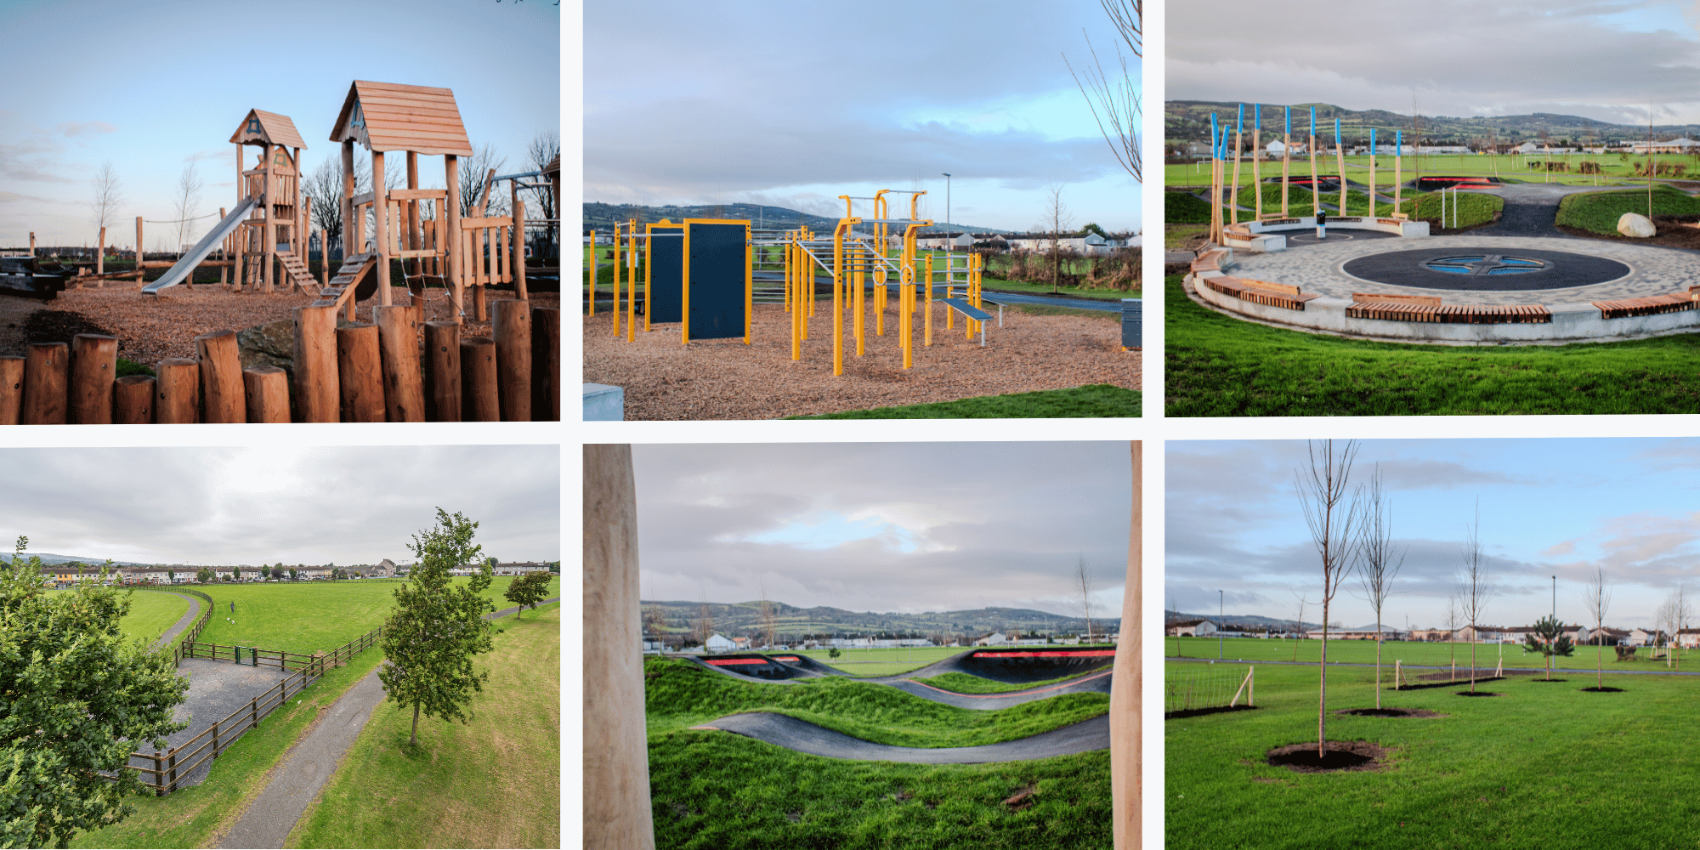

**A new natural playground at Jobstown Park funded by SHC seed funding opened in 2024.**

**Additional Projects**

* Neurodiverse South Dublin initiative at Tallaght Library.
* Joint Women's Group initiative with Tallaght Travellers CDP and South Dublin County Partnership, promoting diversity and shared belonging among Travellers and Black & Irish communities.
* Gambling Harm Prevention Project with Ronanstown Youth Service.
* Grow It Yourself (GIY) primary school gardens initiative in Clondalkin.
* Health Fairs hosted at North Clondalkin Library and Tallaght Library.
* Participation in National Workplace Wellbeing Day.
* Distribution of Period Dignity products.

**Conclusion**

The Sláintecare Healthy Communities Programme continues to deliver measurable improvements in health and wellbeing across South Dublin County. Through strategic partnerships, targeted interventions, and community engagement, the programme addresses the root causes of health inequalities and supports healthier, more inclusive communities.

## **Appendices**

#### Appendix 1

**South Dublin County LCDC membership and attendance 2024**

|  |  |  |  |  |  |  |  |
| --- | --- | --- | --- | --- | --- | --- | --- |
| **Representative** | **Sector** | **Feb**  **2024** | **March 2024** | **April 2024** | **July 2024** | **Oct**  **2024** | **Dec 2024** |
| **Private** | | | | | | | |
| Simon Monds | SDC Partnership | - | - | - | P | P | P |
| Larry O’Neill | SDC Partnership | P | P | P | - | - | - |
| Tricia Nolan | Chair, South Dublin Volunteer Centre | P | P | P | P | P | P |
| Enda Creegan | PPN Community Pillar | A | A | A | - | - | - |
| Vacant | PPN Community Pillar | - | - | - | - | - | - |
| Vacant | PPN Community Pillar | - | - | - | - | - | - |
| Vacant | PPN Environment Pillar | - | - | - | - | - | - |
| Noreen Byrne | PPN Social Inclusion Pillar | P | P | P | P | A | P |
| Andy Leeson | Youth Services | P | P | A | P | P | P |
| Dr. Noel McCarthy | Community Representative | P | A | P | P | P | P |
| Dr. Phil Mulvaney | Community Representative | P | P | P | P | A | A |
| Vacant | Community Representative | - | - | - | - | - | - |
| **Public** | | | | | | | |
| Cllr Kieran Mahon | Elected Member | A | A | A | - | - | - |
| Cllr David McManus | Elected Member | P | P | A | - | - | - |
| Cllr Alan Hayes | Elected Member | P | P | A | A | P | P |
| Cllr Yvonne Collins | Elected Member | - | - | - | A | P | P |
| Cllr Sarah Barnes | Elected Member | - | - | - | - | A | P |
| Margaret McQuillan | Health Service Executive | P | P | P | P | P | P |
| Valerie Hogg | Adult Education, Dublin & Dun Laoghaire Education Training | P | P | P | P | P | P |
| Eugene Donnelly | Department of Social Protection | P | P | A | A | A | A |
| Thomas Rooney | Local Enterprise Office | A | A | A | P | A | A |
| Elaine Leech | A/Director of Community Services | P | P | A | P | P | P |
| In Attendance | | | | | | | |
| Maria Nugent | Chief Officer | P | P | P | P | P | A |
| Edel Clancy | A/Senior Executive Officer | A | P | A | P | P | P |

**P- Present A- Apologies given C- Absent conflict of interest.**

## **Appendices**

#### Appendix 2

###### 2024 LCDC Funding Allocations:

**Local Enhancement Fund 2024**

|  |  |  |  |
| --- | --- | --- | --- |
| **LCDC** | **Organisation Name** | **Amount Approved** | **Electoral Area of Organisation** |
| South Dublin | Spina Bifida Hydrocephalus Ireland (SBHI) | €1,000.00 | Clondalkin |
| South Dublin | Coeliac Society of Ireland | €3,725.60 | Clondalkin |
| South Dublin | Little Stars Arch Club | €1,750.00 | Clondalkin |
| South Dublin | Clondalkin Camera Club | €1,178.99 | Clondalkin |
| South Dublin | Women's Collective Ireland (WCI) - Clondalkin Women's Network | €4,560.84 | Clondalkin |
| South Dublin | Ronanstown Community childcare Centre | €4,691.00 | Clondalkin |
| South Dublin | Bawnogue Youth and Community Centre | €7,500.00 | Clondalkin |
| South Dublin | Clondalkin Youth Band | €24,607.00 | Clondalkin |
| South Dublin | ACE Enterprise Park | €9,107.00 | Clondalkin |
| South Dublin | Rathcoole Community Council Ltd. | €5,000.00 | Clondalkin |
| South Dublin | 73rd Dublin Scouts, Rathcoole | €9,000.00 | Clondalkin |
| South Dublin | Muintir Chrónáin, Áras Chrónáin Ionad Cultúir | €15,983.00 | Clondalkin |
| South Dublin | Acquired Brain Injury Ireland | €8,370.93 | County-Wide |
| South Dublin | Firhouse Community & Leisure Club Ltd | €987.91 | Firhouse/Bohernabreena |
| South Dublin | Firhouse Sister Shed | €199.00 | Firhouse/Bohernabreena |
| South Dublin | Rutland Centre DAC | €2,500.00 | Firhouse/Bohernabreena |
| South Dublin | Quarryvale Community and Leisure Centre | €10,292.24 | Fonthill/Palmerstown |
| South Dublin | North Clondalkin Community Choir | €5,650.00 | Fonthill/Palmerstown |
| South Dublin | St. Patrick's GAA Club | €1,000.00 | Fonthill/Palmerstown |
| South Dublin | Ronanstown Women's Community Development Project | €11,917.50 | Fonthill/Palmerstown |
| South Dublin | North Clondalkin Community Safety Programme | €16,287.25 | Fonthill/Palmerstown |
| South Dublin | Women's Collective Ireland Liffey Valley | €5,000.00 | Fonthill/Palmerstown |
| South Dublin | Neilstown Community Centre | €2,000.00 | Fonthill/Palmerstown |
| South Dublin | Clondalkin Centre for the Unemployed CLG T/a CEEDS | €10,000.00 | Fonthill/Palmerstown |
| South Dublin | Quarryvale Family Resource Centre | €6,080.62 | Fonthill/Palmerstown |
| South Dublin | Stewarts Care Ltd. | €16,813.40 | Fonthill/Palmerstown |
| South Dublin | Lucan United Football Club | €2,000.00 | Lucan |
| South Dublin | Lucan Harrier & Athletic Club | €1,000.00 | Lucan |
| South Dublin | Walkinstown Greenhills Resource Centre | €980.00 | Rathfarnham/Templeogue |
| South Dublin | Greenhills Community Centre | €4,000.00 | Rathfarnham/Templeogue |
| South Dublin | Order of Malta Tallaght Unit | €4,316.25 | Tallaght Central |
| South Dublin | Tallaght Athletic Club | €2,559.97 | Tallaght Central |
| South Dublin | Childhood Development Initiative (CDI) | €1,000.00 | Tallaght Central |
| South Dublin | Kingswood Community and Leisure Centre | €3,185.00 | Tallaght Central |
| South Dublin | St. Marks Youth Club | €8,452.76 | Tallaght Central |
| South Dublin | Anam Cara Parental & Sibling Bereavement Support | €3,725.00 | Tallaght Central |
| South Dublin | Foroige Tallaght Youth Services | €12,500.00 | Tallaght Central |
| South Dublin | South Dublin Taekwondo | €6,000.00 | Tallaght South |
| South Dublin | Sister Sheds | €4,763.63 | Tallaght South |
| South Dublin | Headstart Preschool | €4,437.99 | Tallaght South |
| South Dublin | Killinarden sister shed | €4,493.93 | Tallaght South |
| South Dublin | Women Together Tallaght Network | €2,297.52 | Tallaght South |
| South Dublin | Killinarden Family Resource Centre | €5,886.00 | Tallaght South |
| South Dublin | SAOIRSE Domestic Violence Services | €17,763.56 | Tallaght South |
| South Dublin | New Hope Residential Centre | €5,000.00 | Tallaght South |
| South Dublin | West Dublin YMCA | €4,900.00 | Tallaght South |
| South Dublin | Women's Collective Ireland (WCI) - Clondalkin Women's Network | €4,560.84 | Clondalkin |
| South Dublin | Firhouse Sister Shed | €199.00 | Firhouse/Bohernabreena |
| South Dublin | Ronanstown Women's Community Development Project | €11,917.50 | Fonthill/Palmerstown |
| South Dublin | Women's Collective Ireland Liffey Valley | €5,000.00 | Fonthill/Palmerstown |
| South Dublin | Sister Sheds | €4,763.63 | Tallaght South |
| South Dublin | Killinarden sister shed | €4,493.93 | Tallaght South |
| South Dublin | Women Together Tallaght Network | €2,297.52 | Tallaght South |
| South Dublin | SAOIRSE Domestic Violence Services | €17,763.56 | Tallaght South |

Glossary

|  |  |  |
| --- | --- | --- |
| **Phrase or Acronym** | **Translation** | **Explanation** |
| **ECCE** | Early Childhood Care and Education |  |
| **EMRA** | Eastern and Midlands Regional Assembly |  |
| **EPA** | Environmental Protection Agency |  |
| **ESF** | European Social Fund | The main financial instrument for supporting employment in the member states of the European Union as well as promoting economic and social cohesion.   * Supports the SICAP programme with EU funding |
| **ESRI** | Economic and Social Research Institute |  |
| **ETB** | Education & Training Board |  |
| **EU** | European Union |  |
| **Functional area of a**  **Committee** |  | The administrative area of South Dublin County Council. |
| **FRC** | Family Resource Centre |  |
| **HSDSG** | Healthy South Dublin Strategy Group | Developing Memorandum of Understanding with LCDC |
| **HSE** | Health Services Executive |  |
| **ICT** | Information and Communications Technology |  |
| **IHREC** | Irish Human Rights and Equality  Commission | Ireland’s national human rights institution  and national equality body. |
| **ILDN** | Irish Local Development Network | The representative body for the country’s Local Development Companies who deliver RDP LEADER, Social Inclusion Community Activation Programme, Rural Social Scheme, Tús, Local Employment Service,  Jobs Clubs, Rural Recreation Programme, The Walks Scheme, Back to Work Enterprise Allowance and social  enterprise programmes across rural and urban Ireland. |
| **IRIS** | Integrated Reporting and Information  System | Pobal computer system for managing the SICAP.  programme |
| **JPC** | Joint Policing Committee | Have Memorandum of Understanding with LCDC |
| **KPI** |  | Key Performance Indicator |
| **LAG** | LEADER Advisory Group |  |
| **LCDC** | Local Community Development Committee |  |
| **LCDP** | Local Community Development Programme | Any action, intervention, programme, scheme or any other  support, financial or otherwise, which is concerned with.  promoting the interests of local communities. |
| **LCG** | Local Community Group |  |
| **LDC** | Local Development Company | The company that delivers the SICAP programme usually  and area-based Partnership company |
| **LEADER** | Liaison Entre Actions de Développement.  de l’Économie Rurale | LEADER is a French acronym that roughly translates as  ‘Liaison among Actors in Rural Economic Development.’ |
| **LECP** | Local Economic and Community Plan | A 6-year plan jointly agreed by the LCDC and Economic  SPC |
| **LEO** |  | Local Enterprise Office |
| **LGAS** | Local Government Audit Service |  |
| **LGMA** | Local Government Manager’s Association |  |
| **MOU** | Memorandum of Understanding | An agreement between two (bilateral) or more (multilateral) parties. It expresses a convergence of will between the  parties, indicating an intended common line of action. |
| **NEET** | Not in Employment, Education or Training |  |
| **NESC** | National Economic & Social Council |  |
| **NOSP** | National Office for Suicide Prevention |  |
| **NUI**  **Maynooth** | National University of Ireland, Maynooth |  |
| **PEIL** | Programme for Employability, Inclusion and Learning | The Programme for Employability, Inclusion and Learning 2014-2020 is co-funded by the Government of Ireland and the ESF with a special allocation from the Youth Employment Initiative. |

Glossary

|  |  |  |
| --- | --- | --- |
| **Phrase or Acronym** | **Translation** | **Explanation** |
| **PI** | Programme Implementer SICAP programme | The Local Development Company (LDC) who delivers the |
| **Plan Pobal** |  | The 6-year Local Economic and Community Plan Pobal acts as an intermediary for programmes funded.  by the Irish Government and the EU by supporting groups and communities that are applying for, or receiving, funding for specific programmes. In practical terms, this can involve assessing funding applications, providing support, checking financial returns, processing payments, and auditing to  ensure funds are used for the intended purposes. |
| **Publicly funded**  **body** |  | A body whose funds, directly or indirectly and in whole or in part, come out of moneys provided by the Oireachtas for  the purpose of performing its functions. |
| **PPN** | The Public Participation Network | The South Dublin County Public Participation Network (PPN) is the representative, collective voice of community & voluntary, environmental and social inclusion organisations in South Dublin County.  Resident Association |
| **RA RACI** | Responsible, Accountable, Consulted, Informed | Responsibility assignment matrix: RACI is an acronym derived from the four key responsibilities most typically.  used: Responsible, Accountable, Consulted, and Informed. |
| **RAPID** | Revitalising Areas by Planning, Investment  and Development | Programme ran from 2002-2012. A new programme was.  introduced in 2017 with the RAPID Funding Scheme |
| **Rathcoole**  **EGF** |  | Rathcoole European Globalisation Fund |
| **Representatives of local community interests** |  | In relation to the functional area of a committee, means persons who are representative of community interests that are concerned with promoting the development of aspects of those interests within that area and such representatives may include representatives of non-governmental organisations, development agencies, community-based groups, recognised associations, cultural bodies, sporting  bodies and social movements and networks. |
| **SEAI** | Sustainable Energy Authority of Ireland |  |
| **SDCC** | South Dublin County Council |  |
| **SDC**  **Partnership** | South Dublin County Partnership |  |
| **SDC Volunteer**  **Centre** | South Dublin County Volunteer Centre |  |
| **SICAP** | Social Inclusion and Community Activation  Programme |  |
| **SME** | Small and medium sized enterprise |  |
| **SPC** | Strategic Policy Committee | To formulate, develop, monitor and review policies which relate to the functions of South Dublin County Council and to advise the Council accordingly.   * Economic SPC agreed LECP. * Community SPC deals with community related issues of SDCC |
| **Standing Orders** |  | The Rules of Debate, the Agenda, and any “local” rules concerning the conduct of the meeting are loosely referred to as “Standing.  Orders.” |
| **TU Dublin** | Technological University Dublin | Previously the Institute of Technology Tallaght |
| **Tusla** |  | The Child & Family Agency |

Glossary

|  |  |  |
| --- | --- | --- |
| **Phrase or Acronym** | **Translation** | **Explanation** |
| **The Act** |  | The Local Government Reform Act 2014 |
| **AIRO** |  | All-Island Research Observatory (Maynooth University) |
| **BTWEA** | Back to Work Enterprise Allowance |  |
| **CCMA** | County and City Manager’s Association |  |
| **CDP** | Community Development Project |  |
| **Chief Officer** |  | The person appointed by the Chief Executive of the Local Authority to assist the LCDC and manage the business.  of the Committee. |
| **CEP** | Community Enhancement Programme | (Funding) New scheme in 2018 |
| **CFS** | Communities Facilities Fund (Funding) |  |
| **CIF** | Community Initiative Fund (Funding) |  |
| **Clondalkin Travellers**  **DG (CTDG)** | Clondalkin Travellers Development Group |  |
| **CPG** | Corporate Policy Group |  |
| **CYPSC** | Children & Young People’s Services  Committee | Have Memorandum of Understanding with LCDC |
| **DEIS** | Delivering Equality of Opportunity in Schools |  |
| **DEASP** | Department of Employment Affairs  and Social Protection |  |
| **DoH** | Department of Health |  |
| **Department or DRCD** | Department of Rural & Community Development | To provide a renewed and consolidated focus on rural and community development in Ireland.   * Source of funding for LCDP programmes * Provides policy framework. * Enacts Government policy |



Address: LCDC

Housing, Social & Community Development Department South Dublin County Council

County Hall Tallaght Dublin 24 D24 A3XC

Web: https://sdcc.ie/en/services/community/local-community-development-committee/ Email: [comdevof@sdublincoco.ie](mailto:comdevof@sdublincoco.ie)