COMHAIRLE CHONTAE ATHA CLIATH THEAS

SOUTH DUBLIN COUNTY COUNCIL

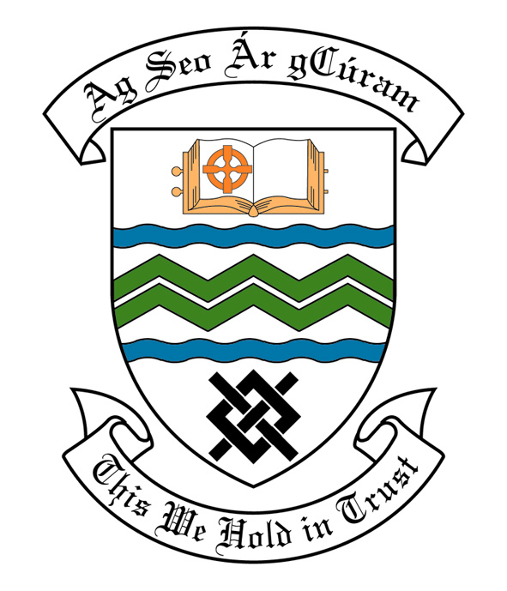

MEETING OF SOUTH DUBLIN COUNTY COUNCIL

Monday 10th July, 2006

MEETING OF THE LUCAN/ CLONDALKIN AREA COMMITTEE(2)

Tuesday 27th June, 2006

HEADED ITEM NO: H- I (2) (g)

Application for Grants

Applications for grants under the Council’s Community Grants Scheme have been received from the organisations listed below. Payment of the following grants to these organisations, in accordance with the conditions of the scheme, in the amounts set out hereunder, is recommended for approval:-

Ref: | Group | Type of Application | Date of Application | Amount
GF 1425 | Abbeydale & Abbeywood Residents Association,  Lucan, | Start Up Costs for Community Groups | 09/05/06 | €500
GF 1445 | Ballyowen Castle Summer Project,  Ballyowen | Community Activity | 12/06/06 | €500
GF 1415 | Ben Clarke,  Clondalkin, | Community Activity Grant Including Sport Activity | 28/04/06 | €500
GF 1438 | Clonburris Youth Club,  Clondalkin, | Equipment Grant | 31/05/06 | €500
GF 1406 | Earlsfort Residents Association,  Lucan, | Start Up Costs for Community Groups | 07/04/06 | €500

Contribution is being made to the following group:-

Group | Type of Application | Date of Application | Amount
Quarryvale Community House After School | Contribution towards summer activities | 08/06/06 | €700

Application for Grants (Arts Act 2003)

Application for a grant under the Council’s Arts Grants Scheme has been received from the organisations listed below. Payment of the following grants to these organisations, in accordance with the conditions of the scheme, in the amounts set out hereunder, is recommended for approval:-

Ref: | Group | Type of Application | Date of Application | Amount  €
AGF 522/  SCRA1726 | Scoil na Camóige  Cluain Dolcáin | Project completion and professional support | 28/03/06 | € 500
AGF 541/  SCRA 262 | Muintir Chrónáin  Áras Chrónáin  Cluain Dolcáin | Professional Concert performance | 24/04/06 | € 600
AGF 543 | Palmerstown One Act Drama Festival | Amateur Drama Festival | 15/06/06 | €700
AGF 545/ SCRA 237 | Bawnogue Women’s Development Group  Clondalkin | Programme of visual arts workshops | 16/06/06 | €600

An Arts contribution is being made to the following group

Group | Type of Application | Date of Application | Amount
St. Mary’s Parish Folk Group  Lucan | Contribution towards a dramatized Pentacostal performance | 11/04/06 | €400

It was proposed by Councillor Fintan Mc Carthy, seconded by An Meára Therese Ridge and RESOLVED:

“That this Committee recommends that South Dublin County Council approve payment of the above grants and contributions, as recommended in the foregoing report”

