Dodsborough District Centre Enhancement
Dodsborough is included in South Dublin County Council’s District Centre Enhancement Programme. These schemes are intended to:
• Improve the district centre in social, economic, and environmental performance.
• Encourage and grow community involvement and partnership.
• Help to develop the district centre as the accessible focus of walking and amenity networks for their adjoining communities.
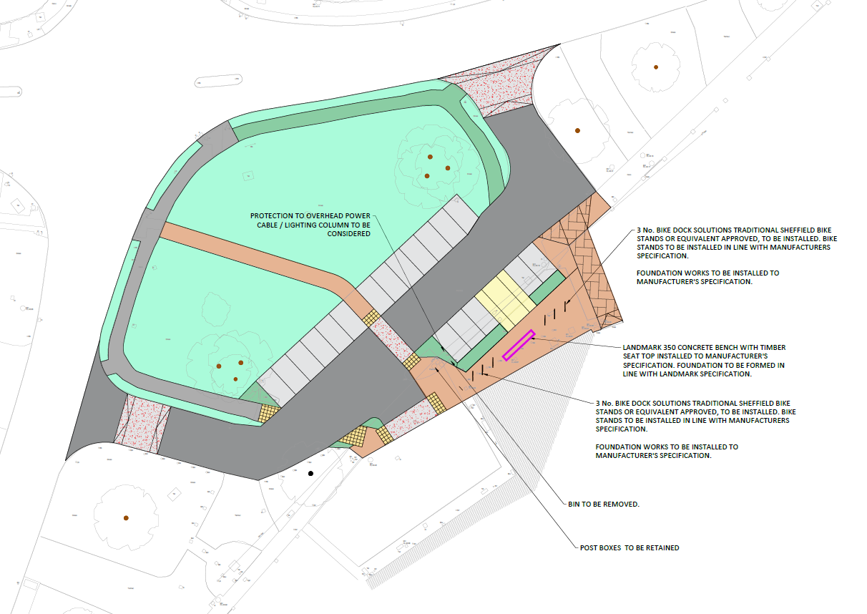

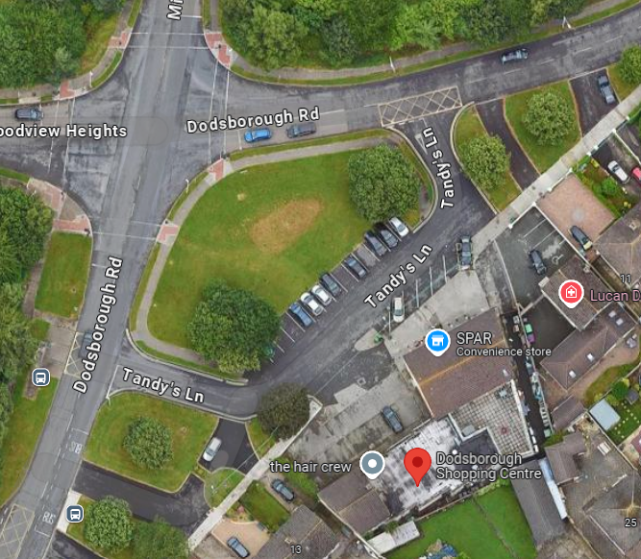

Site Location and Scope of Works
This scheme comprised of the upgrading and modernisation of Dodsborough District Centre parking area and Tandy’s Lane Access/Exit Roads.
Works included:
• Carriageway – Proposed carriageway resurfacing in front of shops, including red chippings on raised table
• Pedestrian facilities - Improvement of footpath fronting the shops to a shared use pavement with new block paving.
• New street furnitures
• Drainage - installation of bioretention raingarden and filter drain.
• Carpark – Rationalization of the car parking layout.

Tender
A works contract was put out to tender using Supply Gov for Small/Minor Civil Engineering Works. Six tenders were returned and the most economically advantageous tender was received from D.M. Morris Limited.

Construction
The contract was awarded to DM Morris Ltd. Works commenced on the contract on 8th April 2024 and were completed in July 2024.
The total cost of construction was €235,450.59

Images
Before
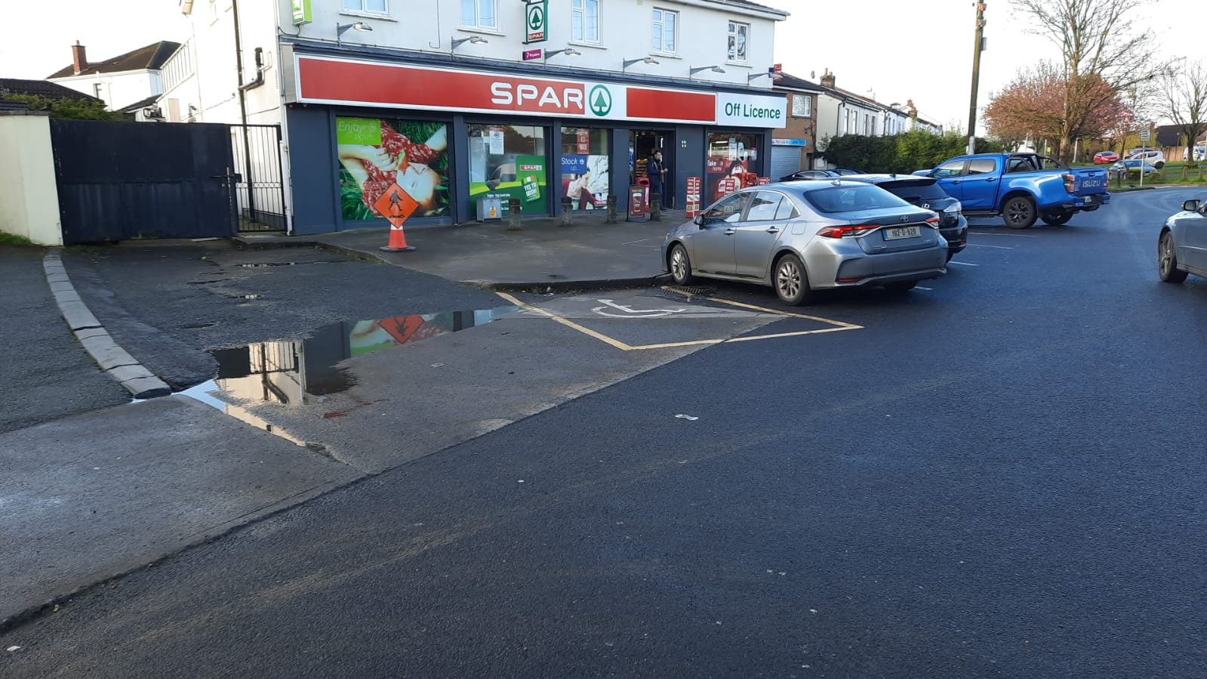

After
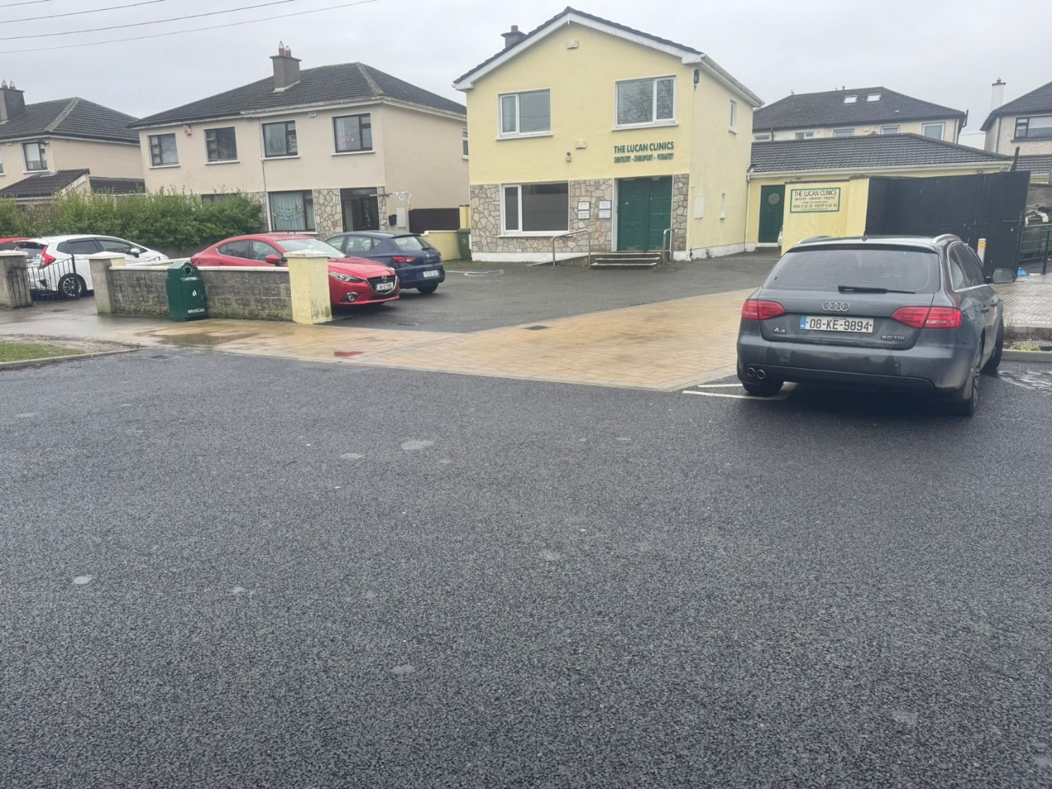

After
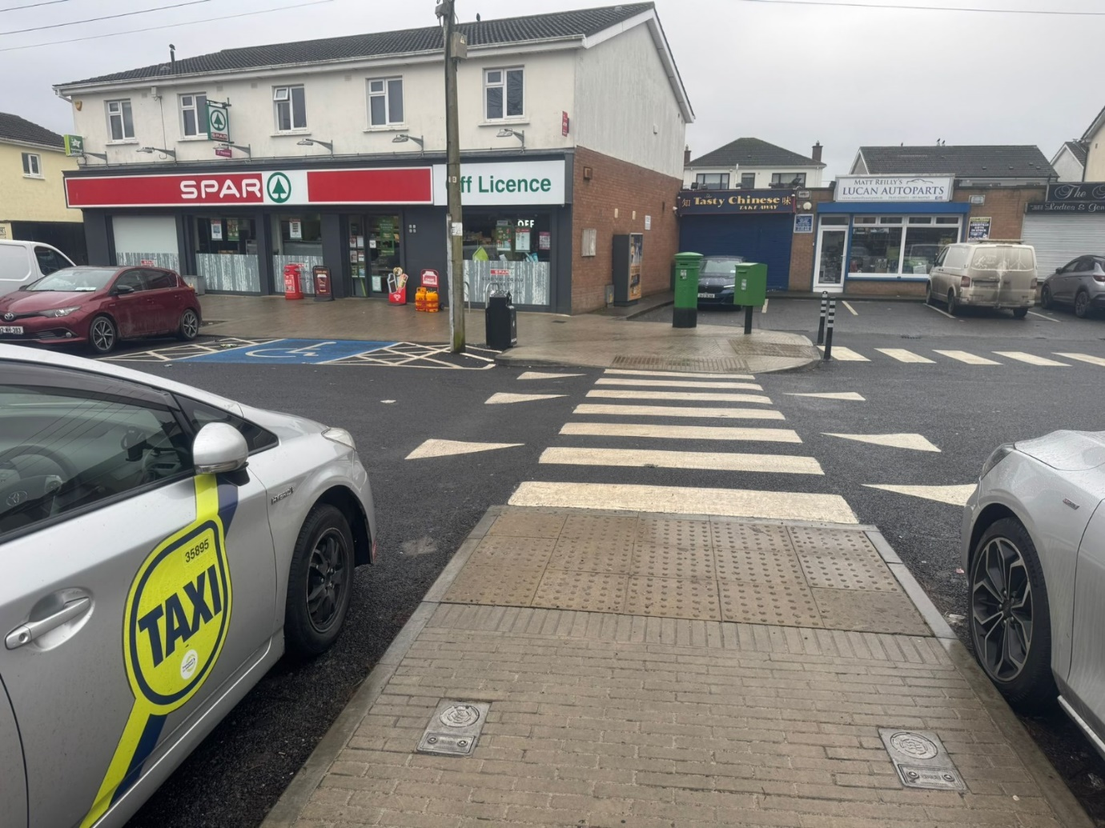

After
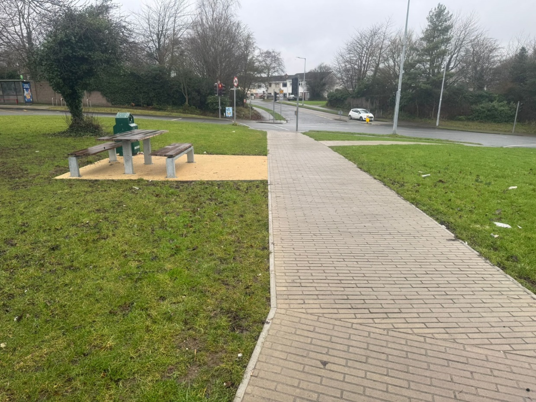

After
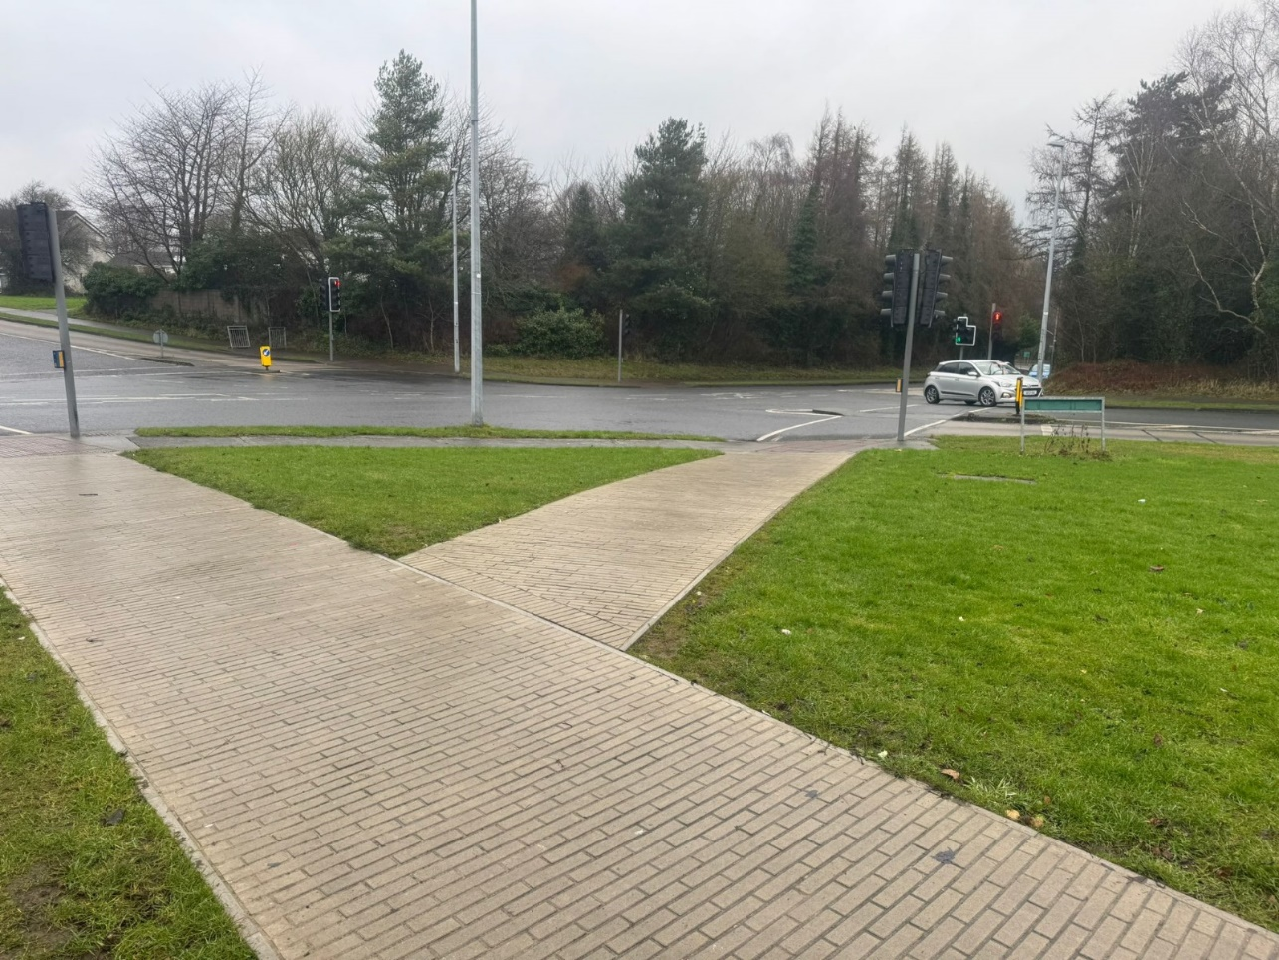
Before
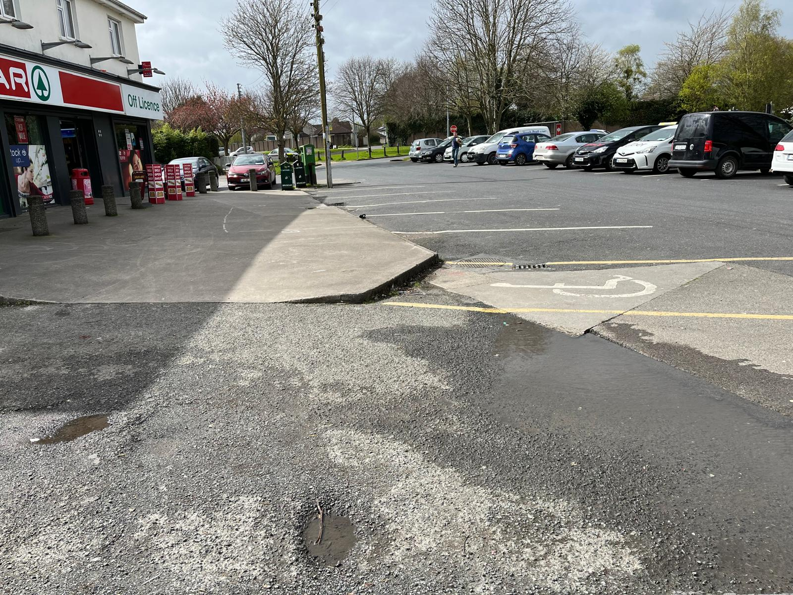

After
