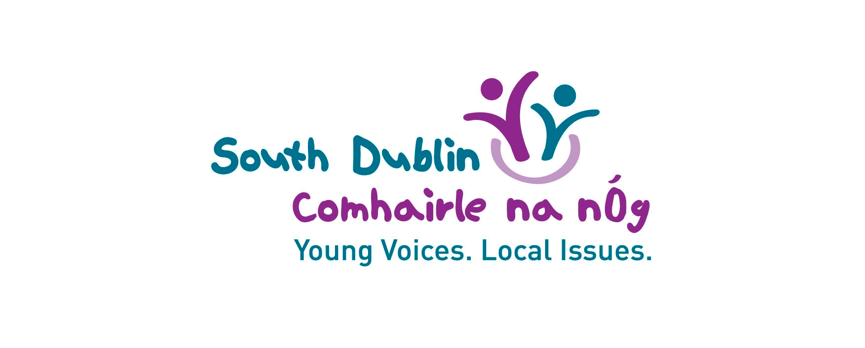

South Dublin Comhairle na nÓg

Annual Report 2023
Youth Conference Report

A Message from the Chairperson
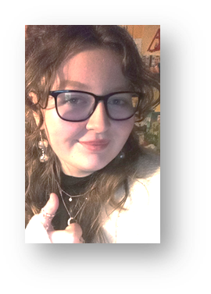
The South Dublin Comhairle tackled the issue
of drugs and addiction for our 2023 topic.
The issue was highlighted at our previous
AGM/Youth Conference 2022 by the young
people in South Dublin and as always, our
Comhairle members rose to the challenge
of creating a project to center around this issue.

The members got involved in more meetings
every month and different subgroups to plan
our 'Comhairle Makes NOISE' event. For the
event we partnered with NOISE music to bring
a fun and unforgettable event to Rua Red,
featuring local bands and incredible DJs from NOISE.

That wasn't all we did this year, we also attended Comhairle ná nÓg's National Showcase in Croke Park a place for every Comhairle all over the country to come and show off the amazing work they did over the past two years, we had our stall set up and spoke to people from all over the country to tell them about the work we've been doing in our Comhairle.

As the chairperson this year watching Comhairle grow and expand to new people has been one of the best experiences I've got out of Comhairle. I'm so proud of all the members to see the amount of teamwork and dedication it took to see this year’s work come to fruition. Everyone in the Comhairle should be so proud of themselves for the amazing work they put in.

Being the chairperson this year has meant so much to me, as Comhairle was the first place to really help me get of my shell and show off my true self, hopefully as chairperson I was able to make new members feel interested and comfortable the same way I did when I joined Comhairle. My last three years being a part of Comhairle have been one of the most rewarding experiences of my life, from gaining better confidence and public speaking skills to making new friends from my own school and all over the country. It will always be something I will remember for the rest of my life.

Thank you for giving me this opportunity,
Alix Brady,
South Dublin Comhairle na nÓg Chairperson.

Steering Committee Members 2023

Thank you to the members of the Steering Committee who helped guide the work of the Comhairle in 2023:

- Andy Leeson, Foróige, Dublin South Area Manager
- Joe Rynn, South Dublin Children & Young People’s Services Committee Coordinator
- Sinead Harris, Manager, Crosscare Youth Service, Ronanstown
- Siobhan Hennessy, Senior Youth Participation Officer, The National Participation Office, DCEDIY
- Aoife Heffernan, Senior Youth Worker, Youth & Sports Development Service DDLETB
- Emer Loughrey Counsellor, HSE Youth Drug and Alcohol Service YoDA
- Alan Mc Donnell, Health Promotion and Improvement Officer, Slainte Care Healthy Communities

- Cllr Carly Bailey, South Dublin County Council
- Cllr Emma Murphy, South Dublin County Council
- Cllr Madeleine Johansson, South Dublin County Council

- Richard McKeever, Comhairle Member
- Liam Kelly, Comhairle Member
- Izzie Solan, Comhairle Member

Objectives and Achievements for 2023

Introduction

Following the 2022 AGM/Youth Conference the key actions agreed by the new Comhairle were:

- Survey of young people about Vaping
- Awareness campaign about Vaping
- Present to services about the outcomes
- Lobby services about the issues identified by young people
- Alternative Event for young people to attend

In 2023 the Comhairle organised and completed a survey of young people in the county on the topic of Vaping and these results were presented to the full Council, the Local Community Development Committee and the Children and Young People’s Services Committee. The members also presented to their Steering Committee that has representatives from YoDA and HSE.

The members highlighted the results of their survey, brought attention to Vapes and had a positive impact on young people attending the ‘Comhairle makes NOISE’ event this year.

The members organised a successful under 18s pro-social music event in August for their peers from the South Dublin Area, in collaboration with NOISE.

The members met with a representative from WEEE Ireland on the issue of disposal of vapes and the issue of single use/users not recycling. Members brought the WEEE battery boxes to their local youth services to be accessible for young people to recycle vape batteries.

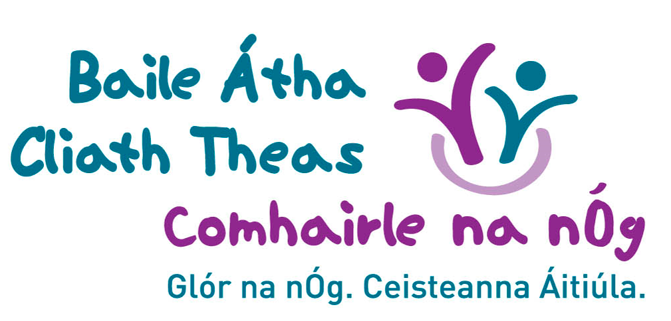

Report from Members on the Work Completed

Comhairle has done an extensive amount of work in 2023. To start, we had our Annual General Meeting in November 2022, which was a great success with us having one of our busiest AGMs in years, It was the first in person AGM we have had since 2019, and was hosted in the Maldron Hotel in Tallaght.

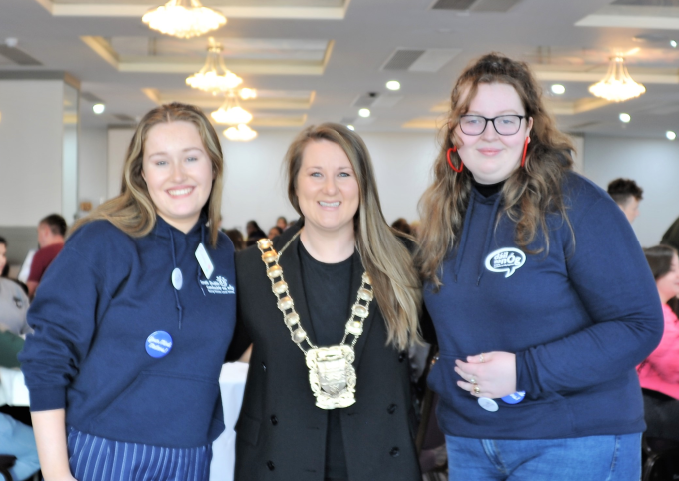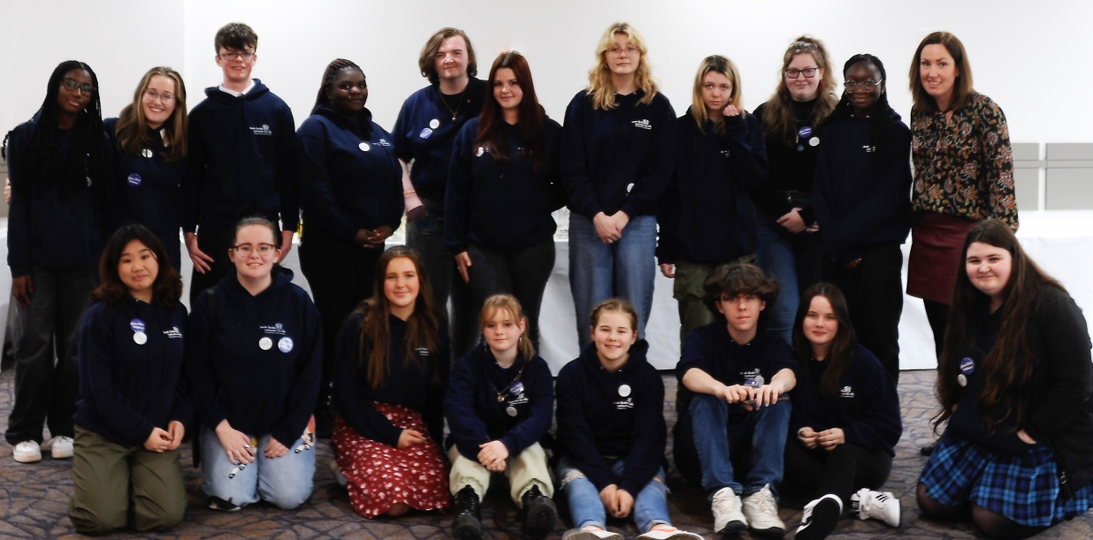

We had our first meeting in the Council Chambers, with a membership of 40 across the county! In this initial meeting we were introduced to each other, and members put themselves forward to represent the Comhairle when we present our work to several committees, such as the Steering Committee, the CYPSC, the LCDC, the SPC, and the elected members of South Dublin County Council.

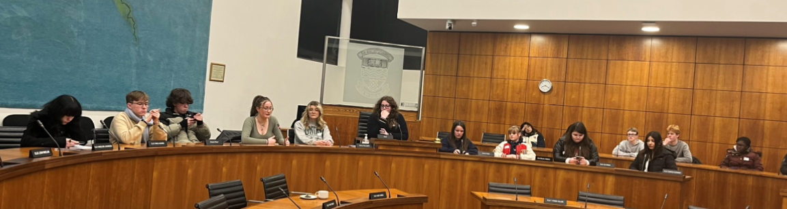

We finished our previous year’s topic of Mental Health, by launching the “Your Mind Matters” Campaign across South Dublin with the help of the previous Mayor, Emma Murphy. Our Comhairle has designed posters with QR Codes, linking them to a site that will display many helpful mental health websites for young people.

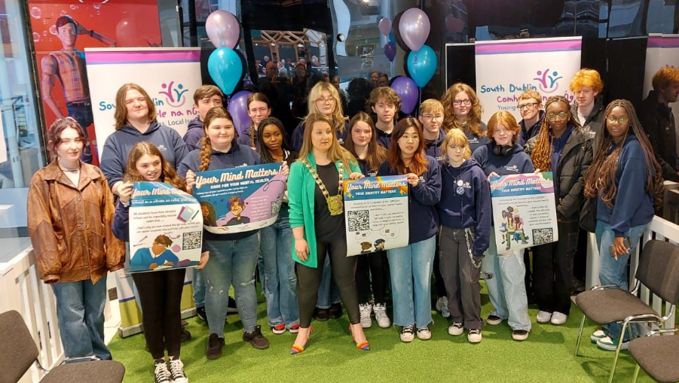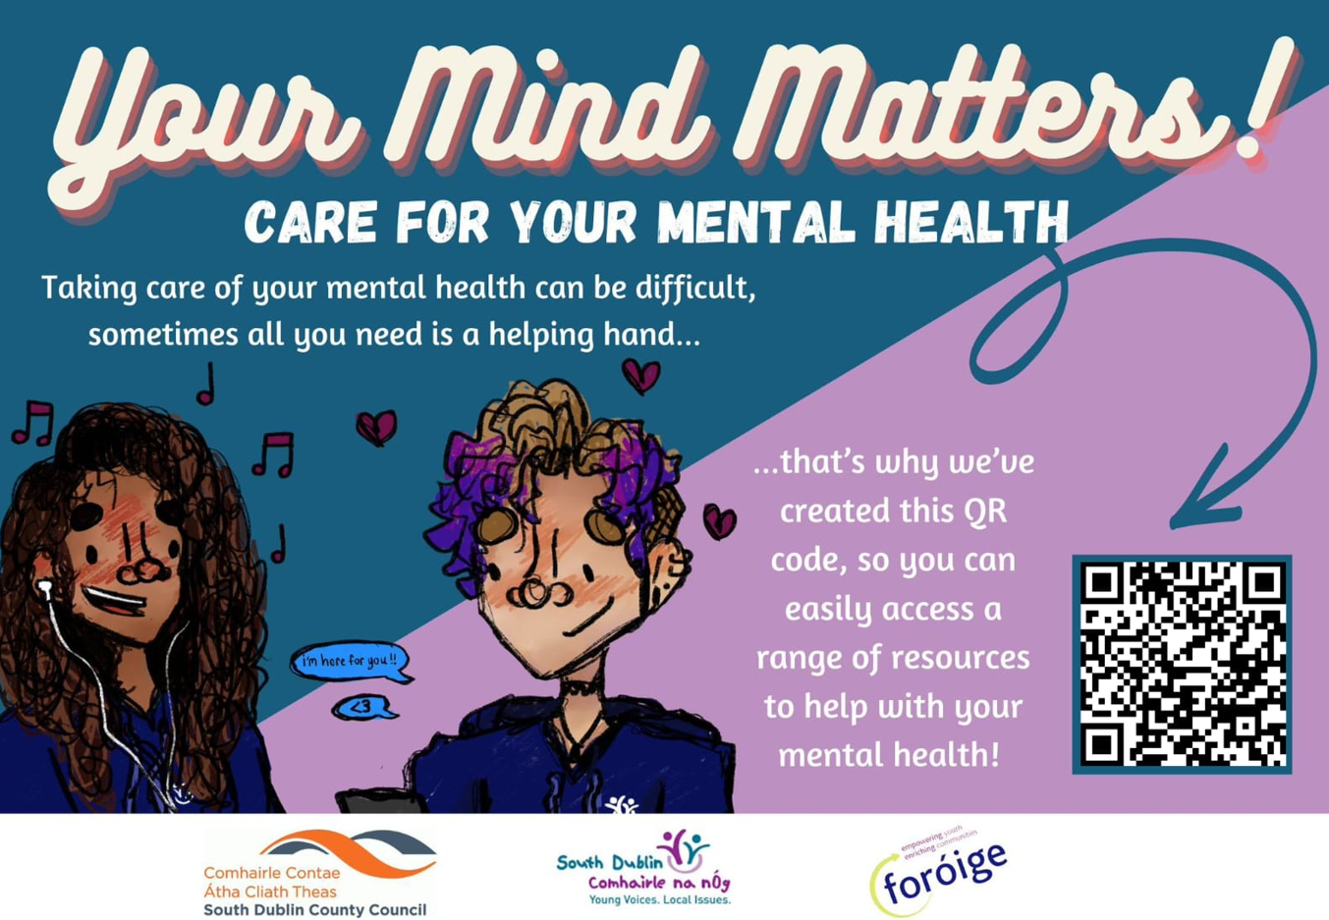

Our chosen topic this year was Drugs & Addiction, which we have done plenty of work on. We met with representatives from YoDA the HSE to discuss the issues with vaping for the upcoming vape legislation. They kindly joined the Steering Committee as our experts on the topic. Our Comhairle also created and sent out a survey through our social media and schools across South Dublin to gather information from young people regarding vaping. Of 432 respondents aged 13 – 17 years, 15% vaped. 61% of those that vape are in the 13–15-year age group. In June of 2023 our Comhairle met with WEEE Ireland to discuss how the Comhairle and WEEE Ireland can raise awareness regarding the incorrect disposable of these disposable vapes.

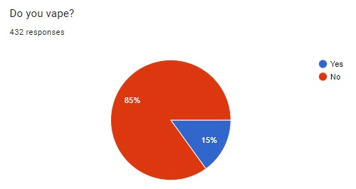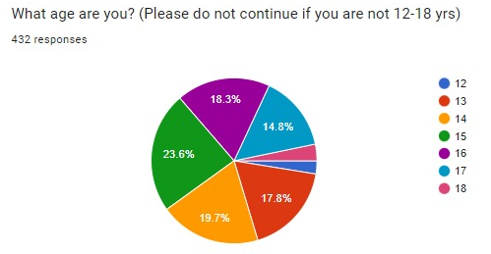

In August we planned, organised, publicised, and ran our “Comhairle Makes Noise” Music Event along with NOISE Dublin, hosting local bands, DJs, and more. The purpose of this event was to show that young people can have fun at an event without needing drugs, smoking, vaping, and alcohol. The event was an incredible success, hosting local bands, selling sweets, and donating the proceeds to Barnardos’ Lorien Project for their sensory garden. A consultation on the LECP was also held during the event. Additionally, this event was also nominated for a Foróige Community Spirit Award.
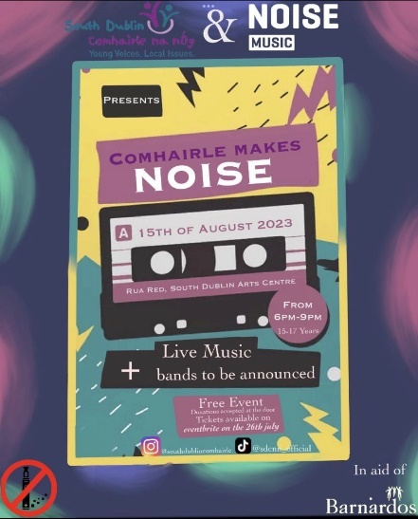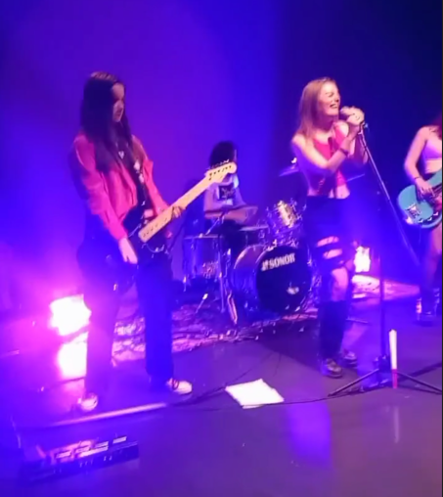

In July we attended the Comhairle na nÓg National Showcase, where we discussed with other Comhairlí about our achievements and even talked to Rodrick O’Gorman about our work.

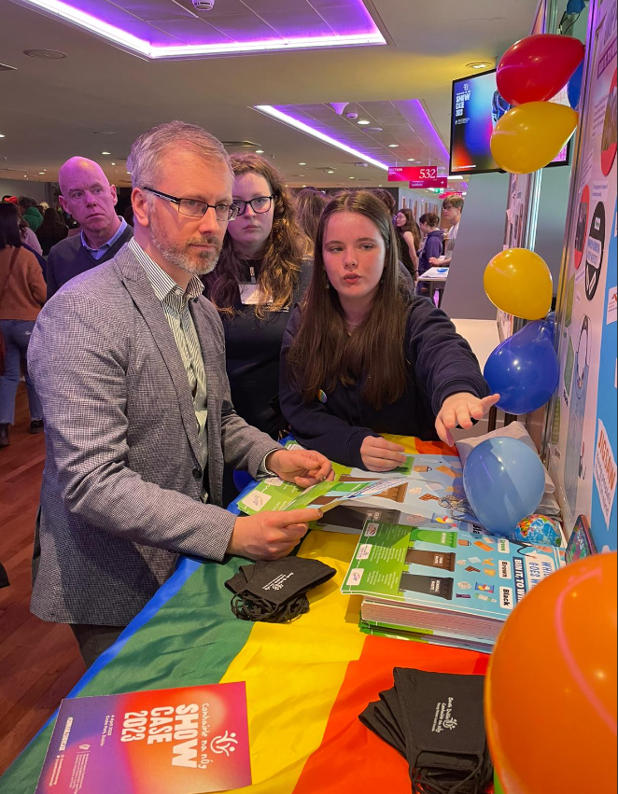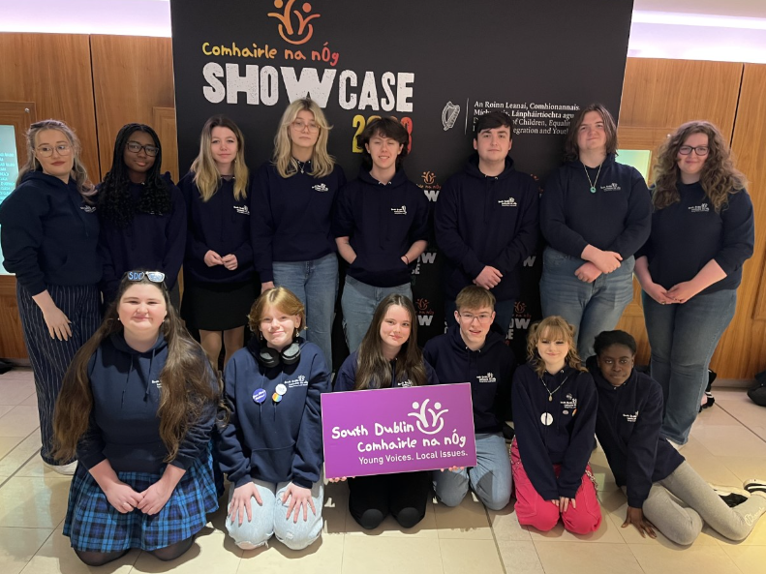

We have additionally had an incredible amount of involvement in Council Work. Earlier in 2023 Comhairle members facilitated and took part in the “€20K Have Your Say” sessions. The Comhairle has also taken part in a Poverty Consultation as part of the preparation for the LECP. Finally, Comhairle Member Izzie chaired a discussion with female South Dublin County Councillors on Women in Politics in the Council Chambers for International Women's Day!

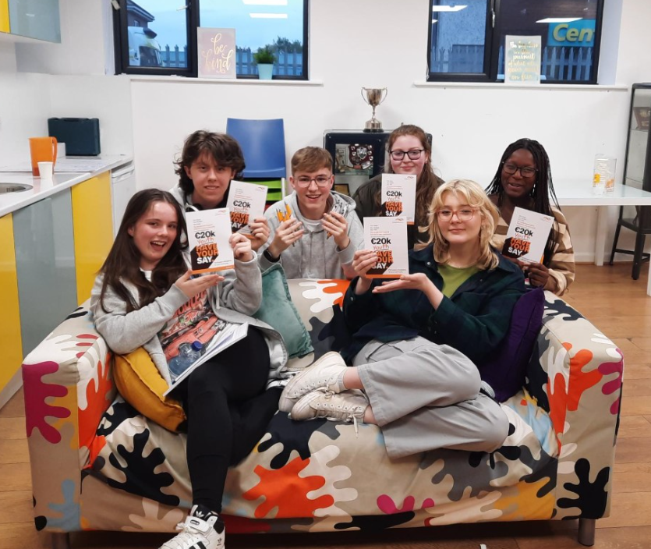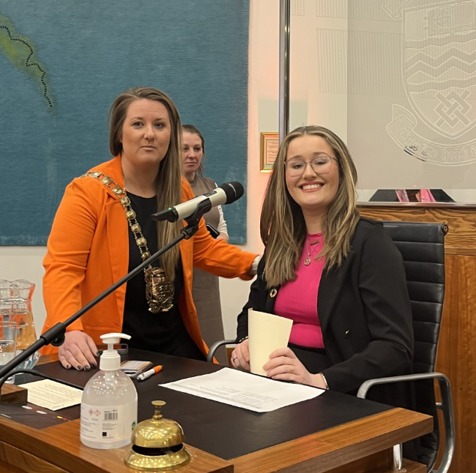

Our Comhairle has been working with local decision and policy makers a lot this year. Several of our members sit on subgroups of the Child & Young People Services Committee (CYPSC) on Youth Diversion, Homelessness, Mental Health, and more. Our members have also given presentations on our work to the CYPSC, the LCDC, the Social, Equality and Community SPC, the OP&F and the Full Council.

Members have been very involved with various national organisations across South Dublin. Some of these achievements include members Alix and Bailey on the HSE Youth Mental Health Fund Consultation Committee, members Richard, Liam, and JJ attending the Comhairle National Networking Event, as well as Richard & Liam attending a consultation regarding Youth Information Centres. We have had Comhairle members involved in the Eco Unesco’s Green Teams Initiative, members Alic & Bailey on the Jigsaw Youth Advisory Panel, and finally members Alix, Izzie, and Bel sit on the SpunOut Action Panel.

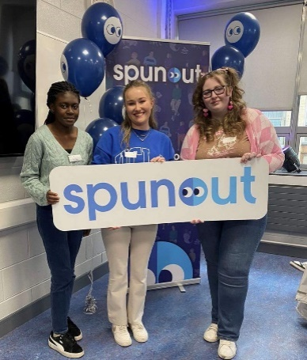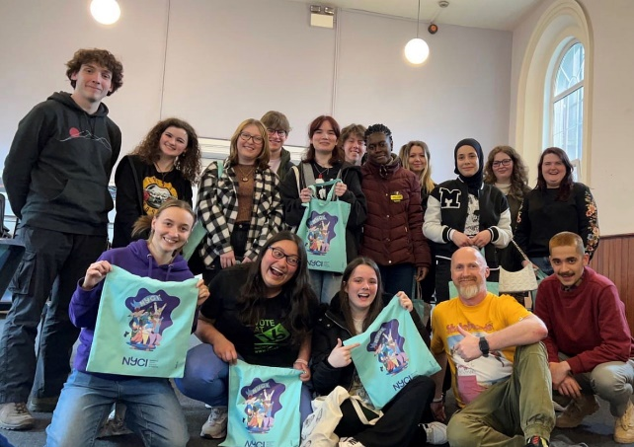

As you can see, our Comhairle has been incredibly successful throughout this year, possibly our biggest year in a long time. We have been posting all of this on our social media, where we have now reached an Instagram following of 1000+ people. This is an incredibly effective way to gain reach and inform people about the South Dublin Comhairle Na nÓg. All our social media posts are designed by our very talented PRO team.

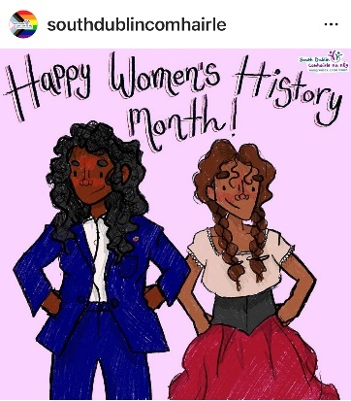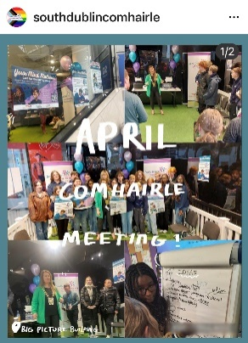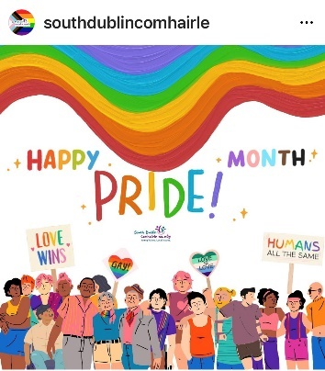

Richard McKeever,
Comhairle Member, 2020-2023.

2023 Youth Conference Report

Attendance

86 young people registered to attend the event this year. This is an increase of 7 registrations on the previous year.

20 of the 38 Schools in the county area were represented, which is an increase of 2 schools on the previous year:

- 7 from Tallaght,
- 3 from Lucan
- 2 from Dublin 16
- 1 from Templeogue
- 2 from Clondalkin
- 1 from Rathcoole,
- 1 from Palmerstown
- 1 from Knocklyon
- 2 from Greenhills & Walkinstown

55 young people registered from school representing 64% of registrations with 51 young people attending on the day. Coordinators have worked with specific teachers within the schools to support the engagement and pass information about the event. This builds each year.

Youth Services and alternative education settings had 11% of the registration for places, all of which attended the event.

Killinarden Community Centre Youth Project had 4 young people register and attend the event for the first time this year. Crosscare Youth Service had 2 registered and attended. Foroige Dublin South registered 3 young people and they attended. Citywise had 2 young people register and attend for the first time.

Much of this engagement is building relationships with youth workers and increasing awareness of the Comhairle within these services to reach the seldom hear.

Current Comhairle members represented 23% of the registrations. 20 members of the 30 members were registered to attend the event.

The breakdown of those that registered to attend is represented in the table below:

Breakdown of Registered to attend by Age
Age | Number | Percentage
12 | 0 | 0
13 | 4 | 5
14 | 21 | 24
15 | 18 | 21
16 | 25 | 29
17 | 18 | 21
 | 86 | 100

Youth Conference Programme and Outcomes 2023

The methods used during the event were developed by the DCEDIY National Participation Office and Hub na nÓg to gather as much information as possible from the attendees using informal youth work methodologies and to gather the data in an interactive and productive way.

This is a diagram of the process used in the South Dublin Youth Conference.
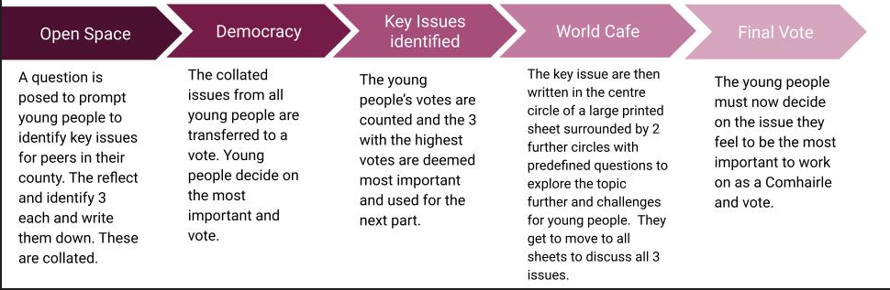

Open Space and Key Issues Identified
The first of such activities involved the young people identifying the key issues that affect them or their peers living in South Dublin. This is a personal reflection piece prompted by a single question displayed on the screen. What are the top 3 issues affecting you/young people in South Dublin? The young people are then asked to write these down and they are gathered up. These issues are categorised by members assisted by youth workers.

The key points made by the attendees that informed the title of the final top three issues are listed. The notes on all are retained as they are important to young people in South Dublin. The number is the votes by the attendees to reduce the list to 3 key topics.

Mental Health (28)
- Anxiety
- Eating Disorders
- Teen Suicide
- Mental Health Supports & Services

Youth Spaces (33)
- More spaces for young people to meet friends, socialise, hangout.
- Activities for under 18s to support socialising and creativity.

Transport (25)
- Quality and Safety on transport.
- New housing developments are causing additional traffic congestion.
- Access to quality public transport.

Education/RSE (25)
- RSE curriculum covering issues such as peer pressure, harassment, slurs, assault, pregnancy, relationship, awareness and education
- Academic pressure and anxiety
- Exam support

Other issues:
- Racism (19)
- Anti-Social Behaviour (19)
- Cost of Living (17)
- Drugs/Addiction (15)
- Vaping (13)
- LGBTQ+ (6)
- Guidance/ Access to Services (6)
- Bullying (5)
- Climate Change (4)
- Litter (3)
- Peer Pressure (2)
- Online Safety (1)

Top 3 Issues as voted for by attendees:

It was decided to combine the issues of mental health with spaces for young people, as the pandemic highlighted the importance of young people being able to see each other in real life.

1.) Mental Health & Facilities/Spaces for young people
2.) Transport
3.) Education/RSE

World Cafe Activity Top Issue Key points
The young people are then asked to consider these top issues and discuss them using the following questions. This exercise is called the World Cafe Activity. The attendees are all given the opportunity to write, draw and /or discuss all 3 of the issues with a youth worker/facilitator. The top issue Youth Spaces/Mental Health and the key points made under the 3 questions are below for you to review.

Tell us more about it….
The attendees felt that there are not many areas for young people to hang around. There are issues with safety in hanging out with their friends in local areas and they are forced to be around the shops.

Often there is a generalisation of young people. They felt other issues such as a lack of mental health resources and a stigma attached to mental health.

What are the barriers/ challenges to solving this issue?
The young people felt that often adults are the problem when they are hanging around with their friends, they act weird, look at them and make them feel uncomfortable. They struggle to find groups and clubs for themselves. They feel parks are often unsafe places to hangout and feel unwelcome too. Often places are too expensive, and hobbies cost a lot of money.
The challenges around mental health are related to accessing services and waiting lists. Mental health is still not discussed enough in school especially when school increases stress. They would like to learn how to help their friends. They would like their parents to be able to help them. Social media is putting a lot of pressure on young people.

What would / could help to solve this issue?
They need to address the safety of young people in public spaces as well as the other populations. This would include lighting, seating, local park warden patrols, more bins, and murals to differentiate it as a teen space. They would like to see more free organised events. They would like some pop-up workshops at teen spaces involving young people in planning i.e. Graffiti.

The young people felt that early intervention was crucial in supporting mental health as they need help even when they aren’t in crisis. If there were more teen spaces, it would help their mental health. Young people coming together to talk helps their mental health. Community mental health hubs for young people. Supports and information for parents to help their young people with their mental health through schools and services. More support in school as it is where young people spend a lot of their day.

Evaluation of the Youth Conference

Evaluation by the Attendees were all positive. The attendees are given a paper evaluation which is categorised using the Lundy Model under the headings of Space, Voice, Audience, Influence using a scale 1-5. 99% of the points were marked as 3 or above.

There are also 3 additional questions relating to the best part of the day, what they want to change, the food and room.

Key points extracted from the sheets were:
- They enjoyed the event and had fun in the process.
- They would appreciate a different food option next time.
- They felt the tables were too close together. This is due to the room and the pillars in the centre.
- Feedback on the agenda was to spread the speeches/speakers out as this was too much all together.
- The icebreaker at the start failed so the need for an icebreaker is needed.
- The request to be at a table with friends was made again. They like the social aspect of the day, so this is a warranted request.
- They acknowledged the methods used and felt they were great and took a lot from the discussion on topics with peers.

______________________________

