**COMHAIRLE CONTAE ÁTHA CLIATH THEAS**

**SOUTH DUBLIN COUNTY COUNCIL**



**MEETING OF LUCAN / PALMERSTOWN / NORTH CLONDALKIN AREA COMMITTEE**

**Tuesday, October 22, 2024**

**QUESTION NO.23**

**QUESTION: Councillor S. Moynihan**

To ask the Chief Executive for a report on the performance of the Outdoor Live Arts Programme for Summer 2024.

**REPLY:**

The South Dublin Live programme was launched at an event in Tallaght Library in May this year. The 2024 Open Call awarded funding to 10 applications, ranging from music tours that visited libraries and community centres around the county, to theatre shows, outdoor spectacle, and a youth music festival.

As part of the summer programme, South Dublin Live initiated a collaboration with SDCC Community Dept which resulted in adding live music performances to the Outdoor Films and Live Music series of events at North Clondalkin Library, Russell Square in Jobstown, Palmerstown, Firhouse, and Dominic’s Community Centre in Old Bawn. South Dublin Live also supported the Community Services Fun Day in The Square Shopping Centre by curating a Buskers Corner and Go Dance for Change Dance Battle. Both collaborations were highly successful and reached large audiences of 1,002 and 9,000 respectively.

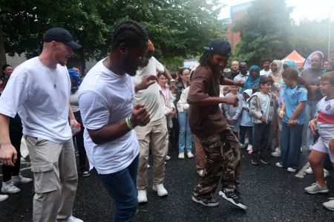

Throughout the summer South Dublin Live also supported live performances at Comhairle Makes NOISE in Rua Red and Tallaght Library; Tymon Markets; The Glen Fullam Memorial in Knockmore; Seo Beo in Áras Chrónáin, Clondalkin; Artscope August in Palmerstown, Saggart, Rathfarnham, Adamstown, Lucan and Tallaght; Ruaille Buaille Children’s Festival in Lucan; and the inaugural Adamstown Festival.

As part of Culture Night and Hallowe’en South Dublin Live is co-producing two events – Two Paths Meet in The Old Courthouse Rathcoole on Culture Night and a neurodivergent and familyfriendly Hallowe’en Event on Saturday 26th October in Tallaght Library in collaboration with This is Me Neurodiversity.

SDCC Arts Office is currently engaging with Public Realm and Environment in order to ensure the sustainable development of the South Dublin Live programme into the, so that the events we produce and support have a positive impact on the performing arts and events sectors, the South Dublin community, and the environment.

|  |  |  |
| --- | --- | --- |
| **South Dublin Live 2024** | **Total Attendance YTD** | **23772** |
|  | No. of Events | 60 |
|  |  | Attendance |
| Strand 1 - Markets and Community Events |  | 15372 |
| Strand 2 - Open Call |  | 1635 (as of 21st October not all events have taken place) |
| Strand 3 - Locally Produced Festivals |  | 6545 |
| Strand 4 - Arts Programmes & Organisations |  | Including Tallawe'en Festival contribution |
| Strand 5 - Culture Night & Halloween |  | Culture Night 220  Tallaght Library Halloween  Spooktacular events will take place on Sat 26th Oct |