SDCC SALT BINS

Community Salt Bin

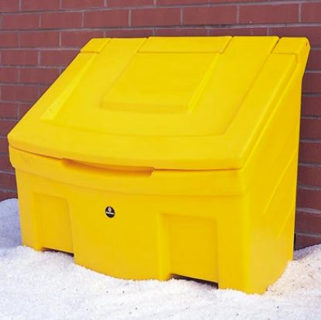

SDCC provide community salt bins at strategic locations around the county

These bins will be re-filled by SDCC personnel as required.

Estate Salt Bin



Estate salt bins are provided to individual estates to assist them in collecting and storing the salt.

Residents are required to fill these from community salt bins