Site and Waste Management Subgroup

The next Site and Waste Management Meeting will take place on Wednesday 10th April 2024
Waste Management on Sites
A skip collection scheme is place on 3 Sites, Stocking Hill, Cherryfield and Belgard Park. This was recently extended to the Kishogue Park and Lynch’s Park Halting Sites.
Cleansing operations due to take place in Cherryfield Way and Lynches Park.

Cleansing operations
STOCKING HILL: March 2024
BEFORE

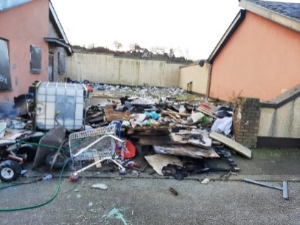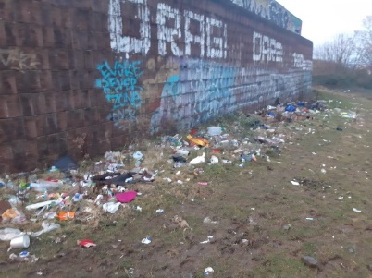

AFTER
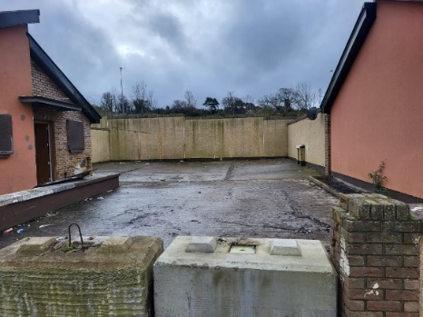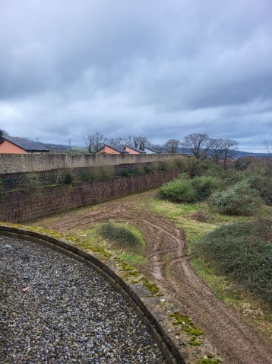

HAZEL HILL: March 2024
Before
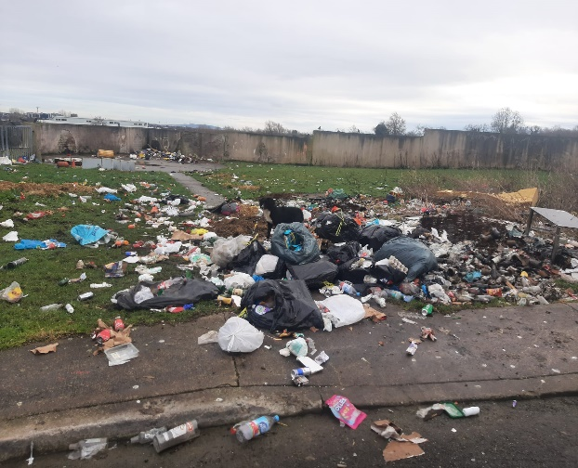
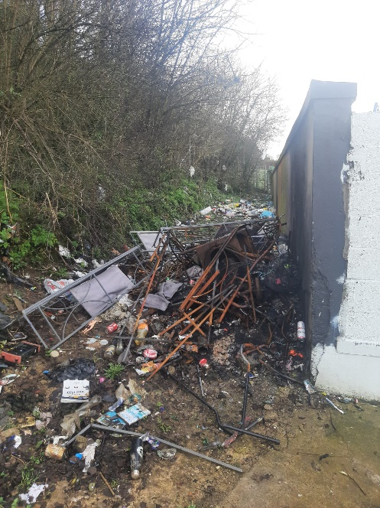

After
