Owendoher Haven Playground officially opened by Mayor, Cllr. Alan Edge on Wednesday 6th March 2024.

Following a successful application to the Traveller Accommodation Unit, Department of Housing Local Government and Heritage Dormant Accounts Funding, South Dublin County Council installed this play areas in Traveller-specific accommodation to improve the environment in which children are living. This playground was designed to reflect the traditions of the Traveller Community. A first of its kind, very welcome addition to the community which will benefit children from the Owendoher Haven Halting Site and residential housing estates in the area for generations to come.
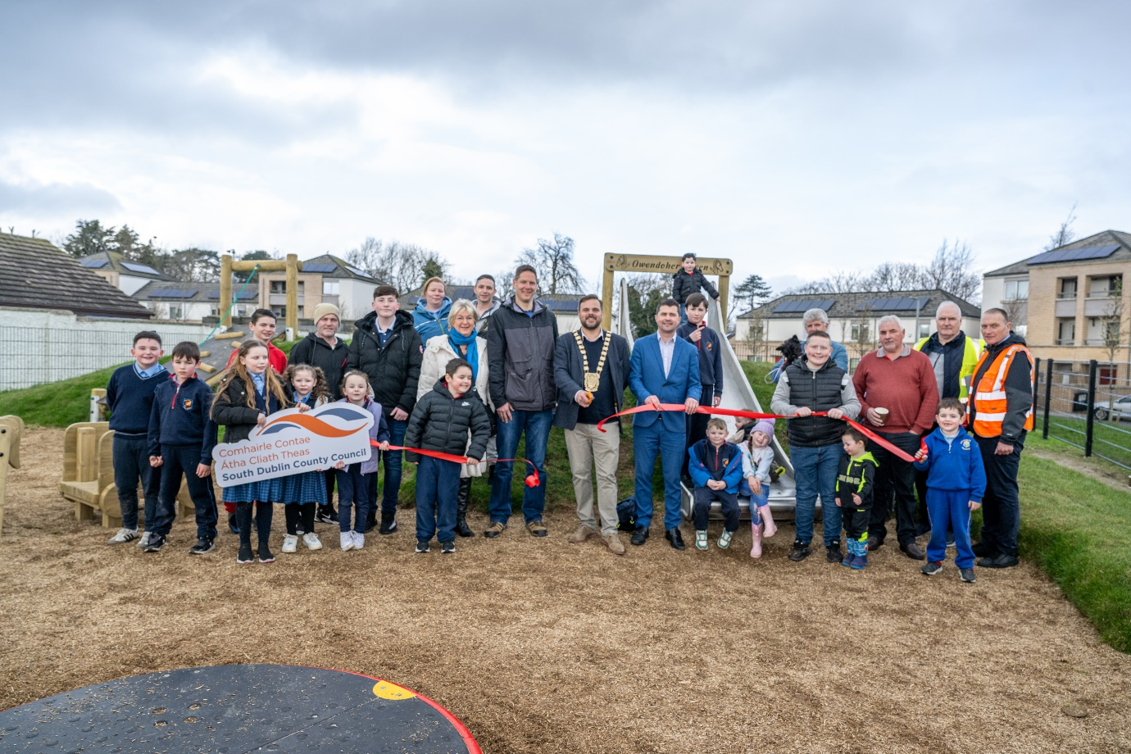

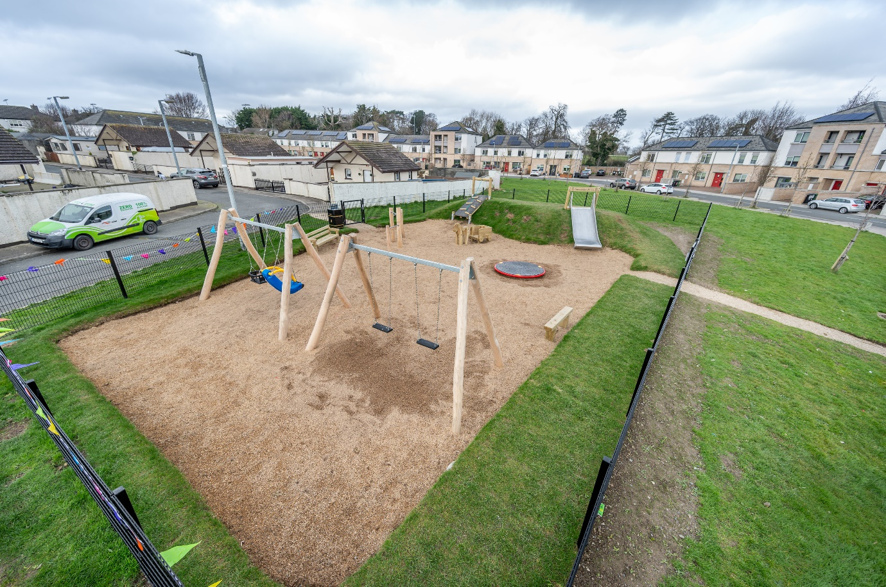
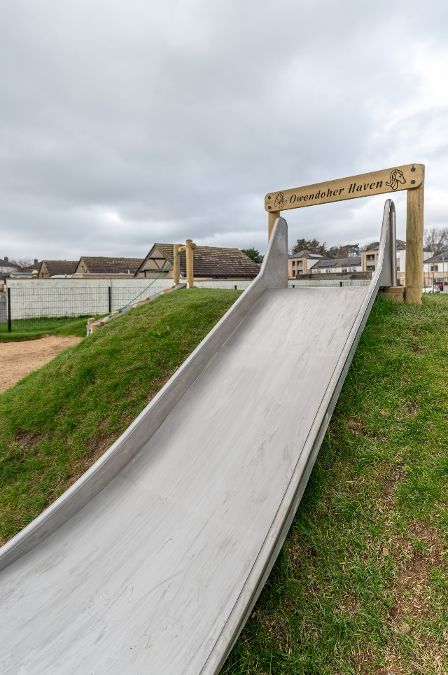

Traveller Liaison Officer Post
The Traveller Liaison Officer post advertised week commencing 1st April 2024.

Caravan Loan Scheme:
1 further mobile Home delivered and installed at Lynches Park

Ethnic Identifier
As of Wednesday, 3rd of April 2024,168 applicants has identified as an Irish Traveller

7 Stocking Hill
Extensive Fire Damage following Arson Attack 27th March 2024

