PAVILLION PROGRAMME REVIEW APRIL 2024

Background including policy:
SDCC’s pavilion programme was agreed by the Council as part of its commitment to the health and well-being of its citizens. As clubs grow and develop, facilities such as changing rooms, and secure storage areas become essential to a club’s sustainability and success. South Dublin County Council currently provides 173 playing pitches for various sporting codes such as Gaelic Football, Hurling, Soccer, Rugby, Cricket, Hockey, Rounders, American Football, Archery, Baseball and Softball. Two running tracks and two all-weather grass pitches are provided to clubs on an annual allocation basis. Currently, SDCC service 45 clubs with 1,040 teams weekly on our pitches. Within the last quarter we have opened 2 Artificial Multi Sport Grass Pitches. Midweek evening timeslots are allocated to local clubs while daytime and weekend slots are available to book by clubs and the public via our online booking system SportsKey. We are also servicing 4 schools on these artificial grass pitches. Combined, the artificial grass pitches have total of 128 active customers to date (March 2024), the majority of whom are local sports clubs.

SDCC County Development Plan
Policy COS4: Sports Facilities and Centers
Ensure that all communities are supported by a range of sporting facilities that are fit for purpose, accessible and adaptable.

COS4 Objective 1:
To promote the provision and management of high-quality, multi-functional, sport and recreational infrastructure across the County, in consultation with relevant stakeholders, to meet existing and future needs, to include sports hubs and multi-sport astro-pitches, in accordance with the South Dublin County Council Sports Pitch Strategy (2020), the National Sports Policy (2018-2027) and the aims of the South Dublin County Sports Partnership, consistent with RPO 9.15 of the RSES.

COS4 Objective 8:
To support the provision of permanent space for well-established sports and recreational activities at appropriate locations within the County, aspiring to the standards and conditions met for such playing areas by National Governing Bodies, where feasible and in accordance with proper planning and sustainable development

COS5 Objective 3: To support the implementation and expansion of the Council’s Teenspace Programme (2021) and the implementation of the Sports Pitch Strategy (2020) or any superseding documents.

COS5 Objective 13: To ensure that parks and open spaces provide for a wide range of recreational and amenity activities that are easily accessible to all in the community, irrespective of age or ability.

COS5 Objective 14: To ensure that public open space and associated recreational facilities are accessible by walking, cycling and public transport, as appropriate to their position within the open space hierarchy set out in Table 8.1 and include safe bicycle parking spaces at appropriate locations.

National Sports Policy 2018-2027
This national policy highlights the influence and importance of sport across Irish society, it provides a vision for Irish Sport in 2027 and defines the key actions required to achieve its ambitious goals:

“Lead Role for Local Authorities
Local Authorities are key stakeholders in the context of the public spaces which are widely used for sport and physical activity. They manage the public parks; they are responsible for the local road network; and they are key facilitators for outdoor recreation with almost 1 in 5 recreational walkers walking in public parks and 1 in 3 adult sports participants taking part in public spaces. Public spaces are often used on an informal basis by meet-and-train groups while sports clubs are also widespread users of these spaces.”

ACTION 8 We will establish, through Sport Ireland, an initiative to support Local Authorities in developing Local Sports Plans consistent with the overall vision and objectives of this National Sports Policy. The Local Plan will review needs and set out actions to increase participation locally. It will be developed and implemented in cooperation with LSPs, clubs, communities and partners within and beyond sport.

ACTION 22 We will work with relevant stakeholders to explore the merits of a new programme of current sports funding under a targeted scheme to support schools on a sustainable basis in defraying reasonable costs (such as necessary transport and facility hire) incurred in delivering the aquatics strand of the PE curriculum. We will encourage Local Authorities to promote and facilitate more sharing of facilities locally, especially where capacity is available at off-peak times during the day, in the evening or during holiday periods in the case of educational establishments. This will involve working closely with clubs and sporting bodies, schools and colleges, leisure facility providers and others. As part of the Local Sport Plans, Local Authorities will also lead on other collaborative initiatives to improve access locally e.g. Local Authorities and LSPs will combine to see how recreational areas can be utilised more fully by local communities for sport and physical activity e.g. for parkruns.

“Local Authorities have a significant role in promoting participation in sport and physical activity in the community. They invest significant resources in physical infrastructure for sport and physical activity and employ sport and recreation development officers. They are strongly engaged in community development through the LCDCs and the associated Local Economic and Community Plans, which seek to enhance the quality of life and wellbeing of communities linking strongly with the policy agenda around sport and physical activity. They have a close working relationship with LSPs and NGBs, sports clubs, facility providers, schools, community groups and other stakeholders locally. As already noted, we see potential for an expanded role for Local Authorities in leading collaboration within and beyond sport in their local area.”

Active South Dublin Plan 2023 (SDCC’s Local Sports Plan):
On the 08/05/2023 SDCC formally ratified the aims and actions of the inaugural Local Sport & Physical Activity Plan for the county for the period 2023-2028.
Titled “Active South Dublin” the plan stems from Action 8 of the National Sports Policy 2018-2017 which seeks all local authorities to develop local sports plans.
South Dublin County Council is the first local authority nationwide to achieve this aim. The plan includes many ambitious objectives and actions in areas such as participation opportunities, facility development, club support and leader training, to support and motivate every citizen in the county, regardless of age, background or ability, to lead active healthy lives.

Relevant sections include:

Ambition 4:
Optimize the potential of existing natural and physical assets such as community centres, parks, mountains, water, leisure centres and schools as places where sport, physical activity and recreation can occur.

Ambition 6:
Significantly enhance the availability of quality sport, recreation and physical activity facilities and spaces through the full delivery of our sports capital programme and other capital programmes.

• Work collaboratively to deliver the planned projects included in the current Three-Year Capital Programme 2023-2025 and beyond, and seek to expand the range of sport, physical activity and recreation projects in the Council’s capital programmes based on assessed need and demand.

• Ensure that the Active South Dublin work programmes are aligned to and support the ongoing implementation of the Council’s strategic plans for pitches, parks and open space, green infrastructure, cycling and other relevant strategies.

South Dublin County Council Sports Pitch Strategy 2020:
SDCC’s Sports Pitch Strategy supports the delivery of ancillary facilities such as changing rooms particularly where targeted to parks with large numbers of pitches and a variety of clubs. Provision shall be considered on a priority basis as follows:

- Provision of facilities based on size of open space and number of pitches accommodated.
- Nos of teams
- Nos of players
- Nos of clubs / community groups to be accommodated
- Evidence of need
SDCC’s Pavillion Programme

The Pavilion Construction Programme set out and agreed the location for the construction of seven no. pavilions which were to be constructed with the assistance of Sports Capital Grant funding, to provide for changing rooms within parks to serve several sports pitches; the following list of pavillions county-wide was agreed by the Council:

- Dodder Valley Old Bawn
- Griffeen Valley Park
- Corkagh Park ORR
- Tymon Park South
- Dodder Valley Mt Carmel
- Griffeen Valley – Arthur Griffith Park
- Collinstown Park
The original location selection was based on the following criteria:
- Large clusters of pitches
- Facilitating the greatest number of clubs
- County wide-spread
- Existing Sports Capital Grants

Programme progress and procurement issues:
- Old Bawn Pavillion is completed and operational.
- Griffeen Park Pavillion has achieved Part 8 Planning permission.
- Corkagh Park Pavillion has achieved Part 8 Planning permission.
- Dodder Valley Mt Carmel Pavillion has achieved Part 8 Planning permission.
Covid and several other global and direct construction industry-related issues have made delivery of the programme challenging (e.g. the difficulty in procuring contractors for ‘one-off special builds’ was off-set to some degree by the council putting in place a construction framework. However, the covid lockdown and subsequent inflationary pressures resulted in this framework collapsing and being re-tendered several times, with little interest from industry). The result is over-inflated construction costs, in an already inflationary environment and lack of value for public money. Several recent tender processes to progress the construction of the programme have been unsuccessful, mainly due to low industry interest and high cost. SDCC are now reviewing the pavillion build proposals to achieve better value for money and ensure progression of the programme.
During the review process, the original programme as set out above has also been reviewed and additional new locations have been considered as it is several years since the programme was developed and needs have changed.

Location review:
Since the development of the original programme, many clubs in the county have continued to build and grow with South Dublin’s developing county, new development areas and increasing population and changes in recreation provision. The additional locations under consideration include:
- Kilnamanagh open space
- Kiltipper Park
- Willsbrook Park
- SDCC’s Artificial Grass Pitch locations

Review of Build Proposals:
The original programme proposed prefabricated structures, via a design and build process. The initial tenders for same resulted in very high costs and poor value for money as the market for same was highly constrained at that time. The specification was changed with the agreement of the council to traditional build structure and Old Bawn pavilion was constructed using this method. Subsequently, several similar tenders for both Corkagh Park and Griffeen Park once again resulted in increased costs and low value for money (as set out above).
An offsite-volumetric construction system has now been examined and it is the intention to offer the overall programme to the market for tender allowing for reduced costs in construction due to a standardised design model, bringing the delivery of the expanded programme of pavilion buildings back within a more acceptable cost range for sports capital grants that have been received or are likely to be applied for. (Current maximum sports capital grant for a local facility is €200,000 as per 2023 grant application process).

Proposed modular system:
The following ‘typical schematic layouts’ have been developed by SDCC Architects Department, and are based around a standard, off-site constructed, ‘modular’ unit that can act as either a changing room or a storage area, this allows for ease of construction / fit out and development of civil works for the area. The modular units are fabricated off site in a factory setting allowing for increased quality control in the finished units, while civil works are completed on sit. The completed units are then delivered to the pre-prepared site and erected in a short timeframe. External finishes can then be completed on site. This has the effect of allowing both phases of construction works to happen concurrently and thereby shorten the overall time required for delivery.
The modular nature of the units allows for flexibility in provision, e.g. 1 changing unit, 2 changing units with or without storage unit, or 3 or 4 modular units as required.
The replication of module size and layout, with the only variation being fit out, should allow for ease of fabrication and money savings in that respect.
The use of off-site manufacture does not relate to any reduction in quality or specification to the finished product. All pavillions will comply with all relevant building regulations in terms of design specification, durability and lifespan
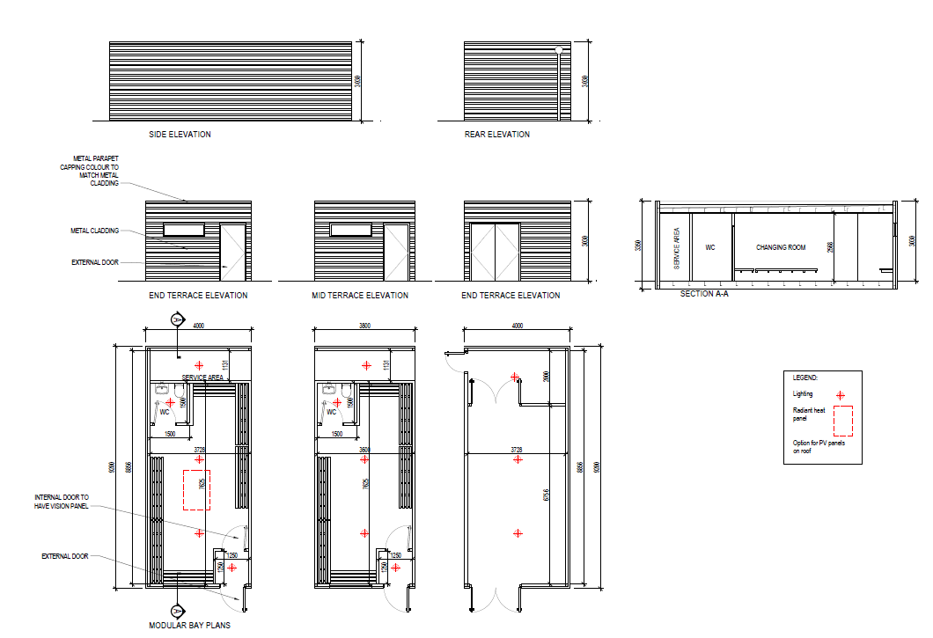
Fig 1: Modular Units: Examples of Changing and Storage Bay units shown.

Table 1: PAVILLION PROGRAMME PROPOSED LOCATIONS
Location | Programme Status | Funding | Planning Status |  | Comment | Programme review
Griffeen Valley. | Part of Current Programme. | 260,000 and 350,000 in Sports Capital Grants | Part 8 complete November 2019. | 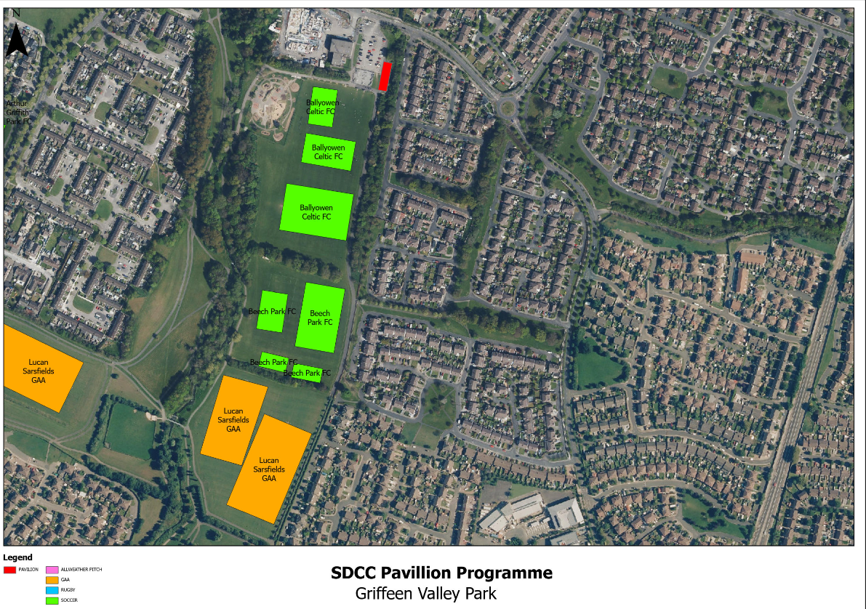 | Required, proceed.  Modular system: 8 Bays (6 change, 2 storage) | Proceed
Corkagh Park | Part of Current Programme. | 300,000 and 250,000 in Sports Capital Grants | Part 8 completed July 2020. | 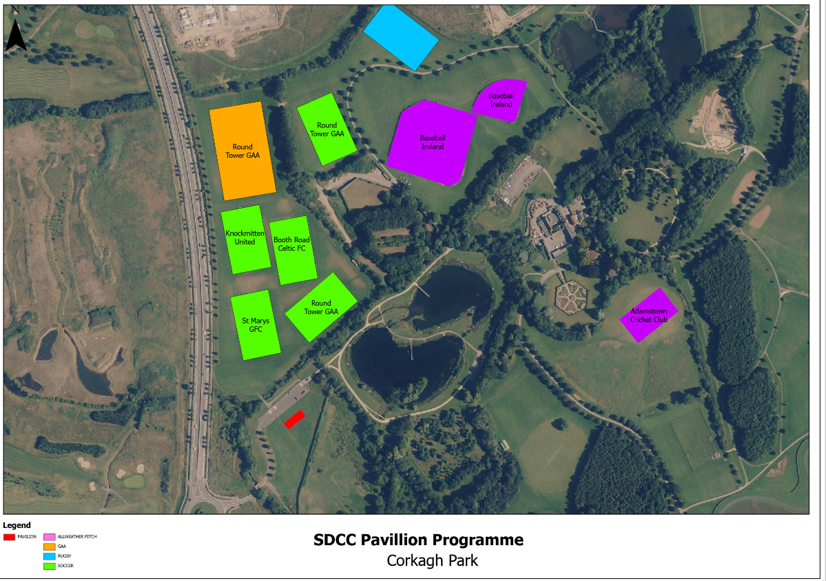 | Required, proceed.  Modular system: 8 Bays (6 change, 2 storage) | Proceed.
Dodder Valley Mt Carmel. | Part of Current Programme. | SCP 20 €259,458 (70% grant only)  2nd grant applied for in 2023, awaiting result. | Part 8 complete. | 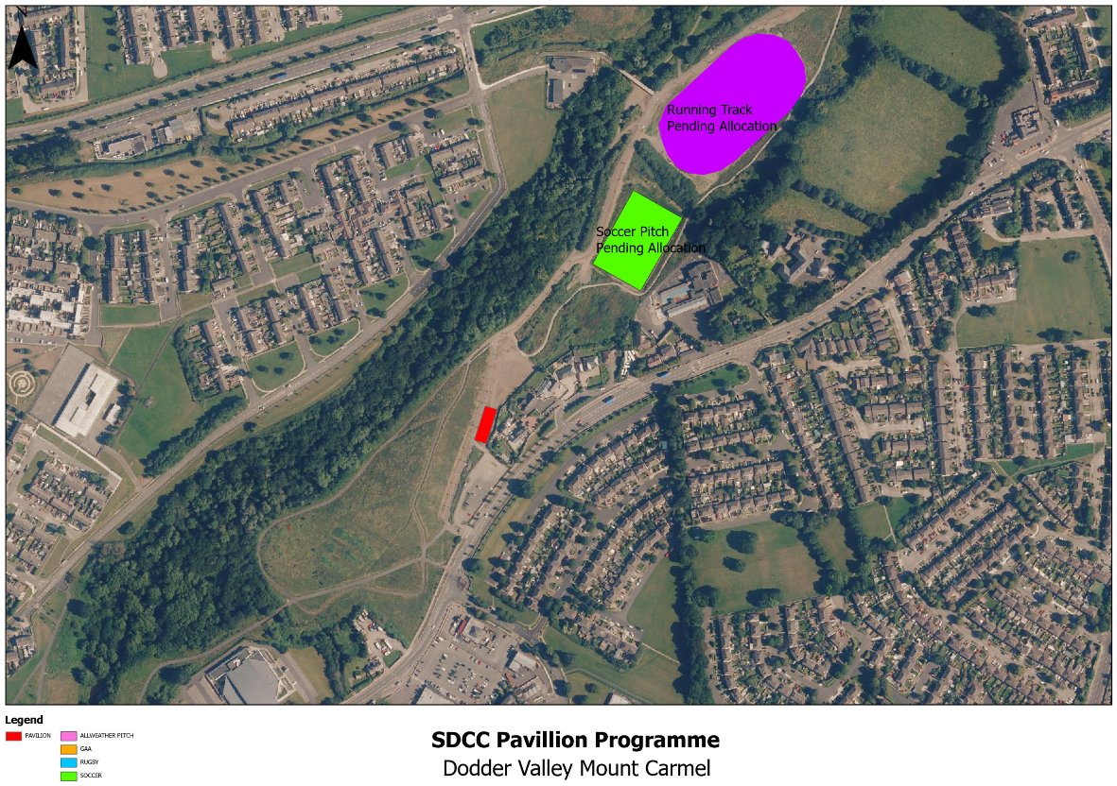 | Required, proceed.  Modular system: 4 Bays (2 change, 2 storage) | Proceed.
Tymon Park South | Part of Current Programme. | No SCG in place. | Part 8 required | 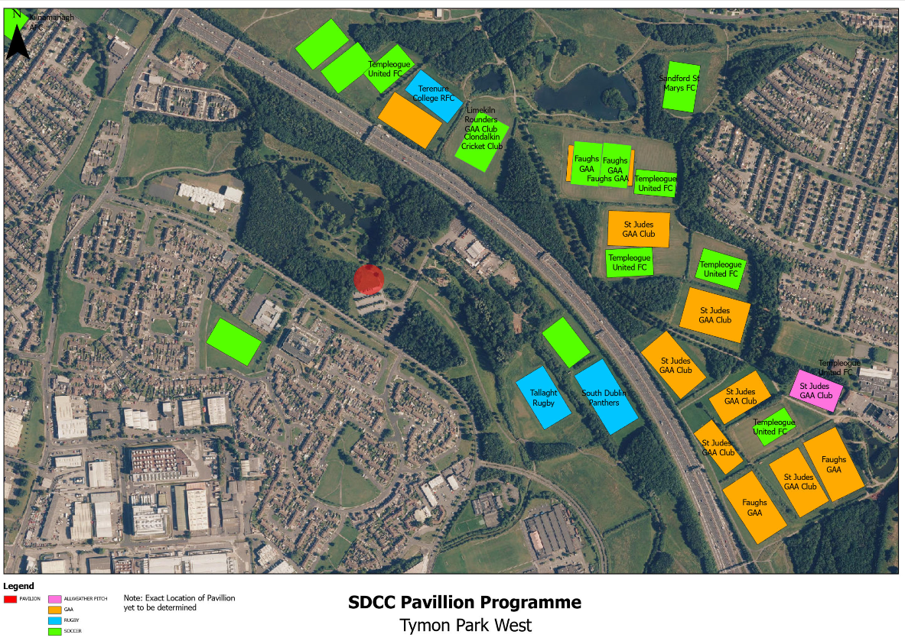 | See location map, original location to be reviewed at Part 8 stage.  Required, proceed.  Modular system: 4 Bays (2 change, 2 storage) | Proceed.
Collinstown Park: | Part of Current Programme. | SCG 18 Grant: 225,000 (70% grant only)  SCP 20 Grant: 230,905. (70% grant only) | Part 8 required | 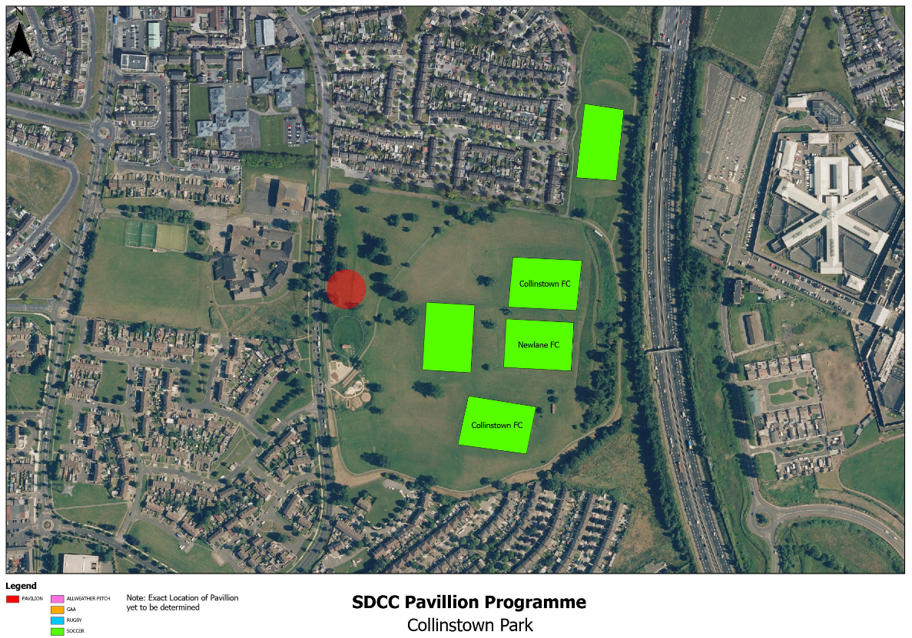 | Required, proceed.  Modular system: 3 Bays (2 change, 1 storage) | Proceed.
Griffeen Valley Arthur Griffith Park | Part of Current Programme. | No SCG in place. | No Part 8 in place | 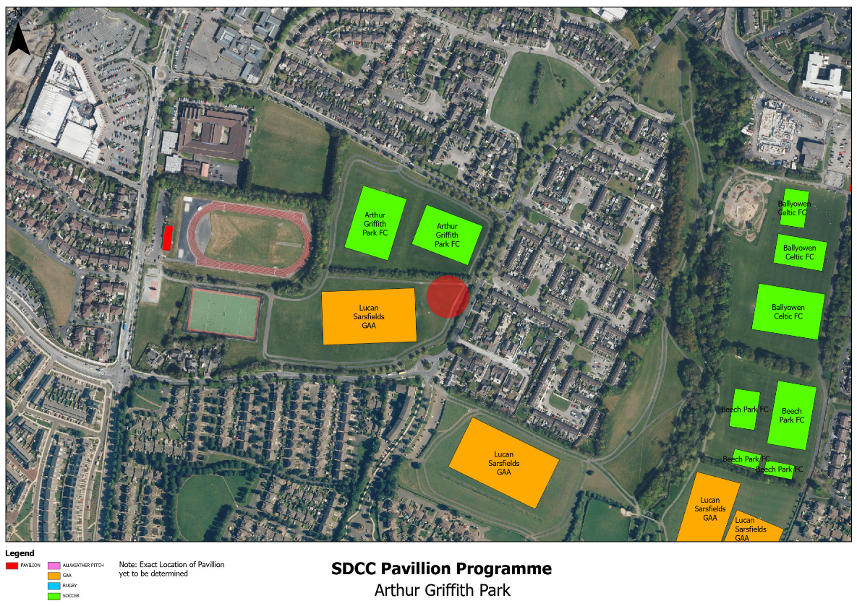 | Required, proceed.  Modular system: 3 Bays (2 change, 1 storage) | Proceed.

NEW LOCATIONS PROPOSED: |  |  |  |  |  | Programme Review
Kilnamanagh | Under consideration. | No SCG in place. | No part 8 in place | 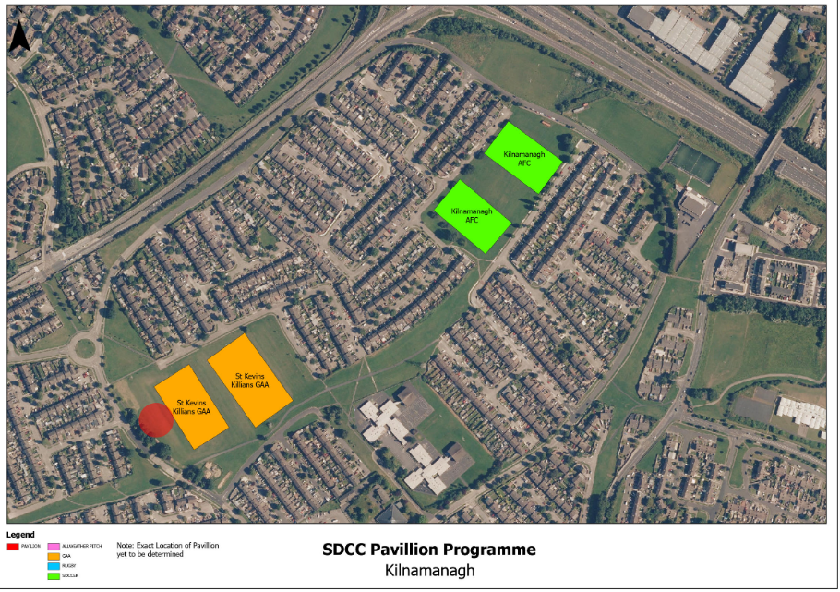 | Proceed:  Modular system: 3 Bays (2 change, 1 storage) | Add to programme
Willsbrook Park | Under consideration. | No SCG. | Part 8 required. | 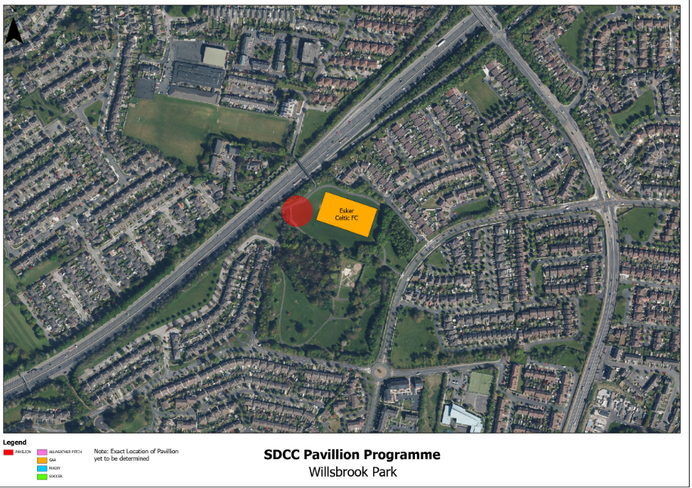 | Proceed:  Modular system: 3 Bays (2 change, 1 storage) | Add to programme
Kiltipper Park | Under consideration. | No SCG. | Part 8 required | 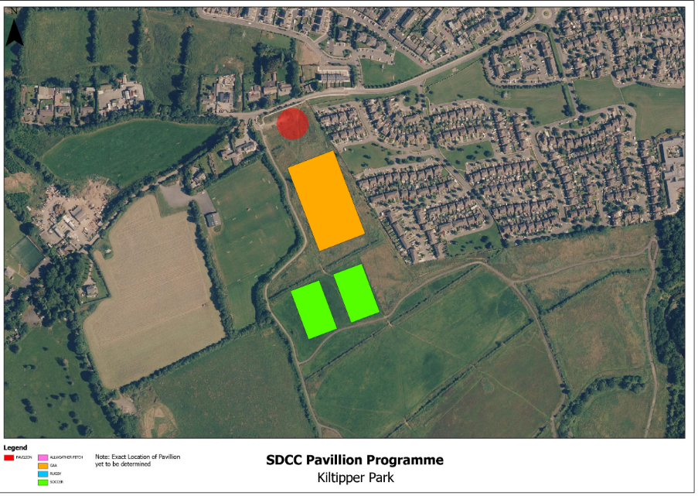 | See location map, may be adjusted at Part 8 stage.  1 GAA pitch and 2 soccer pitches have Part 8 approval and SCG funding  Modular system: 3 Bays (2 change, 1 storage) | Add to programme
Sean Walsh Park Artificial Grass Pitch location | 3G pitch programme Location | No SCG. | Part 8 required | 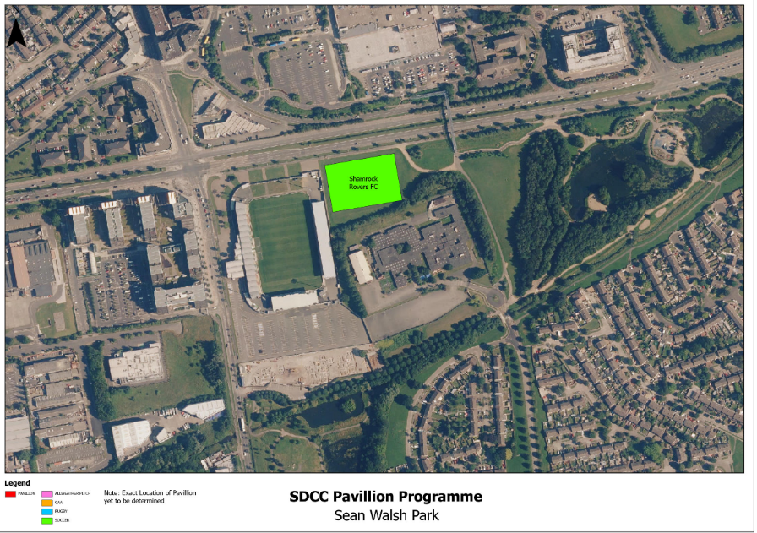 | See location map, exact location may be adjusted at Part 8 stage.  Modular system: 3 Bays (2 change, 1 storage) | Add to programme

SDCC’s Artificial Grass Pitches (AGP):

SDCC are currently delivery a programme of Artificial Grass Pitches across the county. To date, this has seen the delivery of facilities at Airlie Park, (which has an existing changing room pavilion included in the park build) and Sean Walsh Park. Other locations proposed include the east and west of the county and Clonburris SDZ area. Modular system changing rooms are proposed for delivery in tandem with the 3G Artificial Grass Pitch programme delivery. In practical terms this will include additional provision at the existing facility at Sean Walsh Park and, (depending on location) at the proposed facilities in the east and west of the county, (if there are no existing facilities available). Airlie Park contains changing rooms, and park pavilions are proposed to be provided as part of the Clonburris SDZ Infrastructure delivery.
It is proposed that changing room pavilions be delivered as ancillary facilities in tandem with the delivery of the 2 No. AGPs in the east and west of the county going forward, and that these are proposed to be funded under the Astro Pitch Programme budget heading.
It is further recommended to provide a changing facility at the existing Sean Walsh Park Artificial Grass Pitch; to be funded as part of this programme.

Existing Changing Room Locations:

SDCC have several existing changing room facilities under direct management, and it is recommended to continue efforts to maximise their usage and make these available, where capacity exists, to a wider number of groups and clubs:

- Corkagh Park St. John’s Road
- Tymon Park TASC pavillion
- Ballymount Park
The current model of delivery for the pavilion programme includes an Access and Booking System, which is working well to allow a variety of clubs and groups to use the facilities in an efficient manner. It is proposed to upgrade and retro-fit existing changing room pavillions under SDCC management, including appropriate access systems to bring them back to maximum and optimal usage and allow them to be integrated into the Access and Booking System. This will facilitate their increased use by a variety of clubs and groups in each local area. A budget provision is also proposed for this upgrade and retrofit as part of this programme.

Recommendation and Programme:

It is recommended to proceed with the following locations as per the programme below:

Priority List
- Griffeen Valley Park (Part 8 in place).
- Corkagh Park ORR (Part 8 in place).
- Collinstown Park
- Kilnamanagh open space
- Sean Walsh Park Artificial Grass Pitch
- Dodder Valley Mt Carmel (Part 8 in place).
- Griffeen Valley Arthur Griffith Park
- Tymon Park South (deliver in tandem with upgrade of 3 pitches).
- Kiltipper Park
- Willsbrook Park
(Locations in Bold indicate previous programme)

Criteria for Selection:

- Provision of facilities based on size of open space and number of pitches accommodated.
- Nos of clubs / community groups to be accommodated
- Nos of teams
- Nos of players
- Evidence of need
- Facilitation of increased access to sport, particularly for groups with historically low representation
- County-wide spread
- Existing Sports Capital Grants
- Lack of alternative facilities in the area e.g. no alternative community / changing facilities in the area.

The following list shows clubs allocated facilities or regular events at each location for the 2024 season:

- Griffeen Valley Park: Park facilities currently allocated to: Lucan Sarsfields, Ballyowen Celtic FC, Beech Park FC. Park Run Event every Saturday.
- Corkagh Park ORR: Park facilities currently allocated to: Round Towers, Knockmitten United, Na Gaeil Óga, Adamstown Cricket Club, Baseball Ireland. Park Run Event every Saturday.
- Collinstown Park: Park facilities currently allocated to: Knockmitten United, New Team from Sept 2024 TBC.
- Kilnamanagh open space: Park facilities currently allocated to: St. Kevins Killian's GAA
- Dodder Valley Mt Camel: Park facilities currently allocated to: Pearse Bros AC, Soccer Pitch Allocation (TBC)
- Sean Walsh Park AGP location: Park facilities currently available to all clubs in the county, 12 clubs on allocation, 1 school with daily use, 10 – 15 regular users on first come first served basis from local clubs. Increase in event applications for tournaments.
- Kiltipper Park: Park facilities proposed and under tender for construction: 1 GAA pitch, 2 soccer pitches
- Griffeen Valley Arthur Griffith Park: Park facilities currently allocated to: Arthur Griffith FC, Lucan Sarsfields, Lucan Harriers, Weston Hockey, Griffeen Valley Petanque Club.
- Willsbrook Park: Park facilities currently allocated to: Esker Celtic FC
- Tymon Park South (deliver in tandem with upgrade of 3 pitches): Park facilities currently allocated to: Panthers, Tallaght Rugby, Greenhills Archers Club
Artificial Grass Pitches (AGP):

Modular systems changing rooms will also be considered for delivery in tandem with the 3G Artificial Grass Pitch programme delivery and will be proposed to be delivered as ancillary facilities in tandem with the delivery of AGP going forward. These are proposed to be funded under the Astro Pitch Programme heading.
It is further recommended as part of this programme to provide a changing facility at the existing Sean Walsh Park Artificial Grass Pitch due to its popularity.

Procurement:

It is the intention to offer the overall programme to the market for tender to form a framework via a public procurement process for the manufacture of the pavilion buildings off site and delivery to each location.
A separate tender may be carried out to deliver the required civil works on site.

Costings:

Offering the overall programme to the market for tender should allow for reduced costs in construction due to a standardised design model, bringing the delivery of the expanded programme of pavilion buildings back within a more acceptable cost range for sports capital grants that have been received or are likely to be applied for. (Current maximum sports capital grant for a local facility is €200,000 as per 2023 grant application process).

Funding and Budget:

SDCC has been awarded the following Sports Capital Grants which contribute to the capital budget available:
- Griffeen Valley Park €610,000 SCG grant awarded
- Corkagh Park ORR €550,000 SCG grant awarded
- Collinstown Park €455,905 SCG grant awarded
An additional application for funding has been made for a 4th pavillion:
- Dodder Valley Mt Carmel Partially SCG grant funded €259,458.00. (2nd application in 2023 awaiting result)
SDCC allocated €2,000,000 in 2023 for the 2024-2026 capital budget. Total Grants available currently amount to €1,875,363

This review proposes an expanded and accelerated programme, incorporating an upgrade of existing facilities to bring them into increased use, and an additional €4,800,000 is proposed to be included in the capital programme to deliver the expanded programme as set out above in 2024-2025.

SDCC will continue to seek funding for the programme going forward. SDCC’s Sports Pitch Strategy envisaged that funding may come from a wide variety of bodies including Governing Body and / or Club contributions, which could be considered on a case-by-case basis. However, regardless of funding contributions, it must be reiterated that any sporting facilities provided within public parks and open spaces will remain in the management of SDCC and thus available to the general public and not become exclusionary in use (in order to accommodate the widest variety of use possible and ensure value for public money).

Preliminary Outline Programme*:

1. Approval
April 2024: Approval of Programme Review and Recommendation by Council.

2.1 Planning
May 2024-Oct 2024: Part 8s for Collinstown, Kilnamanagh, Sean Walsh Park, Arthur Griffith Park, Tymon Park South, Kiltipper Park, Willsbrook.
*May need separate Part 8 process.

2.2 Procurements
May- August 2024: Framework Tender in place for Modular Buildings Framework using Corkagh Park and Griffeen Park locations.
May- August 2024: Framework Tender for Civil Work

3. Civil Works and Modular Manufacture / Installation and Finishes
September 2024 Contractor Mobilisation.
October 2024- December 2024: Civil Works at Griffeen Park & Corkagh Park and Simultaneous Modular Manufacture.
January 2025-February 2025: Modular Installation at Griffeen Park & Corkagh Park.
March / April 2025 : Expected completion of facilities at Griffeen Park & Corkagh Park.

Remaining approved locations ordered and delivered on foot of the establishment of the two frameworks, after Part 8 approval: (estimated 28-week (approx.) programme of civil work/ modular manufacture/ delivery/ finishes using the frameworks once established).

*Dates are subject to change because of unforeseen events during planning, procurement, manufacture and construction processes.

Operational Model for the facilities:
There have been several operational models trialled over the years in relation to changing facilities. To maintain flexibility in provision and ensure changing facility provision to as many clubs as possible, in line with SDCC’s Sports Pitch Strategy it is proposed to retain the management of the facilities by the council. SDCC have put in place an effective booking system that allows the changing facilities to be booked on-line. This is working effectively at Dodder Valley Park, Old Bawn. The main difference between that site and the sites proposed in this Review is that the pitches at Old Bawn are also available to be booked with the facility.
The other proposed facilities will be provided at locations that pitches are allocated to local clubs on an annual basis. This pavilion proposal will allow clubs with allocated pitches adjacent to the pavillions to book preferred changing room slots (subject to co-ordination by SDCC and availability of slots between these local clubs). Any remaining slots will be available to be booked by other clubs / teams / groups for other uses .e.g. park runs, yoga, orienteering etc. This proposal will be subject to review during the operational stage to ensure on-going effectiveness of facility provision.

February / March 2024
SDCC have met with all clubs that currently are allocated pitches and facilities in the parks where the pavilions are proposed, all have indicated support for the proposal and a need for such facilities.

Fig 2: Map of existing and proposed park pavilion locations across the county:
