COMHAIRLE CHONTAE ÁTHA CLIATH THEAS
SOUTH DUBLIN COUNTY COUNCIL

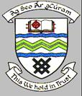

MEETING OF TALLAGHT AREA COMMITTEE (1)

Monday 19th June 2006

Question No. 11
Question: Councillor M. Murphy
"To ask the Manager what is planned to be done with the land where the temporary halting site used to be opposite Glenview Lawns?"

REPLY:

It is proposed that these lands will be reinstated as parkland and incorporated into the Dodder Valley Park.

