Proposed Development of Brine Saturation Facility at the Existing Palmerstown Depot, Adjoining the Deadman’s Inn, Lucan Road Old, Dublin 20.
Part VIII Report

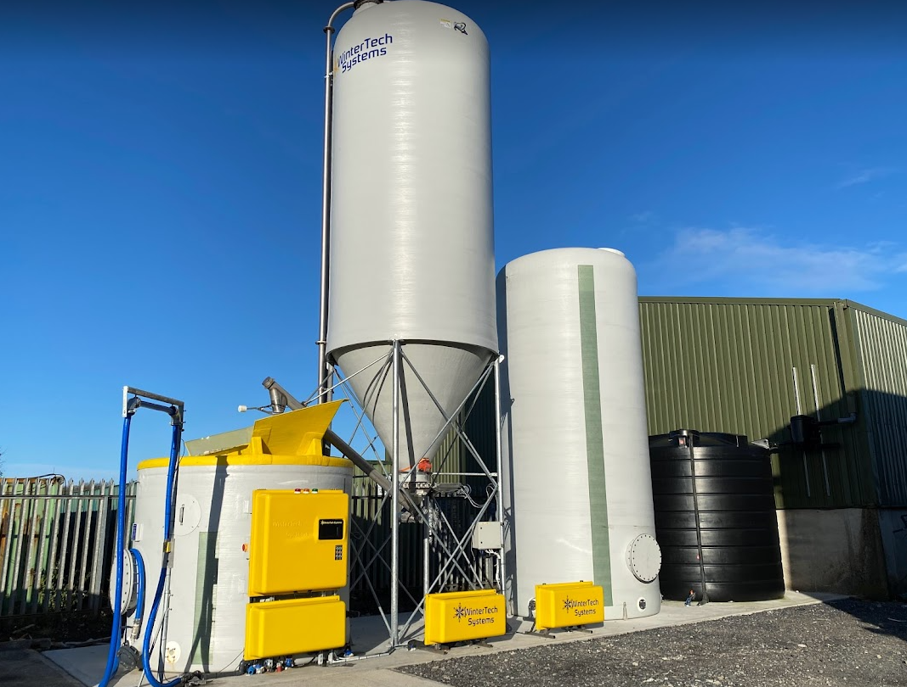

Process under PLANNING & DEVELOPMENT ACT 2000 (AS AMENDED) PUBLIC CONSULTATION PROCEDURE UNDER PART 8 OF THE LOCAL GOVERNMENT (PLANNING & DEVELOPMENT) REGULATIONS 2001 (AS AMENDED).

Introduction
South Dublin County Council currently carry out winter maintenance on over 300km of it’s road network using a dry treatment known as rock salt. To improve the efficiency of this process it is proposed to convert to a pre-wet treatment by introducing brine into the treatment. To enable this conversion, it is proposed to construct a Brine Saturation Facility at the current Salt Depot at Old Dublin Road, Dublin 20.

Site Location
The proposed development is located at the existing Salt Depot located to the North of Junction 2 on the N4, beside the Deadman’s Inn. This proposal is relevant only to the area immediately south east of the existing barn and covers an area of 0.03 hectares. The specific location is outlined in the attached Drawing LA/11/23.
The site has Part VIII for the construction of a Mechanical Depot. This proposal is designed so as to have no impact on the delivery or functionality of the Mechanical Depot.

Proposals
There is an existing barn for storing rock salt at the Salt Depot in Palmerstown. To the southeast of this it is proposed to construct the Brine Saturation Facility.
The facility will consist of;
- Water tank (will harvest rainwater from existing barn)
  - Estimated dimensions: 3.5m diameter, 5m height
- Brine storage tank
  - Estimated dimensions: 3m diameter, 6m height
- Salt Silo
  - Estimated dimensions: 3m diameter, 10m height
- Brine Saturator (width:3m, depth: 3m, height: 2.5m)
  - Estimated dimensions: 3m wide, 3m depth, 5m height

The whole facility will be constructed on a raised concrete plinth.
A cesspool will be constructed to store any brine run-off.
The facility is to be a sealed unit to prevent any contaminants entering the process and it will be fitted with anti-siphon valves and leak detection alerts.

What is Brine and How is it Used
The Brine Saturation Facility function is
- Harvest rainwater from the existing barn
- Store a fine white salt in the salt silo
- As required it will mix water and salt in the saturator to form a solution (23% salt, 77%% water) which is brine
- Brine is stored in the brine tank and from there loaded on to tanks fitted to the side of our gritters.
- During a treatment run we will now spread rock salt and also spray brine
Benefits of incorporating Brine
- Significant environmental benefits - less salt being spread resulting in less environmental impact and less salt in the water table.
- Significant Financial benefits arising out of the reduction in the amounts of salt being applied in given winter situations
- Reduction in Salt Haulage Costs as frequency of salt delivery reduced, also contributing to reduction in our carbon footprint
- More efficient salting operation arising from the reduction in the spread of salt outside the target zone (carriageway lanes). More longevity on the road surface.
- Greater operational efficiency as prewet technologies will result in an increase in residual salt levels therefore leading to a reduction in treatment runs. More effective in severe weather and lower temperatures. Prewet can be applied two days before snow arrives.
- Improvement in the quality of the road environment through a reduction in the use of salt

Environmental Screening Reports
The proposal has undergone Appropriate Assessment (AA) Screening under the Habitats Directive (92/43/EEC) and Environmental Impact Assessment (EIA) Screening under the EIA Directive (2014/52/EU).
The authority has concluded that there is no likelihood of significant effects on the environment arising from the proposed development and a determination has been made that an AA and EIA are not required. Any person may, within 4 weeks from the date of publication of this notice, apply to An Bord Pleanála for a screening determination as to whether the development would be likely to have significant effects on the environment.

Land Zoning
Under the “South Dublin County Council Development Plan 2022 – 2028”, the lands are zoned – Zoning Objective HA (LV, DV, DM) with an objective ‘To protect and enhance the outstanding natural character and amenity of the Liffey Valley, Dodder Valley and Dublin Mountains areas.’

The proposed development is a public services facility, which is a permitted use under the South Dublin County Council Development Plan 2022 – 2028. The facility relates to the provision of essential public transport related services, strategically located at the intersection of two important road networks: the N4 National Primary Road and the M50 motorway, which are an essential part of South Dublin County Council’s and the greater Dublin areas communication network.

Projected Timeline
- Public Consultation: 21/12/2023 – 15/02/2024
- Part VIII Report Preparation: 18/02/2024 – 29/02/2024
- Part VIII Approval: March 2024
- *Procure Design and Build Contractor: April 2024
- *On Site Construction: September 2024
- *Project Complete: October 2024
*Subject to Part VIII Approval

Public Consultation Process
Public Consultation
A public consultation was held from 21/12/2023 – 15/02/2024.
In accordance with the Part VIII process the following statutory notifications were provided;
- Notices erected on site
- Notice placed in Newspaper Advertisement (The Echo)
- Notification to prescribed bodies, access groups and local schools.

In addition to the required notifications the public consultation was
- Presented at the December ACM
- Advertised through SDCC social media channels.

Submissions
Zero submissions were received as part of this Part VIII public consultation

Recommendation
It is recommended that Part VIII approval is granted for the construction of a Brine Saturation Facility at the existing Salt Depot at the Old Dublin Road, Dublin 20.

