**South Dublin**

**County Development Plan**

**Core Strategy Annual Monitoring Report - 2023**

**Introduction:**

The South Dublin County Development Plan 2022-2028 was made on the 22nd of June 2022 and came into effect on the 3rd of August 2022. In line with the provisions of ‘Development Plans – Guidelines for Planning Authorities’ published in July 2022 planning authorities will need to establish a strong, frequent and ongoing monitoring system for their development plan as a permanent function.

The Guidelines set out two strategic elements in monitoring the development plan:

1. Core Strategy Monitoring

This element of monitoring is recommended to be reported on annually

1. Plan Objectives Monitoring (including SEA monitoring).

The guidelines indicate that this element of monitoring should be subject to reporting on every two years

This report details part A, the annual ‘Monitoring the Core Strategy’ of the plan, in this case over the 4 quarters between the end of Q2 2022 to the end of Q2 2023.

**Annual Core Strategy Monitoring Overview:**

The development plan has a primary role in land use and spatial development policy including the provision of new housing development. The monitoring role must provide a focus on development patterns occurring under the settlement strategy of the development plan and the tracking of the nature of new development that is occurring. It is therefore critical that these planning and development trends are reported on and analysed spatially, with accompanying mapping, to illustrate the development trends being experienced at settlement level and to assess the consistency of such trends with the agreed housing and population targets as set out in the core strategy of the development plan.

The data required for successful monitoring will be a mixture of information available in the local authority (e.g. from the development management function) and from external/independently provided sources (eg. CSO).

**Core Strategy Monitoring Content:**

The guidelines set out that the monitoring of the Core Strategy should be broken down under the headings of Residential, Commercial and Settlement Consolidation Areas. To accord with that structure this report has been structured as follows:

**Part 1 Residential Monitoring:**

* 1. New home completions
  2. New home completions per NPO 3 (see below)
* *Deliver at least 40% of all new homes nationally, within the built-up footprint of existing settlements*
* *Deliver at least half (50%) of all new homes that are targeted in the five Cities and suburbs of Dublin, Cork, Limerick, Galway and Waterford, within their existing built-up footprints*
* *Deliver at least 30% of all new homes that are targeted in settlements other than the five Cities and their suburbs, within their existing built-up footprints*

**1.3 Planning permissions granted for residential development with:**

*(i) A breakdown of 1, 2 ,3 and 4+ units permitted and (ii) A breakdown per Tier 1 and Tier 2 lands*

**1.4 Social and Affordable Housing Supply Pipeline during the plan period**

**1.5 The breakdown by relevant rural area type of rural housing:**

*(i) Planning Applications lodged, (ii) Breakdown in decisions, (iii) New home completions*

**Part 2 Commercial Monitoring:**

* 1. **Developed and occupied commercial floorspace**

**2.2 Planning permissions for business/employment**

*(i) Office*

*(ii) Industrial*

*(iii) Retail*

*(iv) Warehousing/Logistics*

**Part 3 Settlement Consolidation Sites:** Specific reporting on the progression of the Settlement Consolidation Sites[1] identified in the development plan. This includes information on enabling infrastructural services delivery, planning permissions granted, housing constructed, funding applications made, project timelines, Vacant Site Levy commentary, etc.

**Part 1: South Dublin Residential Monitoring:**

* 1. **New home completions Q2 2022 to Q2 2023**

**1.1.1 Private Housing Delivery**

Since the making of the South Dublin County Development Plan there have been 2,024 units completed within private housing developments. This is broken down across 66 private housing developments totalling 1,985 Units with a further 39 Units delivered in the form of single/Infill type dwelling units.

**Dublin City and Suburbs Highlights:**

The Templeogue Neighbourhood Area has delivered c. 38% of its housing target with the completion of 590 units along Scholarstown Road accounting for the majority of this growth. The Lucan/Adamstown/ Palmerstown Neighbourhood Area has delivered 25% of its growth with 669 units completed. Development within Palmerstown area accounted for 73 completed units while the vast majority of the remaining completions within the Lucan/Adamstown/Palmerstown Neighbourhood were located within the Adamstown SDZ totalling 587 Units.

**Newcastle Self-Sustaining Growth Town Highlights:**

The Self Sustaining Growth Town of Newcastle has delivered 157 units within the first year of the plan being adopted. The vast majority of these units were delivered through SHD3ABP-305343-19 totalling 144 units at Newcastle South and Ballynakelly.

The breakdown of units completed in each of the Neighbourhood Areas identified within the County Development Plan is set out below in Table 1.

**South Dublin County Development Plan Core Strategy Map 2022-2028**

|  |  |  |  |  |  |
| --- | --- | --- | --- | --- | --- |
| **Neighbourhood Area** | **Target 2022 - 2028 Units** | **Q2 2022 - Q2 2023** | **Q2 2023 Permitted Remaining**  **Not Commenced or Under Construction** | **Percentage of Target Delivered** | **Remaining Units** |
|  |  |
| **Units Completed** | **Units NC or UC** |
| **Tallaght** | 1865 | 59 | 22 | 3% | 1806 |
| **Naas Road/City Edge** | 1010 | 0 | 0 | 0% | 1010 |
| **Templeogue/Walkinstown/Rathfarnham** | 1677 | 632 | 66 | 38% | 1045 |
| **Clondalkin, Clonburris, Grangecastle** | 5189 | 355 | 625 | 7% | 4834 |
| **Lucan/Adamstown/Palmerstown** | 2673 | 669 | 817 | 25% | 2004 |
| **Citywest** | 2113 | 112 | 630 | 5% | 2001 |
| **Newcastle** | 398 | 157 | 0 | 39% | 241 |
| **Rathcoole** | 487 | 1 | 0 | 0% | 486 |
| **Saggart** | 165 | 0 | 0 | 0% | 165 |
| **Rural Neighbourhood** |  | 39 |  |  |  |
| **Total** | 15577 | 2024 | 2160 | 14% | 13592 |

**Table 1: Breakdown of private units completed by each of the Neighbourhood Areas identified within the County Development Plan**

**1.1.2 Part 8 Residential Delivery Programme:**

In addition to the private housing delivery within the County, 221 units have been completed through the Part 8 process or Local Authority development e.g Kilcarbery. Part 8 Developments provided for 58 housing units and 27 apartments (which may include duplex units) with Kilcarbery providing a further 114 housing units and 22 apartments. The delivery of Part 8 and Council affordable homes during this period was particularly prominent in the Clondalkin, Clonburris, Grangecastle Neighbourhood Area which accounted for 90% of SDCC’s delivered units. This reflects the significant level of development and construction activity at Kilcarbery-Grange, a new sustainable community of over 1,000 homes. Development within this development commenced in May 2021. Table 2 below provides a breadown of Part 8 Housing Completions since the adoption of the plan.

***Kilcarbery Grange***

|  |  |  |  |  |
| --- | --- | --- | --- | --- |
| **Neighbourhood Area** | **Scheme Name** | **Units Completed Q2 2022 Q2 2023** | **Houses** | **Apartments** |
|  |  |  |  |  |
| Clondalkin | **Riversdale (Mayfield)** | 25 | 13 | 12 |
| Clondalkin | **St. Marks Avenue** | 38 | 38 |  |
| Clondalkin | **Kilcarbery** | 136 | 114 | 22 |
| Templeogue/Walkinstown | **Riverside Cottages** | 10 |  | 10 |
| Tallaght | **St. Catherines** | 12 | 7 | 5 |
| **Total** |  | **221** | **172** | **49** |

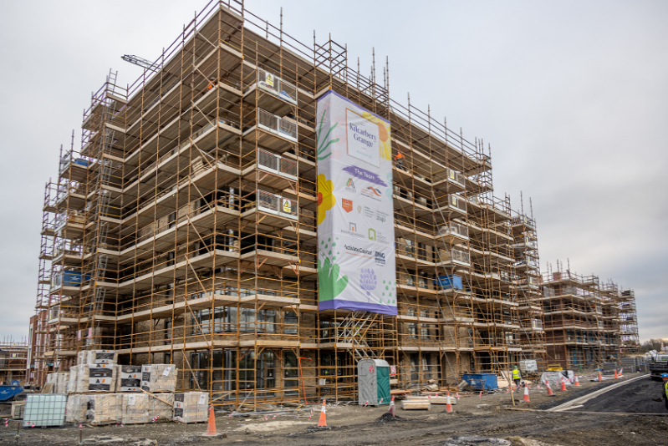  
**Table 2: Part 8 Residential Completions**

* + 1. **Total Housing Delivery**

Taking the private and public housing delivery for the period end of Q2 2022 to the end of Q2 2023 a total of 2,245 Units were delivered across the County during this period. The breakdown by area of this level of development is set out below in Table 3. The County Development Plan Core Strategy set out an overall target of delivering 15,576 units over the plan period. Overall unit delivery within year 1 of the plan equates to 14% of the target set out in the plan as set out below in Table 2.

|  |  |  |  |  |
| --- | --- | --- | --- | --- |
| **Neighbourhood Area** | **Target 2022 - 2028 Units** | **Q2 2022 - Q2 2023** | **Percentage of 6 Year Target Delivered** | **Remaining Units** |
|  |
| **Units Completed** |
| **Tallaght** | 1865 | 71 | 4% | 1794 |
| **Naas Road/City Edge** | 1010 | 0 | 0% | 1010 |
| **Templeogue/Walkinstown/Rathfarnham** | 1677 | 642 | 38% | 1035 |
| **Clondalkin, Clonburris, Grangecastle** | 5189 | 554 | 11% | 4635 |
| **Lucan/Adamstown/Palmerstown** | 2673 | 669 | 25% | 2004 |
| **Citywest** | 2113 | 112 | 5% | 2001 |
| **Newcastle** | 398 | 157 | 39% | 241 |
| **Rathcoole** | 487 | 1 | 0% | 486 |
| **Saggart** | 165 | 0 | 0% | 165 |
| **One Off Infill Houses** |  | 39 |  |  |
| **Total** | 15577 | 2245 | 14% | 13371 |

***Table 3. Total Private and Public Housing Delivery***

While this figure is slightly below the CDP average target of 2,596 units per year, Housing Supply data for the County indicates that there are 37 Active Sites with 782 housing units and 2,982 apartment units under construction. 11 of the 37 active sites comprise of developments which are 100% under construction and set to deliver 75 houses and 1,201 apartments while a further 8 sites comprise of developments which are 75% under construction with the potential to deliver a further 1,113 houses and 553 apartments. Given the level of activity and proportion of permissions for apartment developments which take a longer period to deliver, it is expected that year 2 of the plan should see an uplift in delivery particularly in the delivery of apartments.

**Active Sites**

**Apartment Units Permitted and under construction**

**Housing Units Permitted and under construction**

While there is a significant level of Activity within the County, Housing Supply Data indicates that there are 42 sites (schemes with 10 or more units) with planning permission which are inactive.

**1.2 Delivery within Dublin City and Suburbs**

**City & Suburbs**

It is an objective of NPO3 of the National Planning Framework to deliver at least 50% of all new homes in Dublin City and Suburbs within the existing built-up footprint. Data relating to completed units within the County as set out in Table 3 above shows a total unit delivery of 2,245 units from both private and public/part 8 developments. A spatial breakdown of these units indicates that 1,936 or 86% of these units were located within the settlement area of Dublin City and Suburbs.

The area of Citywest/Fortunestown falling partly within and immediately contiguous to the Dublin City and Suburbs Boundary provided for a further 112 units (5%) during the first year of the plan which, if combined with the city and suburbs area total, would provide for an overall total of 91% of completed developments being located within or contiguous to the Dublin City and Suburbs Boundary, exceeding the 50% target as shown in the map opposite.

**Citywest/Fortunestown**

**1.3 Planning Permissions Granted for residential development during the first year of the plan:**

SDCC House Count Data indicates that there was a total of 4,530 units permitted during the first year of the plan comprising of 1,976 houses and 2,554 apartment units. Table 4 below provides a breakdown of units permitted by Neighbourhood Area.

**Housing Units**

The Planning Department has commenced the collection of data on bedroom breakdown to inform monitoring. This is currently a manual exercise as the data is not easily collated. The Data below shows the potential for a significant pipeline of 3 bed houses in the Lucan, Clondalkin and Tallaght Neighbourhoods. There is a predominance of 1 and 2 bed units in apartment developments in all Neighbourhood Areas particularly Lucan/Palmerstown/ Adamstown reflecting the development of the SDZ and Village Centre lands in Palmerstown, Citywest/Fortunestown and Clondalkin within the Clonburris SDZ.

**Apartments**

|  |  |  |  |  |  |  |  |  |  |  |  |  |  |  |  |  |
| --- | --- | --- | --- | --- | --- | --- | --- | --- | --- | --- | --- | --- | --- | --- | --- | --- |
|  | **Q2 2022 - to Q2 2023 Core Strategy Neighbourhood Areas** | **Units Permitted** | **Housing Units Permitted** | **Housing Mix** | | | | | | **Apartment Units Permitted** | **Apartment Mix** | | | | | |
| **Sites** |  | **Units** |  | **studio** | **1-bed** | **2-bed** | **3-bed** | **4-bed** | **5-bed** |  | **studio** | **1-bed** | **2-bed** | **3-bed** | **4-bed** | **5-bed** |
| 10 | CITYWEST NEWCASTLE SAGGART RATHCOOLE | 769 | 176 (23%) | 0 | 0 | 47 | 120 | 9 | 0 | 593 (77%) | 0 | 150 | 365 | 78 | 0 | 0 |
| 14 | CLONDALKIN CLONBURRIS GRANGECASTLE | 1183 | 374 (32%) | 0 | 6 | 15 | 295 | 42 | 0 | 809 (68%) | 0 | 207 | 378 | 140 | 0 | 0 |
| 15 | LUCAN PALMERSTOWN ADAMSTOWN | 1842 | 928 (50%) | 0 | 1 | 141 | 608 | 176 | 0 | 914 (50%) | 9 | 304 | 413 | 188 | 0 | 0 |
| 9 | TALLAGHT | 674 | 441 (65%) | 0 | 1 | 3 | 404 | 33 | 0 | 233 (35%) | 0 | 21 | 165 | 47 | 0 | 0 |
| 19 | TEMPLEOGUE WALKINSTOWN RATHFARNHAM | 62 | 57 (92%) | 0 | 10 | 17 | 22 | 7 | 1 | 5 (8%) | 0 | 4 | 1 | 0 | 0 | 0 |
| 0 | Naas Road | 0 | 0 | 0 | 0 | 0 | 0 | 0 | 0 | 0 | 0 | 0 | 0 | 0 | 0 | 0 |
| 67 | Totals | 4530 | 1976 | 0 | 18 | 223 | 1449 | 267 | 1 | 2554 | 9 | 686 | 1322 | 453 | 0 | 4530 |

**Table 4: Permitted Units and Bedroom Breakdown**

**Breakdown of permissions by Neighhbourhood Area:**

The following Tables 5-8 provide the breakdown of permissions by Neighbourhood Area. Included in each of the tables is the planning register reference number, the tiering[2] applied to lands during the County Development Plan process, the neighbourhood name, units permitted and the breakdown of the housing and apartment mix. This Data has been gathered through South Dublin County Council’s own house count system. The house count system monitors the progression of sites from planning permission to commencement and finally completion. A new addition to this work has included the detailing of the unit types permitted, houses or apartments alongside the number of bedrooms permitted.

**Of overall County Permissions**

**Citywest Saggart, Newcastle and Rathcoole Neighbourhood Area**

The Citywest, Saggart, Newcastle and Rathcoole Neighbourhood Area accounts for 17% of overall permissions granted during the first year of the plan. A significant level of this development is focused in the Citywest/Fortunestown LAP Area with LRD23A/0001 providing for 378 Units. SHD3ABP-312501-22 located along Mill Road in Saggart makes up the second largest Development providing for 266 units. The Ratio of Houses to Apartments permitted within this Neighbourhood equates to 1:3.4 with 87% of the apartment developments comprising of 1 and 2 bed units. 3 Bed House and Apartment Units make up 26% of the overall units permitted within this neighbourhood area.

**3 Bedroom**

**Units**

**Total Permitted**

**Units**



**Of Apartment Developments 1 and 2 bed Units**

**Ratio of Houses to Apartments**

**1 House: 3.4 Apartments**

|  |  |  |  |  |  |  |  |  |  |  |  |  |  |  |  |  |  |
| --- | --- | --- | --- | --- | --- | --- | --- | --- | --- | --- | --- | --- | --- | --- | --- | --- | --- |
| **Q2 2022 - to Q2 2023 Core Strategy** | **CDP** | **Neighbourhood Area** | **Units Permitted** | **Housing Units Permitted** | **Housing Mix** | | | | | | **Apartment Units Permitted** | **Apartment Mix** | | | | | |
| **Planning Reg Ref.** | **Tier** | **Name** | **Units** |  | **studio** | **1-bed** | **2-bed** | **3-bed** | **4-bed** | **5-bed** |  | **studio** | **1-bed** | **2-bed** | **3-bed** | **4-bed** | **5-bed** |
| LRD23A/0001 | 1 | CITYWEST NEWCASTLE SAGGART RATHCOOLE | 378 | 114 | 0 | 0 | 28 | 84 | 2 | 0 | 264 | 0 | 58 | 170 | 36 | 0 | 0 |
| SD22A/0045 | 1 | CITYWEST NEWCASTLE SAGGART RATHCOOLE | 6 | 6 | 0 | 0 | 0 | 6 | 0 | 0 | 0 | 0 | 0 | 0 | 0 | 0 | 0 |
| SD22A/0082 | 2 | CITYWEST NEWCASTLE SAGGART RATHCOOLE | 20 | 0 | 0 | 0 | 0 | 0 | 0 | 0 | 20 | 0 | 0 | 20 | 0 | 0 | 0 |
| SD22A/0096 | 2 | CITYWEST NEWCASTLE SAGGART RATHCOOLE | 23 | 2 | 0 | 0 | 2 | 0 | 0 | 0 | 21 | 0 | 10 | 4 | 7 | 0 | 0 |
| SD22A/0342 | 2 | CITYWEST NEWCASTLE SAGGART RATHCOOLE | 54 | 0 | 0 | 0 | 0 | 0 | 0 | 0 | 54 | 0 | 16 | 38 | 0 | 0 | 0 |
| SD22A/0362 | 1 | CITYWEST NEWCASTLE SAGGART RATHCOOLE | 1 | 1 | 0 | 0 | 0 | 1 | 0 | 0 | 0 | 0 | 0 | 0 | 0 | 0 | 0 |
| SD23A/0016 | 1 | CITYWEST NEWCASTLE SAGGART RATHCOOLE | 13 | 0 | 0 | 0 | 0 | 0 | 0 | 0 | 13 | 0 | 6 | 0 | 7 | 0 | 0 |
| SD23A/0031 | 1 | CITYWEST NEWCASTLE SAGGART RATHCOOLE | 6 | 0 | 0 | 0 | 0 | 0 | 0 | 0 | 6 | 0 | 0 | 0 | 6 | 0 | 0 |
| SD23A/0032 | 1 | CITYWEST NEWCASTLE SAGGART RATHCOOLE | 2 | 2 | 0 | 0 | 0 | 1 | 1 | 0 | 0 | 0 | 0 | 0 | 0 | 0 | 0 |
| SHD3ABP-312501-22 | 2 | CITYWEST NEWCASTLE SAGGART RATHCOOLE | 266 | 51 | 0 | 0 | 17 | 28 | 6 | 0 | 215 | 0 | 60 | 133 | 22 | 0 | 0 |
|  | 10 |  | 769 | 176 | 0 | 0 | 47 | 120 | 9 | 0 | 593 | 0 | 150 | 365 | 78 | 0 | 0 |

**Table 5: Citywest Saggart Newcastle Rathcoole**

**Clondalkin, Clonburris, Grangecastle Neighbourhood Area**

The Clondalkin, Clonburris, Grangecastle Neighbourhood Area accounts for 26% of overall permissions granted during the first year of the plan. Significant permissions granted are located within the Clonburris SDZ which is progressing at pace. Permissions to date relate to the initial phases of development to the east of the SDZ. These existing permissions mark the start of significant development in the construction of this new urban neighbourhood in South Dublin County.



**Ratio of Houses to Apartments**

**1 House: 2.2 Apartments**

**Of Apartment Developments 1 and 2 bed Units**

**Total Permitted**

**Units**

**Of overall County Permissions**

The Ratio of Houses to Apartments permitted within this Neighbourhood equates to 1:2.2 with 72% of the apartment developments comprising of 1 and 2 bed units. 3 Bed House and Apartment Units make up 37% of the overall units permitted.

In addition to the above private residential developments in the SDZ two SDCC Part 8 Housing developments have been permitted providing for a total of 381 additional new homes. 263 of these homes are located in the Kishogue Southwest Development Area while a further 118 homes have been permitted to the South of the Grand Canal adjoining the Bawnogue Road. Please refer to Table 9 below for further details relating to these Part 8 Developments.

**3 Bedroom**

**Units**

|  |  |  |  |  |  |  |  |  |  |  |  |  |  |  |  |  |  |
| --- | --- | --- | --- | --- | --- | --- | --- | --- | --- | --- | --- | --- | --- | --- | --- | --- | --- |
| **Q2 2022 - to Q2 2023 Core Strategy** | **CDP** | **Neighbourhood Area** | **Units Permitted** | **Housing Units Permitted** | **Housing Mix** | | | | | | **Apartment Units Permitted** | **Apartment Mix** | | | | | |
| **Planning Reg Ref.** | **Tier** | **Name** | **Units** |  | **studio** | **1-bed** | **2-bed** | **3-bed** | **4-bed** | **5-bed** |  | **studio** | **1-bed** | **2-bed** | **3-bed** | **4-bed** | **5-bed** |
| SD21A/0339 | 1 | CLONDALKIN CLONBURRIS GRANGECASTLE | 1 | 1 | 0 | 1 | 0 | 0 | 0 | 0 | 0 | 0 | 0 | 0 | 0 | 0 | 0 |
| SD22A/0021 | 1 | CLONDALKIN CLONBURRIS GRANGECASTLE | 1 | 1 | 0 | 0 | 0 | 1 | 0 | 0 | 0 | 0 | 0 | 0 | 0 | 0 | 0 |
| SD22A/0043 | 1 | CLONDALKIN CLONBURRIS GRANGECASTLE | 1 | 1 | 0 | 0 | 1 | 0 | 0 | 0 | 0 | 0 | 0 | 0 | 0 | 0 | 0 |
| SD22A/0062 | 1 | CLONDALKIN CLONBURRIS GRANGECASTLE | 2 | 2 | 0 | 0 | 2 | 0 | 0 | 0 | 0 | 0 | 0 | 0 | 0 | 0 | 0 |
| SD22A/0131 | 1 | CLONDALKIN CLONBURRIS GRANGECASTLE | 1 | 1 | 0 | 1 | 0 | 0 | 0 | 0 | 0 | 0 | 0 | 0 | 0 | 0 | 0 |
| SD22A/0294 | 1 | CLONDALKIN CLONBURRIS GRANGECASTLE | 1 | 1 | 0 | 0 | 1 | 0 | 0 | 0 | 0 | 0 | 0 | 0 | 0 | 0 | 0 |
| SD22A/0300 | 1 | CLONDALKIN CLONBURRIS GRANGECASTLE | 1 | 1 | 0 | 0 | 1 | 0 | 0 | 0 | 0 | 0 | 0 | 0 | 0 | 0 | 0 |
| SD22A/0436 | 1 | CLONDALKIN CLONBURRIS GRANGECASTLE | 1 | 1 | 0 | 0 | 1 | 0 | 0 | 0 | 0 | 0 | 0 | 0 | 0 | 0 | 0 |
| SD23A/0029 | 1 | CLONDALKIN CLONBURRIS GRANGECASTLE | 1 | 1 | 0 | 0 | 1 | 0 | 0 | 0 | 0 | 0 | 0 | 0 | 0 | 0 | 0 |
| SD23A/0063 | 1 | CLONDALKIN CLONBURRIS GRANGECASTLE | 1 | 1 | 0 | 0 | 1 | 0 | 0 | 0 | 0 | 0 | 0 | 0 | 0 | 0 | 0 |
| SDZ21A/0022 | 2 | CLONDALKIN CLONBURRIS GRANGECASTLE | 647 | 171 | 0 | 4 | 4 | 153 | 10 | 0 | 476 | 0 | 92 | 217 | 83 | 0 | 0 |
| SDZ22A/0010 | 2 | CLONDALKIN CLONBURRIS GRANGECASTLE | 254 | 111 | 0 | 0 | 0 | 77 | 18 | 0 | 143 | 0 | 18 | 73 | 52 | 0 | 0 |
| SDZ22A/0017 | 2 | CLONDALKIN CLONBURRIS GRANGECASTLE | 156 | 81 | 0 | 0 | 3 | 64 | 14 | 0 | 75 | 0 | 25 | 50 | 0 | 0 | 0 |
| SHD3ABP-314701-22 | 1 | CLONDALKIN CLONBURRIS GRANGECASTLE | 115 | 0 | 0 | 0 | 0 | 0 | 0 | 0 | 115 | 0 | 72 | 38 | 5 | 0 | 0 |
|  | 14 |  | 1183 | 374 | 0 | 6 | 15 | 295 | 42 | 0 | 809 | 0 | 207 | 378 | 140 | 0 | 0 |

**Table 6: Clondalkin, Clonburris, Grangecastle**

**Lucan/Palmerstown/Adamstown Neighbourhood Area**

The Lucan/Palmerstown/Adamstown Neighbourhood Area accounts for 41% of overall permissions granted during the first year of the plan. Permissions granted are located within the Adamstown SDZ which is progressing at pace. The Ratio of Houses to Apartments permitted within this Neighbourhood equates to 1:1 a contrast from the housing to apartment ratio in other Neighbourhoods within the County. 972 or 53% of housing units permitted were 3 bed+ units while 78% of the apartment developments comprised of 1 and 2 bed units.

A further 188 number 3 bedroom apartment/duplex units make up the apartment mix alongside 9 studio apartments. Overall, the 3 Bed House and Apartment Units make up 43% of the overall units permitted during the first year of the current County Development Plan.

**Of overall County Permissions**

**Total Permitted**

**Units**

**Ratio of Houses to Apartments**

**1 House: 1 Apartment**



**3 Bedroom**

**Units**

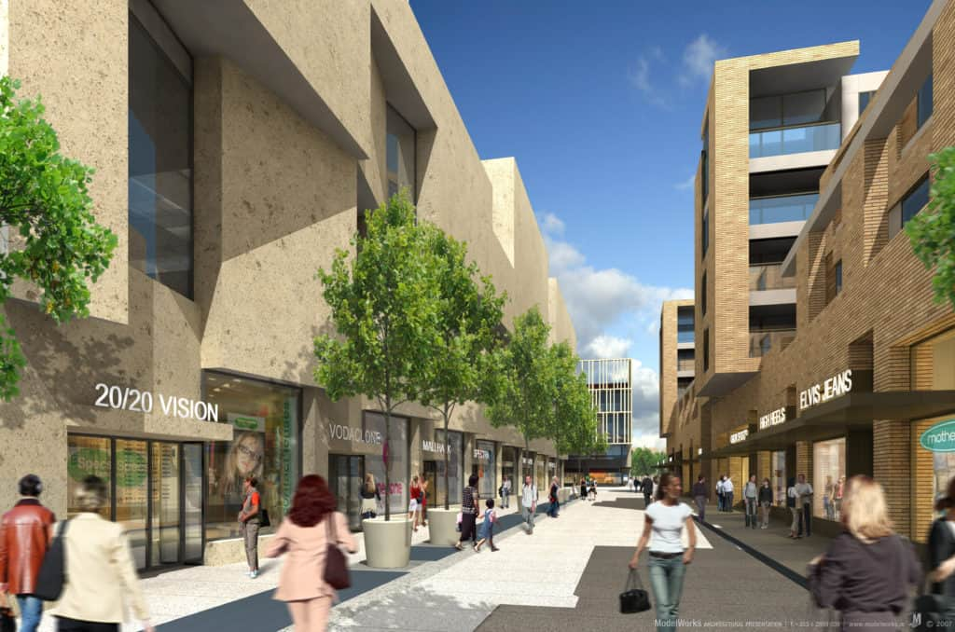

**Of Apartment Developments 1 and 2 bed Units**

|  |  |  |  |  |  |  |  |  |  |  |  |  |  |  |  |  |  |
| --- | --- | --- | --- | --- | --- | --- | --- | --- | --- | --- | --- | --- | --- | --- | --- | --- | --- |
| **Q2 2022 - to Q2 2023 Core Strategy** | **CDP** | **Neighbourhood Area** | **Units Permitted** | **Housing Units Permitted** | **Housing Mix** | | | | | | **Apartment Units Permitted** | **Apartment Mix** | | | | | |
| **Planning Reg Ref.** | **Tier** | **Name** | **Units** |  | **studio** | **1-bed** | **2-bed** | **3-bed** | **4-bed** | **5-bed** |  | **studio** | **1-bed** | **2-bed** | **3-bed** | **4-bed** | **5-bed** |
| SD22A/0066 | 1 | LUCAN PALMERSTOWN ADAMSTOWN | 3 | 3 | 0 | 0 | 0 | 3 | 0 | 0 | 0 | 0 | 0 | 0 | 0 | 0 | 0 |
| SD22A/0263 | 1 | LUCAN PALMERSTOWN ADAMSTOWN | 1 | 1 | 0 | 0 | 0 | 1 | 0 | 0 | 0 | 0 | 0 | 0 | 0 | 0 | 0 |
| SD22A/0293 | 1 | LUCAN PALMERSTOWN ADAMSTOWN | 1 | 1 | 0 | 1 | 0 | 0 | 0 | 0 | 0 | 0 | 0 | 0 | 0 | 0 | 0 |
| SD22A/0320 | 1 | LUCAN PALMERSTOWN ADAMSTOWN | 1 | 1 | 0 | 0 | 0 | 1 | 0 | 0 | 0 | 0 | 0 | 0 | 0 | 0 | 0 |
| SD22A/0343 | 1 | LUCAN PALMERSTOWN ADAMSTOWN | 1 | 1 | 0 | 0 | 0 | 1 | 0 | 0 | 0 | 0 | 0 | 0 | 0 | 0 | 0 |
| SD22A/0396 | 1 | LUCAN PALMERSTOWN ADAMSTOWN | 2 | 2 | 0 | 0 | 0 | 0 | 2 | 0 | 0 | 0 | 0 | 0 | 0 | 0 | 0 |
| SD22A/0458 | 1 | LUCAN PALMERSTOWN ADAMSTOWN | 1 | 1 | 0 | 0 | 0 | 0 | 1 | 0 | 0 | 0 | 0 | 0 | 0 | 0 | 0 |
| SDZ21A/0023 | 1 | LUCAN PALMERSTOWN ADAMSTOWN | 453 | 265 | 0 | 0 | 58 | 193 | 14 | 0 | 188 | 0 | 30 | 64 | 94 | 0 | 0 |
| SDZ22A/0005 | 1 | LUCAN PALMERSTOWN ADAMSTOWN | 434 | 0 | 0 | 0 | 0 | 0 | 0 | 0 | 434 | 9 | 202 | 211 | 12 | 0 | 0 |
| SDZ22A/0006 | 1 | LUCAN PALMERSTOWN ADAMSTOWN | 347 | 319 | 0 | 0 | 8 | 234 | 75 | 0 | 28 | 0 | 0 | 14 | 14 | 0 | 0 |
| SDZ22A/0007 | 1 | LUCAN PALMERSTOWN ADAMSTOWN | 257 | 257 | 0 | 0 | 75 | 113 | 69 | 0 | 0 | 0 | 0 | 0 | 0 | 0 | 0 |
| SDZ22A/0014 | 1 | LUCAN PALMERSTOWN ADAMSTOWN | 207 | 75 | 0 | 0 | 0 | 62 | 13 | 0 | 132 | 0 | 0 | 64 | 68 | 0 | 0 |
| SDZ23A/0006 | 1 | LUCAN PALMERSTOWN ADAMSTOWN | 2 | 2 | 0 | 0 | 0 | 0 | 2 | 0 | 0 | 0 | 0 | 0 | 0 | 0 | 0 |
| SDZ23A/0015 | 1 | LUCAN PALMERSTOWN ADAMSTOWN | 52 | 0 | 0 | 0 | 0 | 0 | 0 | 0 | 52 | 0 | 16 | 36 | 0 | 0 | 0 |
| SDZ23A/0017 | 1 | LUCAN PALMERSTOWN ADAMSTOWN | 80 | 0 | 0 | 0 | 0 | 0 | 0 | 0 | 80 | 0 | 56 | 24 | 0 | 0 | 0 |
|  | 15 |  | 1842 | 928 | 0 | 1 | 141 | 608 | 176 | 0 | 914 | 9 | 304 | 413 | 188 | 0 | 0 |

**Table 7: Lucan/Palmerstown/Adamstown**

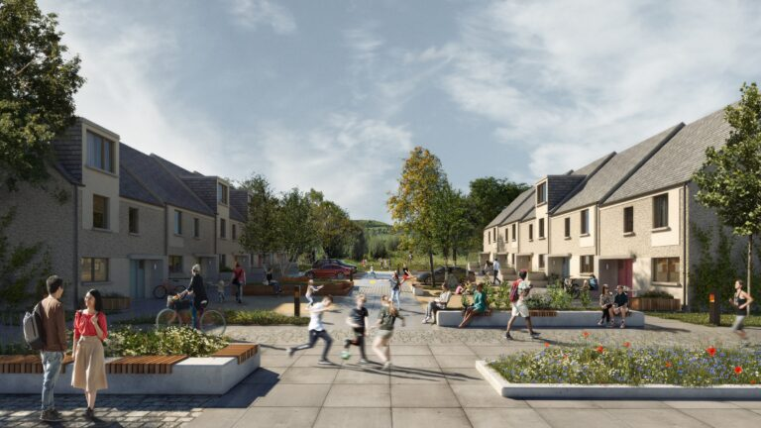**Tallaght Neighbourhood Area**

The Tallaght Neighbourhood Area accounts for 15% of overall permissions granted during the first year of the plan. The majority of the units permitted fall under the Large Scale Mixed Tenure Residential Development at Killinarden and Kiltalown where 635 Units have been permitted. The Ratio of Houses to Apartments permitted within this Neighbourhood equates to 1:0.5 a contrast from the housing to apartment ratio in other Neighbourhoods within the County with the exception of Adamstown SDZ. 674 or 60% of housing units permitted were 3 bed units while 91% of the apartment developments comprised of 1 and 2 bed units. A further 47, 3 bedroom apartment/duplex units make up the apartment mix. Overall, the 3 Bed House and Apartment Units make up 67% of the overall units permitted within this Neighbourhood during the first year of the plan.

**Total Permitted**

**Units**

**Ratio of Houses to Apartments - 1 House: 0.5 Apartments**



**Of overall County Permissions**

|  |  |  |  |  |  |  |  |  |  |  |  |  |  |  |  |  |  |
| --- | --- | --- | --- | --- | --- | --- | --- | --- | --- | --- | --- | --- | --- | --- | --- | --- | --- |
| **Q2 2022 - to Q2 2023 Core Strategy** | **CDP** | **Neighbourhood Area** | **Units Permitted** | **Housing Units Permitted** | **Housing Mix** | | | | | | **Apartment Units Permitted** | **Apartment Mix** | | | | | |
| **Planning Reg Ref.** | **Tier** | **Name** | **Units** |  | **studio** | **1-bed** | **2-bed** | **3-bed** | **4-bed** | **5-bed** |  | **studio** | **1-bed** | **2-bed** | **3-bed** | **4-bed** | **5-bed** |
| LRD22A/0002 | 1 | TALLAGHT | 635 | 434 | 0 | 1 | 2 | 400 | 31 | 0 | 201 | 0 | 18 | 148 | 35 | 0 | 0 |
| SD22A/0015 | 1 | TALLAGHT | 1 | 1 | 0 | 0 | 0 | 0 | 1 | 0 | 0 | 0 | 0 | 0 | 0 | 0 | 0 |
| SD22A/0047 | 1 | TALLAGHT | 1 | 1 | 0 | 0 | 0 | 0 | 1 | 0 | 0 | 0 | 0 | 0 | 0 | 0 | 0 |
| SD22A/0285 | 1 | TALLAGHT | 10 | 0 | 0 | 0 | 0 | 0 | 0 | 0 | 10 | 0 | 3 | 6 | 1 | 0 | 0 |
| SD22A/0318 | 1 | TALLAGHT | 1 | 1 | 0 | 0 | 0 | 1 | 0 | 0 | 0 | 0 | 0 | 0 | 0 | 0 | 0 |
| SD22A/0365 | 1 | TALLAGHT | 22 | 0 | 0 | 0 | 0 | 0 | 0 | 0 | 22 | 0 | 0 | 11 | 11 | 0 | 0 |
| SD22A/0448 | 1 | TALLAGHT | 1 | 1 | 0 | 0 | 1 | 0 | 0 | 0 | 0 | 0 | 0 | 0 | 0 | 0 | 0 |
| SD23A/0038 | 1 | TALLAGHT | 2 | 2 | 0 | 0 | 0 | 2 | 0 | 0 | 0 | 0 | 0 | 0 | 0 | 0 | 0 |
| SD23A/0057 | 1 | TALLAGHT | 1 | 1 | 0 | 0 | 0 | 1 | 0 | 0 | 0 | 0 | 0 | 0 | 0 | 0 | 0 |
|  | 9 |  | 674 | 441 | 0 | 1 | 3 | 404 | 33 | 0 | 233 | 0 | 21 | 165 | 47 | 0 | 0 |

**Table 8: Tallaght**

**Templeogue/Walkinstown/Rathfarnham/Firhouse Neighbourhood Area (TWRF)**

The TWRF Neighbourhood Area accounts for 1% of overall permissions granted during the first year of the plan. There were 19 planning applications permitted with the largest development proposal providing for 24 units comprising eight 2 bed and sixteen 3 bed units. With the exception of 4 planning applications permitted the remaining permitted development comprised of 2 unit or less infill type developments. Of the 62 units permitted houses accounted for 57 units while the remaining 5 apartments permitted comprises of four 2 beds and one 3 bed unit. 3 bedroom housing units provided for 57% of the overall housing units permitted. The Ratio of Houses to Apartments permitted within this Neighbourhood equates to 1:0.09

**Total Permitted**

**Units**

|  |  |  |  |  |  |  |  |  |  |  |  |  |  |  |  |  |  |
| --- | --- | --- | --- | --- | --- | --- | --- | --- | --- | --- | --- | --- | --- | --- | --- | --- | --- |
| **Q2 2022 - to Q2 2023 Core Strategy** | **CDP** | **Neighbourhood Area** | **Units Permitted** | **Housing Units Permitted** | **Housing Mix** | | | | | | **Apartment Units Permitted** | **Apartment Mix** | | | | | |
| **Planning Reg Ref.** | **Tier** | **Name** | **Units** |  | **studio** | **1-bed** | **2-bed** | **3-bed** | **4-bed** | **5-bed** |  | **studio** | **1-bed** | **2-bed** | **3-bed** | **4-bed** | **5-bed** |
| SD21A/0361 | 1 | TEMPLEOGUE WALKINSTOWN RATHFARNHAM | 1 | 1 | 0 | 0 | 0 | 1 | 0 | 0 | 0 | 0 | 0 | 0 | 0 | 0 | 0 |
| SD22A/0028 | 1 | TEMPLEOGUE WALKINSTOWN RATHFARNHAM | 1 | 1 | 0 | 0 | 0 | 1 | 0 | 0 | 0 | 0 | 0 | 0 | 0 | 0 | 0 |
| SD22A/0031 | 1 | TEMPLEOGUE WALKINSTOWN RATHFARNHAM | 1 | 1 | 0 | 0 | 1 | 0 | 0 | 0 | 0 | 0 | 0 | 0 | 0 | 0 | 0 |
| SD22A/0088 | 1 | TEMPLEOGUE WALKINSTOWN RATHFARNHAM | 1 | 1 | 0 | 0 | 0 | 1 | 0 | 0 | 0 | 0 | 0 | 0 | 0 | 0 | 0 |
| SD22A/0126 | 1 | TEMPLEOGUE WALKINSTOWN RATHFARNHAM | 5 | 0 | 0 | 0 | 0 | 0 | 0 | 0 | 5 | 0 | 4 | 1 | 0 | 0 | 0 |
| SD22A/0145 | 1 | TEMPLEOGUE WALKINSTOWN RATHFARNHAM | 13 | 13 | 0 | 9 | 4 | 0 | 0 | 0 | 0 | 0 | 0 | 0 | 0 | 0 | 0 |
| SD22A/0154 | 1 | TEMPLEOGUE WALKINSTOWN RATHFARNHAM | 1 | 1 | 0 | 0 | 0 | 0 | 1 | 0 | 0 | 0 | 0 | 0 | 0 | 0 | 0 |
| SD22A/0287 | 1 | TEMPLEOGUE WALKINSTOWN RATHFARNHAM | 1 | 1 | 0 | 0 | 1 | 0 | 0 | 0 | 0 | 0 | 0 | 0 | 0 | 0 | 0 |
| SD22A/0288 | 1 | TEMPLEOGUE WALKINSTOWN RATHFARNHAM | 2 | 2 | 0 | 0 | 0 | 0 | 2 | 0 | 0 | 0 | 0 | 0 | 0 | 0 | 0 |
| SD22A/0295 | 1 | TEMPLEOGUE WALKINSTOWN RATHFARNHAM | 1 | 1 | 0 | 0 | 0 | 0 | 1 | 0 | 0 | 0 | 0 | 0 | 0 | 0 | 0 |
| SD22A/0304 | 1 | TEMPLEOGUE WALKINSTOWN RATHFARNHAM | 1 | 1 | 0 | 0 | 0 | 1 | 0 | 0 | 0 | 0 | 0 | 0 | 0 | 0 | 0 |
| SD22A/0356 | 2 | TEMPLEOGUE WALKINSTOWN RATHFARNHAM | 24 | 24 | 0 | 0 | 8 | 16 | 0 | 0 | 0 | 0 | 0 | 0 | 0 | 0 | 0 |
| SD22A/0381 | 1 | TEMPLEOGUE WALKINSTOWN RATHFARNHAM | 1 | 1 | 0 | 1 | 0 | 0 | 0 | 0 | 0 | 0 | 0 | 0 | 0 | 0 | 0 |
| SD22A/0403 | 2 | TEMPLEOGUE WALKINSTOWN RATHFARNHAM | 2 | 2 | 0 | 0 | 0 | 0 | 1 | 1 | 0 | 0 | 0 | 0 | 0 | 0 | 0 |
| SD22A/0408 | 1 | TEMPLEOGUE WALKINSTOWN RATHFARNHAM | 1 | 1 | 0 | 0 | 0 | 1 | 0 | 0 | 0 | 0 | 0 | 0 | 0 | 0 | 0 |
| SD22A/0427 | 1 | TEMPLEOGUE WALKINSTOWN RATHFARNHAM | 1 | 1 | 0 | 0 | 0 | 0 | 1 | 0 | 0 | 0 | 0 | 0 | 0 | 0 | 0 |
| SD22A/0450 | 1 | TEMPLEOGUE WALKINSTOWN RATHFARNHAM | 1 | 1 | 0 | 0 | 0 | 0 | 1 | 0 | 0 | 0 | 0 | 0 | 0 | 0 | 0 |
| SD22A/0455 | 1 | TEMPLEOGUE WALKINSTOWN RATHFARNHAM | 3 | 3 | 0 | 0 | 3 | 0 | 0 | 0 | 0 | 0 | 0 | 0 | 0 | 0 | 0 |
| SD23A/0011 | 1 | TEMPLEOGUE WALKINSTOWN RATHFARNHAM | 1 | 1 | 0 | 0 | 0 | 1 | 0 | 0 | 0 | 0 | 0 | 0 | 0 | 0 | 0 |
|  | 19 |  | 62 | 57 | 0 | 10 | 17 | 22 | 7 | 1 | 5 | 0 | 4 | 1 | 0 | 0 | 0 |

**1.4 Social and Affordable Housing Supply Pipeline during the plan period:**

In addition to the above private housing developments there are a number of Social and Affordable Housing Developments which have been permitted through the Part 8 process and which are either under construction or at detailed design/preliminary construction stage. Table 9 below sets out that there have been 421 Units permitted through the Part 8 process during the first year of the plan broken down into 183 Housing Units and 238 Apartments. In addition to these developments there are two sites which were previously permitted through the part 8 process which are due to commence works in 2024 totalling 109 Units (22 houses and 87 apartments), providing an overall potential pipeline of 530 social/affordable units with housing units making up 39% and Apartments making up 61% of this unit pipeline.

**Apartments**

**Housing Units**

|  |  |  |  |  |
| --- | --- | --- | --- | --- |
| **Neighbourhood Area** | **Scheme Name** | **Part 8 Units Approved** | **Houses** | **Apartments** |
|  |  |  |  |  |
| Tallaght | Oldbawn | 12 | 8 | 4 |
| Clondalkin | Grand Canal Lindis Farne | 28 | 24 | 4 |
| Clondalkin | Clonburris SDZ | 118 | 22 | 96 |
| Clondalkin | Clonburris SDZ | 263 | 129 | 134 |
| Total |  | 421 | 183 | 238 |
|  |  |  |  |  |
| **Other Live Part 8s** |  |  |  |  |
| Templeogue Walkinstown | Homeville (2019) | 16 | 7 | 9 |
| Clondalkin | Eircom Site Nangor Road (2019) | 93 | 15 | 78 |
| Total |  | **109** | **22** | **87** |
|  |  |  |  |  |
| **Combined Total Potential** |  | **530** | **205** | **325** |

**Table 9: Part 8 Developments Approved during the lifetime of the plan (*Note this table also includes two Part 8s which are likely to commence development in 2024.**

**1.5 Rural Housing** In regard to rural housing South Dublin County Council received 6 planning applications for rural dwellings during the period Q2 2022 to the end of Q2 2023. 1 permission was granted with the remaining 5 planning applications refused planning permission. There have been no new home completions within the rural area.

**Retail Distribution**

**Logistics**

**Light Industry**

**Part 2. Commercial Monitoring:**

* 1. **Developed and occupied commercial floorspace**

|  |  |
| --- | --- |
| **Industry Type** | **Floor Area (Sqm)** |
| Light Industry | 42,983 |
| Logistics | 48,649 |
| Office/Service Industry | 18,512 |
| Storage/Warehousing | 14,672 |
| Retail Distribution | 88,025 |
| Retail Sales (Includes general retail/cars sales etc | 10,698 |
| Data Centre | 6,681 |
| **Total** | **230,220** |

In order to decipher the level of developed and occupied commercial floorspace within the County from the end of Q2 2022 up to the end of Q2 2023, the postal service Geodirectory spatial dataset was used as to identify all registered commercial buildings which had been identified as new additions during this period. This identified 99 registered commercial postal addresses. The first part of this analysis examined the types of uses detailed and the organisation name alongside a spatial analysis using google earth which allowed a further filtering of sites with site compounds associated with new housing developments, community buildings and rural commercial points being removed from the list of properties to be examined. This reduced the list from 99 entries to 47 entries. Using this revised data set an analysis was carried out using the Eircodes for each property which was then matched to the Valuation Office Data Set in order to obtain a breakdown of floor areas and uses. For each property entry the valuation office data can be used to identify the floor area in sqm for example office, warehouse, workshop, storage etc.

**Table 10:** Developed and Occupied Commercial Floorspace

Having identified the floor areas for each property entry from a combination of the Geodirectory database and the Valuation Office Data set, each entry was categorised by Industry type with 7 broad categories identified; Light Industry, Logistics, Office/Service Industry, Storage./Warehousing, Retail Distribution, Retail Sales and Data Centre. Table 10 provides details in regard to the floor area of the developed and occupied commercial floorspace for each industry type identified totalling 230,220sqm. From a spatial perspective the analysis carried out identifies that 90% of light industry delivered was located within the Citywest/Saggart/Rathcoole Newcastle (CSRN) Neighbourhood Area at Greenogue. In regard to the Logistics Industry 78% of the buildings identified were also located within the CSRN Neighbourhood Area. This neighbourhood area also accounted for 67% of buildings identified as Retail Sales Industry Type. Within the retail and retail sales category the Naas Road/City Edge and Tallaght Neighbourhood areas accounted for 83% of the buildings delivered and occupied within the County.

**2.2 Planning permissions for business/employment uses (m2 of development) for:**

**SQM of Development**

**(i) Office, (ii) Industrial, (iii) Retail, (iv) Warehousing/Logistics**

Since the adoption of the County Development Plan South Dublin County Council have been maintaining a manual dataset relating to permissions for business/employment uses and the sqm of development permitted. The data set includes details of all development types in the County and from a monitoring perspective these commercial permissions are categorised into the four identified categories of Office, Industrial, Retail and Warehousing/Logistics. Table 9 below sets out the Commercial development category, the total development category in sqm alongside the number of applications for each category. Overall, there have been 96 developments permitted in the County, with both retail and warehousing/logistics accounting for a combined total of 48.9% of the overall commercial development types permitted. From a floor area/SQM perspective the 11 Data Centres permitted during this period account for 11.5% of the overall floor area/sqm permitted. Warehousing and Logistics type developments account for 22.9% of the total floor area at 82,389sqm while Industrial development provided for 32.3% of the overall floor area in sqm totalling 10,338sqm.

Warehousing/ Logistics

Industrial

**Industry Type**

|  |  |  |  |  |
| --- | --- | --- | --- | --- |
| **Industry Type** | **Total sqm of Development** | **SQM** | **Development Type (No.)** | **Development Type** |
| Data Centre | 62,337 | 37.1% | 11 | 11.5% |
| Industrial | 10,338 | 6.1% | 31 | 32.3% |
| Office | 4,893 | 2.9% | 7 | 7.3% |
| Retail | 8,243 | 4.9% | 25 | 26.0% |
| Warehousing / Logistics | 82,389 | 49.0% | 22 | 22.9% |
| **Totals** | **168,199** | **100.0%** | **96** | **100%** |

**Table 11:** Number of Industry Types and SQM of Development Permitted.

Retail/Warehousing/Logistics

Industrial

***Note:*** *There were a further 112 planning applications relating to employment type developments which do not fall within the identified development types. Such permissions can relate to schools, healthcare, signage, childcare, telecommunications etc and accounted for a total floor area of 61,000 sqm.*

**Part 3. Settlement Consolidation Sites/Strategic Development Areas:**

**3.1 Introduction**

The Development Plan Guidelines make reference to monitoring Settlement Consolidation Sites identified in the development plan. Such areas are defined as development sites of relative strategic scale and importance located within the existing built-up area such that they have a critical role to play in achieving the core strategy and, in particular, the NPF policy objectives for consolidation and compact growth. For the purposes of this monitoring report such sites are considered to align with the identified Strategic Development Areas as set out in the Regional Spatial and Economic Strategy for the Eastern and Midland Region which within South Dublin relate to Adamstown SDZ, Clonburris SDZ, Tallaght Town Centre, Naas Road/City Edge and the Fortunestown Area.

The following Tables provide a synopsis/update on the general progression of these areas in tabular format under a number of key categories.

**3.1.1 Adamstown SDZ**

Adamstown is a planned urban development of 10,000 residential units with associated transport and community infrastructure. Adamstown is a Strategic Development Zone (SDZ), for which a Planning Scheme was prepared. The Planning Scheme provides a legal framework for phased development of residential and infrastructural works. Adamstown is based around walkable neighbourhoods located in close proximity to high quality public transport linkages.

Adamstown SDZ is developed in accordance with a phased/concurrent delivery of infrastructure and housing. This information and requirements are set out in the Planning Scheme (Chapter 4). Presently, the SDZ is in phase 6/7 of the planning scheme.

|  |  |
| --- | --- |
| **Category** | **Commentary** |
| **Enabling Infrastructure** | The majority of roads, walkways, bus lanes etc have been delivered, with wastewater, water services and surface water drainage delivered in advance/pro-rata approach.  Notable Transport and Infrastructure delivery:  DART + SW under consultation via Railway Order process:  Located on the Dublin-Kildare Railway Line and Grand Canal, Adamstown was Ireland’s first Strategic Development Zone (SDZ) and has the benefit of a detailed and robust Planning Scheme which is planned to deliver up to 9,395 new homes and a population of up to 25,000 people by the time of completion. Delivery at Adamstown is already underway, and some 3,700 homes have already been built, with planning permission in place for over 6,800 homes. |
| **Permissions Granted** | Total Units 2967  930 Units permitted and Under Construction  2037 Units Permitted not commenced |
| **Housing Constructed** | 1949 Units Constructed |
| **Funding Applications Made** | The €9.997 million in URDF funding announced will provide for public infrastructure and amenities that will facilitate the development of the Adamstown Town Centre and the continued roll-out of homes around the Town Centre. On foot of this funding, more than 580 new homes will be constructed, which will support the provision of much needed social, affordable, and private housing in the west Dublin area.  The delivery of high-quality public spaces and facilities will support the creation of the town centre adjacent to Adamstown Train Station to serve the existing and new communities. |
| **Project Timelines** | Currently within Phases 6/7 of the SDZ Planning Scheme. |
| **Other Relevant Information** | There is an increased population in the area, likely population is 23,000. To serve the growing population, SDCC has taken on/delivered multiple projects as below:  Completion of 2 out of 3 LIHAF projects: Celbridge Link Road and Tandy’s Lane Park (opened). Airlie Park soon to be opened.  2000 homes benefited from LIHAF.  Adamstown Boulevard now open allowing for increased access/mobility within the SDZ: Date – 25/06/2022.  -----  The Celbridge Link Road in Adamstown has delivered significantly improved accessibility and connectivity on the western side of Adamstown - to not only the existing and future residents of Adamstown but also the residents within the adjoining communities of Celbridge and Leixlip. This north/south connection from the R403 provides a direct link from the R403 to the Adamstown Rail Station, which will provide for shorter commuter times and more sustainable and environmentally friendly commuting patterns within the area.  -----  Tandy’s Lane Park is approximately seven hectares in size and includes extensive areas of footpaths with seating. The Park is designed with a mix of formal and informal recreation facilities, with a large sports pitch, three interconnected playgrounds, a space designed specifically for teenagers and fitness areas alongside high quality soft and hard landscapes. Much of the soft landscape consists of biodiverse flower meadows and there are views of the retained, mature hedgerows and woodland areas.  The Tandy’s Lane Park project has delivered a large-scale public park within Adamstown for the use of residents and visitors of all ages, including a range of amenities such as playgrounds and playing pitches.  DES progress school site 3 (Tandy’s Lane).  -----  Airlie Park due to open Q2/3 2023, funded by LIHAF.  -----  Central Boulevard Park at Tender appointment stage – funded by URDF.  -----  Change of Use approved for Health Centre – to be operated by HSE. |

**3.1.2 Clonburris SDZ**

The Clonburris Strategic Development Zone (SDZ) Planning Scheme represents a shared outlook for the future residential, social, economic and environmental development of a new planned and sustainable community in South Dublin County. The development of the entire Planning Scheme is expected to deliver a target of 9,416, new homes, a minimum of 7,300 sq.m gross community floorspace, approximately 22,520 sq.m gross retail floorspace and in the range of 30,000 to 40,000 sq.m employment floorspace.

Clonburris SDZ is developed in accordance with a phased/concurrent delivery of infrastructure and housing. This information and requirements are set out in the Planning Scheme.

|  |  |
| --- | --- |
| **Category** | **Commentary** |
| **Enabling Infrastructure** | Clonburris SDZ is planned to be developed in accordance with a phased/concurrent delivery of infrastructure and housing. This information and requirements are set out in the Planning Scheme (Section 4). Presently, the construction of Housing has commenced alongside the delivery of Stage 1 Infrastructure on the SDZ. As part of Stage 1 Infrastructure, South Link Street is being constructed which provides access to upcoming housing estates, and wastewater pumping station is being established. Additionally, tender process for appointment of consultants is ongoing for Stage 2 Infrastructure.  DART + SW under consultation via Railway Order process  Dart+ SW will serve the new community at Clonburris with more regular trains and quicker journey times.  Kishoge Station Opening in Q4 2023:  SDCC understands that the NTA and Irish Rail are to appoint a contractor to carry out the remedial works to the station towards the opening of this station for public use. The station, when completed and opened, will serve the new community at Clonburris. Irish Rail has confirmed that the station will open in Q4 2023. SDCC is coordinating with stakeholders to ensure it can open at the earliest opportunity possible coordinated with adjacent development. |
| **Permissions Granted** | 569 |
| **Units Constructed** | 0, 115 units permitted and under construction. 415 Units permitted but not commenced. |
| **Funding Applications Made** | €186.3 Million allocated under URDF call 2 |
| **Project Timelines** | Phased in accordance with SDZ Planning Scheme |
| **Other Relevant Information** | Grand Canal Loop Greenway  Part VIII Consent in November 2022  Next stage: Request for tenders Q3 2023 |

**3.1.3 Naas Road City Edge**

Following detailed analysis of the area and public consultation on an emerging preferred concept, the City Edge Strategic (Non-Statutory Framework) Framework was noted by the Elected Members of South Dublin County Council and Dublin City Council in May and June 2022 respectively.

The purpose of the Framework is to set out a high level approach and transformational trajectory for the regeneration of a new liveable, sustainable and climate resilient urban quarter. As part of Phase 2 ‘Plan-Making’ of the City Edge Project, South Dublin County Council (SDCC) is preparing background reports to inform a proposed Variation (change) to the County Development Plan to refine and incorporate the provisions of the City Edge Strategic Framework.

This will give the Strategic Framework a statutory (legal) basis; and provide more detailed planning and design guidance on the future planning of the area. The indicative timeframe for the commencement of public consultation on the variation is September 2024.

|  |  |
| --- | --- |
| **Category** | **Commentary** |
| **Enabling Infrastructure** | * **Engagement with NTA** to progress public transport and active travel initiatives for City Edge. Progress on same to date includes: * Dart + South West Railway Order Application currently under consideration by An Bord Pleanála. Proposal would upgrade rail commuter line from Heuston Station to Hazelhatch to a DART-style service, with future-proofed design of the Kylemore Road Bridge to take the loading of a future Luas line and future provision of IE station at Kylemore (to be pursued in parallel). * New Luas stop on Naas Road at initial design stage under Luas Upgrade programme of works. * BusConnects progress to include S4 route September 2023; D-Spine in Q3 2024; and Clondalkin and Greenhills CBC application Q2 2023. * Site assembly through investigation of development potential of some SDCC owned lands within City Edge. * Consideration of regional approach to facilitate relocation of existing industrial uses potentially displaced by brownfield regeneration. * Engagement with Irish Water regarding provision for foul drainage in County including City Edge, informing local intervention programme of works. * Progress to enable and facilitate green infrastructure including a Feasibility Study for a major park, and Community Park Strategy. * Area-wide and district-specific Energy Provision Feasibility study currently underway for City Edge. * Investigation of feasibility of undergrounding existing overhead power lines (in partnership with DCC and LDA) across City Edge area. |
| **Permissions Granted** | 163 permitted |
| **Units Constructed** | 0 |
| **Funding Applications Made** | URDF drawdown of €920,000 by SDCC/DCC to fund preparation of Strategic Framework, fully complete, with 25% match funding provided. |
| **Project Timelines** | City Edge Strategic Framework published in August 2022, setting out the long term vision for the area to 2070, to create a new urban quarter with potential for 40,000 new homes and 75,000 jobs, making it one of the largest regeneration schemes in Europe.  The Strategy includes 24 priority actions to enable implementation, relating to housing policy; foul network capacity; public transport and active travel provision; undergrounding of overhead lines; green infrastructure provision; land assembly and state support for business relocation; and funding and financing.  Proposed Variation of SDCC Development Plan 2022-2028 to give statutory basis to City Edge Strategic Framework, commencing November 2023. Background studies, in conjunction with DCC currently underway for City Edge area, include additional baseline analysis, area-wide and district level design guidance, and environmental reports. Timeline for variation Q3 2024. |

**3.1.4 Tallaght**

The elected members of South Dublin County Council resolved to make the Tallaght Town Centre Local Area Plan on 8th June 2020 and the Plan has effect from 20th July 2020.

The purpose of the Local Area Plan (LAP) is to provide a strategic framework for the sustainable development of Tallaght Town Centre. The LAP seeks to deliver high quality housing and well connected neighbourhood areas with a strong sense of community and social cohesion. It seeks to promote prosperity and opportunity in terms of employment, economic development and tourism, while ensuring the conservation and enhancement of green infrastructure and built heritage.

The LAP represents a new era of opportunity for Tallaght Town Centre under the guidance and direction of the National Planning Framework. The purpose of the Plan is to resume momentum and to build upon the achievements of the past, which have contributed to Tallaght’s recognition as an important settlement of regional significance, and to provide a strategic and progressive Plan to guide development into the future, throughout the statutory life of the Plan, and beyond.

|  |  |
| --- | --- |
| **Category** | **Commentary** |
| Enabling Infrastructure | SDCC has been progressing a number of Council led schemes within the Tallaght LAP development area. The Tallaght Town Centre Project comprises a number of works in central Tallaght, including an innovation centre, a transport hub, public realm the Airton Road extension and ambitious plans for Tallaght Stadium, including a fourth stand which is near completion. The majority of these projects are funded, or part funded by URDF.  This is in addition to a number of Part 8s.  Notable Transport and Infrastructure delivery:  Transport Hub – commenced.  Public Realm – commenced. |
| Permissions Granted | 1918 |
| Units Constructed | 32 (1095 permitted and under construction) |
| Funding Applications Made | URDF Funding obtained c.€32 million with a further 25% funding by South Dublin County Council. |
| Project Timelines | Works underway and nearing completion.  Tallaght Public Realm – commenced.  Transport interchange – commenced.  Affordable Housing – Contractor Appointed  4Th Stand – Near Completion  Innovation Centre – Nearing Completion |
| Other Relevant Information | Airton Road and Wider Active Travel linking Tallaght to Clondalkin – Design team appointed. |

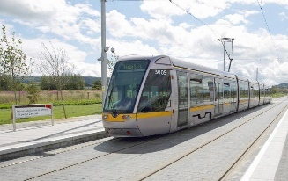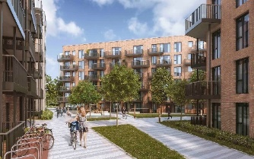**3.1.5 Citywest/Fortunestown**

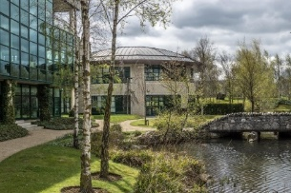The Fortunestown Local Area Plan was adopted by the Elected Members of South Dublin County Council on the 16th of April 2012 and came into operation on the 14th of May 2012. On the 12th of June 2017, by resolution, the Local Area Plan was extended for further period (in accordance with Section 19 of the Planning and Development Act 2000, as amended). The Local Area Plan expired on the 13th May 2022. A significant level of development has taken place within the LAP area with the vast majority of the lands identified for development either complete, under construction or having the benefit of planning permission for development.

|  |  |
| --- | --- |
| **Category** | **Commentary** |
| Enabling Infrastructure | None of note. Citywest Neighbourhood Park will enhance the open space and Green Infrastructure offering within the area. Citywest junction link at Tallaght/Fortunestown LUAS has now been completed. |
| Permissions Granted | 2,378 |
| Units Constructed | 1,345 Units constructed within the LAP Area. 2,378 Units permitted with 912 under construction and 1466 units permitted and yet to commence. |
| Funding Applications Made | N/A |
| Project Timelines | The vast majority of the zoned residential lands within the LAP area are expected to be completed during the life of the current County Development Plan. |
| Other Relevant Information | Warehousing units now constructed in the north-east of Fortunestown LAP area as per SD21A/0150. Four warehousing units are contained within three buildings (13,611sq.m.). |

**3.1.5 Kilcarbery Grange**

Kilcarbery-Grange is designed to deliver a new sustainable urban neighbourhood of 1,000 homes with a flexible mix of tenure and house-type options accompanied by a high standard of residential amenity. The circa 35 hectares of land at Kilcarbery-Grange are bounded by the R136 Outer Ring Road / Grange Castle Road to the west, Corkagh Demesne to the south and an existing residential development to the north east and east. Scoil Mochua and Spina Bifida Hydrocephalus Ireland are located to the north of the site.

The overarching vision for the Kilcarbery-Grange Masterplan was to “to realise a distinct and high-quality sustainable place with a local sense of character and community, which is closely connected to its own and its surrounding landscape and provides for a range of community needs, within attractive, permeable and connected urban structure.”

|  |  |
| --- | --- |
| **Category** | **Commentary** |
| **Enabling Infrastructure** | Delivery of LIHAF Funding infrastructure is as follows:   * Phase 1 - Access Road to PPP site (Corkagh Grange- Kilcarbery). **Completed** * Phase 2 – Spine Road JV site Kilcarbery Grange Sections A & B **partially completed** plus junctions one (Outer ring road) and Junction 2 (Old Nangor road) **completed**. Final 2 sections (C&D – footpaths & top wearing course) due for completion mid-2024.   Foul drainage system and Pump station **completed.**  Remaining sections of spine road to be **completed** by mid-2024. |
| **Permissions Granted** | 1,133 |
| **Units Constructed** | 285 Unit Constructed, 309 permitted and under construction. 539 Units permitted not commenced |
| **Funding Applications Made** | N/A |
| **Project Timelines** | 2021 - 2025 |
| **Other Relevant Information** | Kilcarbery-Grange – Total Constructed to date - 285 Units  Two Sites   1. PPP site completed (109 units)   Contractor: Comhar Housing (Sisk) Permitted under Reg. Ref. SD17A/0002.   1. SDCC/Adwood joint venture site (1,024 units)   Contractor: Ashwood Limited. Permitted under ABP Ref. SHD3ABP-305267-19.  **Progress to date:**   * The first homes in Kilcarbery-Grange commenced development in May 2021 * By the end of Q4 2022, 255 units had been completed (153 houses and 102 apartments); * A further 30 Units are constructed with 309 units under construction (158 houses and 181 apartments)*   Kilcarbery-Grange JV site (SHD3ABP-305267-19) Existing mature trees, hedgerows and drainage ditches have been integrated into the development scheme through the landscape masterplan which is based on a concept of ‘Biophilic Design’ to protect and integrate with existing features. This ‘biophilic’ design concept is where buildings are fitted into the existing natural landscape – mature trees, hedgerows and drainage ditches – to act as biodiversity corridors and facilitating nature-based SUDs solutions. |

**3.1.6 Grangecastle Business Park**

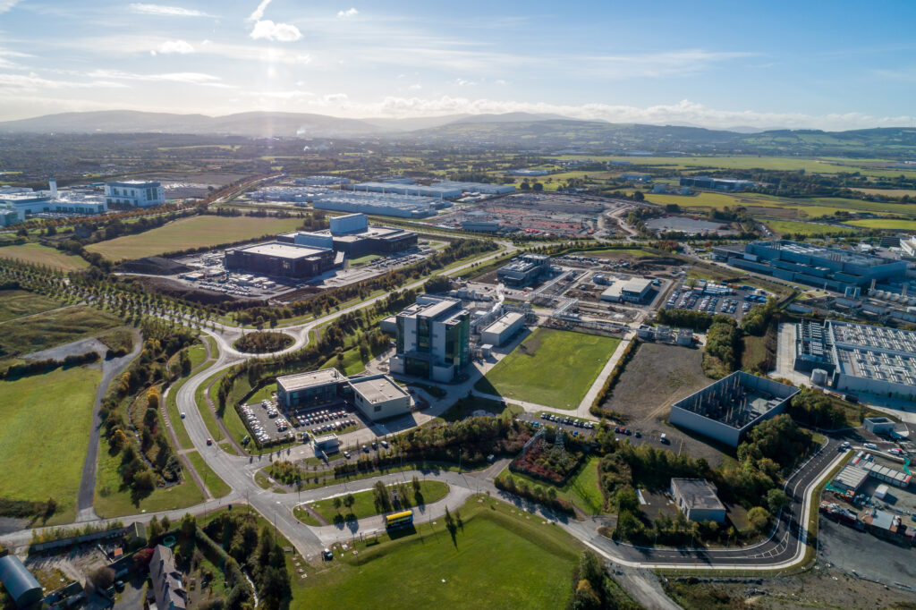Grange Castle Business Park is a modern business park located in the west of the County with capacity to attract large scale industries of regional, national and international significance, due to the availability of large plot sizes, infrastructure and corporate park style environments. This area has attracted a significant number of blue-chip national and multi-national corporations. Significant investment has been made in infrastructure and services to support this economic area. Grange Castle Business Park is identified in the MASP as a strategic development area for the promotion of high-tech manufacturing, research and development.

Grange Castle West aims to build upon the existing access, services and landscaping strategies to create a sustainable and vibrant extension to the business park at Grange Castle. This development will attract new economic development opportunities to the area, while enhancing the climate resilience of the existing environment and providing a healthy and attractive place to work for a growing local population.

|  |  |
| --- | --- |
| **Category** | **Commentary** |
| **Enabling Infrastructure** | Grange Castle West Access Road Complete. This is the first phase of infrastructure delivered that will provide access to approximately 500 acres of development land. The access road contains over 1km of dual carriageway and comprises one double lane and three single lanes with fully segregated roundabouts with pedestrian and cyclist crossing facilities provided. This €13 million investment has provided dual carriageway, as well as a full services corridor with gas, water, electricity and fibre broadband to allow South Dublin County Council to offer fully serviced sites to prospective clients. |
| **Permissions Granted** | There have been 11 grants of planning permission within Grangecastle since the plan has been adopted providing for a total of 102,000sqm. 6 of the applications relates to general industry, 4 Data Centres and 1 Warehousing/Logistics Development |
| **Units Constructed** | N/A |
| **Funding Applications Made** | N/A |
| **Project Timelines** | N/A |
| **Other Relevant Information** | **Jobs:** Grange Castle Business Park is home to 6,500 jobs, in addition to 2,500 jobs in the construction sector, with plenty of high-profile international clients such as Google, Amazon, Cyrus 1, Microsoft, Grifols, Pfizer, Aryzta and Takeda.  **Pharma:** Pfizer have committed to investing an additional €1 Billion into its Grange Castle campus which will create a further 400-500 jobs for the business campus.  **Data Centres:** The data centre monitor has been set up to monitor the continuing growth in the sector. At present on Council owned land within the Grange Castle Business Campus there are 4 (Microsoft and Interxion) data centres currently under construction. Grange Backup Power is also under construction to the north of the campus and will provide energy back to the grid at times when energy demand is high. |

1. The need for the identification of these sites in DPs was brought in through the guidelines in 2022, after the County Development Plan was adopted. For the purposes of this monitoring report such sites are considered to align with the identified Strategic Development Areas as set out in the Regional Spatial and Economic Strategy for the Eastern and Midland Region which within South Dublin
2. Tier 1 Serviced lands Tier 2 Lands deemed to be serviceable during the lifetime of the plan