Directorate: Land Use Planning and Transportation
Department: Traffic and Roads Forward Planning Date: 21/02/2024
Re: DRAFT: Palmerstown Laneways, proposed one-way traffic cell system
----------------------------------------------------------------------------------------------------------------
Background to this Headed Item:
Lucan ACM - December 2023:
The traffic section agreed to look at the feasibility of installing one-way only system within the Laneways for a Motion in December (Item ID 81424).
“This committee requests that the Council investigate the feasibility of installing a one-way system in the Laneways (or those that can accept a one-way system)_at Palmerstown and that a headed item be brought to this committee on the matter. A recent survey amongst residents backing on to the laneways showed a majority in favour”.
Report Answer:
I will examine the feasibility of implementing a one-way system on the laneways that can accept a one-way system early in 2024. I will return with a Headed Item with a workable plan for the vehicular access to the Laneways. I would like a copy of the survey results to help understand the extent of the support for the proposals.
At the January ACM a Headed Item ID 81878 was submitted detailing a Pilot One-way scheme in this regard. The contents of that report are set out below:
The members agreed to bring it to the residents to discuss the proposals.
At the current February ACM, Headed Item 82441 has been tabled. The elected member has conducted opinion surveys and they have sent several documents with various suggestions for the Laneways. The scope of this Headed Item has significantly enlarged to cover several key issues and the responsibility for which covers several service areas.
The Traffic Section will only comment at this time on issues to do with the feasibility of providing one-way system on the Palmerstown Lanes, which was the subject of the original Motion back in December 2023.

Report on One way System within the Palmerstown Laneways (February 2024)
It is proposed to introduce a one-way system within the Palmerstown laneways to resolve issues of cut-through driving through the estate, provide clarity (systemic flow) to road-users accessing the laneways and to improve the safety of road-users and pedestrians. It should be understood, that this proposal involves significant signage to implement properly.
We acknowledge there are other laneways further south. We may look at these at some later stage should this scheme be successful.
The following one-way cell systems is proposed due to narrow widths (which only permits the passing of a singular vehicle) and uncontrolled/unclear traffic flow (rights of way). It is proposed to install only anti-clockwise loops to improve the vision lines of road-users utilising righthand-drive vehicles due to the observed narrow widths for vehicle movements.
- Cell 1: Palmerstown Drive to The Oval one-way loop.
- Cell 2: Culmore Road to The Oval one-way loop.
- Cell 3: Culmore Road and Palmerstown Drive to The Oval one-way loop.
- Cell 4: Glenmaroon Road to Glenaulin Road and Culmore Road one-way loop.

Figure 1: Plan of the proposed one-way cell systems
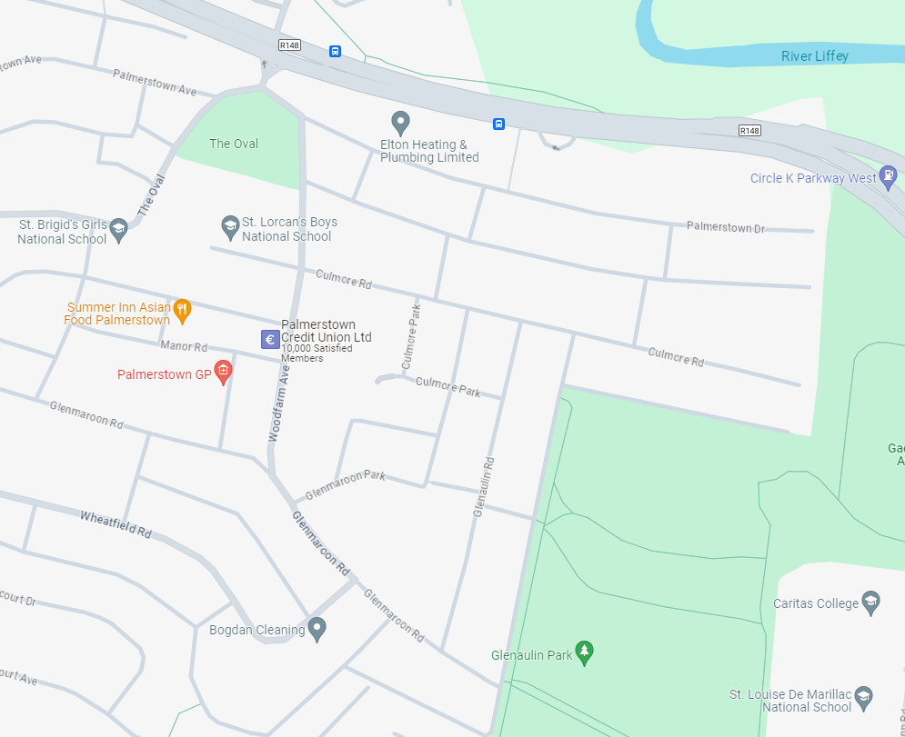
C
B
A
Cell 4
Cell 1
Cell 2
Cell 3
Cell 1: Palmerstown Drive to The Oval one-way loop.
It is proposed to install a short one-way (anti-clockwise) loop from Palmerstown Drive to The Oval which feeds into the larger one-way loop system (Cell 2 and Cell 3) which comprises the main egress route for properties along Palmerstown Drive and Culmore Road with rear access.
The purpose of this is to maintain way-finding consistency of traffic flow throughout the laneways.
The width of the laneway was approximately 3.25m metres with sufficient turning space for vehicles to gain access to the laneway running parallel to Palmerstown Drive and Culmore road.

Figure 2: Entrance to Cell 1.
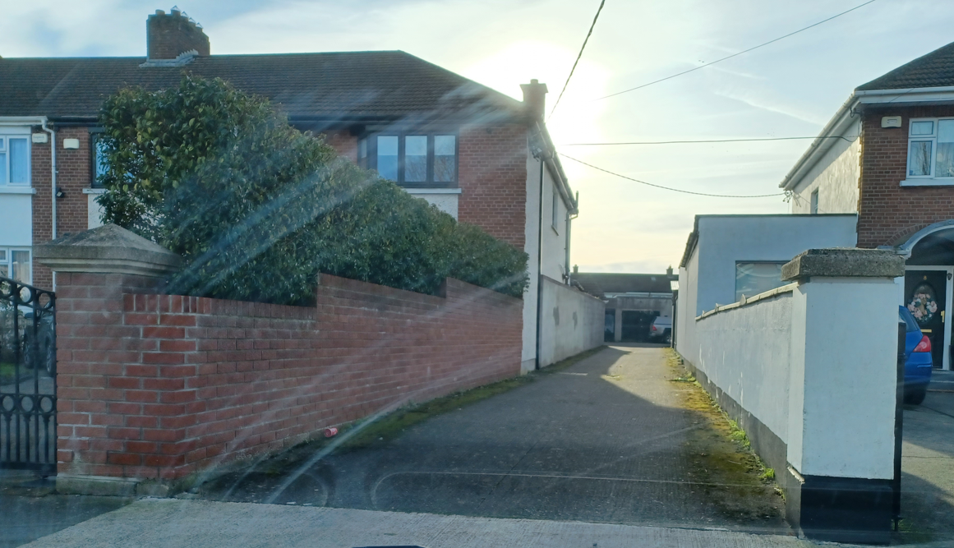

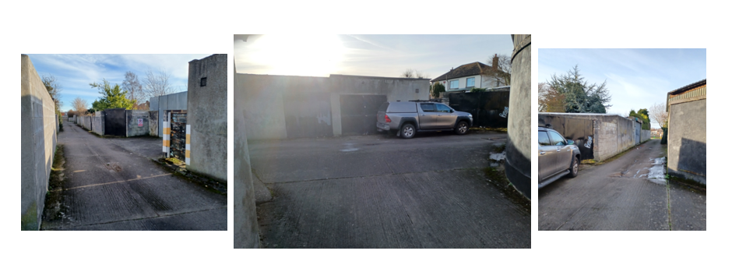
Figure 3: Intermediate Junction (Cell 1) for main egress route

Figure 4: Exit for Cell 1.
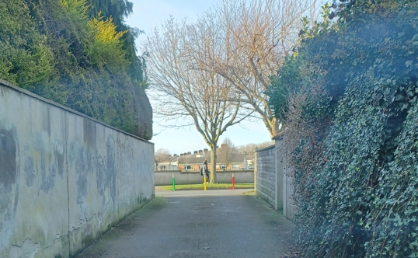

Cell 2: Culmore Road to The Oval one-way loop.
It is proposed to install a short one-way (anti-clockwise) loop from Culmore Road for properties with rear access on Culmore Road. It is foreseen that all egress for the laneway feeds directly onto the main road, The Oval.
The width of the laneway was approximately 3.25m metres with sufficient turning space for vehicles to gain access to the laneway running parallel to Palmerstown Drive and Culmore road.

Figure 5: Entrance to Cell 2.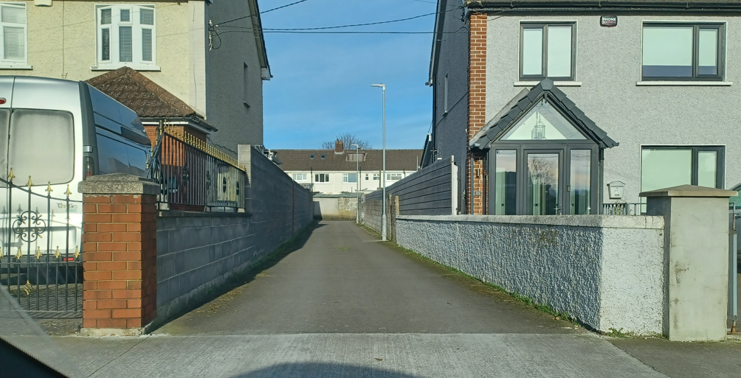

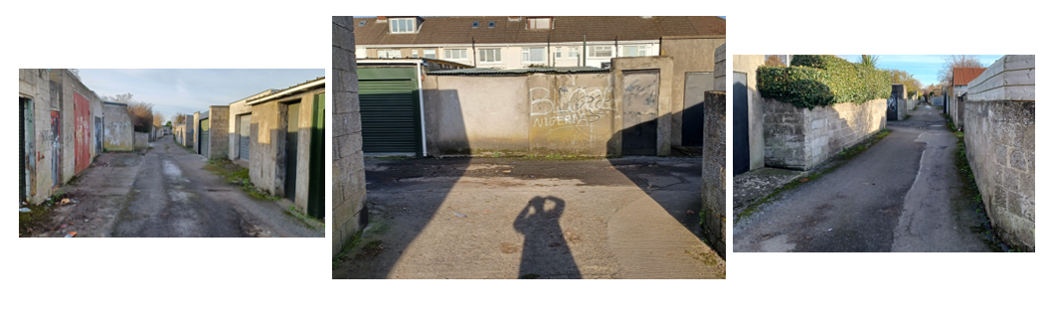
Figure 6: Intermediate Junction for main egress route
Note: Exit for Cell 2 is the same as the exit for Cell 1.

Cell 3: Culmore Road and Palmerstown Drive to The Oval one-way loop.
It is proposed to install a one-way (anti-clockwise) loop for all access into the laneway.
Access from Palmerstown Drive will be permitted by heading in a southward direction and access from Culmore Road will be permitted by heading in a northward direction to maintain way-finding consistency.
The width of the laneway was approximately 3.25m metres with sufficient turning space for vehicles to gain access to the laneway running parallel to Palmerstown Drive and Culmore road. It is foreseen that all egress for the laneway feeds directly onto the main road, The Oval.

Figure 7.1: Entrance (A) to Cell 3 from Palmerstown Drive
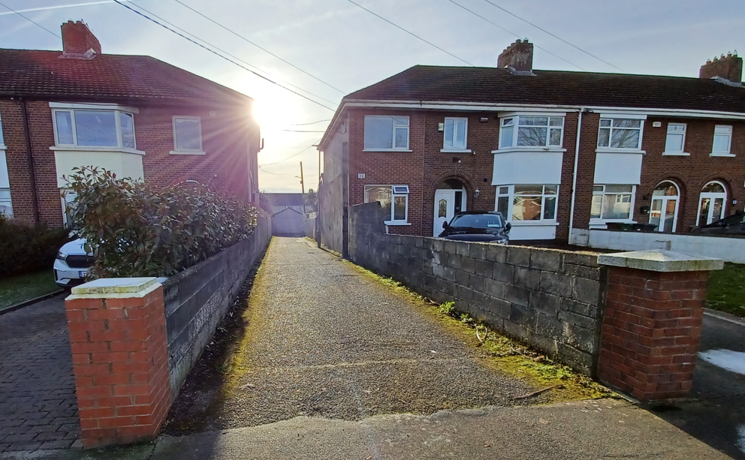

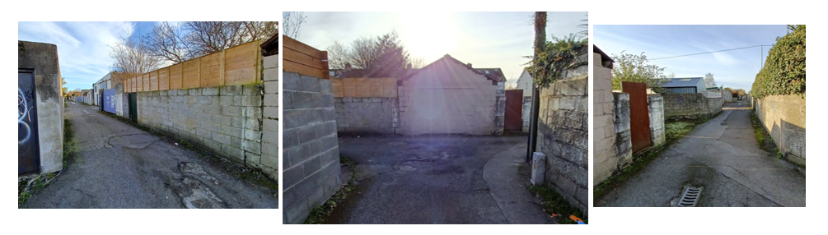
Figure 7.2: Intermediate Junction (Cell 3) for main egress route

Figure 8.1: Entrance (B) to Cell 3 from Palmerstown Drive.
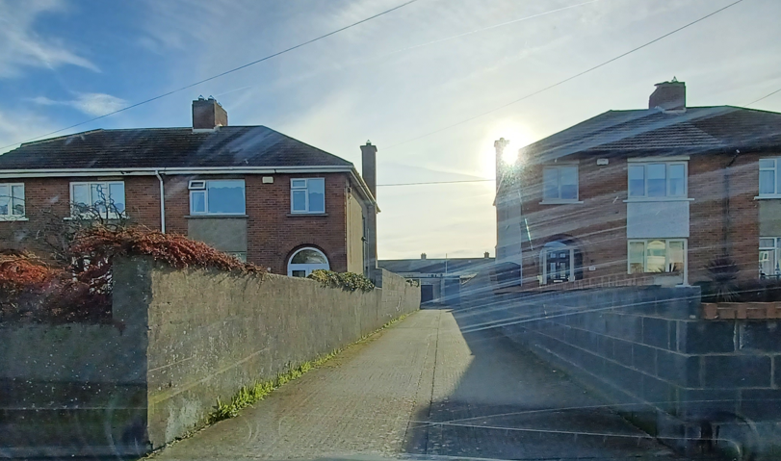

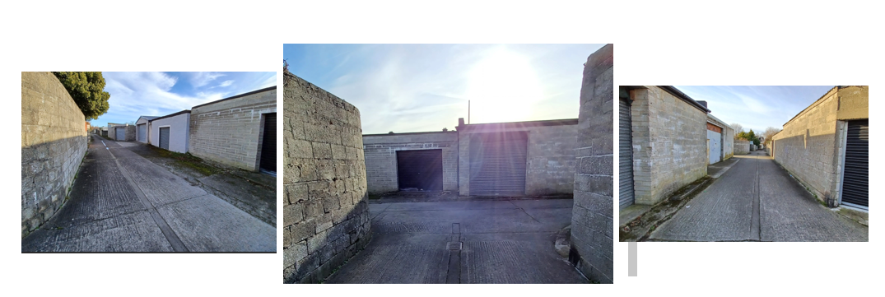
Figure 8.2: Intermediate Junction (Cell 3) for main egress route

As highlighted above, access from Culmore Road will be permitted by heading in a northward (and anti-clockwise) direction to maintain way-finding consistency.
The width of the laneway was approximately 3.25m metres with sufficient turning space for vehicles to gain access to the laneway running parallel to Palmerstown Drive and Culmore road.

Figure 9.1: Entrance (C) to Cell 3 from Culmore Road.
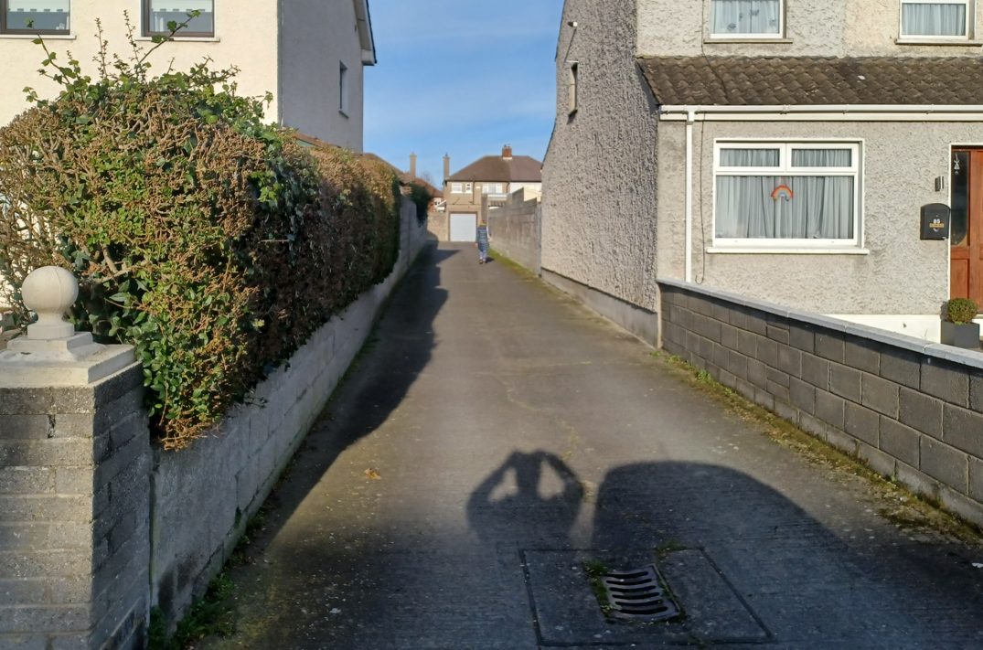

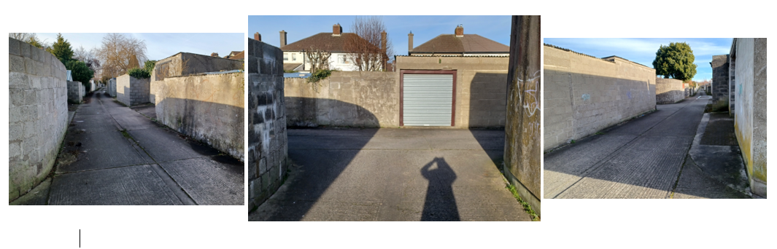
Figure 9.1: Intermediate Junction (Cell 3) for main egress route

Note. Exit for Cell 3 is the same as the exit for Cell 1.

Cell 4: Glenmaroon Road to Glenaulin Road and Culmore Road one-way loop.
It is proposed to install a one-way (anti-clockwise) loop from Glenmaroon Road to Culmore Road with an additional egress point mid-way along the laneway to Glenaulin Road. The purpose of this direction is to maintain way-finding consistency of traffic flow throughout the laneways by standardising an anti-clockwise direction.
The width of the laneway was approximately 3.25m metres with sufficient turning space for vehicles to gain access to Glenaulin Road.
Figure 10: Entrance to Cell 4 (from Glenmaroon Road)
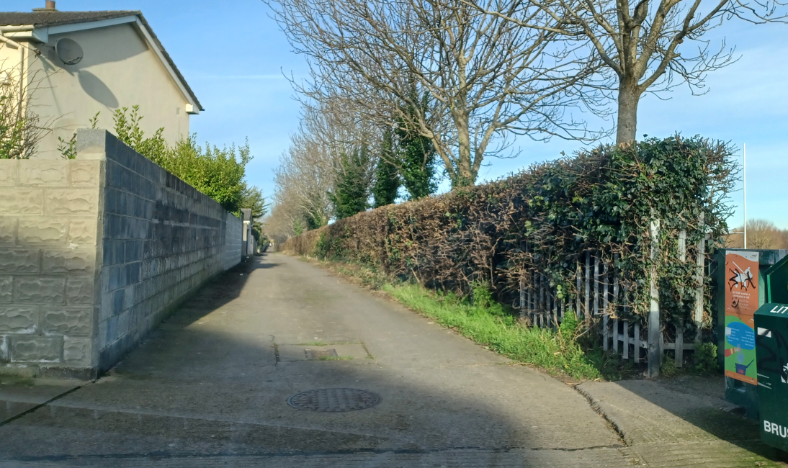
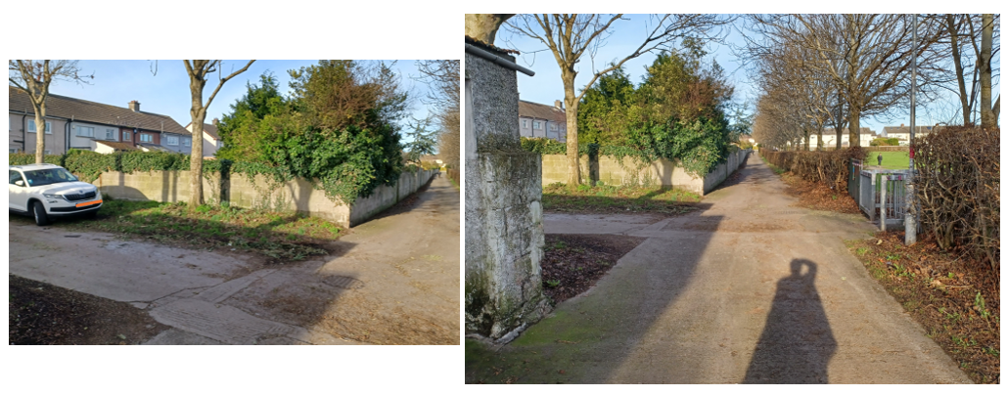
Figure 11: Intermediate Junction (Cell 4)

Figure 12: Exit 1 (onto Glenaulin Road) for Cell 4
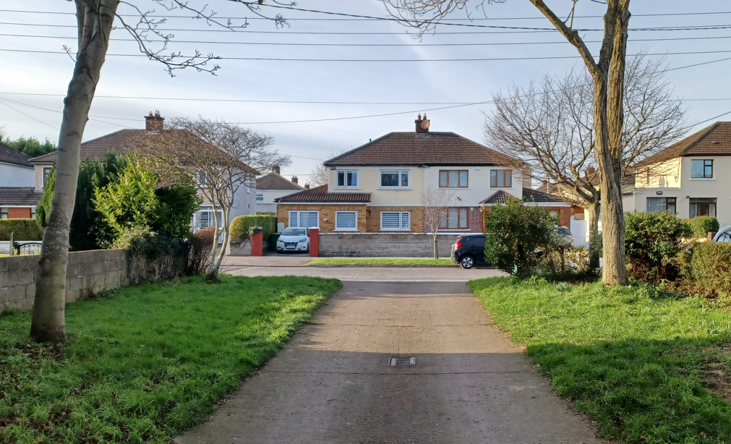

Figure 13: Exit 2 (onto Culmore Rd) for Cell 4
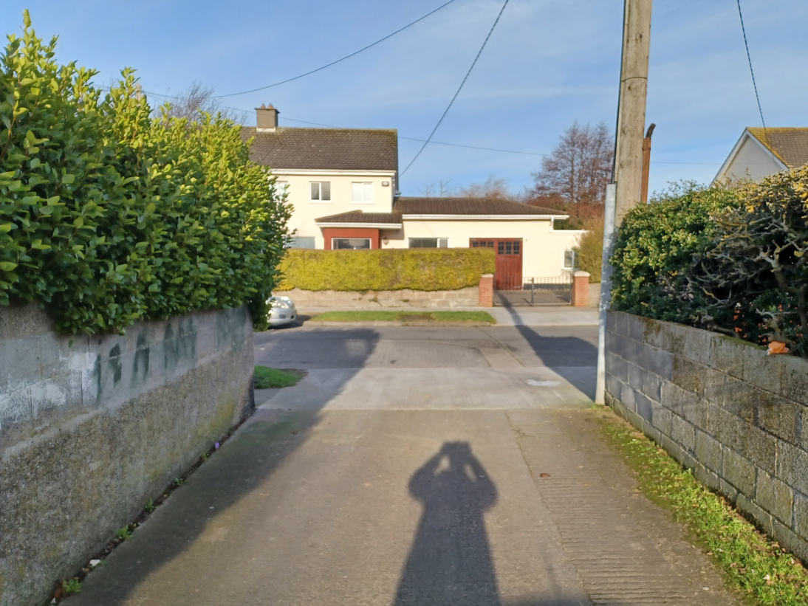

Figure 14: Additional photo (maximum width of lane way)
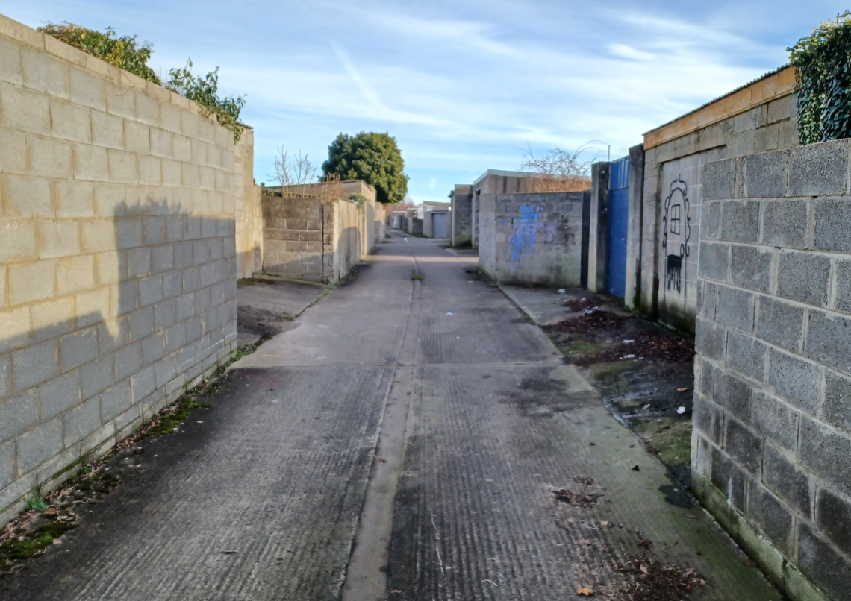

It is noted that the maximum width of the laneway (laneway running parallel to Palmerstown Drive and Culmore Road) where there were two ‘layby’ sections directly opposite (as shown in Figure 14) is 6m wide.
The Traffic Section will continue to look at the feasibility of the installing of one-way system in the Palmerstown Laneways. In particular, the Traffic section will look at “Wheatfield Oak Court Lane” and “Wheatfield Road” sketches supplied to see if any of these proposals are feasible. When we have decided what movement system is most appropriate, we will email our suggestions to the members and have follow up meetings to decide the details of the any pilot one-way scheme to be delivered in the Laneways.

End of One-Way System Headed Item Report

Footnote: Follow Up Information supplied by the Elected Member:
Several opinion Surveys have been conducted with the residents of the Palmerstown Laneways.
These surveys cover several types of issues and cover several Council Service areas. It will take time to analyse these survey results and the Executive will decide on a response and how this response will be made on the matters raised.

