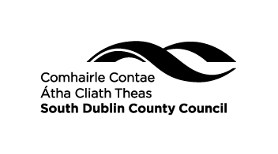

**South Dublin County Council Flag Policy**

1. **Policy statement**

This policy outlines the proposed Council practice in relation to the flying of flags at Civic Offices, including the decision-making processes for requests relating to same**.** This is in the context that flying of flags at Civic buildings may represent a statement of identity, image and values associated with the Council and therefore requires a formal policy and consistent management process.

In the interests of clarity, “Civic Offices” are defined as County Hall, Tallaght, Dublin 24 and Civic Offices, Clondalkin, Dublin 22.

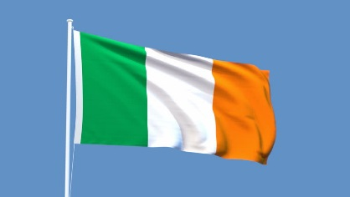

**2.0. The Irish National Flag**

The Irish National Flag (herein referred to as the National Flag) will be flown on Council Meeting Days in County Hall, Tallaght, as well as St. Patrick’s Day, 1st May to commemorate International Workers' Day and in advance of Irish national teams participating in international sporting occasions, such as the World Cup, European Championship and Olympic Games and on the flying of other flags included in the Policy.

2.1 Where a building has two or more flagpoles, the flag of Dublin, may be flown in addition to the National Flag, but not in a superior position. For example, if three poles are available, then the National Flag should be flown from the middle, higher pole and be flanked on either side by the Dublin flag.

2.2 The National Flag should be flown at Full Mast, all day (with the exception of occasions where it is to be flown at half mast, see Item 4). The National Flag must be illuminated at night. Investigation as to the costs and appropriate methods of illumination will be undertaken. Until such illumination is approved and installed, the flag shall only be flown by day.

2.3 When raising and lowering the National Flag, the flag must not be allowed to touch the ground.

2.4 Where the National Flag has become worn and frayed it is no longer fit for display and should not be used in any manner implying disrespect. The Communications Unit should be notified in this instance and a new flag will be procured.

**3.0. Days on which South Dublin County Council fly other flags**

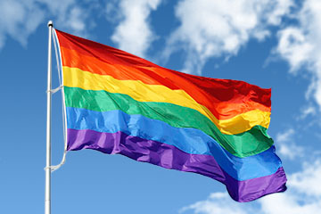 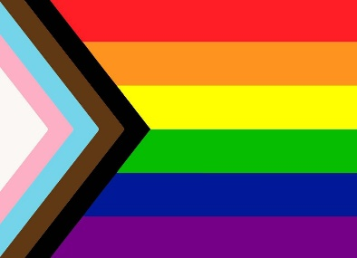

**3.1 Rainbow Flag**

The *Rainbow Flag will fly every year in support of the Pride Movement and to demonstrate the Council’s commitment to equality and the inclusion of all its citizens. Pride month usually occurs during June but should be checked in advance with the Dublin Pride organisers.

* Note: the Rainbow Flag was replaced in 2021 with a new more inclusive design. Both designs are shown above.

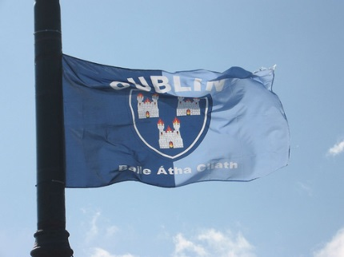

**3.2 Dublin County Flag**

The Dublin County Flag will fly at County Hall and Clondalkin Civic Offices in advance of the Dublin Teams participating in the All-Ireland Championships.

**3.3 The European Flag**  
This is flown on occasions where there is a representative of the European Union visiting or where there is a function connected to a project which has received funding from the European Union.

**3.4 Other national flags**Where there is a visiting dignitary the national flag of the dignitary is flown.

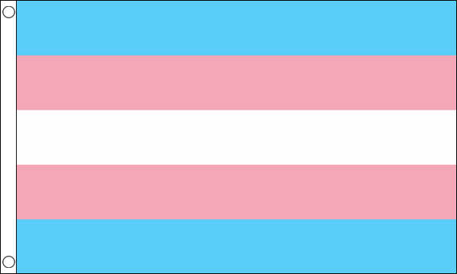

**3.5 Transgender Pride Flag**The Transgender Pride Flag will fly every year in support of the Transgender Pride Movement and to demonstrate the Council’s commitment to equality and the inclusion of all its citizens. The flag will fly on International Day of Transgender Visibility (31 March), and for one month thereafter.

**3.6 Palestinian Flag**

The Palestine flag will fly every year on United Nations International Day of Solidarity with the Palestinian people which is observed annually on or around the 29th November.

**4.0 Occasions on which the National Flag is to be flown at Half Mast.**The National Flag is frequently flown at half-mast on the death of a national or international figure on Council buildings equipped with a flagpole. The Council occasionally receives such requests from Central Government Departments to fly the National Flag at half-mast as a mark of respect for victims of national or international tragedies. The death of a prominent local figure may also be marked locally by the National Flag being flown at half-mast. The decision to fly at half-mast will be taken by the Executive in consultation with Corporate Policy Group members, owing to the timeliness of such requests.

**Note**: Half Mast means the flag is flown two-thirds of the way up the flagpole, with at least the height of the flag between the top of the flag and the top of the flagpole. If another flag is to normally flown beside the National Flag, whilst the National Flag is at Half Mast the second flag shouldn’t be flown at all.

**5.0 Decision making process**

Any request to fly a flag, other than the flags listed above, will be considered by the Corporate Policy group and a final decision determined by the full Council. In cases where the request is to fly the flag at half-mast in recognition of a deceased person or in response to a tragic event, the Mayor will decide in the interests of timeliness and notify the CPG members of the flag being raised (this is in the absence of any such instruction from Central Government).

**6.0 Requests and assessing requests outside Policy**

Requests to fly flags not referenced in this Policy shall be submitted to the Mayor’s Office in order to be considered by the CPG. (Email: [mayor@sdublincoco.ie](mailto:mayor@sdublincoco.ie) )

Assessment of requests to fly flags outside those stated within this policy must ensure as the primary guiding principle that the opportunity aligns with the South Dublin County Council’s values and policies and enhances the image and identity of the South Dublin County Council.

**7.0 Policy non-compliance**

The Council reserve the right to revoke any flag arrangement that has not been approved in accordance with this Policy.

**8.0 Policy review**

The Policy will be reviewed by the Organisation Procedure and Finance Committee periodically, or as required to ensure fitness for purpose.

**________________**