COMHAIRLE CONTAE ÁTHA CLIATH THEAS

SOUTH DUBLIN COUNTY COUNCIL

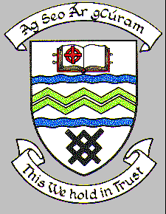

**MEETING OF TALLAGHT AREA COMMITTEE**

**MONDAY 26th FEBRUARY 2024**

HEADED ITEM NO. XX

**PROPOSED EXTINGUISHMENT OF THE PUBLIC RIGHT OF WAY OVER LANEWAY** **AT THE REAR OF 3,5,1B AND 1A TYMONVILLE COURT, TALLAGHT, DUBLIN 24 (RT-4-364)**

This proposal was considered at the Tallaght Area Committee Meeting on Monday, 27th November 2023.

**“An application has been received requesting the extinguishment of the public right of way over the laneway at the rear of 3,5,1B and 1A Tymonville Court, Tallaght, Dublin 24. It is proposed to affect the closure by means of disposal. (map below).”**

Following consideration of the report, it was agreed to initiate the procedure.

The proposal to extinguish the public right-of-way at this location was advertised in the Tallaght Echo on Thursday, November 30th, 2023. Public Notices were also erected on site on this date in accordance with Section 73 of the Roads Act, 1993.

No submissions were received in response to the public advertisement/notice. There were also no objections from the various Council departments & public utility companies who were contacted regarding the proposal.

It is therefore proposed to proceed with the extinguishment of public right of way at this location.

The decision regarding the extinguishment of a public right-of-way and the granting of an oral hearing is a reserved function of the Council. Accordingly, if this committee agrees to proceed, the recommendation of this Committee will be brought to full Council.

