Directorate: Land Use Planning and Transportation
Department: Traffic and Roads Forward Planning Date: 19/01/2024
Re: DRAFT: Palmerstown Laneways, proposed one-way traffic cell system
----------------------------------------------------------------------------------------------------------------
Pilot Proposal:
It is proposed to introduce a one-way system within the Palmerstown laneways to resolve issues of cut-through driving through the estate, provide clarity (systemic flow) to road-users accessing the laneways and to improve the safety of road-users and pedestrians. It should be understood, that this proposal involves significant signage to implement properly.
We acknowledge there are other laneways further south. We may look at these at some later stage should this scheme be successful.
The following one-way cell systems is proposed due to narrow widths (which only permits the passing of a singular vehicle) and uncontrolled/unclear traffic flow (rights of way). It is proposed to install only anti-clockwise loops to improve the vision lines of road-users utilising righthand-drive vehicles due to the observed narrow widths for vehicle movements.
- Cell 1: Palmerstown Drive to The Oval one-way loop.
- Cell 2: Culmore Road to The Oval one-way loop.
- Cell 3: Culmore Road and Palmerstown Drive to The Oval one-way loop.
- Cell 4: Glenmaroon Road to Glenaulin Road and Culmore Road one-way loop.

Figure 1: Plan of the proposed one-way cell systems
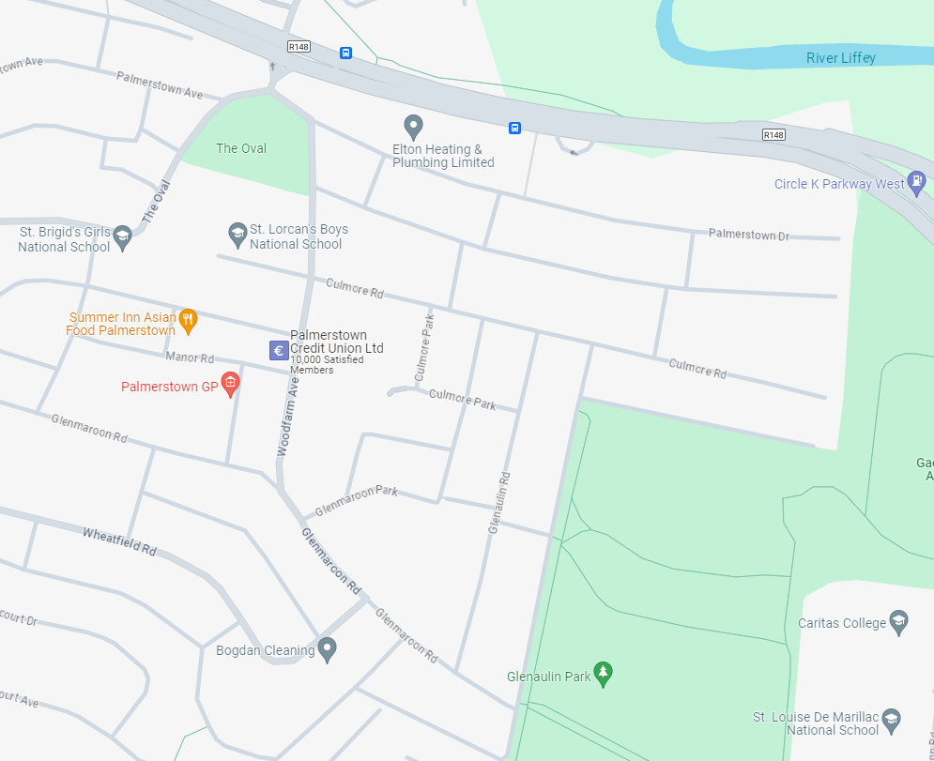
C
B
A
Cell 4
Cell 1
Cell 2
Cell 3
Cell 1: Palmerstown Drive to The Oval one-way loop.
It is proposed to install a short one-way (anti-clockwise) loop from Palmerstown Drive to The Oval which feeds into the larger one-way loop system (Cell 2 and Cell 3) which comprises the main egress route for properties along Palmerstown Drive and Culmore Road with rear access.
The purpose of this is to maintain way-finding consistency of traffic flow throughout the laneways.
The width of the laneway was approximately 3.25m metres with sufficient turning space for vehicles to gain access to the laneway running parallel to Palmerstown Drive and Culmore road.

Figure 2: Entrance to Cell 1.
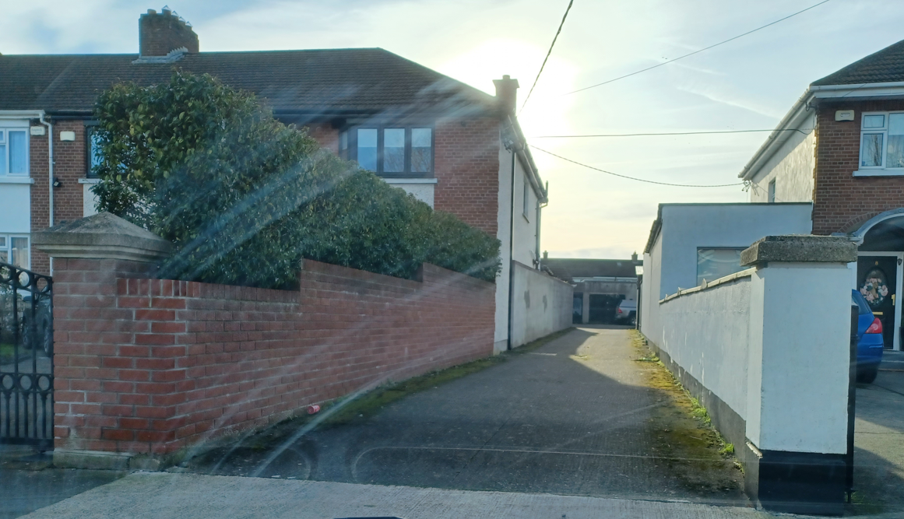

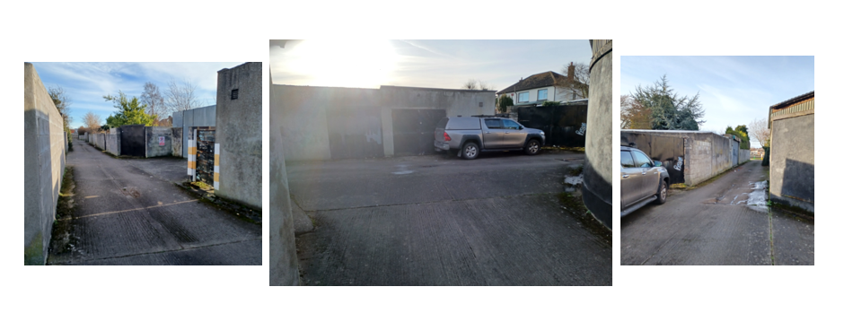
Figure 3: Intermediate Junction (Cell 1) for main egress route

Figure 4: Exit for Cell 1.
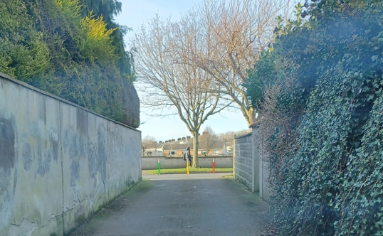

Cell 2: Culmore Road to The Oval one-way loop.
It is proposed to install a short one-way (anti-clockwise) loop from Culmore Road for properties with rear access on Culmore Road. It is foreseen that all egress for the laneway feeds directly onto the main road, The Oval.
The width of the laneway was approximately 3.25m metres with sufficient turning space for vehicles to gain access to the laneway running parallel to Palmerstown Drive and Culmore road.

Figure 5: Entrance to Cell 2.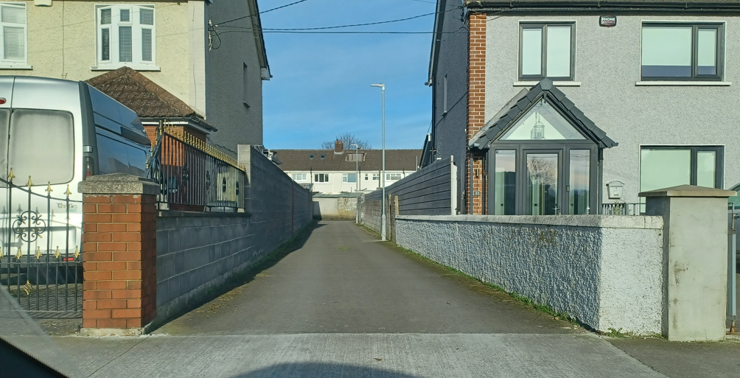

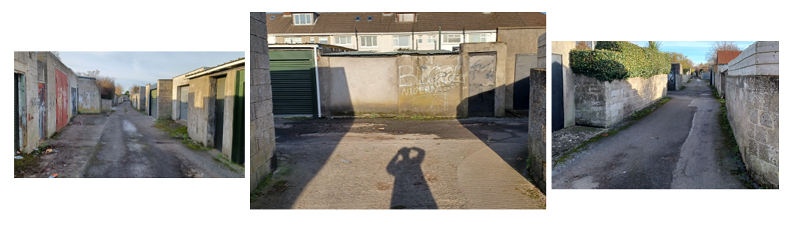
Figure 6: Intermediate Junction for main egress route
Note: Exit for Cell 2 is the same as the exit for Cell 1.

Cell 3: Culmore Road and Palmerstown Drive to The Oval one-way loop.
It is proposed to install a one-way (anti-clockwise) loop for all access into the laneway.
Access from Palmerstown Drive will be permitted by heading in a southward direction and access from Culmore Road will be permitted by heading in a northward direction to maintain way-finding consistency.
The width of the laneway was approximately 3.25m metres with sufficient turning space for vehicles to gain access to the laneway running parallel to Palmerstown Drive and Culmore road. It is foreseen that all egress for the laneway feeds directly onto the main road, The Oval.

Figure 7.1: Entrance (A) to Cell 3 from Palmerstown Drive
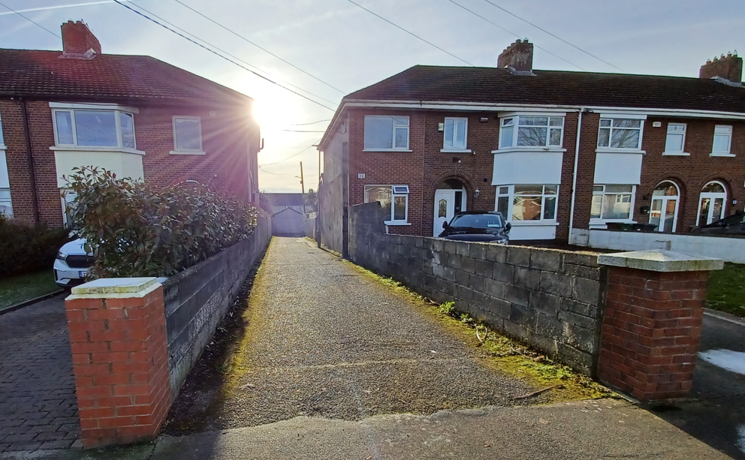

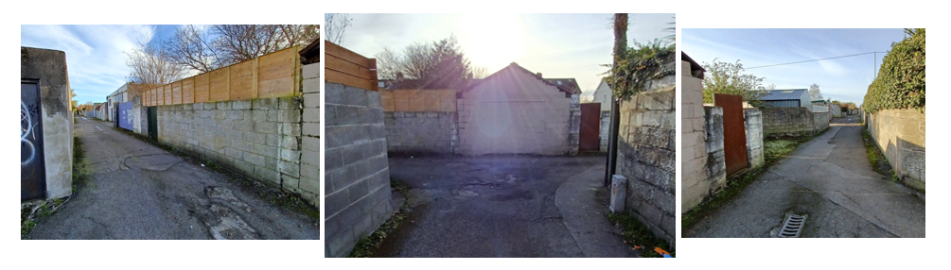
Figure 7.2: Intermediate Junction (Cell 3) for main egress route

Figure 8.1: Entrance (B) to Cell 3 from Palmerstown Drive.
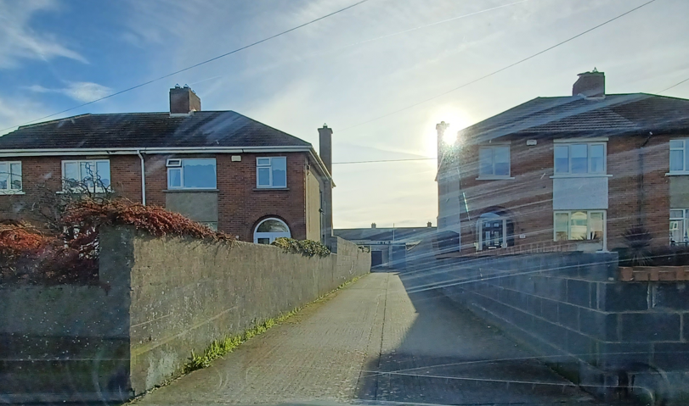

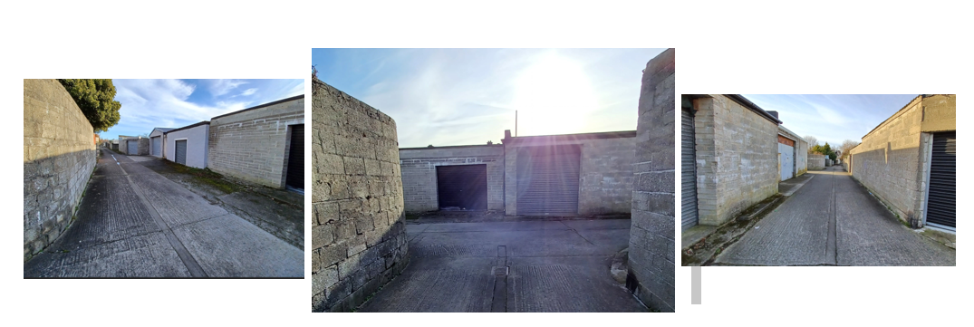
Figure 8.2: Intermediate Junction (Cell 3) for main egress route

As highlighted above, access from Culmore Road will be permitted by heading in a northward (and anti-clockwise) direction to maintain way-finding consistency.
The width of the laneway was approximately 3.25m metres with sufficient turning space for vehicles to gain access to the laneway running parallel to Palmerstown Drive and Culmore road.

Figure 9.1: Entrance (C) to Cell 3 from Culmore Road.
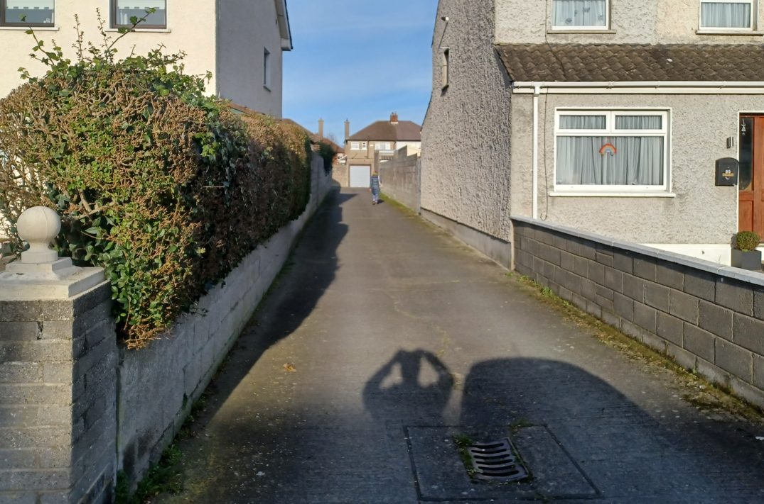

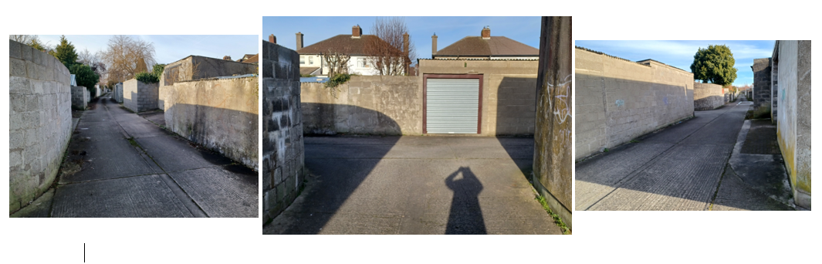
Figure 9.1: Intermediate Junction (Cell 3) for main egress route

Note. Exit for Cell 3 is the same as the exit for Cell 1.

Cell 4: Glenmaroon Road to Glenaulin Road and Culmore Road one-way loop.
It is proposed to install a one-way (anti-clockwise) loop from Glenmaroon Road to Culmore Road with an additional egress point mid-way along the laneway to Glenaulin Road. The purpose of this direction is to maintain way-finding consistency of traffic flow throughout the laneways by standardising an anti-clockwise direction.
The width of the laneway was approximately 3.25m metres with sufficient turning space for vehicles to gain access to Glenaulin Road.
Figure 10: Entrance to Cell 4 (from Glenmaroon Road)
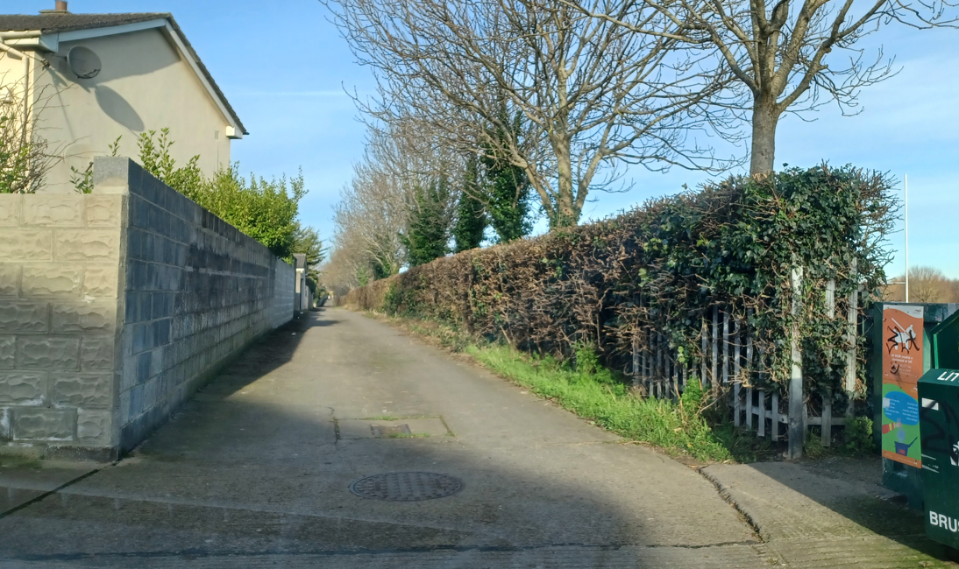
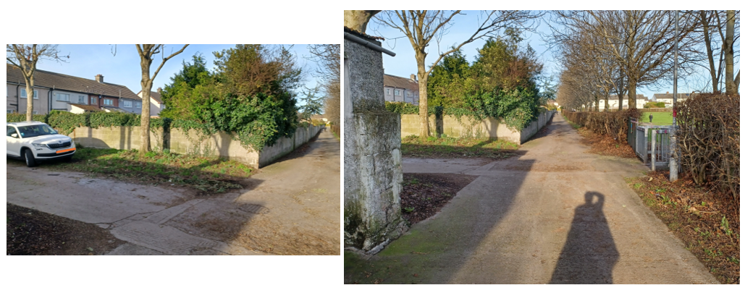
Figure 11: Intermediate Junction (Cell 4)

Figure 12: Exit 1 (onto Glenaulin Road) for Cell 4
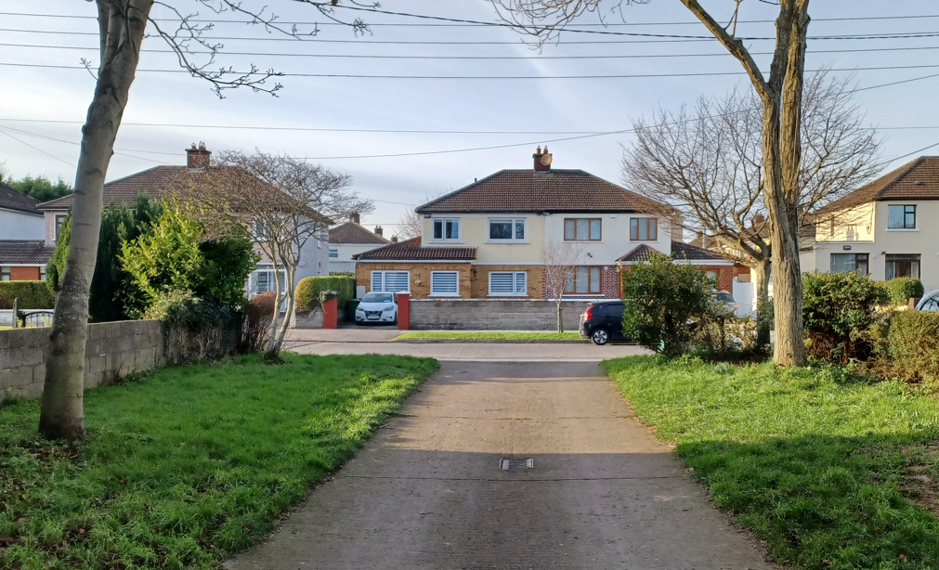

Figure 13: Exit 2 (onto Culmore Rd) for Cell 4
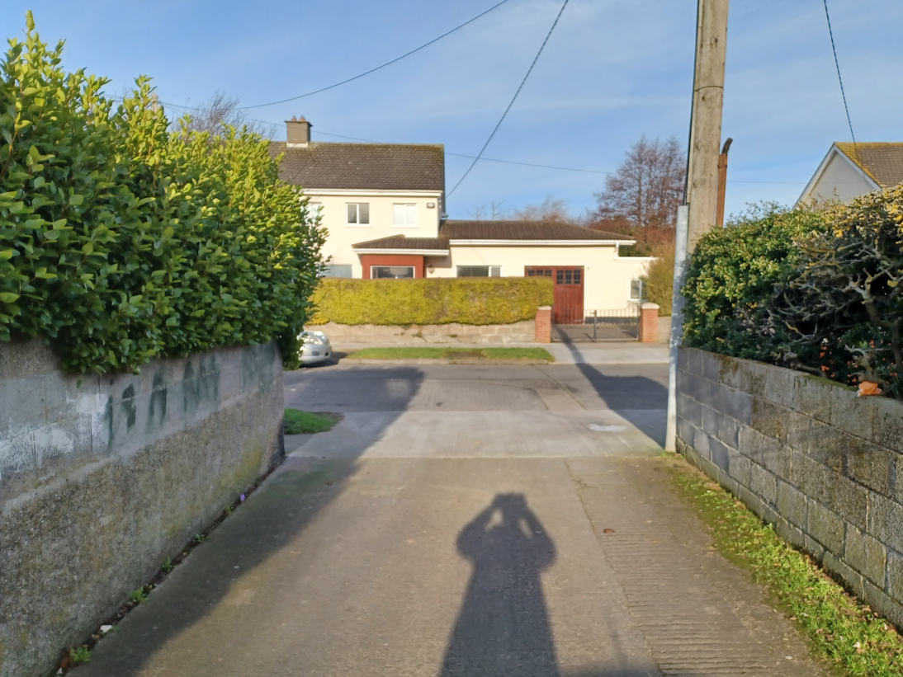

Figure 14: Additional photo (maximum width of lane way)
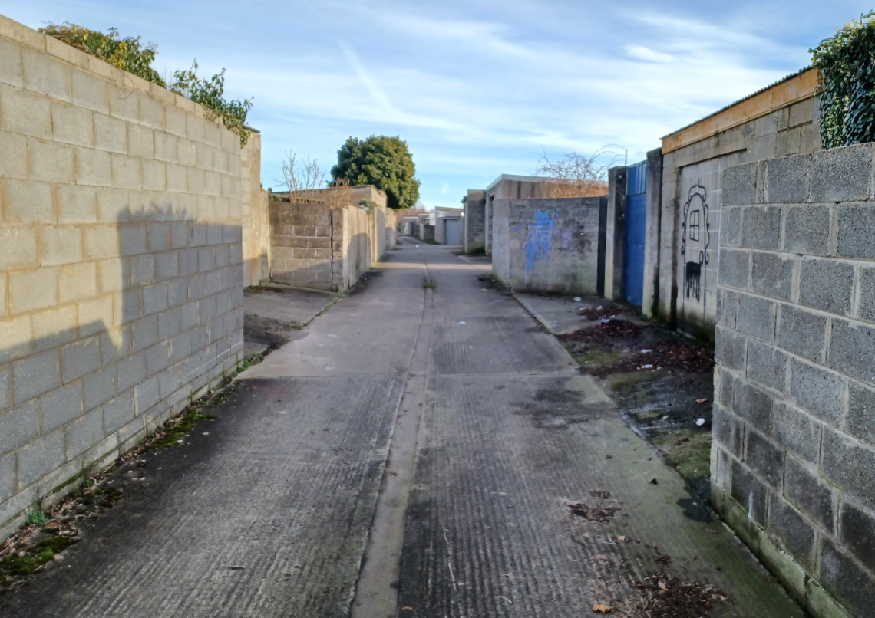

It is noted that the maximum width of the laneway (laneway running parallel to Palmerstown Drive and Culmore Road) where there were two ‘layby’ sections directly opposite (as shown in Figure 14) is 6m wide.

