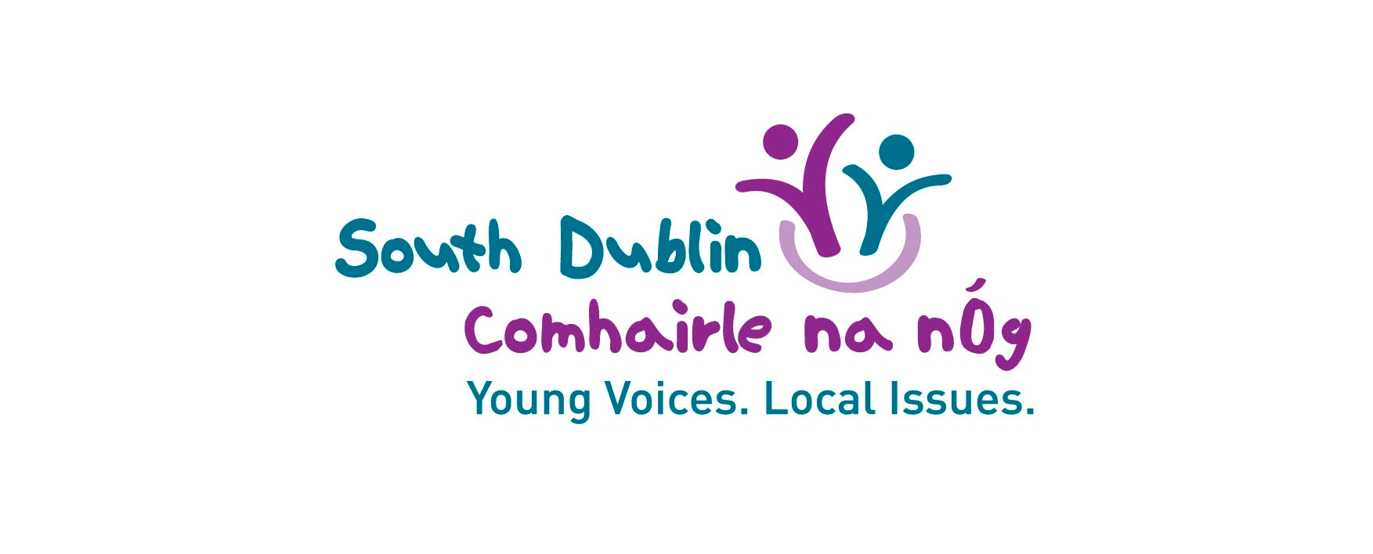

December 2023 Lucan/Palmerstown/North Clondalkin Area Committee Meeting

To ask the Chief Executive to report on how many schools are currently engaging with the Council in relation to actively promoting Comhairle na nÓg membership and interaction, and how this compares with five years ago?

___________________________

The process of forming a new Comhairle is as follows:
September
- Information is sent to all the schools, youth services and Alternative Learning Programmes in the county about the upcoming AGM/Youth Conference
- Schools nominate a key staff member to link with coordinators with questions/queries and to identify students
- Further communication about the Youth Conference is sent and how to register to a key staff person who sends it to the parent
- Parents' and young people's details are gathered from forms
- Services communicate with coordinators about hard-to-reach/seldom-heard young people to engage and they are sent relevant information and forms
October
- Registration forms are completed and returned by parents to coordinators
- Coordinators communicate with young people/parents with any further information they need to know
- AGM/Youth Conference takes place
- Delegates vote on the top issue for young people in the county and this becomes the work plan for the coming year
November/December
- Communication with Delegates about expressing interest in being a member of Comhairle
- Those that are interested come to an initial meeting to hear more about Comahirle and how it works.
- After this, meetings are held to form the group, elect roles, and develop the plan
- All communication is directly with young people/ parents

January
- Comhairle starts work on the topic selected at the AGM.

AGM/Youth Conference 2023

19 of the schools in the county area were represented in 2023, which is an increase of 1 school on the previous year.

- Colaiste Bride, Clondalkin
- Colaiste Eanna, Rathfarnham
- Collinstown, Clondalkin
- Firhouse Community College, Tallaght
- Firhouse ETSS, Tallaght
- Greenhills CC, Greenhills
- Holy Family Community School, Rathcoole
- Killinarden Community School, Tallaght
- Kingswood Community College, Tallaght
- Kishoge Community College Lucan
- Lucan Community College, Lucan
- Old Bawn Community School, Tallaght
- Pobailscoil Iosolde, Palmerstown
- St Aidan Community School, Tallaght
- St Colmcille's, Knocklyon
- St Joseph’s College, Lucan
- St Mac Daras Community School, Templeogue
- St Marks Community School, Tallaght
- St Pauls Secondary School, Walkinstown

AGM/Youth Conference 2018
18 of the schools in South Dublin attended the AGM in 2018.
- Adamstown Community College, Lucan
- Cois Life, Lucan
- Colaiste Bride, Clondalkin
- Colaiste Cillian, Clondalkin
- Colaiste de hÍde, Tallaght
- Deansrath Community College, Clondalkin
- Firhouse Community College, Tallaght
- Firhouse ETSS, Tallaght
- Holy Family Community School, Rathcoole
- Killinarden Community School, Tallaght
- Kingswood Community College, Tallaght
- Kishoge Community College Lucan
- Mount Seskin Community College, Tallaght
- Old Bawn Community School, Tallaght
- Pobailscoil Iosolde, Palmerstown
- St Aidan Community School, Tallaght
- St Pauls Secondary School, Walkinstown
- Tallaght Community School, Tallaght

The engagement with Comhairle post-AGM is the responsibility of the members of Comhairle and not the school/youth service/ALP, as communication turns directly to the parents and young people.
Every effort is made to ensure a broad cross section of schools, youth services and ALPs send delegates to the AGM. However, attendance at the AGM can be dependent on specific Principals/teachers/youth workers and their level of interest in youth participation. Ultimately membership of the Comhairle is by self-selection, with officer posts voted for by the membership.

