COMHAIRLE CONTAE ÁTHA CLIATH THEAS

SOUTH DUBLIN COUNTY COUNCIL

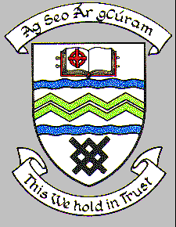

MEETING OF SOUTH DUBLIN COUNTY COUNCIL

MONDAY 13TH NOVEMBER 2023

HEADED ITEM NO. 14

PROPOSED EXTINGUISHMENT OF PUBLIC RIGHT OF WAY ON LANDS AT CASTLETYMON SHOPPING CENTRE, TALLAGHT, DUBLIN 24
RT/4/360

An initial proposal to Extinguish the Public Right of Way (EPROW) on lands at Castletymon Shopping Centre, Tallaght, Dublin 24 was originally presented to a meeting of the Tallaght Area Committee held on 27th September 2021, to request approval to initiate the EPROW process, which was agreed by the Councilors.

At that time a public notice was erected on site and an advertisement was placed in the local paper. No objections were received. There were no objections from the utility’s companies or other departments within the Council except for notification from the Water and Drainage section as follows:

Please note that there is a public 100mm dia. Watermain in part of the extinguishment area. This would require a wayleave. Also note that there may be private drainage in the area that will need to be investigated on site. Services map does not show private drainage & no records of these are held.”

Inadvertently, the matter was not subsequently progressed at that time, and the proposal was re-examined internally in September 2023. It was established that the proposal was still valid, and that there was no reason not to progress with the proposed Extinguishment of Right of Way.

On Monday, October 23rd, 2023, the Proposed Extinguishment was RECONSIDERED at the meeting of the Tallaght Area Committee.

The following report was circulated.

COMHAIRLE CONTAE ÁTHA CLIATH THEAS

SOUTH DUBLIN COUNTY COUNCIL

MEETING OF TALLAGHT AREA COMMITTEE

TUESDAY 23rd OCTOBER 2023

HEADED ITEM NO. 11

PROPOSED EXTINGUISHMENT OF PUBLIC RIGHT OF WAY ON LANDS AT CASTLETYMON SHOPPING CENTRE, TALLAGHT, DUBLIN 24
MAP REF: LR 06 21

This proposal was considered at the Tallaght Area Committee Meeting on Monday, 27th September 2021.

“An application has been received requesting the extinguishment of the public right of way over the laneway which is adjoining Castletymon Shopping Centre. It is proposed to affect the closure by means of disposal. (map below).”

Following consideration of the report, it was agreed to initiate the procedure.

The proposal to extinguish the public right-of-way was advertised in the Tallaght Echo and signs were erected on site in accordance with Section 73 of the Roads Act, 1993. No submissions were received in response to the public advertisement/notice.

There were no objections from the various Council departments who were contacted however the Senior Executive Technician from the Water and Drainage section has advised the following:

“Please note that there is a public 100mm dia. Watermain in part of the extinguishment area. This would require a wayleave. Also note that there may be private drainage in the area that will need to be investigated on site. Services map does not show private drainage & no records of these are held.”

The area required for a wayleave is hatched in Blue on Map no LR-06-21.

Following consideration of the reports received from utility providers and the technical reports received from internal departments, it is proposed to proceed with the extinguishment of public right of way at this location.

The decision regarding the extinguishment of a public right-of-way and the granting of an oral hearing is a reserved function of the Council. Accordingly, if this committee agrees to proceed, the recommendation of this Committee will be brought to full Council.

End of Report to Tallaght ACM October 2023.

At the Tallaght ACM, it was proposed by Councilor C. O’Connor, seconded by Councilor M. Duff, and AGREED:

“That this Committee recommends to the Council that the public right of way on lands at Castletymon Shopping Centre, Tallaght, Dublin 24 (Highlighted on Map LR-25-23) be extinguished.”

Accordingly, as the decision regarding the extinguishment of a Public Right-of-Way and the granting of an oral hearing is a reserved function of the Council,
If the Council agrees to the recommendation, the following resolution is required.

“South Dublin County Council in pursuance of its power under Section 3 of the Roads Act, 1993 hereby orders that the public right-of-way on lands at Castletymon Shopping Centre, Tallaght, Dublin 24 (Highlighted on Map LR-25-23) be extinguished.”

In line with the conditions required by Water & Drainage.
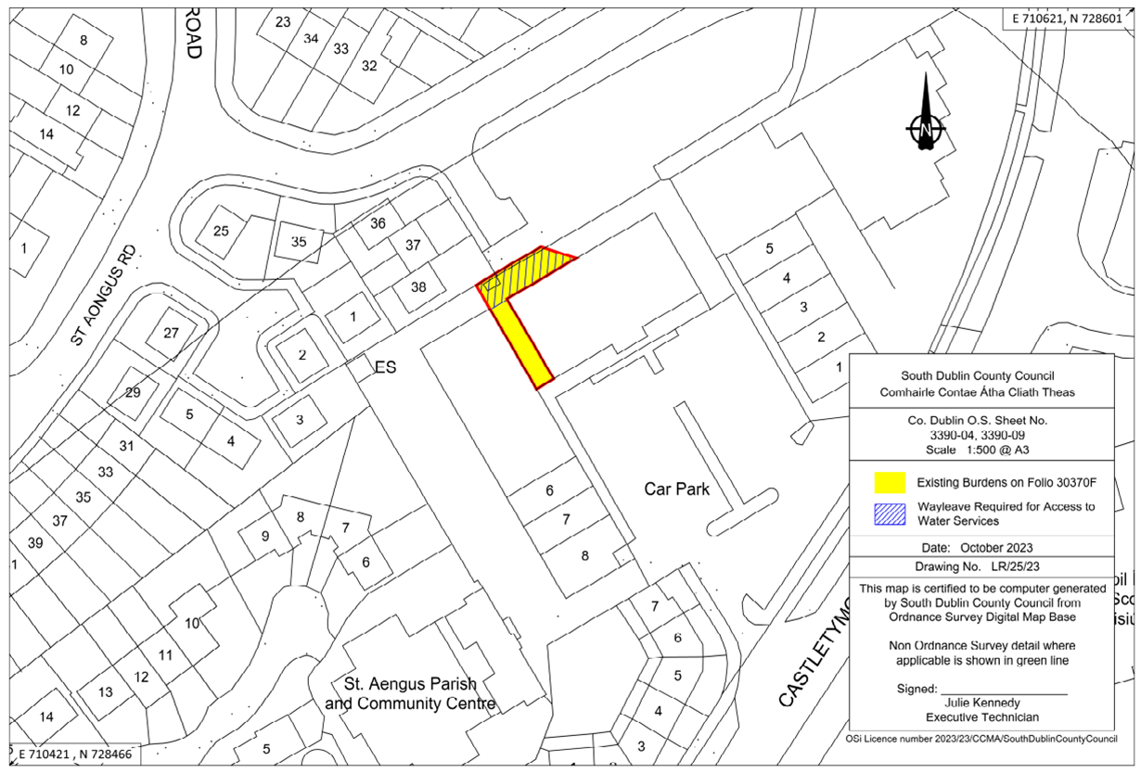

This matter is now before the Council.

