**Re Lucan/Palmerstown/North Clondalkin Area Committee**

**Committee request to carry out an air pollution study in Lucan, Palmerstown and North Clondalkin area.**

Dear Cllr O’Connell

In answer to your query above, please see below existing information and studies completed in the area of air quality.

**1** Environmental Protection Agency (EPA) have a website <https://airquality.ie/> that provides real time data on ongoing air quality measurements across Ireland, with 34 monitoring stations, both local and those on the network in the Dublin area. On occasion because of routine maintenance a few can be offline, where readings are temporarily unavailable.

The website displays the measurements taken, the corresponding Air Quality Index for Health (AQIH), and can be displayed as individual readings or on a calendar view over a selected timeframe. Screenshot of September 2023 calendar view below. In the main, readings are in the Good Air Quality Index for Health. There are monitoring stations in and around the local area. I have included a few screenshots for your convenience so you can see the type and level of information contained but the website provides the full data set.

***Screenshot 1 Overview of Dublin’s monitoring stations***

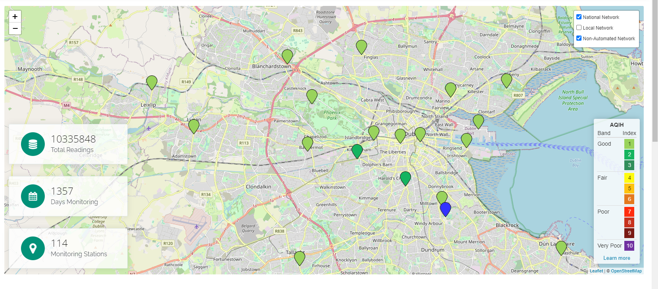

***Screenshot 2 Calendar View 18th September 2023 Lucan Monitoring Station***

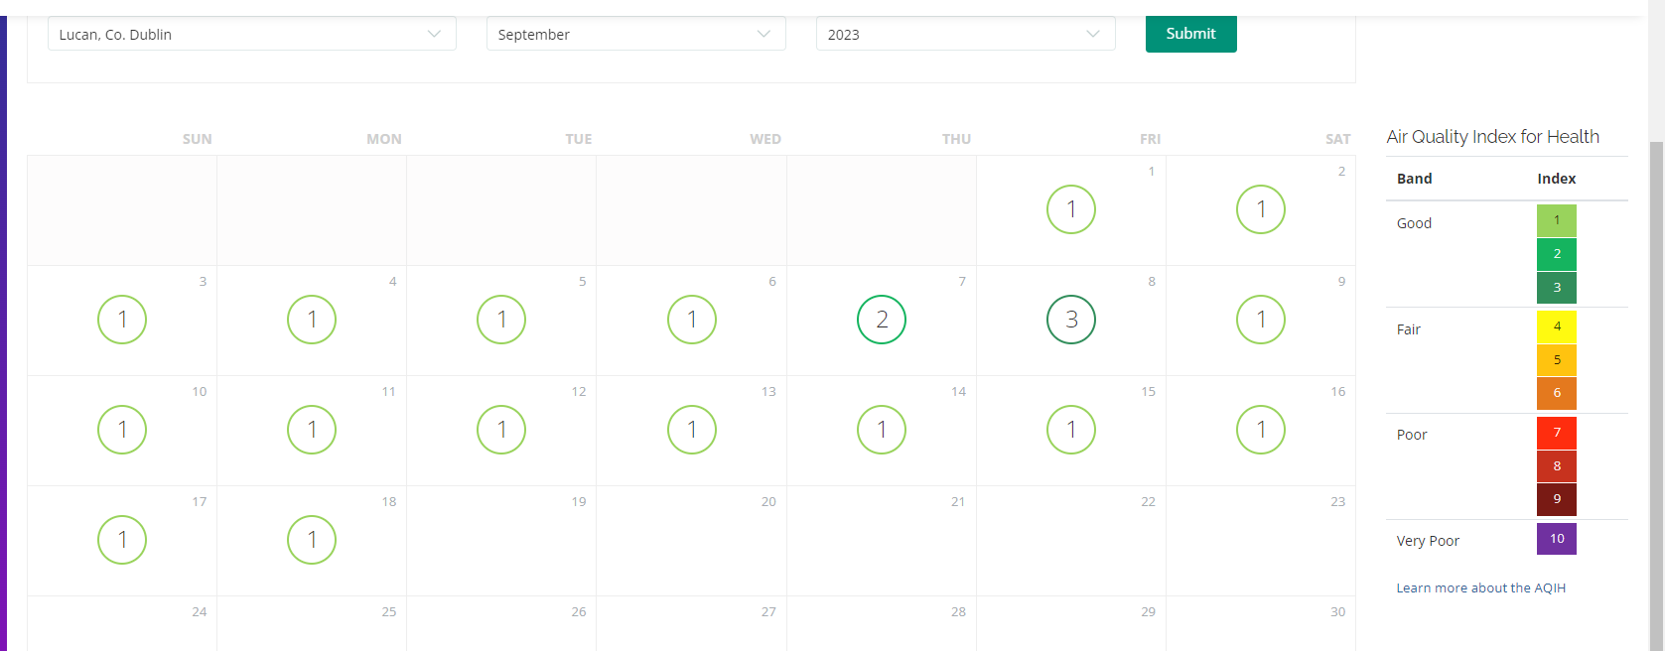

***Screenshot 3 Individual readings for the air quality parameters Lucan Monitoring Station on 18th***

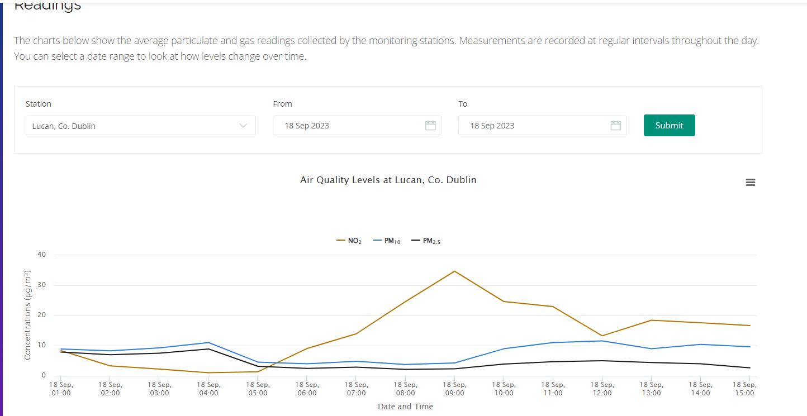

On the website, if you select any point on the graph, it provides the individual reading for NO2, PM10 and PM2.5 for that date andtime. The date range can be altered to give a longer term trend, displays a maximum of 6 months at a time.

***Screenshot 4 Overall view of measurements Lucan March to September 2023***

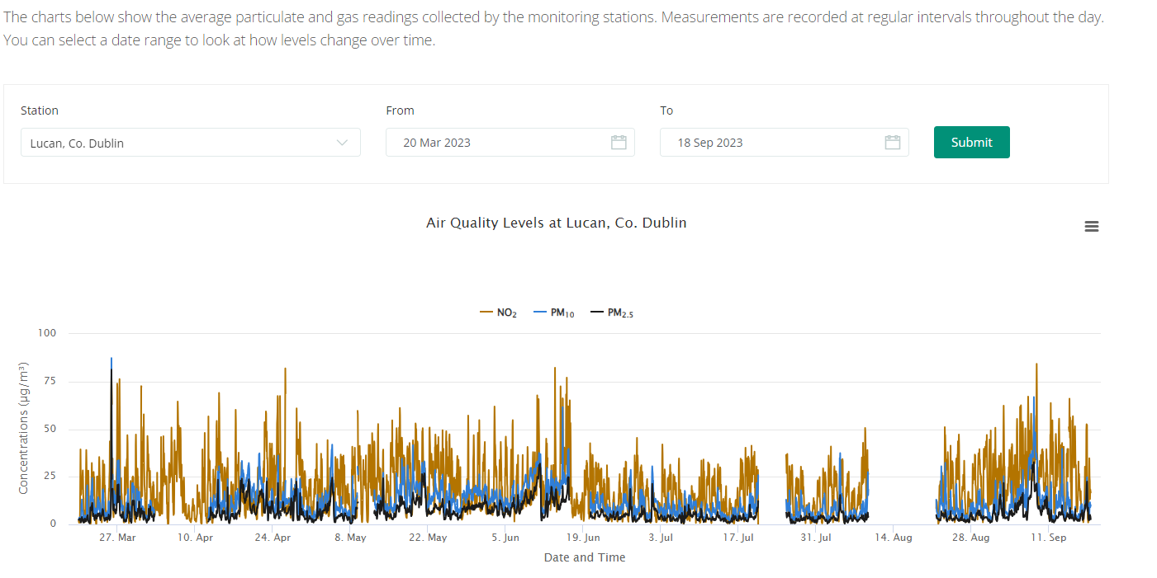

The website has useful explanatory data such as the screenshot below which gives an explanation of how the banding of the Air Quality for Health Index applies, based on the recorded readings.

***Screenshot 5 AQIH Levels associated with each band of AQIH.***

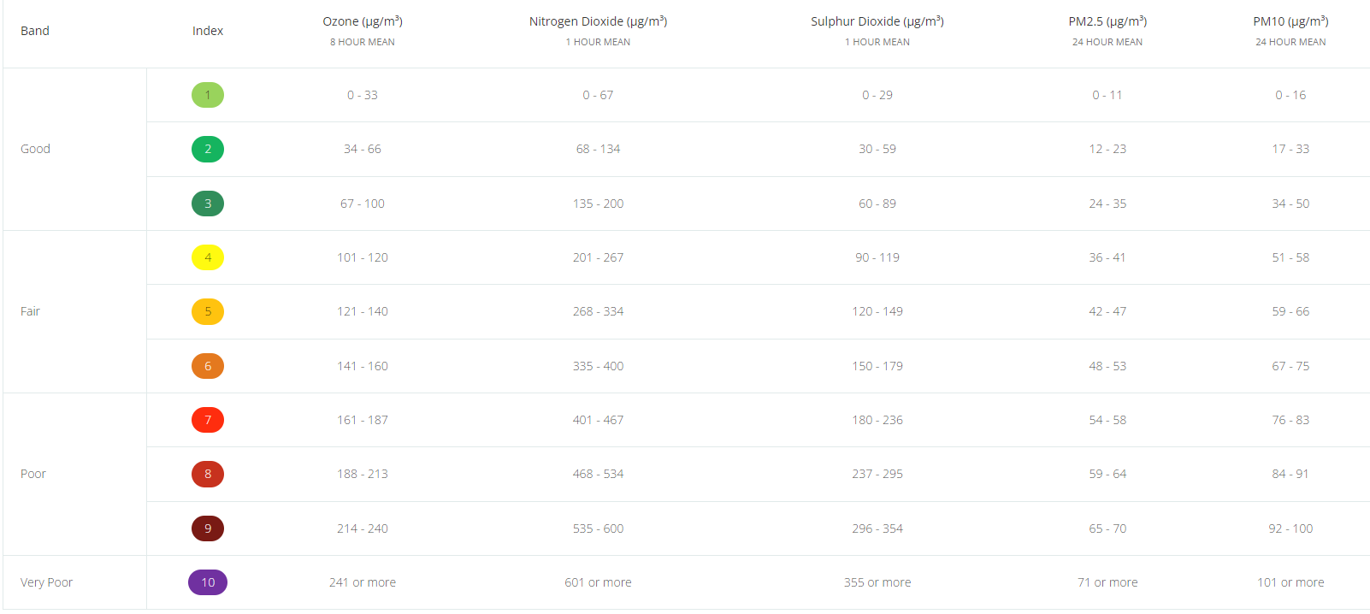

**Monitored Parameters explained**

**Particulate matter (PM10 and PM2.5)**

* PM are particles in the air typically measured as PM10 and PM2.5 with diameters of 10μm (microns) or 2.5μm. In Ireland, the main sources are solid fuel burning and vehicular traffic.
* Other sources are soil and road surfaces, construction works and industrial emissions or natural sources such as windblown salt, plant spores and pollens. These direct emissions are known as primary PM. Particulate matter can be formed from reactions between different pollutant gases (secondary sources).
* Small particles can penetrate the lungs and cause damage. There are high levels of PM10 in many cities and towns.

**Nitrogen dioxide (NO2) and Nitrogen oxides (NOx)**

* Emissions from traffic are the main source of nitrogen oxides in Ireland along with electricity generating stations and industry. Nitrogen dioxide can affect the throat and lung. The main effects are emphysema and cellular damage.
* It impacts visually as it has a brown colour and gives rise to a brown haze. Oxides of nitrogen contribute to the formation of acid rain and of ozone.
* Levels in Ireland are moderate but are increasing due to growth in traffic numbers.

**Applicable Legislation**

The **Ambient Air Quality and Cleaner Air for Europe (CAFE) Directive** (2008/50/EC) was published in May 2008.  It replaced the Framework Directive and the first, second and third Daughter Directives.  The **fourth Daughter Directive** (2004/107/EC) will be included in CAFE at a later stage. The limit and target values for both Directives are outlined below.

The CAFE Directive was transposed into Irish legislation by the **Air Quality Standards Regulations 2011** (S.I. No. 180 of 2011). It replaces the Air Quality Standards Regulations 2002 (S.I. No. 271 of 2002), the Ozone in Ambient Air Regulations 2004 (S.I. No. 53 of 2004) and S.I. No. 33 of 1999.

In relation to the snapshot of readings from the local air quality monitoring stations above, a few of the limits are outlined below. All of this information is available in greater detail on <https://airquality.ie/information/air-quality-standards>

***Table 1 Limit values of CAFE Directive 2008/50/EC***

|  |  |  |  |  |  |
| --- | --- | --- | --- | --- | --- |
| **Pollutant** | **Limit Value Objective** | **Averaging Period** | **Limit Value µg/m³** | **Limit Value ppb** | **Basis of Application of the Limit Value** |
| NO2 | Protection of human health | 1 hour | 200 | 105 | Not to be exceeded more than 18 times in a calendar year |
| NO2 | Protection of human health | calendar year | 40 | 21 | Annual mean |
| NO + NO2 | Protection of ecosystems | calendar year | 30 | 16 | Annual mean |
| PM10 | Protection of human health | 24 hours | 50 |  | Not to be exceeded more than 35 times in a calendar year |
| PM10 | Protection of human health | calendar year | 40 |  | Annual mean |
| PM2.5 - Stage 1 | Protection of human health | calendar year | 25 |  | Annual mean |
| PM2.5 - Stage 2 | Protection of human health | calendar year | 20 |  | Annual mean |

The readings measured by the air quality monitoring stations are within the values listed above as indicated by the Good Air Quality Index for Health. There have been a few isolated incidents for example at the end of August 2023 measured at St John’s Road monitoring station but the overall quality measured in all stations in Dublin to date in 2023 is in the Good category AQIH.

**2** **Additional Monitoring**

Additional to the ongoing monitoring at the air quality monitoring stations, measurements for NO2 were taken using diffusion tubes in SDCC area in 2021/22. Various locations including, Lucan, Esker, Clondalkin and Adamstown were monitored and all values were returned under 40µg/m³ limit for NO2 as listed above.

**3 EPA Air Quality Bulletins**

These are issued monthly by EPA and review the compliance levels at all air quality monitoring stations. The August 2023 bulletin which monitors all results from January to end of August 2023, shows only a single exceedance for Ozone > 120 µg/m³ in the Dublin area in Swords and no instances of PM10 being exceeded across the Dublin area.

Based on the information as briefly summarised above, there is no current evidence to indicate that there are air quality issues in the Lucan/Palmerstown/North Clondalkin area that would necessitate the need for further studies. The <https://airquality.ie> website is open to all members of the public and provides real time measurements of key air quality indicators. This is reviewed to monitor the levels recorded. The monitoring stations tend to be located in areas where traffic volume is high and/or residential areas where burning of fuels may impact the recorded levels so it provides a representative picture of the air quality.

I would be happy to answer any specific queries you may have or provide additional information as necessary. You can contact me on [peho.clondalkin@hse.ie](mailto:peho.clondalkin@hse.ie)

Patricia Doonan  
Principal Environmental Health Officer.