Wilkins Court Taking in Charge:
Submissions received during the Public Consultation:

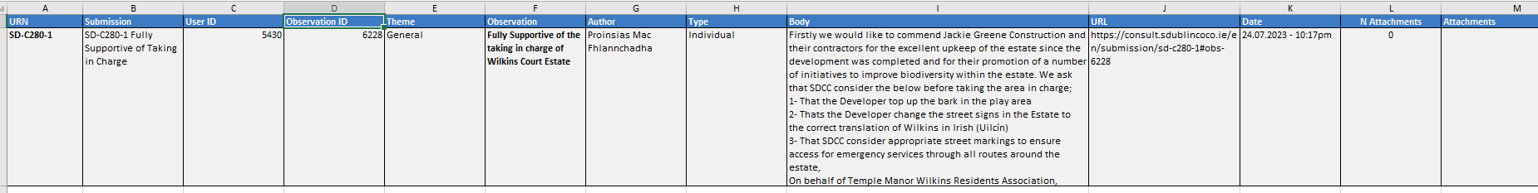

SDCC Response to submission received:
- SDCC will, as a matter of course, replace or top up the Bark mulch in the play area. This bark mulch is a safety feature of the play space.
- The Irish translation of the Street signs has been corrected since this submission was received.
- SDCC will ensure that emergency vehicle access is maintained within the estate. SDCC will keep this item under review and implement any appropriate actions necessary.

