**Library Facilities & Resources for Neurodiverse patrons:**

South Dublin Libraries has lots to offer to our neurodiverse adults and children. A resource collection has been developed to offer support to children and adults with additional sensory needs, making libraries more accessible and welcoming for them. Engaging children with ASD in sensory activities is beneficial in several ways, as it can help with stimulating the brain, creating neural pathways, and improving sensory processing systems. It also improves social skills such as communication and co-operation.

**What do we offer?**

**Neurodiverse South**

**Specialist toy lending collection** This new and updated toy collection caters for neurodiverse children, teens, and adults and those with more significant needs - improving the library experience.

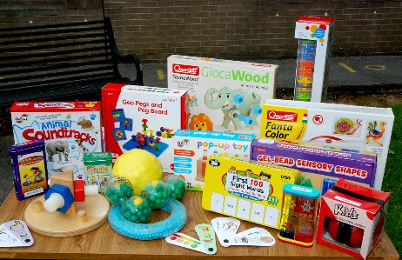Each branch will stock basic developmental items. More specialised toys will be housed in our 3 larger libraries, Tallaght, Ballyroan and North Clondalkin Library (covering areas such as language, communication, fine motor, gross motor, play & life etc). In addition, a collection of specialised sensory toys and items will be made available through the mobile library service to facilitate outreach visits. This specialised collection has been funded through the Community Recognition Fund.

**Quiet Time at Your Library:**

Each library provides a quiet time. During this time, the buildings will be a designated quiet space, and sensory items and toys will be available for Library customers to use.

**Social Stories:** Available in each library.

**Tovertafel Table:** The Magic Table (Tovertafel) is a fun care innovation designed for use by patrons with autism, additional learning needs dementia or cognitive impairment. Interactive light games are projected onto a table and infrared sensors respond to arm movements of players. Currently available in NCL & Tallaght library, the tovertafel table will be introduced into Ballyroan and Lucan library towards the end of 2023 (Community Recognition fund)

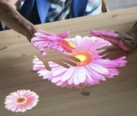

**Sensory walls:** available in Tallaght, Ballyroan and NCL. A sensory wall is being commissioned for Palmerstown Hub (DAF funding).

**Sensory Garden:** NCL & Tallaght library.

**Sensory Pods/Sensory Rooms:** NCL has the facility to transform its conference room into a sensory space/room. Our sensory wall/blackout tents/ sensory boxes and magic table are all portable. This can be made available to groups /individuals on request. (Subject to room availability). In addition, we are currently going through a procurement process to purchase a self-contained sensory modulation space for our 3 larger branches. (Tallaght/Ballyroan/NCL). It is envisaged that this facility will be available in all 3 branches by the end of 2023. (Community Recognition Fund)

**Programming:** We offer a wide range of events across the library service both inclusive and specific events for neurodiverse children/patrons. In addition, we will be running an Autumn Programme of talks and workshops aimed at supporting parents, carers and professionals working with neurodiverse patrons/children. These will be given by experts in the field including AsIAm, CATTs and Silvia Angel Education.

* A full list of talks is attached.

We are continually expanding our services, resources and programming to ensure increased library accessibility for our neurodivergent patrons.