COMHAIRLE CHONTAE ATHA CLIATH THEAS

SOUTH DUBLIN COUNTY COUNCIL

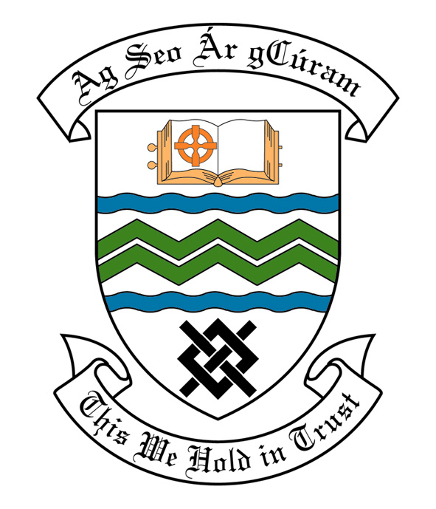

MEETING OF SOUTH DUBLIN COUNTY COUNCIL

Monday 12th June, 2006

MEETING OF THE LUCAN/ CLONDALKIN AREA COMMITTEE (2)

23rd May 2006.

HEADED ITEM NO:

Application for Grants

Applications for grants under the Council’s Community Grants Scheme have been received from the organisations listed below. Payment of these grants, in accordance with the conditions of the Scheme and in the amounts set out hereunder, is recommended for approval:

Ref: | Group | Type of Application | Date of Application | Amount
GF 1420 | Quarryvale Festival,  Quarryvale Community & Leisure Centre,  Greenfort Gardens,  Clondalkin,  Dublin 22. | Community Activity | 15/03/06 | €500
GF 1419 | Foxdene Summer Project,  Ronanstown Youth Service,  Neilstown Village Centre,  Neilstown Road,  Clondalkin,  Dublin 22. | Community Activity | 15/03/06 | €500
GF 1418 | Summer Bratz,  Ronanstown Youth Service,  Neilstown Village Centre,  Neilstown Road,  Clondalkin,  Dublin 22. | Community Activity | 15/03/06 | €500

Report on Summer Projects 2006

Summer Projects are aimed at providing a supervised programme of recreational and educational activities for young people over a consecutive number of weeks in the summer period. Emphasis is placed on community involvement and the development of resources and groups within localities. A wide range of activities are encouraged such as arts & crafts, sports, educational trips, drama, films, games etc. The use of available community facilities (schools, community centres, halls, open spaces) is also encouraged.

South Dublin County Council assists Summer Projects in the County area by way of grant-aid, assistance in kind, organised activities and staff support. In 2006 it is estimated that approximately 10,000 young people in the Council’s administrative area will participate in projects.

County Dublin V.E.C have agreed to continue their financial support to Summer Projects for the year 2006. These grants will be complementary to the above resulting in co-ordination between the two authorities, ensuring there is added value from this approach.

Catholic Youth Care provides insurance cover for Summer Projects.

It should be noted that in some cases the necessary insurance cost will be deducted from the grant provided by South Dublin County Council and will be paid directly to Catholic Youth Care.

Name of Project: Duration of Project Grant Amount

Clondalkin Travellers 4 Weeks €2,000

Bawnogue Summer Project 3 Weeks €1,500

Lucan Youth Fun 2 Weeks €750

Neilstown Summer Project 2 Weeks €900

Quarryvale Summer Project 2 Weeks €900

Rowlagh Summer Project 2 Weeks €900

Esker Summer Project 2 Weeks €750

Sruleen Summer Project 3 Weeks €1,250

Clonburris Summer Project 4 Weeks €1,600

Clondalkin Village Summer
Project 4 Weeks €1,600

St. Ronan’s Summer Project 2 Weeks €900

Knockmitten Area Summer
Project 3 Weeks €1,500

It was proposed by Councillor Fintan Mc Carthy, seconded by Councillor Eamon Tuffy and RESOLVED:-

“That this Committee recommends that South Dublin County Council approve payment of the above grants as recommended in the foregoing report”.

