COMHAIRLE CONTAE ÁTHA CLIATH THEAS  
SOUTH DUBLIN COUNTY COUNCIL



**South Dublin County Council Meeting**

**12th June 2023**

**Part 8 Report**

**PROPOSED UPGRADE OF JOBSTOWN PARKIN THE TOWNLAND OF JOBSTOWN, TALLAGHT**

Pursuant to the requirements of the relevant Planning Acts and Regulations, South Dublin County Council gave notice to upgrade Jobstown Park.

**PROPOSED UPGRADE OF JOBSTOWN PARK IN THE TOWNLAND OF JOBSTOWN, TALLAGHT**

**The upgrade of the Jobstown Park will consist of:**

* + - * Upgrade of existing boundaries and access points including provision of focal entrances.
      * A shared pedestrian/cycle route with lighting columns linking Butler McGee Park to Whitestown Stream Park, via Dromcarra Estate.
      * Upgrading existing footpaths where required, install new secondary footpath linkages and realignment of other footpaths.
      * Retention of existing sports pitches (northern pitch re-orientated) - refurbished where necessary with drainage and re-levelling.
      * Four new pedestrian entrances to provide access into the Leisure Centre, in the southeast, southwest and the northeast of the site.
      * Retaining existing kissing gates and upgrade where required.
      * An activity circuit 900m long - with seats and play/exercise equipment
      * A provision for teenspace area, fitness/workout area, natural play areas, pump track and natural play mounds.
      * The provision of on-street parking and associated hard and soft landscaping on Fortunestown Way.
      * Retention and replanting of existing hedgerows.
      * Attenuation swales for enhanced biodiversity.
      * Planting of trees, shrubs, hedgerows, and bulbs.
      * All associated landscape works.
      * All ancillary works.

The proposal has undergone Appropriate Assessment Screening under the Habitats Directive (92/43/EEC) and screening for Environmental Impact Assessment. The Planning Authority has made a preliminary examination of the nature, size and location of the proposed development.  The authority has concluded that there is no real likelihood of significant effects on the environment arising from the proposed development and a determination has been made that an Environmental Impact Assessment (EIA) is not required. Any person may, within 4-weeks from the date of publication of this notice, apply to An Bord Pleanála for a screening determination as to whether the development would be likely to have significant effects on the environment.

Persons wishing to inspect drawings and particulars of the proposed development can do so as follows between the period from **5th April 2023 to 18th May 2023**.

**IN PERSON:**    Plans and particulars of the proposed development will be available for inspection or purchase at a fee not exceeding the reasonable cost of making a copy, at County Hall, Tallaght, Dublin 24 during office hours from  **5th April 2023 to 18th May 2023**.

Submissions and observations with respect to the proposed development dealing with the proper planning and sustainable development of the area in which the proposed development will be situated, may be made in writing up to **5.00pm on the 18th May 2023** and may be submitted:

**Online:**[**https://consult.sdublincoco.ie/browse**](https://consult.sdublincoco.ie/browse)

or

**Post to:**

**Senior Executive Officer,**

**Environment Water and Climate Change Department,  
South Dublin County Council,  
County Hall, Tallaght, Dublin 24 YNN5.**

NOTE: Please make your submission by one medium only. All submissions should include your name and a contact address. It should be noted that the Freedom of Information Act, 1997-2006 (as amended) applies to all records held by South Dublin County Council.

Director, Environment Water and Climate Change Department, South Dublin County Council, County Hall, Tallaght, Dublin 24.

# 1. Introduction

## **1.1 Purpose of the Report**

The purpose of this Chief Executive’s Report is to present the outcome of the Part 8 consultation, to respond to submissions made during the consultation period and to make recommendations in relation to the proposed development where appropriate.

## **1.2 Structure of the Report**

This report provides the following:

* An introduction including details on the purpose of the report and an outline of the public consultation programme that was carried out.
* Description of Proposed Development
* List of Submissions received during the consultation period.
* A summary of the issues raised in the submissions made during the consultation period and the Chief Executive’s responses and recommendations.
* Assessment as to whether or not the proposed development would be consistent with the proper planning and sustainable development of the area.
* Recommendation as to whether or not the proposed development should be proceeded with as proposed, or as varied or modified as recommended in the report, or should not be proceeded with, as the case may be.

# 2. Proposed Development

## **2.1 Description of the Proposed Development**

The proposed upgrade of the Jobstown Park at Jobstown, Tallaght Dublin 24 will consist of:

* Upgrade of existing boundaries and access points including provision of focal entrances.
* A shared pedestrian/cycle route with lighting columns linking Butler McGee Park to Whitestown Stream Park, via Dromcarra Estate.
* Upgrading existing footpaths where required, install new secondary footpath linkages and realignment of other footpaths.
* Retention of existing sports pitches (northern pitch re-orientated) - refurbished where necessary with drainage and re-levelling.
* Four new pedestrian entrances to provide access into the Leisure Centre, in the southeast, southwest and the northeast of the site.
* Retaining existing kissing gates and upgrade where required.
* An activity circuit 900m long - with seats and play/exercise equipment
* A provision for teenspace area, fitness/workout area, natural play areas, pump track and natural play mounds.
* The provision of on-street parking and associated hard and soft landscaping on Fortunestown Way.
* Retention and replanting of existing hedgerows.
* Attenuation swales for enhanced biodiversity.
* Planting of trees, shrubs, hedgerows, and bulbs.
* All associated landscape works.
* All ancillary works.

**2.2 Plans and Details**

Plans and details are available at the following link:

[Jobstown Park Upgrade | South Dublin County Council's Online Consultation Portal (sdublincoco.ie)](https://consult.sdublincoco.ie/en/consultation/jobstown-park-upgrade)

Note: as outlined in the plans drawing are to be considered as indicative only

# 3 Outline of Public Consultation Programme

## **3.1 Informal Non-Statutory Consultation**

On the 26th of January 2023 initial engagement occurred with local Councillors of the Tallaght Area. Councillors welcomed the proposed investment in the Jobstown Park.

In addition to this initial engagement with local Councillors, efforts were made to connect with key community leaders in the Jobstown area with a view to linking in with their respective networks and facilitating engagement with a wide range of community interests. Support was sought in identifying community leaders from colleagues within South Dublin County Council (SDCC) and a list of potential contacts was drawn up. This list included:

* All primary and secondary schools in the vicinity of Jobstown Park
* Community bodies
* An Cosán
* Citywise
* Jobstown Community Centre
* Brookfield Community Centre
* Foroige
* Dodder Action Group
* Local residents
* Local Sports Clubs
* Jobstown Celtic
* Tamhlacht FC
* St Marks GAA
* South Dublin County Council staff members
* Active Cities Coordinator
* Sports Partnership

Local community leaders, groups and organisations were contacted and asked to participate in the consultation exercise. These consultation exercises were undertaken either face-to-face or remotely via Zoom or telephone call. A total of 15 interviews and a group workshop took place as part of the consultation.

Participants in Consultation Interviews

* Ciaran Farrelly, Sports and Recreation Officer for SDCC
* Conor McCarthy, Principal, Tallaght Community National School
* Tomás Hayes, Principal, St. Aidan’s Senior National School (SNS)
* Tracy Singleton and Patrick Keating, Jobstown Celtic Football Club (FC)
* Sean McMahon, Tamhlacht FC
* Darragh Conway, Active Cities Coordinator, SDCC
* Thomas McDermott, Coordinator, South Dublin Local Sports Partnership
* Bríd Doran, Home School Community Liaison Coordinator, St. Aidan’s SNS
* Anita Doody, Home School Community Liaison, Mount Seskin Community College
* Liza Coyle, Home School Community Liaison, St. Aidan’s Community School
* Julie McKenna, Home School Community Liaison, St. Thomas’ SNS
* Stephen Cunningham, Manager, Tallaght Leisure Centre
* Paul Norton, Get Ireland Cycling Officer; Eamon Wyer, BMX Commission Track Development Officer and Gary Lavery, Membership Development Officer, Cycling Ireland
* The Youth Steering Committee of Citywise Education5
* Kevin Shortall, Principal, St. Aidan’s Community School.

Local primary and post-primary schools in West Tallaght facilitated a series of classroom-based exercises (discussions, surveys, etc.) with pupils in their respective establishments. Five local schools returned feedback to the consultation team from their students.

Internal school consultations were also conducted.

* Mount Seskin Community College, Jobstown
* St. Aidan’s Community School, Brookfield
* St. Thomas’ SNS, Jobstown
* St. Aidan’s SNS, Brookfield
* Tallaght Community NS (3rd + 6th class lists and drawings)

An online community survey was created which was circulated to community leaders for onward distribution to their members and via various social media platforms. In total 175 people participated in the survey.

The proposed park development and the concept plan have been warmly welcomed and will transform the park from an “underused space” and “just a big field” to a high-quality public amenity that will meet and exceed the needs of the local community.

Below is a summary of points raised during the non-Statutory consultation process:

* Need for a playground.
* Requirement for active recreation (outdoor fitness)
* Somewhere for teenagers to hang out.
* Enhance the playing pitches to maximise usage.
* Enhance the paths in the park for walking and running.
* Skate and pump track
* Drinking water stations
* Seating areas & event space for all age groups
* Biodiversity area (hedgerows, trees, meadows, water features)

The key issues above were considered and addressed in the preliminary design/ part 8 documents.

## **3.2 Statutory Consultation**

The proposed development and accompanying reports and determinations were placed on public display for the statutory period from **5th April 2023 to the 18th of May 2023.**

Copies of the plans and particulars of the proposed scheme were available for inspection or purchase at a fee not exceeding the reasonable cost of making a copy at the following locations:

South Dublin County Council Offices, County Hall, Tallaght, Dublin 24 between the hours of 9:00am – 5.00pm Monday to Thursday and 9.00am - 4.30pm on Friday. Closed at weekends and bank holidays. **(Inspection and purchase)**

The plans and particulars could be viewed on the Council’s Public Consultation Portal website

[Jobstown Park Upgrade | South Dublin County Council's Online Consultation Portal (sdublincoco.ie)](https://consult.sdublincoco.ie/en/consultation/jobstown-park-upgrade)

Submissions and observations with respect to the proposed development dealing with the proper planning and sustainable development of the area in which the proposed development will be situated, could be made in writing up to 5pm on the **18th of May 2023** and submitted either via:

Online Submissions: [Jobstown Park Upgrade | South Dublin County Council's Online Consultation Portal (sdublincoco.ie)](https://consult.sdublincoco.ie/en/consultation/jobstown-park-upgrade)

or

Post to: Senior Executive Officer, Environment Water and Climate Change Department, South Dublin County Council, County Hall, Tallaght, Dublin 24 YNN5.

A total of 5 submissions were received by 5.00pm on the **18th of May 2023**

## 3. List of Submissions

**5** submissions were received during the specified period of the public consultation in respect of the proposed development from the following:

* Proinsias Mac Fhlannchadha
* Sean Corrigan
* Erin Ni Chumascaigh
* Rob Valerio
* South County Dublin Leisure Services

# 4. Summary and Categorisation of Issues Raised and Chief Executives Response

## **4.1 Proinsias Mac Fhlannchadha**

**Summary and Categorisation of Issues Raised:**

The submission welcomes the plans and makes the following comments / suggestions:

* Create mini woodlands/ steppingstone forest areas.
* Additional biodiversity/pollinator planting
* Installation of sensory communication boards and play equipment.
* Allow meadows to grow to support pollinators and biodiversity.
* Request for water fountains, bike parking, basketball facilities and bike/scooter track/area.

**Chief Executives Response**

* The general welcome and support of the plans are noted.
* The plan has included signature and native trees with native hedgerows which will provide key ecological corridors supporting pollinators and local biodiversity. In addition to this, the plan has outlined a generous area for meadow grassland (through changed management practice) with native bulbs to provide additional colour, habitats, and food sources. Further planting opportunities will be considered at the detail design stage this will include mini woodland planting.
* As part of SDCC’s Pollinator Plan 2021-2024 and Biodiversity Plan, SDCC are committed to planting pollinator and biodiversity-supportive trees and plants. At the detail design stage, SDCC will ensure the landscape masterplan and planting plans complies with the above plans.
* SDCC will include sensory play within the playground and park, the detail will be explored during the detail design stage and be in line with COS5 Objective 25 of the Development Plan, *“To continue to provide innovative play spaces, including sensory play areas and play trails, in parks and open spaces throughout the County”.*
* The Jobstown Park upgrade includes plans for a pump track (suitable for bikes, skating), and a cycle south Dublin link that connects Whitestown Stream Park to Butler Magee Park. Bike parking and a water station will be provided within the park footprint.
* The MUGA within the footprint of the park facilitates basketball and is not proposed as part of the park upgrade.

**Chief Executives Recommendation:**

It’s recommended that no changes be made to the part 8 proposal.

## **4.2 Sean Corrigan**

**Summary and Categorisation of Issues Raised:**

The submission welcomed the plans and made the following comments:

* Appropriate management of the park once completed.
* CCTV cameras (in tandem with existing ones) with Public Address System
* Additional lighting at entry/exit points.
* Request for dog area/park
* A dedicated Park Ranger and/or a Community Garda.
* Controlled access points
* Community clean ups
* Event spaces for the community

**Chief Executives Response**

* The welcome for the proposals is noted.
* In tandem with the master plan and park upgrade, a detailed maintenance plan will be put in place to ensure the park is maintained and managed to the highest standards.
* The suggestion regarding the installation of CCTV will be examined in the context of the relevant statutory requirements.
* Lighting columns are proposed along the main footpath of the park which will include entry/exit points.
* A dog area will be included in the park, the location will be examined at the detailed design stage.
* The Public Realm have 14no. Park Rangers operating across the County are tasked with monitoring all parks and open spaces. In addition, SDCC works closely with An Garda Síochána on an ongoing basis in relation to park and open space matters and Jobstown Park will continue to be included in those conversations.
* SDCC will facilitate community clean-ups.
* Within the park’s footprint there will be various green spaces which will facilitate community events

**Chief Executives Recommendation:**

It’s recommended that no changes be made to the part 8 proposal.

## **4.3 Erin Ni Chumascaigh**

**Summary and Categorisation of Issues Raised:**

The submission requested a dog park as part of the park upgrade.

**Chief Executives Response:**

* A dog area will be included in the park, the location will be examined at the detailed design stage.

**Chief Executives Recommendation:**

It’s recommended that no changes be made to the part 8 proposal.

## **4.4 Rob Valerio**

**Summary and Categorisation of Issues Raised:**

The submission welcomed the plans and made the following comments & requests:

* Provide biodiversity areas – trees hedgerows & ponds.
* Request for active recreational to be provided such as play area, football, walking areas and calisthenics.
* Community gathering spaces.

**Chief Executives Response:**

* The plan has included a sustainable drainage areas, signature and native trees with native hedgerows which will provide key ecological corridors supporting pollinators and local biodiversity. In addition to this, the plan has outlined a generous area for meadow grassland (through changed management practice) with native bulbs to provide additional colour, habitats, and food sources.
* The Jobstown Park upgrade includes the retention of the 4 existing pitches, in addition to this there will be additional areas for informal kick around.
* Calisthenics/ exercise area has been included in the proposed plans.
* There is a 900m exercise loop for running and walking.
* The Jobstown Park upgrade is planned to create a community gathering space for all ages that offers welcoming, inclusive, and flexible recreation opportunities for all.

**Chief Executives Recommendation:**

* It’s recommended that no changes be made to the part 8 proposal.

## **4.5 South County Dublin Leisure Services**

**Summary of submission:**

* The management team at the centre welcome the proposed upgrade and investment to Jobstown Park.
* The management team have outlined the project will benefit the people of the surrounding areas and is aligned with the leisure centre’s objectives to provide a healthier lifestyle for the residents of Tallaght.

**Chief Executives Recommendation:**

* The welcome for the proposals is noted.

**Chief Executives Recommendation:**

It’s recommended that no changes be made to the part 8 proposal.

# 5. Proper planning and sustainable development

**Context for the Project**

## **5.1 National Policy**

The Masterplan proposals have been developed in the context of:

Project Ireland 2040: National Planning Framework

The Eastern and Midlands Regional Spatial and Economic Strategy 2019-2031, and

Smarter Travel – A Sustainable Transport Future: A New Transport Policy for Ireland 2009-2020

National Cycle Policy Framework 2009-2020

Design Manual for Urban Roads and Streets

## **5.2 Regional Policy**

Regional Spatial and Economic Strategy for the Eastern and Midland Region 2019-2031, including the Dublin Metropolitan Area Strategic Plan (MASP)

To achieve the vision the MASP identifies a number of Guiding Principles for the sustainable development of the Dublin Metropolitan Area, which include:

Metropolitan Scale Amenities – To enhance provision of regional parks and strategic Green Infrastructure, to develop an integrated network of metropolitan scale amenities, and to develop greenways/blueways along the canals, rivers and coast, as part of the implementation of the National Transport Authority’s Cycle Network Plan for the Greater Dublin Area.

## **5.3 National Transport Authority (NTA), Greater Dublin Area Cycle Network Plan, 2013**

This document sets out existing and proposed cycle network plans for the urban network, inter- urban network and green route network for each of the seven Local Authority areas which includes SDCC. The Cycle Network Plan is to be developed in accordance with the National Cycle Manual and best industry practice.

Route 9C of the GDA Cycle Network provides a continuation from Route 9A west of Tallaght via Fortunestown and Citywest to Saggart. The Fortunestown Way section of the route extends along the southern edge of Jobstown. The along Cookstown Road section of Orbital Route SO6 adjoins the northern edge of the park, linking Dun Laoghaire to Tallaght via Sandyford and Ballinteer.

In addition, the GDA Network identifies the Whitestown Stream corridor to the south of Jobstown Park as a Minor Greenway, extending from Jobstown/the N81 in the west through Killinarden Park to Sean Walsh Park/Whitestown Way in the east.

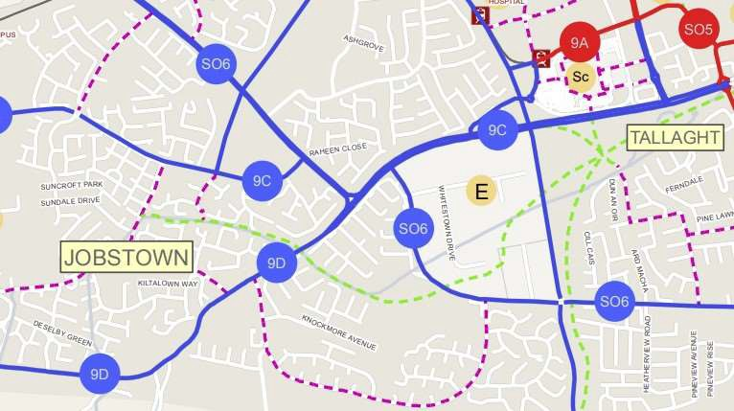

*Dublin South West Cycle Network Extract, Sheet N6 (Jobstown Park shown in orange)*

**5.4 South Dublin County Council, Draft Cycle South Dublin 2020**

SDCC published the Cycle South Dublin document for public consultation in November 2020, and following completion of this process an updated version will be issued.

The Cycle South Dublin document sets out the wider vision for South Dublin to become one of Ireland’s most cycle friendly counties. This includes the identification of several plans and proposed cycle routes, complementing the NTA GDA Cycle Network document. The cycle priorities are categorised into three: Now (next 4 years), Soon (4 to 8 years) and Later (8+ years).

Route 21 (Later Scheme) of the Cycle South Dublin strategy, replicating Route 9C of the GDA Cycle Network, follows Fortunestown Way along the southern boundary of Jobstown Park. Further south of the park, the Cycle Plan identifies a Soon Scheme through Killinarden Park and Whitestown Stream Park (Route 19A-C), linking with other existing and future cycle routes on the N81 and Whitestown Way and forming part of a wider scheme between Citywest and Rathfarnham (Route 19a-e).

The connection between Jobstown Park and Whitestown Stream is the only missing link in this extensive green corridor network, which could be effectively provided by roadside enhancements through the Bawnlea residential area and/or along Fortunestown Way to the N81.

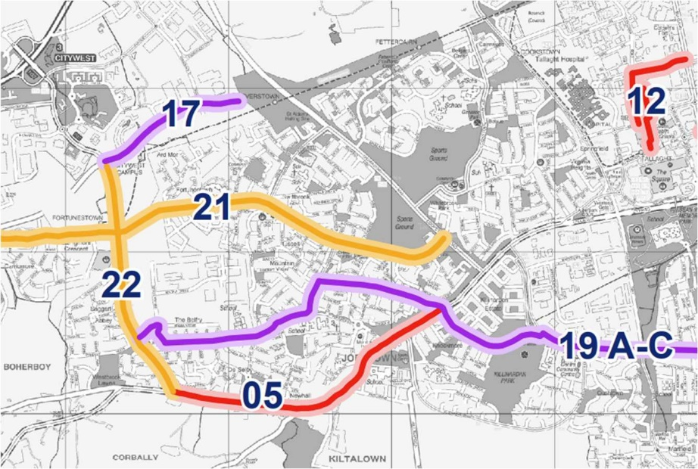

*Cycle South Dublin Proposed Cycle Routes (Jobstown Park shown in orange)*

## **5.4 Local Policy - South Dublin Development Plan 2022-2028**

The new South Dublin County Development Plan (the Plan) sets out the framework to guide future development where a focus is placed on the places we live, the places we work, and how we interact and move between these places while protecting our environment. The aim is to progress to a more sustainable development pattern for South Dublin in the immediate and long-term future up to 2040 and beyond.

Chapter 8.7 ‘Parks and Public Open Space’ deals with the function, hierarchy, quality and quantity of parks and public open space in the County. As set out in the Plan, the overarching aim of the Council in the provision of parks and open space is to encourage the development of a well-connected and integrated public open space network that contributes towards achieving a broad range of policy objectives, including:

*Improving community, health and wellbeing – Parks and open spaces provide a valuable role as a sanctuary for the community; the benefits of engaging with the natural world are now widely understood to be particularly beneficial to mental and physical health.*

*Enhancing visual amenity – Parks and open spaces form an attractive green and open setting which enhances the character of urban neighbourhoods in particular.*

*Promoting sustainable development – Parks and open spaces contribute to sustainable development objectives where they are appropriately located and accessible by walking, cycling and public transport.*

*Promoting climate change adaption and mitigation – Parks and open spaces provide opportunities for sustainable drainage while trees and plants perform a vital role by capturing and storing carbon.*

*Reinforcing Green Infrastructure – Parks and open spaces are core elements in the County’s*

*green infrastructure network (see Chapter 4: Green Infrastructure).*

*Promotion of biodiversity – Parks and open spaces offer opportunities to conserve and restore biodiversity and ecosystems. They are often focused on natural environments such as river valleys which support valuable wildlife habitats; parks also offer opportunities to increase pollinator-friendly planting.*

*Supporting culture and heritage – Parks and open spaces often contain heritage elements and play host to many outdoor community, arts and cultural events.*

*Supporting the local economy, including tourism – Many parks and open spaces contain facilities such as cafes, heritage features and other attractions that are valuable visitor amenities.*

It is the policy of the Plan that a hierarchical network of high-quality open space is available to those who live, work and visit the County, providing for both passive and active recreation, and that the resource offered by public open spaces, parks and playing fields is maximised through effective management.

The hierarchy of open space is a key element of the green infrastructure network, which connects and forms green corridor linkages across the County.

Objective 1 of the Green Infrastructure strategy (GI6) of the Plan is:

*To support a hierarchy of accessible open spaces and recreational facilities, appropriate for neighbourhood size and catchment area, which are adaptable and capable of accommodating multiple uses.*

The Public Open Space Hierarchy outlined in Table 8.1 sets out the rationale for the existing and planned parks and open space network for the County, identifying the range of functions at each level in the hierarchy. Jobstown Park falls within the hierarchical category of ‘Local Park’, which is defined in the Plan (Table 8.1: Public Open Space Hierarchy) as:

*‘Local parks range in size from between 2 to 20ha. They provide mostly for amenity and passive recreation, although some may have playing pitches and play equipment; they are located in close proximity to homes and thereby easily accessible by pedestrians and cyclists.*

*Examples of local parks in South Dublin County are Vessey and Hermitage Parks in Lucan, Ballycragh Park, Firhouse Community Centre Park and Quarryvale Park.*

*Local Parks serve a local population within a 400m catchment.*

*These parks primarily consist of improved grassland but offer considerable opportunities for contributing to the local level GI network through enhancement schemes that include native trees, small woodlands, hedgerows, meadows and other planting’.*

The Plan stresses that the provision of high quality public open space that is appropriately designed, located and maintained is a key element of placemaking. Public open space should have active and passive recreational value and should enhance the identity and amenity of an area. The key principles of particular relevance to Jobstown Park are:

*COS5 Objective 8: To ensure the design of parks and public open space areas is of high quality; to provide a pleasant setting, accommodate use by people of all ages and abilities, to support life-long activity and good health and well-being by the provision of a balanced mix of active and passive recreation and access to, or view of, nature, ensuring that the design considers:*

*provision of an appropriate mix of hard and soft surfaced areas;*

*enhancement of biodiversity and existing trees and hedgerows;*

*incorporation of water courses, other natural features and existing built heritage into the design of parks and open spaces as appropriate;*

*provision of new planting, landscape features and appropriate site furniture including a variety of accessible, well located and designed seating.*

*COS5 Objective 9: To ensure that parks and public open space are appropriately located within the County and within development sites, to facilitate and support its multifunctional role.*

*COS5 Objective 10: To support and facilitate the key role of parks and open spaces in relation to green infrastructure including sustainable drainage systems (SuDS), flood management, biodiversity and carbon absorption and to promote connections between public open spaces and the wider GI network.*

*COS5 Objective 11: To promote the role of parks and open spaces in conserving and restoring biodiversity and ecosystems in accordance with the objectives of the National Biodiversity Action Plan (2017-2021) and the All-Ireland Pollinator Plan 20212025, the Council’s Biodiversity Action Plan 2020-2026 or any superseding plans. In the development of individual management plans for parks the requirements of the aforementioned biodiversity and pollinator plans will be taken into consideration and will form a part of the management requirements for the park. The development of individual management plans for parks will include consultation with local stakeholders.*

*COS5 Objective 12: To ensure that proposed SuDS measures are only accepted as an element of public open space where they are natural in form and integrate well into the open space landscape supporting a wider amenity and biodiversity value.*

*COS5 Objective 13: To ensure that parks and open spaces provide for a wide range of recreational and amenity activities that are easily accessible to all in the community, irrespective of age or ability.*

*Objective 14: To ensure that public open space and associated recreational facilities are accessible by walking, cycling and public transport, as appropriate to their position within the open space hierarchy set out in Table 8.1.*

*COS5 Objective 15: To support the development of passive recreation within open spaces, such as walking trails, seating provision and areas which provide for passive amenity/ hobbies, and visual interest.*

*COS5 Objective 16: To ensure that parks and public open spaces are carefully designed as safe spaces, by implementing the following measures:*

*Providing active frontages and maximising passive surveillance from adjacent housing*

*and/or public thoroughfares;*

*Eliminating buildings which back-on or gable-front public open spaces;*

*Designing corner units with active frontage;*

*Encouraging increased use through improved access and quality of facilities’; and*

*Careful location, design and choice of surface materials and site furniture.*

*COS5 Objective 17: To ensure that incidental areas of open space which do not function as useable open space and/or are not clearly visible from the public realm, are designed out of a proposed scheme.*

**Planning Recommendation**

The proposed development is in accordance with the ‘OS’ land use zoning objective of the area and would not adversely impact on the residential amenity of the adjoining residential lands. It is considered that the proposed development is consistent with the County Development Plan and the proper planning and sustainable development of the area.

*South Dublin County Development Plan 2022-2028, Use Zoning Objectives Sheet 9 extract*

# 6. Chief Executives Recommendation

Having regard to the nature and extent of the proposed project, it is considered that the proposed development is in accordance with the South Dublin County Development Plan 2022-2028 and the proper planning and sustainable development of the area.

Following consideration of the submissions, the Chief Executive is of the view that the issues raised by way of the submissions can be satisfactorily addressed at the detailed design stage, operational stages and as outlined in the foregoing report.

It is recommended that, as the proposal is consistent with the County Development Plan and the proper planning and sustainable development of the area, the Council proceed with the Part 8 proposal for the upgrade of Jobstown Park.