**Adamstown**

**Creative connections - place making through creativity**

Through a Creative Ireland grant, SDCC arts office commissioned Creative Connections to undertake a place making project in Adamstown. They ran a survey which was distributed on Social Media and through various organisations including:

* Creative Connections
* Adamstown Residents Group
* Adamstown Community Centre

**Circulated by:**

* SDCC departments
* Quintain Community Forum
* South Dublin PPN
* Creative Connections
* The Big Tree Creative Art Project

Creative Connections next phase is to partner with NOISE Music for Cruinniu na nOg and programme a mini Urban Music, Dance and Visual Arts Event on June 10th. Funding is from Creative Ireland Cruinniu na nOg grant, awarded through the SDCC arts office.

Creative Connections will also work with members of the local community to collaborate on two murals based on the themes **Diversity and Community** which emerged from the survey. Imagery for the mural will be workshopped with members of the community in Adamstown community centre. This is currently being organised with the manager of the centre.  Dates to be announced.

The murals will be located in the Adamstown Youth and Community Centre and on Quintain’s hoarding at the Crossings.

The artist that will work on the murals is Kevin Bohan.

Examples of Kevin Bohan murals:

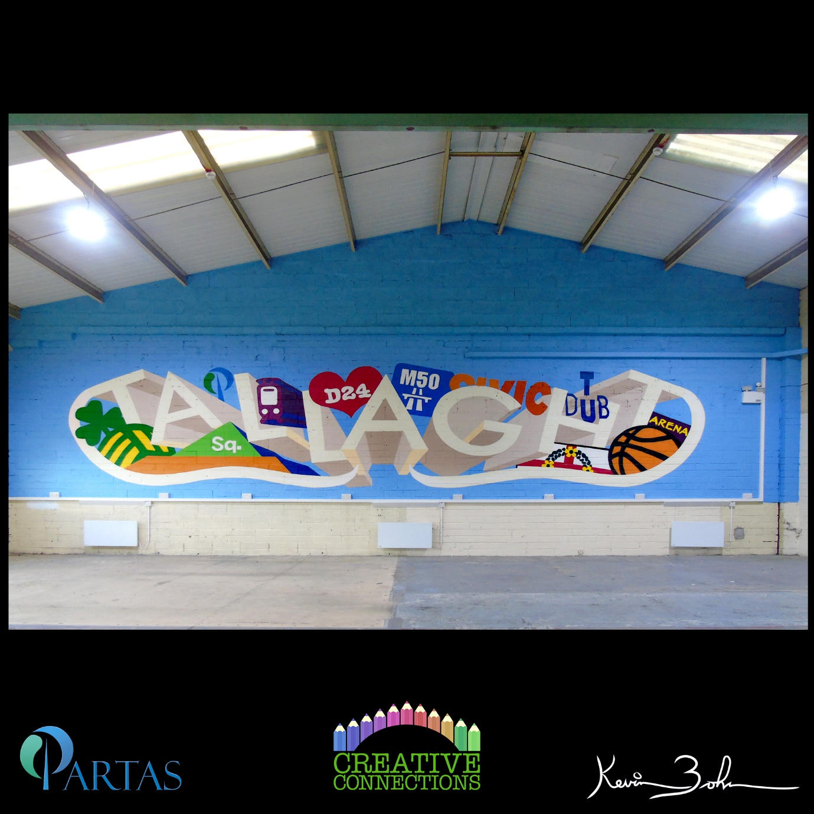

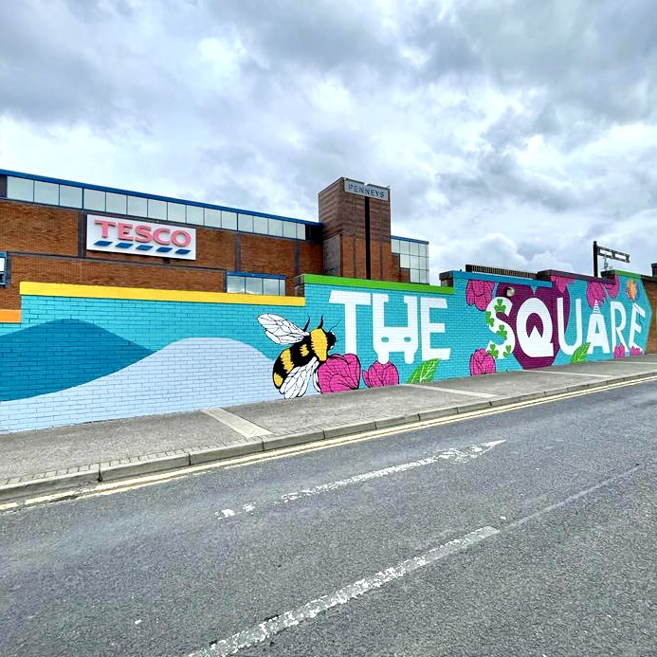

**Cruinniu na nOg**

Cruinniu na nOg is Irelands national day of creativity for children and young people and takes place on the 10th of June.

SDCC’s arts office has commissioned NOISE music to run music and dance workshops over 8 weeks preceding Cruinniu day, working with 14 - 18 year olds. The workshops will culminate in an open air performance that all the community can attend. The young people will also participate in street art workshops with well known mural artist Neto Vettorello. The resulting art works will be the backdrop to the performance by the young people and invited musicians,  taking place on Cruinniu day.

Over the past year SDCCs arts office has been working with The Big Tree project ( an initiative run by  the company Blue Elephant arts whose director is Joyce Jackson) to increase cultural provision in Adamstown for early years, children and young people. This series of workshops builds on this work and

NOISE Music is SDCC Arts office music programme. It has built a collective of some of the most innovative and exciting musicians and DJs working in Irish music today, including the artists performing at this event. They deliver workshops and performances throughout South Dublin County, working with young people aged 14 to 18 to develop their creativity, make music, and perform.

**Example of Neto Vettorello Mural**