**RTFB ACM May**

**Libraries Report | Ballyroan Library | May 2023**

Ballyroan Library had 21,072 visitors in April and 15,823 items were issued.

**Ten Year Anniversary**

Saturday 20th May from 11am

To celebrate the 10th anniversary of the opening of the redesigned Ballyroan library, we will be hosting a day of celebrations. The Mayor, Councillor Emma Murphy, will launch the day at 11am. Captain Ho Ho’s magic show will follow. There will be music from RUGS (Rathfarnham Ukulele Group) ukelele orchestra at 12.30pm and face painting will be ongoing from 12-2pm. *All welcome*.

**Bealtaine**

We have a wide variety of events to celebrate Bealtaine, Ireland’s national celebration of the arts and creativity as we age. These include:

Friday 5th May from 11am to 1pm

**Start to Sew with Siobhán**

Is the Aldi sewing machine you bought during lockdown still in its box? Would you like to get better acquainted with it? Sign up for this once off absolute beginner sewing machine class and get yourself started on your sewing journey. *Booking through Eventbrite*.

Wednesday 10th May from 6pm to 8pm

**Make your own Brat Bhríde with Rita O’Loughlin**

The Brat Bhríde (St Brigid’s Cloak) is an Irish tradition of decorating scarfs which bring blessings and protection to the wearer. Find out more about this wonderful tradition which is being revived by Rita O’Loughlin. *Booking through Eventbrite*.

Wednesday 17th May at 11am

**Make your own headband for our Great Gatsby event!**

If you’re thinking of coming along to our Great Gatsby music event on 30th May, then this is the class for you. Learn how to make your own 1920s flapper style headband which you can wear on the evening. *Booking through Eventbrite*.

Tuesday 23rd May at 6.30pm

**Ballyroan Bingo**

It’s eyes down for some numbers fun and prizes too! Bring a friend. *All welcome*.

Tuesday 30th May at 6.45pm

**Great Gatsby Evening with the Cotton Club Quartet**

Enjoy music from the golden age of Jazz with the Cotton Club Quartet. We are encouraging everyone to dress up 1920s style with beads, feathers and fringes! Drinks reception at 6.45pm, music starts at 7pm. *Booking through Eventbrite*.

Saturday 20th May at 12.30pm

**Music from RUGS (Rathfarnham Ukulele Group)**

Enjoy the uplifting sound of a ukulele orchestra! The ever-popular RUGS are back to brighten up your day. *All welcome*.

**Red Line Presents**

Wednesday 24th May at 7pm

**Catherine Ryan Howard in Conversation with Sinéad Cuddihy**

Join bestselling crime author Catherine Ryan Howard as she chats to Sinéad Cuddihy of the Tired Mammy Book Club about her career, her influences, her books and what the future holds. *Booking through Eventbrite.*

Wednesday 17th May at 6.30pm

**Special Once-Off Catherine Ryan Howard Book Club with Louise Phillips**

Join award winning author Louise Phillips to discuss *Run* by Catherine Ryan Howard in preparation for her event on May 24th. *Booking through Eventbrite.*

**Exhibitions**

Catherine Morrin (24th April to 13th May) and Mim Cassidy (from 15th May) will be exhibiting their work in our exhibition space this month.

**Other Adult Events**

Thursday 4th May at 7pm

**The Shared Reading Experience**

Shared Reading is a novel way of enjoying the reading experience with others. A friendly trained leader provides a welcome and the text of something chosen to read aloud. Shared Reading offers a welcoming space for individuals to form real connections with the literature, each other and themselves in real-time. *Booking essential via Eventbrite.*

Saturday 6th May at 2pm

**A screening of “Not My Bag” a film by Beta Bajgart and Olga Tiernan**

This short documentary examines individual responsibility we all face within the climate crisis. The story follows a journey of two women, Beta and Olga who meet in their Crumlin neighbourhood during regular Saturday morning litter-picks. *All welcome*.

Tuesday 9th May 18.30

**So you know Rathfarnham Part 2**

Local History Talk by Tony Duffy. *All welcome.*

Thursday 18th May at 7pm

**Rare at South Dublin: The Work of the National Rare Diseases Office**

Join us either in person or online for this fascinating event with Jacqueline Turner. Jacqueline has worked for over 25 years as a Genetic Counsellor in Ireland. She will talk about the Rare Disease patient journey and the advancements that have taken place and that are foreseen that will hopefully shorten the journey and lighten the load. *Booking through Eventbrite*.

Monday 22nd May at 7pm

**Understanding Childrens Needs: Self Regulation** (with South Dublin Childcare Committee)

For parents, childminders and Early Years providers in South Dublin in need of tips to better support children with additional needs - with Occupational Therapist Dr. Dorothy Armstrong.

Thursday 25th May at 6:30pm

**Poetry Competition Prize Giving and Reading**

Join us for an evening of poetry as our competition shortlisted poets read their poems and we announce the winners. Refreshments will be served.

**Regular Adult Events**

Every Monday at from 11am until 12.30pm and every Thursday from 6.30 until 8pm

**Stitched Together – Our Self-Helping Crafting Group** *All welcome.*

Wednesday 3rd, 17th and 31st May at 11am

**Scrabble Club** *All welcome*.

Friday 5th May at 10am

**Ballyroan Gardening Group** *Gardeners of all ages welcome.*

Thursdays at 10.30am

**Age Action Computer Classes**

These are one-to-one classes for older people facilitated by Age Action every Thursday.

**Sensory time at Ballyroan Library**

This takes place from 6pm-8pm every Monday unless otherwise advertised.

**Children’s Event Highlights**

Tuesday May 2nd at 10am

**Toddler Time with Sarah Sparkles**. *All welcome*.

Thursday May 4th at 3.30pm

**Star Wars: Makerspace Workshop**

C﻿ome along this May the 4th and design your own Star Wars themed baseball cap. For 10-14 year olds. *Booking through Eventbrite.*

Saturday 13th May at 3.30pm

**Game Zone – Get Your Game On!**

Can you beat your opponent at the latest video games or table-top football? Try our penalty shoot-out area or have a go at Connect 4 or Jenga. 10 years +. *Booking through Eventbrite.*

Monday 15th May at 3.30pm

**Philosophy Club**

Join Ian for this month’s Philosophy Club, the final club of the school year. *Booking via Eventbrite.*

Friday 26th May

**Baby Book Club**

Come along with your little one and enjoy some rhymes, songs and stories! For ages 0-18 months. *Booking through Eventbrite.*

**Regular Children’s Events**

**Storytime** (Mondays) **Toddler time** (Tuesdays) **Chess** (Saturdays)

**Coderdojo Rathfarnham** Wednesdays 3rd, 17th, 31st at 6pm.

**Libraries Report | Castletymon Library | May 2023**

*DJ workshops with Music Generation and NOISE*

This four week programme began April 21st, with transition year students from Tallaght Community School attending at the library every Friday morning for 4 weeks. Students are learning beat-making, critical listening skills and how to put together sets of music with the fantastic facilitators from Music Generation, led by Gerry Horan.

***Baby Sign Classes***

Beginning Tuesday, 9th May

A 4-week session of classes for parents of newborns and toddlers, teaching how to communicate with little ones using basic Irish Sign Language. This session is fully booked.

**BEALTAINE AGE AND OPPORTUNITY FESTIVAL**

***Engineering and Steam session for older adults***

Thursday, 11th May @ 11am

A relaxing session of building model cars and having chats

***Ukulele for Beginners***

Beginning Friday, 19th May @ 11am

A five week class of ukulele for older beginners in a relaxed, fun environment. This session is fully booked.

**REGULAR EVENTS IN CASTLETYMON LIBRARY**

Castletymon Library host regular events every week for members of the community of all ages.

**Parent and toddler group**: Takes place every Wednesday morning @ 10.30am

**TTRS classes**: Our Touch, Type, Read, Spell classes for children with additional literacy needs take place every Wednesday and Thursday evening @ 6pm

**Computer classes** for older adults: Facilitated by the DDLETB, these classes are currently fully booked and take place every Thursday morning @ 10am.

**Castletymon crafters**: A casual get together with tea, coffee (and the odd biscuit!) for older members of the community every Thursday morning @ 10am. All knitters, crocheters and crafters welcome.

**Children and Adult book clubs**: Our children’s book club takes places on the second Tuesday of every month while our adult book club takes place on the second Monday of each month.

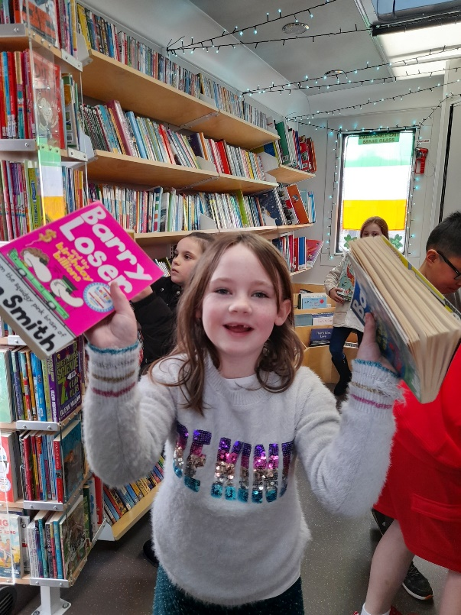

**Libraries Report | Mobile Library Service**

The Mobile Library visited 132 public stops in April where we welcomed 2277 visitors. We made eight visits to primary schools in April either side of the schools Easter holidays.

Our Library@Home service continues to deliver books to vulnerable people in the community and we made 108 home deliveries in April. We held a further nine outreach events in April, including our regular monthly visit to Ukrainian refugees at Citywest Hotel, and a visit to the Easter camp at Balgaddy Community Centre. For May, we are introducing a new regular outreach visit to the transit hub at Citywest Convention Centre.