Pedestrian Bridge and Pedestrian Path proposed to be Taken in Charge

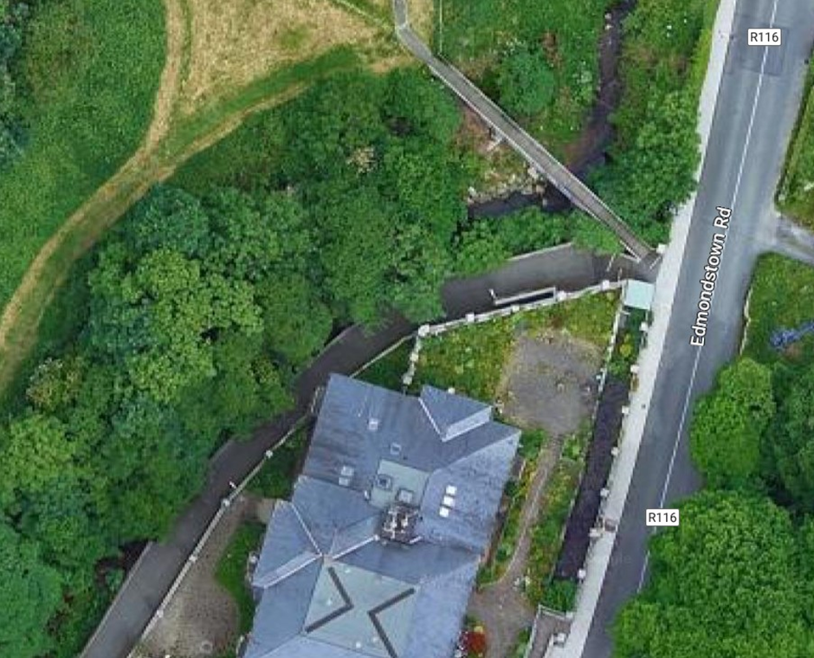

Pedestrian Path

Pedestrian Bridge

Green Open Space proposed to be Taken in Charge

Green Open Space