**Clondalkin ACM**

**Libraries Report | Clondalkin Library | April 2023**

Throughout April Clondalkin Library issued 4314 items and our current membership is 14,195

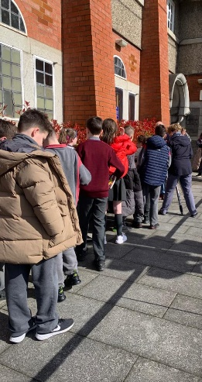A total of 90 events were hosted by the library throughout the month, with 1,708 people attending.

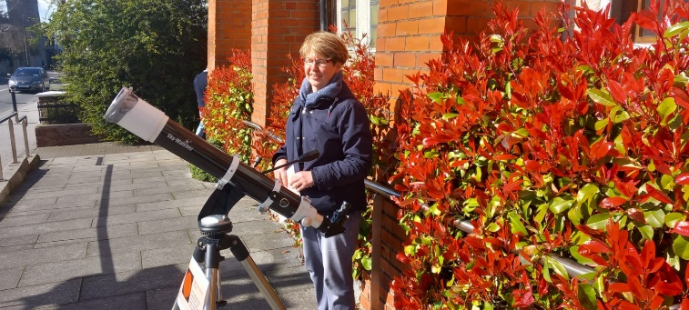Our Astronomy Week took place from 20-25th March with great success. We had 8 events in total, an exhibition, and a competition. We had 185 people in attendance at the events which was a great success. This was a new addition to our annual programme for Clondalkin Library and will be run again in 2024.

*Photo of school children lining up to view the sun through a filtered lens.*

**Events for April**

**Tech Week 17th-22nd April**

This is a new addition to our annual programme for Clondalkin Library. We will showcase all our devices and hard and software during this week including 3D printer/the hublets/touch and tilt table our express PCs and all our online resources including BorrowBox and resources for adults and children. We will also have stop animation workshop and a 3D printing workshop for school children We hope to use this week to highlight both our in-house and online resources to members of the public.

For the Easter break we ran a programme for children including Captain Splash on 5th April which had over 60 in attendance, Gymboree music workshops for our baby and toddler groups on Tues 4th & Sat 15th. 3 Irish History Live events for children on 12th April and Waffles the Wonderful puppet show on 13th April.

Our Joe Williams annual lecture took place on 12th April at 6.30pm with a talk on Slí Mór by Sean Cullen and we also had a talk by holistic gardener and author Fiann O'Nuallain on 13th April as part of our Grow It Yourself group.

**Events for May**

During May, we celebrate the Bealtaine Festival which is Ireland’s national celebration of the arts and creativity as we age. Our headline event for this festival is an author talk with Sheila O Flanagan Wednesday 10th May 6.30pm. We will also have a 6-week course on healthy food made easy with Sláintecare starting 25th May and a talk by Nell Regan on Helena Moloney- the life-long trade unionist who advocated for improved conditions and representation for women.

**Other events in May/June**

* We will also have another 6-week Mother Tongues course with two artists starting on 8th May.
* ***Stories From the Garden with Roisin Murphy.***

On Thursday 25th May we will host 4 storytelling session by storyteller Roisin Murphy which will cater to schools and families. This will be held in the Clondalkin Round Tower Garden. *(Weather permitting).*

* **Murderous Ballads** with Pádraig Ó Nualláin 1st June at 6.30pm. This performance by traditional singer Pádraig Ó Nualláin will include songs and the stories behind the songs accompanied by a visual presentation, from the 18th to 20th century of serial murderers, executions, hauntings, and grave robbing.

**Libraries Report | Mobile Library Service**

The Mobile Library visited 160 public stops during March. We visited 17 primary schools as well as making deliveries to creches. Our Library@Home service continues to deliver books to vulnerable people in the community and we made 108 home deliveries in February. We held a further nine outreach events in February, including our regular monthly visit to Ukrainian refugees at Citywest Hotel, and a visit to the National Learning Network in Tallaght.

Our Mobile Libraries also took part in the St. Patrick’s Day Parades in Lucan and Clondalkin this year with the aim of promoting the Mobiles service, and the library service as a whole. The parades were very well attended and supported locally and we were delighted to play a part, and with the reaction that the Mobiles received.

