**RTFB ACM April**

**Libraries Report | Ballyroan Library | April 2023**

Ballyroan Library had 21,915 visitors in March. We hosted 74 events with a total of 1,330 attendees. 15,570 items were issued and 588 new members joined the library.

**Event Highlights**

**Exhibitions**

Jennifer Grogan (3rd to 22nd April) and Catherine Morrin (24th April to 6th May) will be exhibiting their work in our exhibition space this month.

**Adult Event Highlights**

Saturday 1st April, 2-4pm

**Green in ’23: Upcycling Jeans to Bag Workshop**

Bring along your old jeans and join us for an upcycling workshop for adults, with Niki Collier. *Booking essential via Eventbrite.*

Tuesday 11th April at 11am

**Adult Arts and Crafts Class with Christine**

Learn to draw a still life with pencils in a relaxed and enjoyable way. Learn the drawing techniques of shading, observing form and structure of a still life arrangement. *Booking essential via Eventbrite*.

Thursday 13th April from 7pm

**One Dublin Two Authors**

Past and present One Dublin One Book authors Joe Joyce and Andrew Hughes will be in conversation about Dublin city as canvas and setting for historical crime fiction. They will talk about the research required to recreate a version of Dublin from the past, as well as the inspiration to be found in its landmarks, people, and historical events. *Booking via Eventbrite.*

Tuesday 18th April from 6-7.45pm

**Study Skills and Revision Seminar for 6th Years**

Calling all 6th year students who want to improve their organisational skills, build confidence and improve their study methods. This motivating seminar will give practical advice and ideas to help you succeed in your exams. *Booking via Eventbrite.*

Tuesday 25th April 6-7.30pm

**Green in ’23: Book Swap**

Join us for a second-hand book swap. Participants can bring up to 5 books of any age or genre, collect tokens and swap them for the same number of books. Books must be in good condition. Books can be dropped into the library on Monday 24th from 6-8pm and Tuesday 25th from 11-4pm. We will recycle any books not swapped. *Booking essential via Eventbrite.*

Wednesday 26th April at 11am

**Golden Moments Social Club – Gardening for Biodiversity: A Talk by Aoife Munn**

Discover what you can do to improve your garden for biodiversity while still keeping it low maintenance and looking great all year round. Plant a pot of bee friendly seeds to take home too. Enjoy some refreshments and a get-together after the talk. *All welcome.*

**Regular Adult Events**

Every Monday at from 11am until 12.30pm and every Thursday from 6.30 until 8pm

**Stitched Together – Our Self-Helping Crafting Group** *All welcome.*

Wednesday 5th April and Wednesday 19th April at 11am

**Scrabble Club** *All Welcome.*

Friday 3rd March at 10am

**Ballyroan Gardening Group** *Gardeners of all ages welcome.*

Wednesday 8th March and Wednesday 22nd March at 11am

**Scrabble Club** *All Welcome*

Thursdays at 10.30am

**Age Action Computer Classes**

These are one-to-one classes for older people facilitated by Age Action every Thursday.

**Sensory time at Ballyroan Library**

This takes place from 6pm-8pm every Monday unless otherwise advertised.

**Children’s Event Highlights**

**Philosophy**

This year we welcome back the UCD Department of Philosophy and their students to run a series of workshops for children and teens. The workshops are fun, interactive, discursive introductions to philosophy involving games and activities. There is an open session for teenagers on 14th and 5th/ 6th classes will be offered workshops on 21st and 28th.  We also have our regular **Philosophy Club** with Ian on Monday 17th April 3:30pm for ages 10 – 12.

Monday 3rd April 2-4pm

**Peter Rabbit Hunt in Rathfarnham Park**

Over 170 children attended the Peter Rabbit themed treasure hunt at Rathfarnham Castle.

Tuesday 4th April 10am

**Sarah Sparkles Toddler Time**

Fun storytelling, music and songs with Sarah Sparkles. *All Welcome.*

Thursday 6th April at 3pm

**Easter Crafts**

For ages 4-6 years. *Booking via Eventbrite.ie*

Wednesday 12th April at 10am

**Songs from Many Lands: Music for tots with South Dublin Music Generation**

In this fun music session you and your little one will learn some new songs and musical activities from around the world. For ages 0-4 years.

Thursday 13th April at 2pm and 3.30pm

**Superpowers with the National Reptile Zoo**

Meet some super cool animals from The National Reptile Zoo! Create your own creature and learn about the superpowers of reptiles. Suitable for ages 5+. *Booking via Eventbrite.*

Saturday 15th April at 3pm

**Easter Family Movie – Peter Rabbit**

Join us for a screening of the Peter Rabbit movie.

**Regular Children’s Events**

**Storytime** (Mondays) **Toddler time** (Tuesdays) **Chess** (Saturdays)

**Coderdojo Rathfarnham** Wednesdays 5th and 19th April at 6pm

**Libraries Report | Castletymon Library | March 2023**

***Easter Midterm*** Castletymon Library host coding camps for children aged 7 – 14 years old. Attendees will learn the basics of Scratch, coding etc and all equipment is provided.

The library will also host arts and crafts and a variety of events for children over the midterm break.

***STEAM workshops for children with additional needs***These sessions continue to be well attended. Next session takes place on Saturday, 22nd April @ 12pm

***DJ workshops with Music Generation and NOISE***Beginning on April 21st, the library will host 15 students from Tallaght Community School every Friday morning for 4 weeks. The TY students will learn beat-making, critical listening skills and how to put together sets of music they’re interested in. Guaranteed to be noisy and fun!

***History Book Launch: “Turn Left at the Lamb”***

Monday, 17th April, 6.30pm

South Dublin Libraries and the Lakeside Heritage Group present this collaborative work "Left at the Lamb", a wonderfully researched book bringing a flavour of the history and heritage of the Blessington area.

The evening will involve a talk from local historian Aidan Cruise, one of the contributors to the book. Attendees include members of the Castletymon History and Heritage group, which was started by staff in Castletymon library in 2021 and now has over 50 members.

***Baby Sign Classes***

Beginning Tuesday, 9th May

A 4-week session of classes for parents of newborns and toddlers, teaching how to communicate with little ones using basic Irish Sign Language

**BEALTAINE AGE AND OPPORTUNITY FESTIVAL**

***Engineering and Steam session for older adults***

Thursday, 11th May @ 11am

A relaxing session of building model cars and having chats in the library

***Ukulele for Beginners***

Beginning Friday, 19th May @ 11am

A 5-week class of ukulele for older beginners in a relaxed, fun environment. This is the second run of these classes, our first run in September 2022 fully booked out and had great feedback.

***Trad in Tymon:*** We had one of our biggest Trad in Tymon sessions during Seachtain na Gaeilge with over 50 people attending. Our next session takes place as part of Bealtaine on Wednesday, 24th May @ 6.30pm

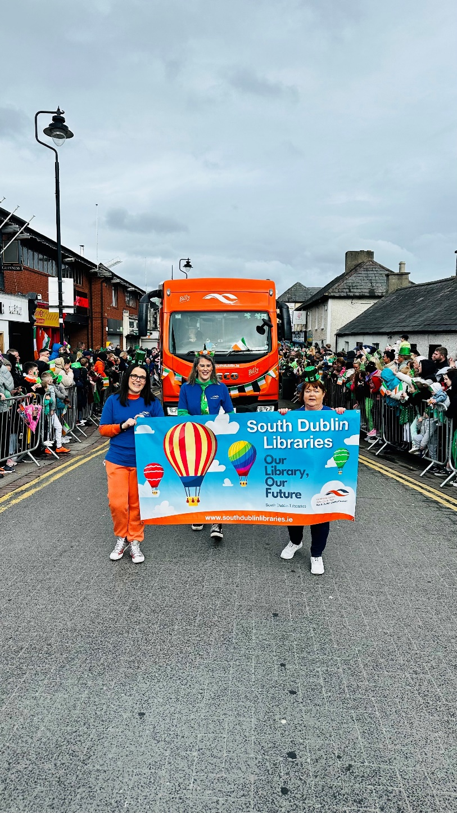**Libraries Report | Mobile Library Service**

The Mobile Library visited 160 public stops during March. We visited 17 primary schools as well as making deliveries to creches. Our Library@Home service continues to deliver books to vulnerable people in the community and we made 108 home deliveries in February. We held a further nine outreach events in February, including our regular monthly visit to Ukrainian refugees at Citywest Hotel, and a visit to the National Learning Network in Tallaght.

Our Mobile Libraries also took part in the St. Patrick’s Day Parades in Lucan and Clondalkin this year with the aim of promoting the Mobiles service, and the library service as a whole. The parades were very well attended and supported locally and we were delighted to play a part, and with the reaction that the Mobiles received.

