**RTFB ACM January**

**Libraries Report | Ballyroan Library | March 2023**

Ballyroan Library had 18,358 visitors in February. 14316 items were issued and 500 new members joined the library. We hosted 69 events with 1252 attendees.

**Launch of Seachtain na Gaeilge**

The launch of Seachtain na Gaeilge Átha Cliath Theas took place in the presence of the Mayor Cllr. Emma Murphy on Tuesday February 21st at 10.30am. Jim Gavin is this year’s Patrún. Pupils from three local schools attended and were entertained as Gaeilge agus as Béarla by the circus skills of Stephen McGinley.

**Event Highlights**

**Exhibitions**

Beautiful exhibition of paintings by Ukrainian artist Volodymyr Shkred continues until March 11th.

Paula Daly from the Castle Art Group will be exhibiting her paintings from the 13th.

**Adult Event Highlights**

Thursday 2nd March 9.45 to 11.30am

**Enable Ireland** are hosting a coffee morning for parents of children with sensory processing issues facilitated by an occupational therapist.

Tuesday 7th March from 6.30pm

**Live Music from No Direction (Seachtain na Gaeilge event)**

Join us when our local band No Direction (AKA the Ballyroan Men’s Shed) will belt out some favourite sing-along ballads.  All welcome.  Bring a friend!

Tuesday 14th March from 6pm – 8pm

**Make your own Brat Bhríde (Seachtain na Gaeilge event)**

The Brat Bhríde (St Brigid’s Cloak) is an Irish tradition of decorating scarfs which bring blessings and protection to the wearer. Please bring one of your own scarfs to decorate.

*Booking via Eventbrite*

Tuesdays

**Irish classes** for adults continue from 2.30-4.30pm

Wednesday 8th March from 11am

**Community Coffee morning to celebrate International Women’s Day.**

Spoil yourself on. Take the weight off your feet and enjoy a coffee and pastry. All welcome.

Thursday 9th March at 6.30pm

**All You Need to Know About Menopause**

With Catherine O’Keeffe. *Booking via Eventbrite*

Friday 10th March from 10am to 1pm

**Business Advice and Mentoring with LEO**

Are you looking to start a small business or already have a business in South Dublin and are looking for advice and support? As part of Local Enterprise Week, LEO South Dublin is hosting a 1-on-1- mentor clinic in Ballyroan Library on Friday, 10th March, from 10 am - 1 pm.

Booking is essential and can be made at 01-4149215

Tuesday 21st March at 11am

**Adult Arts and Crafts with Kim**

Join Kim Jenkinson for this simple embroidery workshop.

*Booking essential via Eventbrite*

Tuesday 28th March at 6.00pm-7.30pm

**Green in ’23: Kids Clothes Swap**

Following the success of our Adult Clothes swop, we will be hosting a children’s clothing swap at Ballyroan Library. We will recycle any items of clothing not swapped.

*Booking essential via Eventbrite*

Wednesday 29th March at 2pm

**Golden Moments Social Club – Healthy Reading: a talk by Physiotherapist Colette O’Flynn**

During this talk, Colette will offer advice on finding reliable medical information, making informed decisions and dealing with medical professionals. Colette O’Flynn is a chartered physiotherapist, a licensed acupuncturist and a Pilates instructor.

*All welcome*

Regular Adult Events – All Welcome

**Stitched Together** –**Crafting Groups** Mondays at 11:00am and Thursdays at 6:30pm, **Ballyroan Gardening Group,** Friday 3rd March at 10am; **Scrabble Club,** Wednesday 8th and 22nd March at 11am.

Thursdays at 10.30am

**Age Action Computer Classes**

These are one-to-one classes for older people facilitated by Age Action every Thursday.

**Sensory time at Ballyroan Library**

This takes place from 6pm-8pm every Monday unless otherwise advertised.

**Children’s Event Highlights**

**School Quiz**

The School Quiz returns for the first time since 2019 with schools from across the County taking part. The Ballyroan heat will be on March 30th and the winning teams will go on to the final in April.

**School visits**

We will be hosting a number of class visits to celebrate **World Book Day**. We have organised a variety of workshops for schools to celebrate **Seachtain na Gaeilge** and **Engineers Week**.

Thursday 9th March at 3:30pm

**3D Modelling Workshop for Engineers Week**

Learn how to design your own keyring using 3D modelling software with the help of Ballyroan Library staff. For ages 8 to 12 years.

Booking Via Eventbrite

Saturday 11th March from 2.30pm to 3.30pm

**Game Zone – suitable for ages 10 and over**

Can you beat your opponent at Fifa 23, Mario Cart or table-top football? Try our penalty shoot-out area or have a go at Connect 4 or Jenga. Ages 10 and over.

Wednesday 15th March at 4pm

**Design your own Tote Bag**

A staff led workshop for teens using our sublimation printer.

*Booking essential via Eventbrite.*

Thursday 16th March at 3pm

**St Patrick’s Day Crafts for Little Ones**

Staff facilitated St.Patrick’s Day crafts suitable for 4-6 year olds.

Booking Essential via Eventbrite

Monday 20th March at 3:30pm

**Philosophy Club**

Join Ian for this month’s philosophy club. For ages 10-12.

Wednesdays 8th and 22nd March at 6pm

**Coderdojo Rathfarnham**

Our fortnightly coding classes for 7-17 year olds continue. Coders of all abilities are welcome.

*Saturday 4th and 25th March at 2pm*

**Family Movie Time**

Saturday 4th March – Disney Pixars “Luca”

Saturday 25th March – Cloudy With A Chance Of Meatballs

**Weekly Children’s Events**

**Storytime** (Mondays) **Toddler time** (Tuesdays) **Chess** (Saturdays)

**Advanced Notification!**

*Thursday 13th April from 7pm*

**One Dublin Two Authors**

Past and present One Dublin One Book authors Joe Joyce and Andrew Hughes will be in conversation about Dublin city as canvas and setting for historical crime fiction. They will talk about the research required to recreate a version of Dublin from the past, as well as the inspiration to be found in its landmarks, people, and historical events.

*Tickets available now via Eventbrite.*

**Libraries Report | Castletymon Library | March 2023**

**Healthy Cooking for Parents**

This 6 week class finished up at the end of February. Lidl Ireland donated vouchers to every participant who finished the course. Another 2 courses are planned for September, one for parents and one for children wishing to learn to cook for themselves.

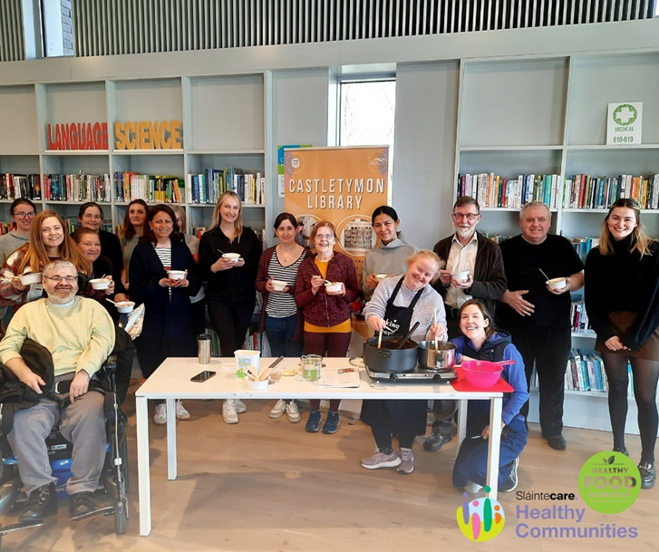

**World Book Day 2023**

The first ever Quidditch Pong Tournament was held in the library on March 2nd, with children from the Tymon area getting dressed up and joining teams to take part in the fun.

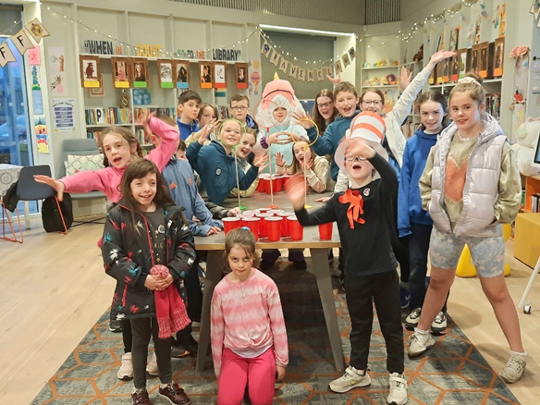

**Seachtain na Gaeilge**

Following on from a hugely popular Halloween talk last year, local historian Albert Perris presents “Behold the Daughters of Tallaght” a talk celebrating Seachtain na Gaeilge and International Women’s Day. Albert will present this celebration of Tallaght’s greatest women on Wed, March 8th @ 6.30pm.



**Trad in Tymon**

Our music nights return for 2023 with a session in the library on Wed, 15th March @ 6.30pm. Fiddle, guitar and uillean pipe players are joined by members of the community who are encouraged to bring their own instruments to play, sing a few songs or simply come down and enjoy listening to the music. Always a well-attended event.

**Leo Mentoring Clinic**

A one on one clinic for advice on starting your own business takes place in the library on Friday, 10th March

**ADHD Ireland** present an online talk on Wed 22nd March @ 6.45pm as part of Neurodiversity Week 2023. This talk will give an introduction to ADHD and available resources and supports for adults and parents.

**In Conversation with author Gill Perdue**

Tallaght native and crime novelist Gill Perdue will be in Tymon Library on Thursday, 30th March @ 7pm to talk about writing and what inspires her work. Gill will discuss her newest book “If I Tell”, which is currently receiving glowing reviews.

**Easter Midterm**

Castletymon Library will host coding camps for children aged 7 – 14 years old. Attendees will learn the basics of Scratch, coding etc and all equipment is provided.

The library will also host arts and crafts and a variety of events for children over the midterm break.

**DJ workshops with Music Generation and NOISE**

Beginning on April 21st, the library will host 15 students from Tallaght Community School every Friday morning for 4 weeks. The TY students will learn beat-making, critical listening skills and how to put together sets of music they’re interested in. Guaranteed to be noisy and fun!

**Libraries Report | Mobile Library Service**

The Mobile Library continued to visit 36 public stops each week during February. We introduced one new regular public stop at the new housing development at Kilcarbery Grange, Clondalkin. This promises to attract lots of new families into the library who may not have visited us before. We visited 12 primary school in February. Our Libary@Home service continues to deliver books to vulnerable people in the community and we made 107 home deliveries in February. We held a further five outreach events in February, including our regular monthly visit to Ukrainian refugees at Citywest Hotel.

