**RTFB ACM January**

**Libraries Report | Ballyroan Library | February 2023**

Ballyroan Library had 19,695 visitors in January, We hosted 48 events in January with a total of 781 attendees.

**Event Highlights**

**Exhibition**

We will be hosting a photo exhibition from Cantonese in Ireland until February 18th.

There will follow an exhibition of paintings by Ukrainian artist Volodymyr Shkred from the 20th.

**Launch of Seachtain na Gaeilge**

The launch of Seachtain na Gaeilge Átha Cliath Theas will take place in the presence of the Mayor on Tuesday February 21st at 10.30am.

**Adult Event Highlights**

Tuesday 7th February at 6.30pm

**Green in ’23: Energy Saving Talk with Codema**

Are you interested in learning how to save energy in your home? Are you looking for simple actions you can take to reduce your energy bill? Then make sure to come along to this talk in Ballyroan Library where Codema, Dublin’s Energy Agency, will share easy, everyday actions you can take to get you saving energy. The tips will cover a range of areas of energy use in the home, such as heating, lighting and electrical appliances.

Tuesday 21st February at 6.00pm-7.30pm

**Green in ’23: Adult Clothes Swap**

Bring up to 3 items of clean adult clothing, in good condition and swap them for the same number of items. Drop off clothes between 11:00am and 4:00pm and collect swap tokens. Clothes swap will take place between 6.00pm and 7.30pm. We will be recycling any clothes that are not swapped.

Tuesdays from 21st February

**Irish for Beginners**

This is a six-week course happening every Tuesday from 2.30pm for 1 hour.

**Irish for Improvers**

If you already know the basics, this is the course for you. Classes every Tuesday from 3.30-4.30pm.

Wednesday 22nd February at 11am

**Golden Moments: Unusual Dublin Pub Names – a talk by Cathy Scuffil**

Dublin's fascinating history hides in plain sight, it can be in placenames, road signs, people, houses and buildings. Dublin's pubs also have their share in that story. Join historian, Cathy Scuffil on a journey through the pubs of Dublin and the stories behind them.

Monday 27th February at 6.30pm

**Touched By Faith, Surrounded By History.**

A talk by local historian Tony Duffy.

Tuesday 28th February from 6pm – 8pm

**Adult Arts and Crafts with Christine**

Make a beautiful collage landscape picture from coloured paper.

Booking essential.

Wednesday 15th February 11am to 12pm

**Scrabble Morning**

Test your skills with this addictive word game or try a selection of other games.

All welcome.

Mondays at 11:00am and Thursdays at 6:30pm

**Stitched Together** –**Crafting Groups**

Pick a day that suits you and come along to our informal, friendly, and very crafty meet-up! Bring your crafts and enjoy a chat and some refreshments. We have a sewing machine and other craft items available to make use of. All welcome.

Monday 27th February from 3:30pm

**Ballyroan Gardening Group**

This new group, formed from a series of library workshops, is a community of local people who have a shared interest in both gardening for horticultural reasons as well as for mindfulness. The ethos of the group is underpinned by being as sustainable as possible in their methods. Gardeners of all ages welcome.

Thursdays at 10.30am

**Age Action Computer Classes**

These are one-to-one classes for older people facilitated by Age Action every Thursday.

**Sensory time at Ballyroan Library**

Monday 16th February 6pm-8pm and every Monday moving forward.

From February Ballyroan hopes to retain these two hours every Monday evening as a quiet sensory friendly space. We would ask all patrons to limit noise of speaking and devices. We will lower staff phones and any events will be limited during this time to keep the library as sensory friendly as possible

**Children’s Event Highlights**

Friday 3rd February at 10am

**Bouncing Baby Book Club**

Rhymes, songs and stories for 0-18 month olds plus their adult.

Wednesday 8th at 3.30pm

**Valentine Craft Class for kids**

Add some extra fun to Valentine's Day by making your own gifts for your loved ones. Ages 6-10 years.

Saturday 11th February at 2.30pm

**Game Zone – The Great Sticker Swap!**

Swap your cards, complete your collections! Panini World Cup, Match Attax and Pokémon catered for. All welcome.

Wednesday 15th February 1-2pm and 2.30-3.30pm

**Cool Food School workshops**

Join Deirdre from the award winning The Cool Food School for a fun cooking workshop in Ballyroan Library. We'll have fun chopping and peeling and making tasty smoothies! Which one will be your favourite? For ages 6-12 years

Monday 13th February at 3.30pm

**Mid-Term STEAM! ORIGAMI – suitable for 8 years and older**

Fold, stars, cups, toys and more! Learn the ancient art of paper folding by making and creating 2 dimensional and 3 dimensional objects. Booking essential.

Tuesday 14th February at 1.30pm

**Mid-Term STEAM! MAKE A SPINNER TOY – suitable for 8 years and older**

Create your very own "Whirlygig" - a toy that was made before the industrial age. Your toy will be able to spin up to 125,000rpm! Booking essential.

Monday 27th February from 3:30pm

**Philosophy Club**

Join Ian for this month’s philosophy club. For ages 10-12.

Wednesdays 8th and 22nd February 6:00-8:00pm

**Coderdojo Rathfarnham**

Our fortnightly coding classes for 7-17 year olds continue. Coders of all abilities are welcome.

Thursday 23rd February at 4:00pm

**Ballyroan Junior Book Club**

This month's book will be *The Powers* by Kevin Stevens.

Saturday February 18th at 2pm

**Family Movie Time**

The Bad Guys

Every Tuesday at 10am (except February 21st)

**Toddler time**

Stories, music and fun for toddlers. All welcome. No Booking required.

Every Monday at 3.30pm

**Storytime**

Weekly storytime for ages 3-6 years. All welcome. No booking required.

**Libraries Report | Castletymon Library | February 2023**

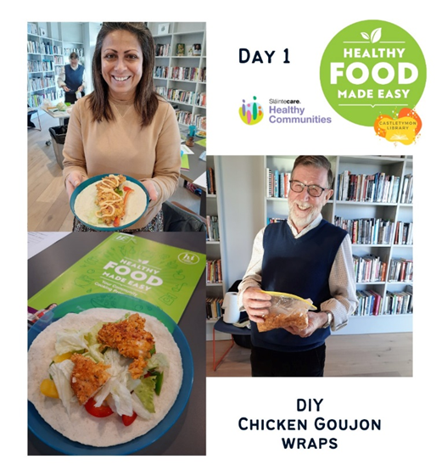***Healthy Cooking for Parents*** A partnership with Sláintecare and SDC Partnership, this 6 week practical cooking class has been a huge hit. Fully attended each week, participants are shown how to cook healthy, homemade lunches on a budget. Ingredients and equipment are provided. Some of those attending are adults with additional needs who are learning to cook before moving into independent living. Feedback from the group has been fantastic.

**Conversational Irish classes** Beginning Wed, February 8th, a 10 week course of Irish for people with varying degrees of Irish who want to hold a conversation as Gaelige. Already fully booked.

**Art classes for older adults** Our series of meditative art classes for older adults continues through February and March with meditative colouring and workshops on watercolours for beginners

**STEAM workshops** Castletymon Library holds different STEAM workshops on Saturdays, including a monthly session for children with additional needs and their carers. These specialised sessions facilitate a smaller group allowing children to be more comfortable, and each session consists of an activity specially designed to encourage interaction with the activity and their surroundings.

**Seachtain na Gaeilge** Following on from a hugely popular Halloween talk last year, local historian Albert Perris presents “Behold the Daughters of Tallaght” a talk celebrating Seachtain na Gaeilge and International Women’s Day. Albert will present this celebration of Tallaght’s greatest women on Wed, March 8th @ 6.30pm.

**Trad in Tymon:** Our music nights return for 2023 with a session in the library on Wed, 15th March @ 6.30pm. Fiddle, guitar and uillean pipe players are joined by members of the community who are encouraged to bring their own instruments to play, sing a few songs or simply come down and enjoy listening to the music. Always a well-attended event.

***Sensory time*** Castletymon Library hold sensory times twice a month

Tuesday 7th February, 6pm – 8pm

Friday 24th February, 10am – 12pm

Tuesday 7th March, 6pm – 8pm

Friday 24th March, 10am – 12pm

**Leo Mentoring Clinic** Castletymon library hosts the local enterprise office mentoring clinic Friday, 10th March @ 10am

**Libraries Report | Mobile Library Service**

The Mobile Library returned on 3rd January 2023 visiting all our regular stops across the County. We made 144 public stops this month. Our school service resumed on 9th January and we visited 14 primary schools in the month. Our Libary@Home service continues to deliver books to vulnerable people in the community and we made 107 home deliveries in January. On 26th January we returned to Citywest Hotel for our fifth Ukrainian Outreach event.

