**Clondalkin ACM**

**Libraries Report | Clondalkin Library | January 2023**

Throughout December Clondalkin Library issued 2,970 items and registered 52 new members. 3,460 people visited the library over the course of the month.

A total of 42 events were hosted by the library throughout the month.

Overall in 2022, Clondalkin Library issued 38,153 items, registered 1,807 new members, and had 49,242 visitors.

**Events for January**

We will celebrate Chinese New Year: Year of the Rabbit with a children’s arts & crafts class on 19th January and a movie night for adults on 18th January.

In conjunction with Pearse College we are offering a ***Creative Arts for Early Childhood*** module for library staff and teachers which will be given in Clondalkin Library. The course is free and is being offered to library staff, teachers and SNAs in local schools. This collaboration with Pearse College is being piloted in Clondalkin Library and, if successful, will run again in September 2023. The course will run for 12 weeks and will be held on Tuesday afternoons from 3-5pm.

RTE will be running a book club series in 2023 called the Page Turners. One of the books clubs (The Iron John Book Club) which has been supported by Clondalkin Library will feature on 5th Jan at 10.15pm. They will discuss Sean O’Driscoll’s book - Heiress, Rebel, Vigilante, Bomber (The Extraordinary Story of Rose Dugdale).

*Schools*

We have created a strong relationship with local schools and have 5 classes booked in for weekly visits for the month of January. As part of SFI funding secured by our development team we are providing 6 STEAM workshops to schools in January and February.

*Outreach visits*

As part of our Outreach programme, we visited the IBIS Hotel, the Red Cow Moran Hotel and the Clondalkin Towers on Christmas week with boxes of books for children and over 140 craft packs.

We also set up a small library in the *Lexington Nursing Home* for the residents where stock will be replenished every six weeks.

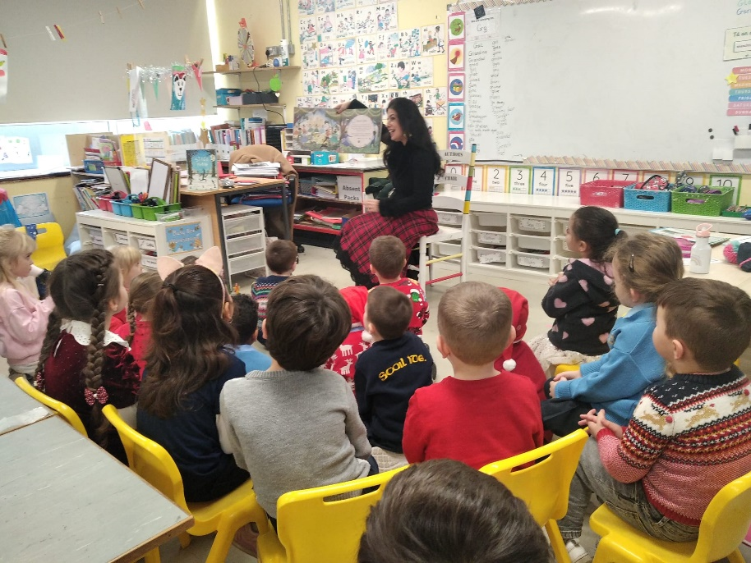

*Pic 1: Red Cow Pic 2: Stroytelling at Scoil Ide, Clondalkin*

We also set up a small library in the *Lexington Nursing Home,* *Monastery Avenue* for the residents, stock will be replenished every six weeks.

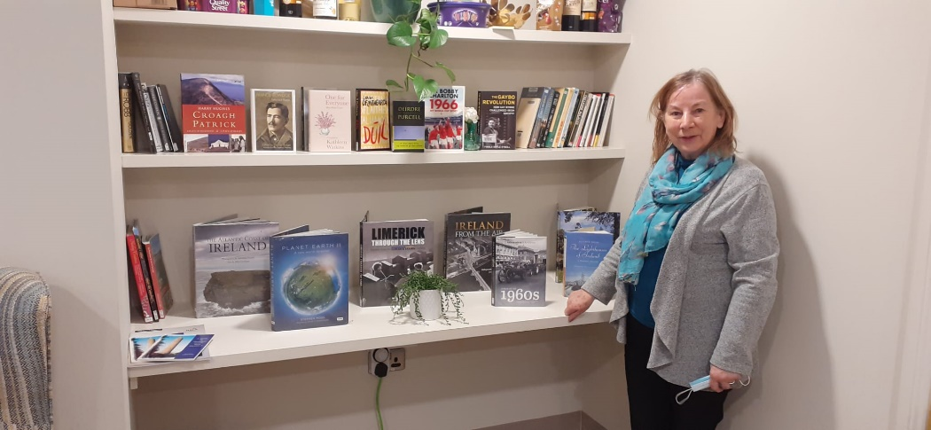

*Pic 3: Lexington Nursing Home, Clondalkin*

**Events for February**

**St Brigid’s Day Celebrations**

Towards the end of January, we will commence our St Brigid’s Day celebrations with craft workshops for children & adults with a theme of Spring. We will host some entries from the annual art competition in conjunction with the Lá Féile Bríde Festival.

Michael Fortune of folklore.ie will give a talk to school children and adults about St Brigid on 26th January 2023.

We will also have our regular events, including baby and toddler time, storytelling, daily class visits, adult craft classes and book clubs, etc.

**Libraries Report | Mobile Library Service**

The Mobile Library service completed a busy year’s work on Thursday 22nd December. We made 106 local stops in neighbourhoods across the county in December. We visited nine primary schools to complete an uninterrupted school visits programme for the term. Our Library@Home service made 109 home deliveries to people who have difficulty leaving their houses. On 14th December we took part in a Musical Christmas event at Bloomfield Health Care Centre to wrap up our programme of “outreach” events for the year.

