**RTFB ACM January**

**Libraries Report | Ballyroan Library | January 2023**

Ballyroan Library had 12,444 visitors in December, with 10,322 items issued, and 308 new members registered.

The annual totals for 2022 are 191,797 visitors, 153,585 items issued, and 7,437 new members registered.

**Event Highlights**

**Exhibition**

January’s exhibition is by local artist Morgan Gibbs.

From Rathfarnham, Morgan is completely self-taught, initially working with pencil, he has now moved into the medium of oil painting, under the guidance of Brian McCarthy, one of Ireland’s leading artists. One of Morgan’s passions and subsequent inspirations for his paintings comes from his love of wildlife.

Morgan has been lucky enough to have visited and photographed all seven continents and has seen all of his subjects in their natural habitats, which gives him a unique insight and allows him to capture this in his paintings.

**Event Highlights**

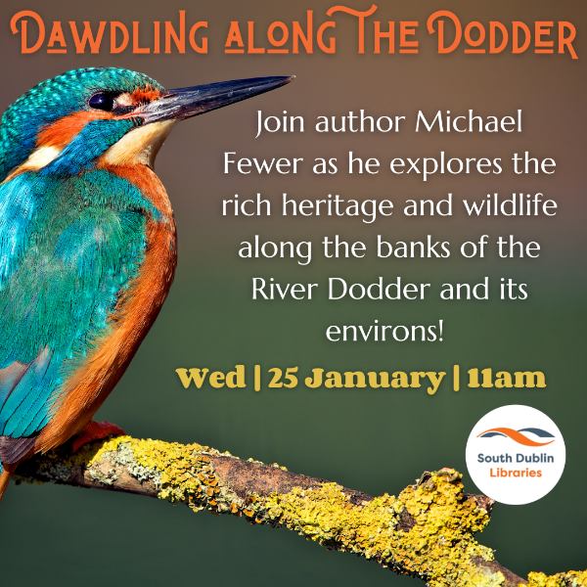Friday 6th January at 10:00am

**Ballyroan Gardening Group**

This new group, formed from a series of library workshops, is a community of local people who have a shared interest in both gardening for horticultural reasons as well as for mindfulness. The ethos of the group is underpinned by being as sustainable as possible in their methods. Gardeners of all ages welcome.

Thursday 12th January 10:30am and every Thursday thereafter

**Age Action Computer Classes**

These are one-to-one classes for older people facilitated by Age Action.

Wednesday 25th January at 11am

Golden Moments Social Club

**Dawdling Along the Dodder with Michael Fewer.**

A talk with author Michael Fewer, exploring the rich heritage and wildlife along the banks of the River Dodder and its environs.

Mondays at 11:00am and Thursdays at 6:30pm

**Stitched Together Craft Group**

Social skills-share events for crafters of all kinds and abilities. All welcome.

Tuesday 24th January at 6:30pm

**Green in ’23: Declutter Your Home, a talk with Fiona Hall**

This Decluttering Workshop is presented by Fiona Hall, counsellor, psychotherapist and owner of Consciously Clearing. This workshop will provide practical tips on where to start, what to tackle, and will guide you through the emotional blocks that may get in your way. It will also consider the sustainability aspects of decluttering – freeing your home of items you don’t use and allowing others to repurpose them in the circular economy. This is the first in a series of events, ‘Green in ‘23’ which will continue in February and March and will include clothing swap and repair events and an energy awareness talk with Codema.

Wednesdays 11th and 25th January 6:00-8:00pm

**Coderdojo Rathfarnham**

Our fortnightly coding classes for 7-17 year olds continue in 2023! Coders of all abilities are welcome.

Thursday 26th January at 4:00pm

**Ballyroan Junior Book Club**

Our monthly bookclub for 8-12 year olds returns for 2023. This month's book will be The second book in The Trapdoor Mysteries, *The Scent of Danger* by Abie Longstaff.

Thursday 26th January and Tuesday 31st January at 10:00am

**STEM Workshops for Schools with MakerMeet**

These student-centred, discovery-led workshops are funded by Creative Ireland.

**Libraries Report | Castletymon Library | January 2023**

A total of 36 events were hosted by the library throughout the month of December, with 913 people attending. 45 people joined the library during December, and 3,121 books were issued.

**January Highlights – Adults**

**MINDFUL ARTS AND CRAFTS**

Monday, 9th & 16th January @ 12pm

Get the best start in the new year with this 2-part mindful arts and crafts session with Jen.

Suitable for older adults. Contact the library to book.

**CHAIR YOGA**

Tuesday, 10th January @ 10.30am

Ease into the new year with a gentle session of chair yoga with Sally Dunne.

Suitable for older adults. Booking from Tuesday 3rd January @ 10am, contact the library.

**CASTLETYMON CRAFTERS**

Beginning Thursday 12th January @ 10am

Our knitting/crochet/crafting group starts back on Thursday 12th January.

New members welcome, no experience required. Come down to the library for a cuppa, some crafts and a chat! Suitable for older adults, no booking necessary.

**COOKING FOR PARENTS MADE EASY**

Beginning Tuesday, 17th January @ 10am

6-week practical course for parents of younger children.

Come to the library every Tuesday morning to cook healthy, nutritious meals with a trained instructor in this fun, practical, hands-on course. There will be a focus on nutrition, healthy eating and cooking tasty food on a budget! All ingredients will be provided and each participant will receive a grocery voucher on completion of the course. Booking now open Castletymon Library Eventbrite

**January Highlights – Children**

**PARENT AND TODDLER GROUP**

Beginning Wednesday, 4th January @ 10.30am

Our regular parent and toddler group begins back after the Christmas break on Wed, 4th Jan. All welcome, no booking necessary.

**ROB’S RADICAL READERS – JUNIOR BOOK CLUB**

Tuesday 10th January @ 3.30pm

Get kids into reading, using their imagination and developing their critical thinking with Rob’s book club. Each month, the group will get together to discuss a new book and have a chat

Suitable for ages 8 – 11 years. Contact Rob at the library for details.

**TOUCH TYPE READ SPELL**

Beginning Wednesday 18th January

Every Wednesday & Thursday @ 6pm

TTRS is a multi-sensory course that teaches touch-typing to help children improve their reading and spelling skills. Particularly suited to children with mild learning difficulties.

Suitable for children aged 8 – 12 years, contact the library to be added to the waitlist

**SENSORY TIME**

Tuesday 17th January @ 6pm and Friday 27th January @ 10am

Sensory times for children and families with additional needs. Lights will be dimmed, and sensory toys will be available for use in the library. All welcome, no booking necessary.

**STEAM SATURDAY: ENGINO SETS**

Saturday 28th January @ 11am

Join John for some engineering fun with Engino sets. Suitable for children aged 8 – 12 years. Booking via Castletymon Library Eventbrite.

**Libraries Report | Mobile Library Service**

The Mobile Library service completed a busy year’s work on Thursday 22nd December. We made 106 local stops in neighbourhoods across the county in December. We visited nine primary schools to complete an uninterrupted school visits programme for the term. Our Library@Home service made 109 home deliveries to people who have difficulty leaving their houses. On 14th December we took part in a Musical Christmas event at Bloomfield Health Care Centre to wrap up our programme of “outreach” events for the year.

