**Lucan ACM Highlights December/Jan**

**December is all about Family Time and Seasonal Celebration at Lucan Library!**

**Thursday 8th December – Thank You Thursday**

The staff at Lucan Library held a very special day of events to thank the local community for their support for the library over the past year. We are all delighted to see so many people of all ages return to their library after the disruption of the Covid years. We were very grateful for the support of Mayor Councillor Emma Murphy and Councillors Joanna Tuffy and Vicki Casserly, who joined us either during our Special Seasonal Storytime, Family Workshop Workshop with Claire and Ciara from SD Music Generation and the finale music event with the wonderful Niamh Keane Trio.

**Winter Craft Fair**

Saturday 10th December Lucan Library hosted the annual Winter Craft Fair, back with a bang this year. With 20 tables the library was packed with delightful craft items, Christmas treats and beautiful photographs. Entertainment offered throughout the day included Face Painting, Captain Ho Ho Magic Show, Festive Favourites Singalong with the Esker Folk Group and finally the visit of the big man himself, Santa!! All in all a super day with great support from the local community.

**Children and Adults with Additional Needs**

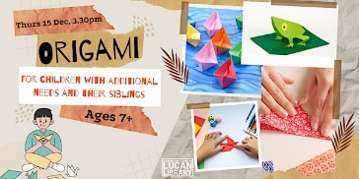Tuesday 6th December we welcomed a regular group of clients from Stewarts Care for the ever-popular Music Therapy Session with James Burns while on Thursday 15th December Aoife Munn is hosting an Origami Workshop for children. Origami is particularly useful in assisting fine motor skills and helping children who struggle with their handwriting. Booking essential via Lucan Library Eventbrite: [Origami for Children with Additional Needs and their Siblings Tickets, Thu 15 Dec 2022 at 15:30 | Eventbrite](https://www.eventbrite.ie/e/origami-for-children-with-additional-needs-and-their-siblings-tickets-477345893417?aff=ebdsoporgprofile)

**Seasonal Family Film**: Our Family Time at the Library will finish with a showing of Arthur Christmas, our seasonal family film on Saturday 17th December at 11am.

**History and Heritage**

On Thursday 1st December **Cathy Scuffil** gave a great talk on the **Dublin Camino**. Cathy is always a popular and engaging speaker and there was a great turnout for her talk. We are sure there will be Lucan residents following the Dublin Camino on their walks in 2023.

**NCL ACM Highlights December**

**North Clondalkin Library ACM Highlights**

**Rowlagh Reads Roddy: Intergenerational Reading Programme**

A month-long Intergenerational reading programme took place in NCL throughout the month of November. Locals and Councillors took part in the programme by taking photographs of themselves reading a Roddy Doyle book and posting on social media. The programme culminated with an interview with Roddy Doyle in NCL on Friday 2nd December at 6.30pm. There was huge interest in the event – with 120 attendees on the evening. Music from the Commitments was provided by the Cotton Quartet with refreshments provided. The event was well supported by local councillors - with the Mayor of SDCC Emma Murphy also attending the event.

**Christmas Festivities at NCL: Christmas Family Fun Day: Saturday 11th November**

Festive activities kicked off in North Clondalkin Library early this year with a **Christmas Family Fun Day** on Saturday 19th November . Over **2 000 customers** attended on the day-which included over 20 craft stalls packed with crafts & treats of all types. Events & activities included: Magic Show, Go Fly your kite STEAM sessions, Christmas movie and lots more. A special appearance of Santa delighted children. Families were presented with a Santa photo and some sweets. Music was provided on the day by Niamh Keane.

**NCL Community Choir** will be performing for the first time on Thursday 15th December at 6.30pm. The intergenerational choir has been meeting weekly since September and working hard with musical director Noel Collins. Lyric fm have featured the Choir on their website and their radio station. [https://www.rte.ie/radio/lyricfm/info/2022/1207/1340478-rte-choirs-for-christmas-2022-entries/](https://eur04.safelinks.protection.outlook.com/?url=https%3A%2F%2Fwww.rte.ie%2Fradio%2Flyricfm%2Finfo%2F2022%2F1207%2F1340478-rte-choirs-for-christmas-2022-entries%2F&data=05%7C01%7Crhand%40SDUBLINCOCO.ie%7C5425f025d88d4979a22608dadabf78b2%7C6a3c00c019d0492da8de95fad8fda1d4%7C0%7C0%7C638062813314765934%7CUnknown%7CTWFpbGZsb3d8eyJWIjoiMC4wLjAwMDAiLCJQIjoiV2luMzIiLCJBTiI6Ik1haWwiLCJXVCI6Mn0%3D%7C1000%7C%7C%7C&sdata=zZi0pbo3ehwsoMslJEbRqiZFHGXt6O%2Bphq1UpH6LyBg%3D&reserved=0)

There is huge interest in the performance -with 120 alreadybooked in**. T**he event will be attended by Mayor of SDCC Cllr Emma Murphy.

**Engagement with outside Organisations: Stewarts Special School**

On Tuesday 6th & Wednesday 7th December staff from NCL were invited to Stewarts Special school to engage with students. The event was a huge success - with Aoife engaging with over 16 class groups, entertaining them with Storytime sessions. We brough along our Magic Table encouraging students to try out our interactive fun games. Carers will be bringing their students down to NCL in the new year-where we will set up our sensory room.

**Palmerstown Library: ACM Highlights:**

**Beginner’s Yoga**, 1st December - We had a lovely relaxing yoga workshop with [Fanny Savickis](https://eur04.safelinks.protection.outlook.com/?url=https%3A%2F%2Fwww.facebook.com%2Ffanny.yogini%3F__cft__%255b0%255d%3DAZWH9XrnDb0bpDAvGwsG90Q53KQnNlqj_tiYaoHubjEFMQr1NoKmN5KCaHj7EsxApTVxPn31jeMVA3d3a4ajX6s_aNo6KgAPcaOKC7Cz1HzZxrlYoSqtz9bBL4oigdI5JuPKSJAQtOHK8K0TAVfil7dVuRWaW51VpV1gGulz9v3U310Y-OYrVsm3TJoUlJYaTXBqzo6cJFEhPhxdYX_8NHe1%26__tn__%3D-%255dK-R&data=05%7C01%7Crhand%40SDUBLINCOCO.ie%7C628d7a5573914435269b08dadc251b16%7C6a3c00c019d0492da8de95fad8fda1d4%7C0%7C0%7C638064349173353082%7CUnknown%7CTWFpbGZsb3d8eyJWIjoiMC4wLjAwMDAiLCJQIjoiV2luMzIiLCJBTiI6Ik1haWwiLCJXVCI6Mn0%3D%7C3000%7C%7C%7C&sdata=dFiYhRjiGZgFTW%2Bl4OYXsfbUghbrDRO0e07n8k2KDhE%3D&reserved=0) in Palmerstown Library as part of the Healthy Ireland Programme.

**Christmas LED Cards Workshop**, Wednesday 14th December. Learn about electronic circuits in this STEAM activity for 9-12 year olds and make a unique card for someone special.

**Seasonal Storytime with Crafts**, 21st December. For 3–5-year-olds. Seasonal tales for holiday time and little craft with parents/guardian. Wear red & white hats, Santa jumpers, seasonal PJs etc.! For Family Time at Your Library.

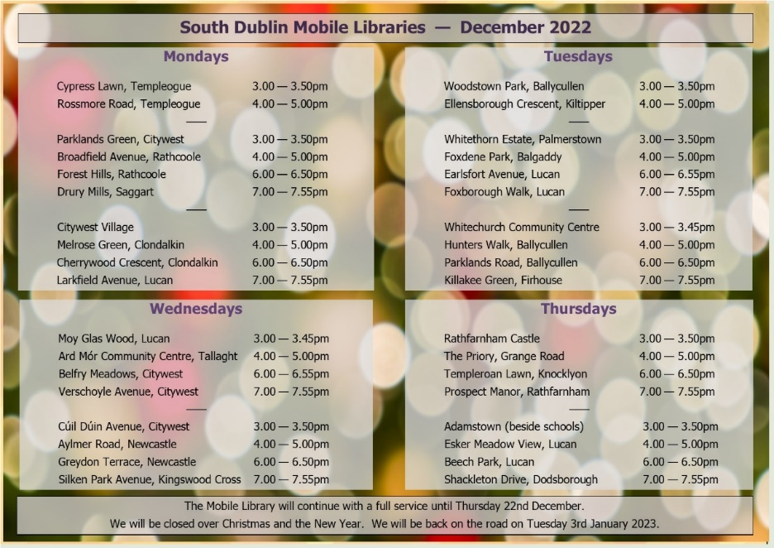

**Mobiles Report – November/December 2022**

Our Mobile libraries had a very busy month in November with 2,041 patrons using the public stops. We had a full schools and crèche programme and 108 home deliveries. We also continued our service to City West refugee centre. On December 14th we are bringing some Christmas cheer to Bloomfield Residential Home – with the Christmas Crooners live performance as well as our usual mobile service.