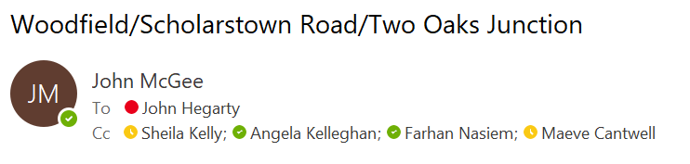

Hi John Joe,

Please find the Woodfield/Scholarstown Road/Two Oaks Junction report below.

Following the customer and elected member comments regarding the safety of the Woodfield/Scholarstown Road/Two Oaks Junction, SDCC Roads Dept. contacted the developers of Two Oaks (Walls Construction) who were responsible for the recent junction upgrade works. Walls Construction in turn forwarded our query on to DBFL Consulting Engineers who designed the junction and produced the accompanying drawings.

DBFL noted that;
• Corner radii and arrangement of crossing points are as per DMURS guidelines.
• Lighting at the junction has also been upgraded as part of the works.
• The junction design is to moderate vehicle speed.
• The works along Scholarstown Road and at the junction have been subject to a Stage 2 Roads Safety Audit.

SDCC Roads Dept. reviewed the junction design drawings and carried out a site visit on 18/11/2022.
It was concluded that:
- The junction design was in line with the standards set out in DMURS (2019)
- The junction construction is in line with the permitted planning application. (SHD3ABP-305878-19)
- The principles behind DMURS design is to moderate traffic speeds and to this effect the junction is functioning well.
- Vehicles can safely turn left and right when exiting Woodfield but must do so at low speeds. The location of pedestrian crossings on both side of the junction would justify these moderated speeds.
- There is an issue with the visibility of the splitter island to the east for drivers turning right exiting Woodfield. It was also noted that the keep-left bollard at the end of the island needs to be reinstated.

Following consultation with SDCC Roads Dept., DBFL will improve visibility of the islands for drivers exiting Woodfield by the application of black / amber marking to the face / top of kerbs around the islands. This approach has been used elsewhere along Scholarstown Road.

DBFL have also be requested to reinstate any missing keep-left bollards on the splitter islands.

SDCC Roads Dept. have requested that DBFL provide updates on the progress of works.

Kind regards.

John McGee | Assistant Engineer | Roads Forward Planning
South Dublin County Council, County Hall, Tallaght, Dublin 24.
Phone: 01-4149000 (Ext. 4299)
Email: jmcgee@sdublincoco.ie

