Clondalkin ACM
Libraries Report | Clondalkin Library | December 2022

Throughout November Clondalkin Library issued 3,654 items and 130 new members were registered.
A total of 67 events were hosted by the library throughout the month of November, with 685 people attending.

Events for December
For children we had a magical Christmas story time with Santa yesterday.


For adults we had a full house for Dickens in Dublin on Wednesday 7th December.
We also had our ongoing monthly clubs inc. genealogy club/book club/ G.I.Y club.
We continue to have weekly story times and host baby and toddler mornings every Tuesday and alternating weekends, as well as our monthly STEAM activities, junior book club and TTRS three days a week.

We were also delighted to welcome back our friends of the elderly for a coffee morning and some more line dancing on Thursday 8th Dec.

Outreach visits
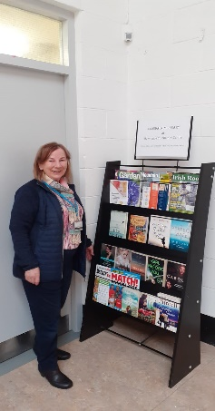
As part of our Outreach programme, we set up a small library stand in Bawnogue Community Centre and visited the Villagers Active Retirement group in Clondalkin Village. We will be setting up a small library in the Lexington Nursing Home and visit the Ibis Hotel and Red Cow Hotel Christmas week with picture books for children.
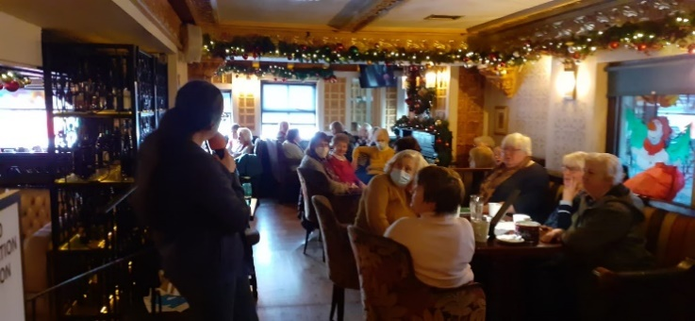

Events for January

We will be celebrating Chinese New Year with a year of the rabbit children’s arts & crafts class 19th Jan and movie night for adults 18th Jan.


In conjunction with Pearse College we are offering a Creative Arts for early Childhood module. This course will run for 12 weeks in Clondalkin Library on Tuesdays from 2-4pm.


St Brigid’s Day celebrations.
Towards the end of January, we will commence our St Brigid’s Day celebrations with craft workshops for children & adults, our annual colouring competition and folklore talks by Michael Fortune of folklore.ie. Michael will give a talk to school children and adults about St Brigid on the 26th January 2023.

We will also have our regular events, including baby and toddler time, storytelling, daily class visits, adult craft classes, book club etc…

Mobiles Report – November/December 2022
Our Mobile libraries had a very busy month in November with 2,041 patrons using the public stops. We had a full schools and crèche programme and 108 home deliveries. We also continued our service to City West refugee centre. On December 14th we are bringing some Christmas cheer to Bloomfield Residential Home – with the Christmas Crooners live performance as well as our usual mobile service.

