RTFB ACM
Libraries Report | Ballyroan Library | December 2022

A total of 75 events were hosted by the library throughout the month of November, with 2,628 people attending. 602 people joined the library during November, and 16,887 books were issued.

Ballyroan Library November Highlights

Christmas Craft Fair
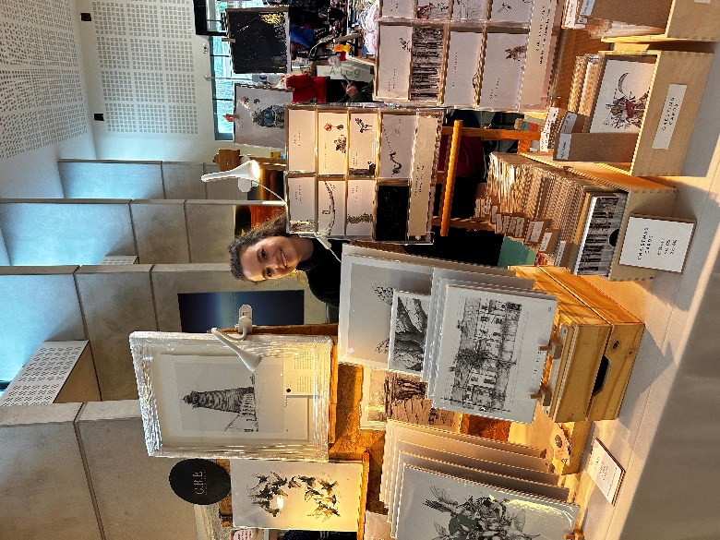
Our annual Christmas Craft Fair took place on 26th November, with handmade gifts from local crafters, cakes and bakes, and live music from Rathfarnham Ukelele Group.

Season of Science
Our month-long programme of science events for schools. Workshops at Ballyroan included Make Mini Rockets with MakerMeet, The Eccentric Energy Show with Dr. How’s Science Wows and Colourful Science with Anyone4Science.

December Highlights – adults

Monday 5th December at 2:00pm
First Monday Film Club: Elf
Festive edition of our monthly film club aimed at adults with additional needs. All welcome.

Every Monday at 11am and Thursday at 6:30pm
Stitched Together
Friendly crafty meet up – come along and share skills with others or get inspiration for your next craft project! All welcome.

Tuesday 6th December at 7:00pm
Rebel Statesman: the Life and Times of WT Cosgrave
Join historians Liz Gillis and Cathy Scuffil for a discussion of the Civil War experience of WT Cosgrave, first president of the Executive Council of the Irish Free State, including his local connections to Rathfarnham. This Decade of Centenaries talk is a hybrid event that will take place in the library and will be streamed live on Zoom. Arrive early for festive refreshments!

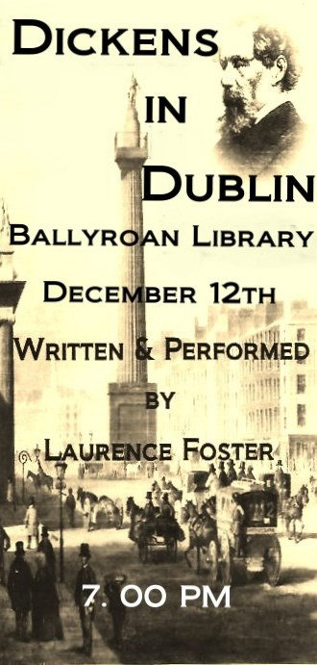
Monday 12th December at 7:00pm |Dickens in Dublin
A one-man theatre show written and performed by Laurence Foster
Charles Dickens was born on February 7th 1812 in a shabby suburb of Portsmouth. Shortly afterwards the family moved to London. Literally self-taught, at the age of 19, Charles became a reporter, recording the parliamentary speeches of Daniel O’Connell, the Irish Liberator, retaining a lifelong mutual admiration.

He also became a devotee of the works of Thomas Moore. In August 1858, the first of three lengthy visits to Dublin, he was hailed with delight everywhere he went. He found it difficult to make his way from Morrison’s Hotel (Nassau St.) through the crowds who were queuing to see his performance in the Rotunda Concert Room. Dickens in Dublin is a recreation of that dramatic evening in Ireland’s capital city.

Tuesday 13th of December at 11am | Scandinavian wreath-making workshop for adults
Get in the festive spirit with this fun and easy wreath making session suitable for beginner and advanced crafters! Booking essential.

Wednesday 14th of December at 11am |The Dublin Village: Rathfarnham
Screening of this 1988 RTE film about Rathfarnham, presented by Shay Healy and Ingrid Miley.
Booking advised.

Thursday 15th December at 6:30pm |Adult Makerspace Workshop: Design and Print a Custom Mug
Try out our brand new makerspace equipment, and learn how to design and print a custom mug. Booking essential.
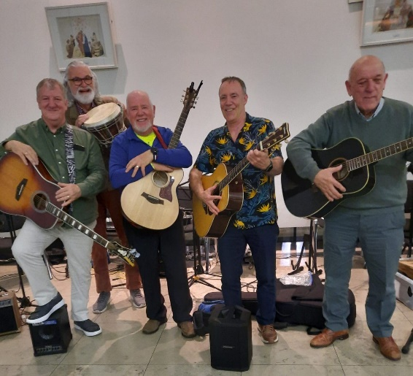
Monday 19th December at 1pm| The Secrets in Dublin Pub Names
An alternative 12 Pubs of Christmas! Join Cathy Scuffil as she takes us through the history of some of Dublin's most fascinating pub names. Part of our Golden Moments series of events.
Booking advised but not essential

Tuesday 20th December at 6:30pm| Live Music with No Direction
Join us for a festive singalong with local band No Direction (aka Ballyroan Men’s Shed)
All welcome!

December Highlights – Children

Thursday 8th December at 3.30pm|Christmas Crafts For Kids
Add some extra fun to your Christmas by making your own decoration to celebrate the magic of the season.

Saturday 10th December at 10:30am |Family Time at Your Library: Magic Show with Captain Hoho
Family Time at Your Library is a national initiative to encourage families to check out everything that membership of their local library has to offer.

Christmas Storytime Events
Winter Storytime with actress and storyteller Róisín Murphy on 13th December, and a Very Special Christmas Storytime with library staff on 20th December. Our annual Christmas Pyjama Storytime takes place on 19th December at 6pm – a fun evening of stories before bed, full of festive cheer!

Fridays at 10:00am|Christmas Toddler Time
Songs, stories and play time for wobblers and toddlers. Special Christmas edition with Sarah Sparkles on Friday 16th December. All welcome.

Monday 12th December at 3pm | Family Christmas Movie – Muppet Christmas Carol
A fun family friendly screening at the library! All welcome.

Libraries Report | Castletymon Library | December 2022

A total of 81 events were hosted by the library throughout the month of November, with 1,100 people attending. 169 people joined the library during November, and 8,213 books were issued.

December Highlights

Creative Aging: Tymon Music Sessions
Wednesday, 30th Nov & Wednesday 14th December @ 6.30pm
Join us for our last two music sessions of the year. If you’ve never been down to the famous Tymon sessions, now’s the time! Audience participation is encouraged but not mandatory, so whether you want to bring your instrument, sing a song or just listen to the music, come down and enjoy!
Suitable for older adults. No booking necessary

Christmas Craft Fair
This year, we held our inaugural Christmas Craft Fair in the library on Saturday, 3rd December from 11am - 4pm
We got into the spirit of the season with the best arts and crafts South Dublin has to offer! Borrowers found the perfect gift and supported local artists at the same time.
Captain Ho – Ho performed a magic show for children @ 11am
There was something for everyone at the Castletymon Library Christmas Craft Fair!

Christmas At Castletymon Library: Connect Café
Monday, 5th Dec @ 11am
Come to the cosy space of the library for games, hot beverages and chats! Come with friends or strike up conversation with someone new!
Suitable for older adults. No booking necessary.

Christmas At Castletymon Library: Children’s Arts and Crafts
Monday, 5th Dec @ 3.30pm
A fun Christmas themed arts and crafts session for children. Adult participation required.
Suitable for ages 5+ years
Booking from Monday 28th Nov @ 10am, contact the library or book via castletymonlibrary.eventbrite.ie

Borrowbox Workshop
Tuesday, 6th Dec @ 11am
Did you know you can download ebooks and audiobooks onto your tablet, phone or device? Its simple and free!
Join John for a straightforward guide to downloading the app and how to use it.
Booking from Tuesday 22nd Nov @ 10am, contact the library

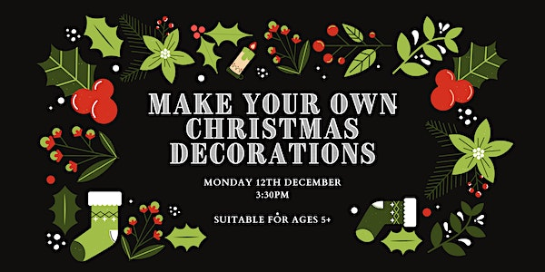
Christmas At Castletymon Library: Make Your Own Christmas Decorations
Monday, 12th December @ 3.30pm
Children can make their own lovely Christmas decorations to bring home!
Suitable for ages 5+, adult participation required.

Christmas At Castletymon Library: Christmas Pyjama Storytime
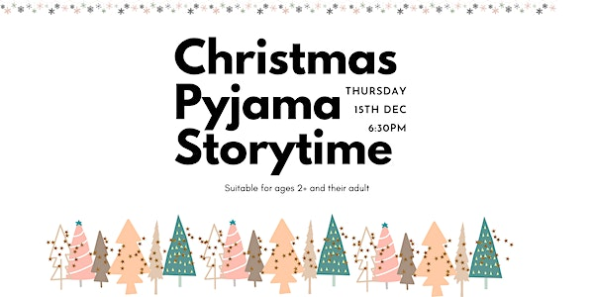
Thursday 15th December @ 6.30pm
Dress up in your PJs, bring your favourite teddy and join us for a very special Christmas story time by torchlight.
Suitable for ages 2+ and their adults.
Booking essential from Monday, 5th Dec @ 10am via castletymonlibrary.eventbrite.ie

Sensory Time
Friday 16th Dec @ 10am
Tuesday 20th Dec @ 6pm
Sensory times for children and families with additional needs. Lights will be dimmed and sensory toys will be available for use in the library.

Regular Events

Toddler And Parent Group
Every Wednesday @ 10.30am
Come along and enjoy songs, nursery rhymes and toys in Castletymon Library.
No booking necessary, all welcome

Rob’s Radical Readers: Children’s Book Club
Takes place on the 2nd Tuesday of every month @ 3.30pm
Rob hosts our new children's book club in a relaxed, fun environment. Kids discuss what book to read and are encouraged to think critically and review honestly!
Suitable for ages 9-11.
For more details, contact the library

Weekly Storytime
Every Wednesday @ 3.30pm
Come along and enjoy a gentle story time for young children.

Knitting And Crochet Club
Every Thursday, 10am - 12pm
Our knitting group has started just in time for winter! Bring your needles and wool and come to the library for tea, chats and knits!

No booking required. Please note you must bring your own materials, this is not a taught class.
Nollaig Shona Daoibh ó
Leabharlann Chaisleán Thigh Motháin!

Mobiles Report – November/December 2022
Our Mobile libraries had a very busy month in November with 2,041 patrons using the public stops. We had a full schools and crèche programme and 108 home deliveries. We also continued our service to City West refugee centre. On December 14th we are bringing some Christmas cheer to Bloomfield Residential Home – with the Christmas Crooners live performance as well as our usual mobile service.

