Clondalkin ACM
Libraries Report | Clondalkin Library | November 2022

Throughout October there were 774 events across South Dublin branches with an attendance of 11,857.
Of these, 769 were in person events with an attendance of 11,599 and 5 were online with an attendance of 258. Clondalkin Library held 71 events with an attendance of 951. Clondalkin issued 3992 items and 157 new members were registered.

Events for November
We have started our 6-week computer course for beginners in conjunction with DDLETB, the course includes fundamentals and contemporary needs such as email, booking flights/ shopping online and Zoom. As part of our ongoing programmes for adults we started a 5-week Ukulele for Beginners course on Fri 4thNov.

We hosted a talk by Monica McGill titled Where There’s a Will based on the Caldbeck family and a talk by Michael Kelly on G.I.Y diaries which was well received. We will also have a talk on social media and its impact on our mental health with Psychotherapist Fiona Hall.

For our Season of Science children’s event Dr. How’s Science Wows was very well attended.

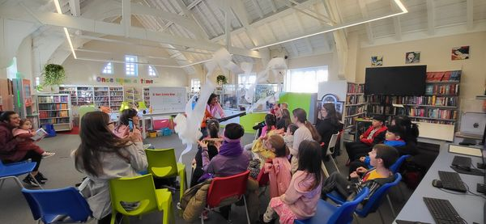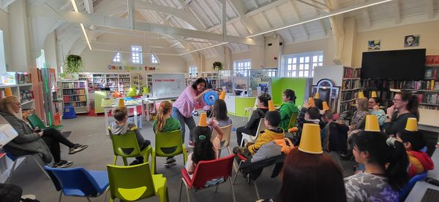

The second event called Break the Ice challenge, took place on the 4th November. We also had a decade of centenaries workshop for children called design your own stamp to mark the creation of the Irish Free State.

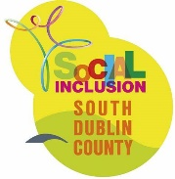As part of the Social Inclusion Festival, we will have an adult craft workshop which will invite our new Ukrainian members of the community to join a craft circle with residence of Clondalkin.
Children’s author Juliette Saumande will host two workshops to cater for 8-12 years on exploring the sense of touch and tactile books and exploring the world through sounds respectively. The first of which will be aimed at a school completion project which the library has made positive connections with. These are children that are at risk of not attending or not completing primary school.

For schools

We continue to have regular school visits on a weekly basis and will introduce a new software tool to teachers for their use called Lexia Core5 Reading. This is a fun, web-based program that has helped millions of students improve their literacy skills.

As part of our ongoing programmes for adults we are starting a 5-week Ukulele for beginners' course on Fri 4th November and computers classes for beginners on 7th Nov in conjunction with DDLETB. We will also host several talks including a talk by author Michael Kelly on his new book The G.I.Y diaries on 1st November and a history talk by Monica McGill on Where There's a Will about the Caldbeck family in Clondalkin on 3rd Nov. We also have our ongoing monthly clubs inc. genealogy club/book club/ G.I.Y club.
We also continue have weekly story times and host baby and toddler mornings every Tuesday and alternating weekends, as well as our monthly STEAM activities, junior book club and TTRS three days a week.

Events for December

For children we will have 2 Christmas Arts & Crafts workshops, a magical Christmas story time and Santa will give out our Christmas craft bags to children, we will also visit schools for Christmas story time as part of our outreach. We will also have arts and crafts for adults.
For adults we are delighted to have a one man show called Dickens in Dublin on Wed 7th December at 8pm. Actor Laurence Foster will play Charles Dickens and will recreate the dramatic evening Dickens performed in the Rotunda Concert Room in 1858. Foster as Dickens will recount some of Dickens’s characters from A Christmas Carol, Hard Times, Pickwick Papers and Oliver Twist.
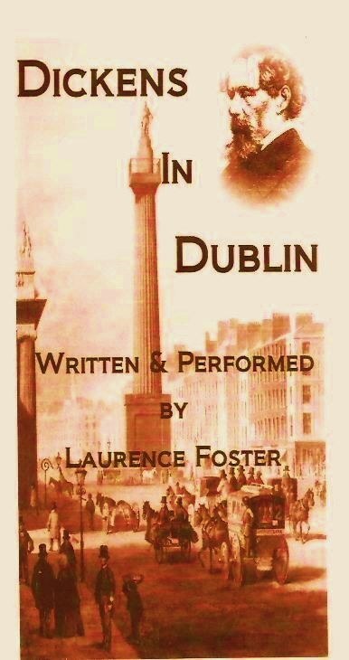

We are delighted to welcome back our friends of the elderly for a coffee morning and some more line dancing on Thurs 8th Dec starting at 10.30. Tea/coffee and mice pies will be served.

Mobile Library | October/November 2022
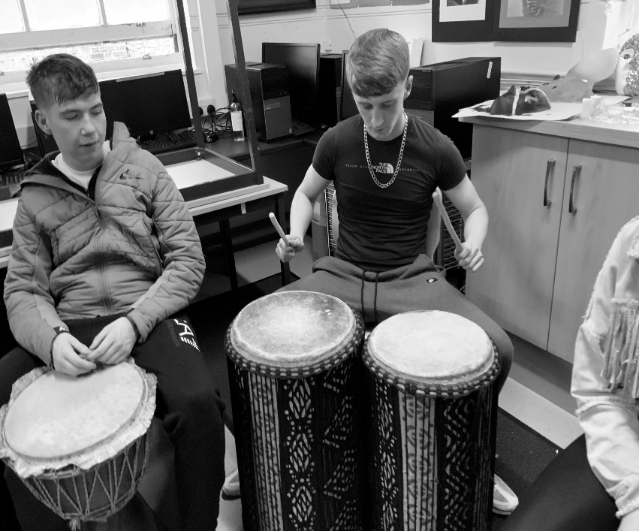
The Mobile Library delivered another full programme in October. We made 144 public stops around the county and made 16 visits to primary schools. We had a great response to our call for children to come on board the Mobile Library in their Halloween costumes. They each collected a spooky reward, and many parents allowed us to take a photograph and share it on social media. Our home delivery service, Library@Home, aimed at people who have difficulty leaving their houses, continues to deliver books to 109 homes each month. On 20th October we paid our first visit to Youthreach Priory in Tallaght where the young people visited the library truck, took out membership and engaged in a drumming workshop. On 27th October we made our third visit to Citywest Hotel for our monthly Ukrainian Outreach event”.

Red Line Festival

The Red Line Festival was a great success this year and ran from October 13-16th in over 40 events in fascinating performance venues including Rathfarnham Castle, Pearse Museum and Baldonnel Aerodrome as well as the Civic and branch libraries across South Dublin. From ‘True Crime’ with Paul Williams, Ex-State Pathologist Dr Marie Cassidy and Private Investigator Patrick Marry to rapping with writer in residence Selló at The Civic or readings of Ulysses at Rathfarnham Castle to Shadow puppet making at Pearce Museum and a whole series of sports events at Tallaght Stadium, poetry awards and Puca puppets, the Red Line Festival was a celebration of all things literary be it spoken, written, sung, played, illustrated, or even just thought!
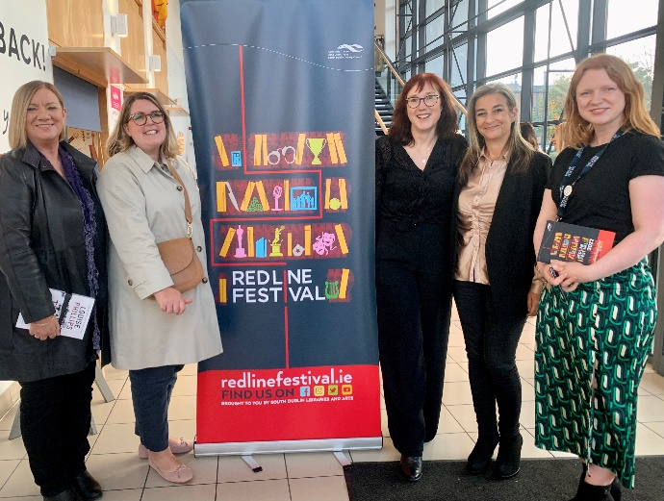
The Red Line Festival was produced by South Dublin Libraries and Arts at South Dublin County Council offering a programme of events and workshops that appeals to people of all ages and interests, from children to adults, casual readers to bookworms with events in six different strands As Gaeilge, Literary, Sport & Wellbeing, Music & Performance, Crime & Horror and Family. The festival featured wonderful authors such as Michael Harding, Donal Ryan and Emilie Pine, Conor Creighton, Louise Phillips and many more.

History, heritage and the Irish language featured throughout the festival. Dean Ruxton discussed his book Death on Ireland’s Eye and Rebecca Brownlie brought her Abandoned Ireland exhibition to the Tallaght Library, highlighting the social importance of our forgotten buildings. Colmán Ó Raghallaigh, Micheál Ó Conghaile and Réaltán Ní Leannáin took part in the As Gaeilge strand.

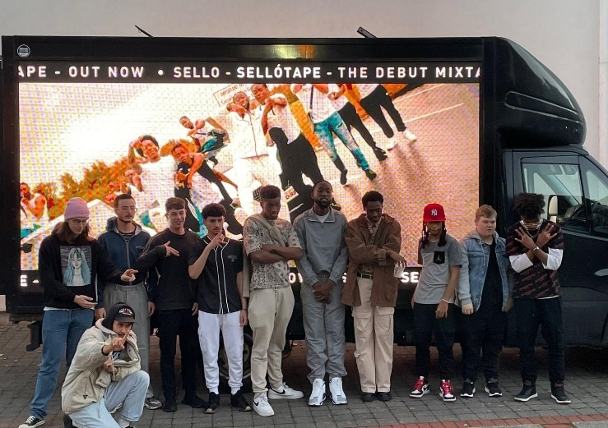
Red Line Festival was also delighted to work with NOISE Music DJ Programme and ‘Give Us The Night’ providing opportunities for young people to learn how to DJ and develop their musical knowledge. The poetry programme took the limelight when award winning poet Jessica Traynor announced the winners of the Red Line Poetry Competition. First place went to Nuala Roche for 'Spirit of American Youth Rising from the Waves. Second place went to Winifred McNulty for 'When Lough na Suil Drains' and third place went to Ruth Quinlan for her poem 'Lamping' This was an incredible achievement as almost 300 poems were entered this year of an exceptionally high standard.

On Sunday at Tallaght Stadium Jonathan Wilson discussed his biography of Bobby and Jack Charlton with local journalist Ronan O’Flaherty. Siobhán Doyle gave a brilliant talk on The History of GAA in 100 objects and George Hamilton had a rousing discussion with Gareth Maher about his book: Away Days - 30 years of Irish footballers in the Premier League.

